1.In this hands-on lab, you will learn how to
· Setup your machine with Git Configuration
· Integrate notepad++.exe to Git and make it a default editor
· Add a file to source code repository

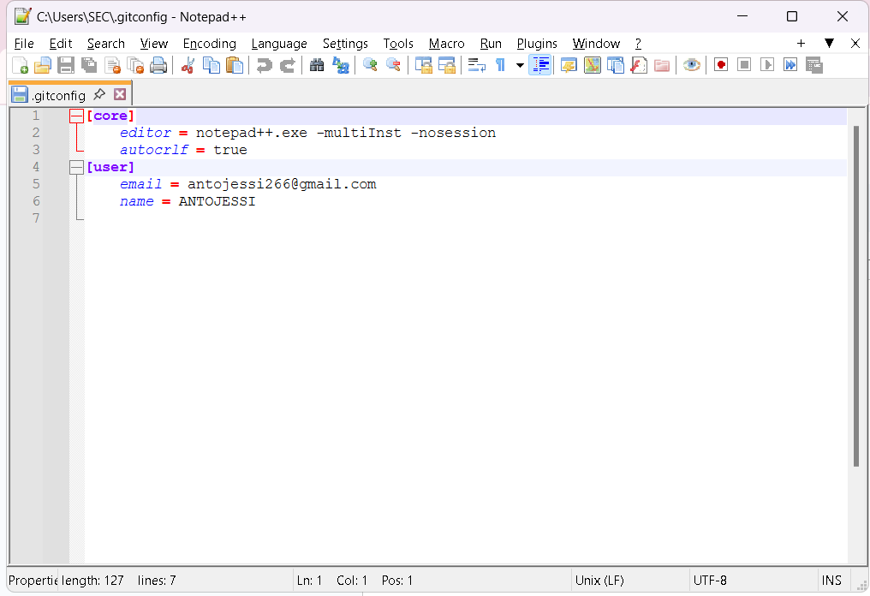

OUTPUT:

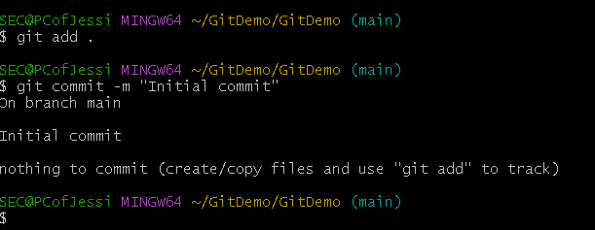

2.Estimated time to complete this lab: 20 minutes.
Create a “.log” file and a log folder in the working directory of Git. Update the .gitignore file in such a way that on committing, these files (.log extensions and log folders) are ignored.
Verify if the git status reflects the same about working directory, local repository and git repository.

OUTPUT

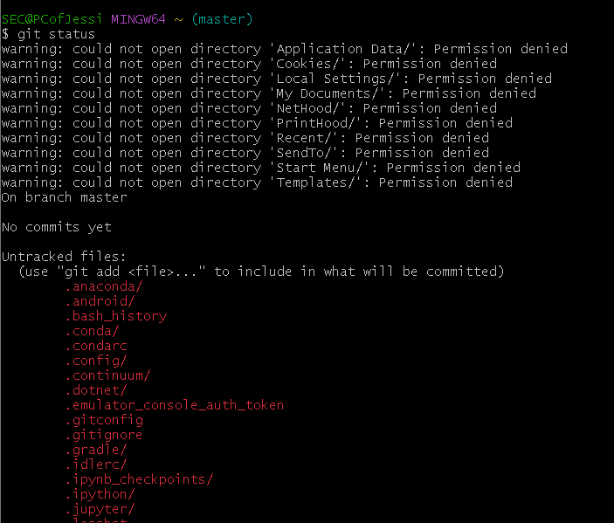

3.

Please follow the instruction to complete the hands-on. Each instruction expects a command for the Git Bash.

Branching:
1. Create a new branch “GitNewBranch”.
2. List all the local and remote branches available in the current trunk. Observe the “*” mark which denotes the current pointing branch.
3. Switch to the newly created branch. Add some files to it with some contents.
4. Commit the changes to the branch.
5. Check the status with “git status” command.

Merging:
1. Switch to the master
2. List out all the differences between trunk and branch. These provide the differences in command line interface.
3. List out all the visual differences between master and branch using P4Merge tool.
4. Merge the source branch to the trunk.
5. Observe the logging after merging using “git log –oneline –graph –decorate”
6. Delete the branch after merging with the trunk and observe the git status.
OUTPUT

