Amazon Music Clustering
Final Project Report
Grouping 94,098 songs by how they sound — with no genre labels
Domain: Music Analytics · Unsupervised Machine Learning | August 2026

1. Executive Summary
This project groups 94,098 Amazon Music tracks into clusters using only ten numeric audio characteristics (danceability, energy, loudness, speechiness, acousticness, instrumentalness, liveness, valence, tempo and duration). No genre labels were used at any point.
Three clustering algorithms were compared — K-Means, DBSCAN and Agglomerative (Hierarchical) clustering. K-Means with k = 3 was selected as the final model: it achieved the best silhouette score (0.2465), produced well-balanced cluster sizes, and gave the most interpretable profiles. The three clusters map cleanly onto listener-friendly moods:
- Happy / Upbeat: 51,466 songs (55%) — loud, energetic, happy tracks.
- Acoustic / Chill: 30,156 songs (32%) — quiet, acoustic, low-energy tracks.
- Speech / Spoken-word: 12,476 songs (13%) — very high speechiness, short duration (spoken word, skits, hip-hop).
Every song in the dataset was assigned a cluster label and exported to outputs/songs_with_clusters.csv, ready to power playlist generation, similar-song recommendation and listener segmentation. An interactive Streamlit dashboard (app.py) lets a non-technical user explore the clusters and find similar songs.

2. Problem Statement & Objective
Streaming platforms host tens of millions of tracks. Manually tagging each one with a genre or mood is impractical, inconsistent, and never keeps up with new releases. Yet almost every product feature users love — playlists, radio, “more like this” recommendations — depends on knowing which songs sound similar.
Objective: build an unsupervised machine-learning pipeline that automatically groups songs into meaningful clusters based purely on measurable audio characteristics, then interpret and name those clusters so the business can act on them.

3. Dataset
Source file: single_genre_artists.csv — 95,837 rows × 23 columns. Each row is one track with identifiers (song/artist IDs and names), metadata (release date, popularity, followers, genres) and ten numeric audio features.
Feature | What it measures | Range
danceability | How suitable the track is for dancing | 0 – 1
energy | Perceived intensity and activity | 0 – 1
loudness | Average volume in decibels | ≈ −50 – 5 dB
speechiness | Presence of spoken words | 0 – 1
acousticness | Confidence the track is acoustic | 0 – 1
instrumentalness | Likelihood of no vocals | 0 – 1
liveness | Presence of a live audience | 0 – 1
valence | Musical positiveness / happiness | 0 – 1
tempo | Speed in beats per minute | 0 – 240 BPM
duration_ms | Track length in milliseconds | 6 s – 80 min

Data quality: the file contains no missing values and no fully duplicated rows. Identifier and text columns (id_songs, name_song, name_artists, genres, release_date) were excluded from clustering — distance calculations on strings are meaningless — but kept as reference columns so each clustered row can still be traced back to a real song. After removing 1,739 rows that were duplicates across all ten audio features, 94,098 unique-sounding tracks remained.

4. Methodology
The pipeline (clustering.py) is fully modular — one function per step:
1. Load & explore — shape, dtypes, missing values, duplicates, descriptive statistics.
2. Clean — drop ID/text columns from the feature set; remove audio-feature duplicates.
3. EDA plots — feature distributions and a correlation heatmap.
4. Scale — StandardScaler (mean 0, std 1) on all ten features.
5. Choose k — Elbow method (inertia) plus silhouette score for k = 2…10.
6. Cluster — final K-Means on ALL songs; DBSCAN (20k sample) and Hierarchical (3k sample) as challengers.
7. Evaluate — silhouette, Davies-Bouldin and Calinski-Harabasz for every algorithm.
8. Visualise — PCA 2-D projection coloured by cluster; dendrogram for the hierarchical view.
9. Profile & export — per-cluster feature means, human-readable mood labels, labelled CSV.
Why scaling is mandatory: all three algorithms rely on Euclidean distance. Unscaled, duration_ms (hundreds of thousands) and tempo (0–240) would dominate the distance while danceability (0–1) would be ignored. StandardScaler puts every feature on an equal footing.
PCA was used strictly for visualisation. Clustering runs in the full 10-dimensional feature space; reducing to two components first would discard over half the variance.

5. Exploratory Data Analysis
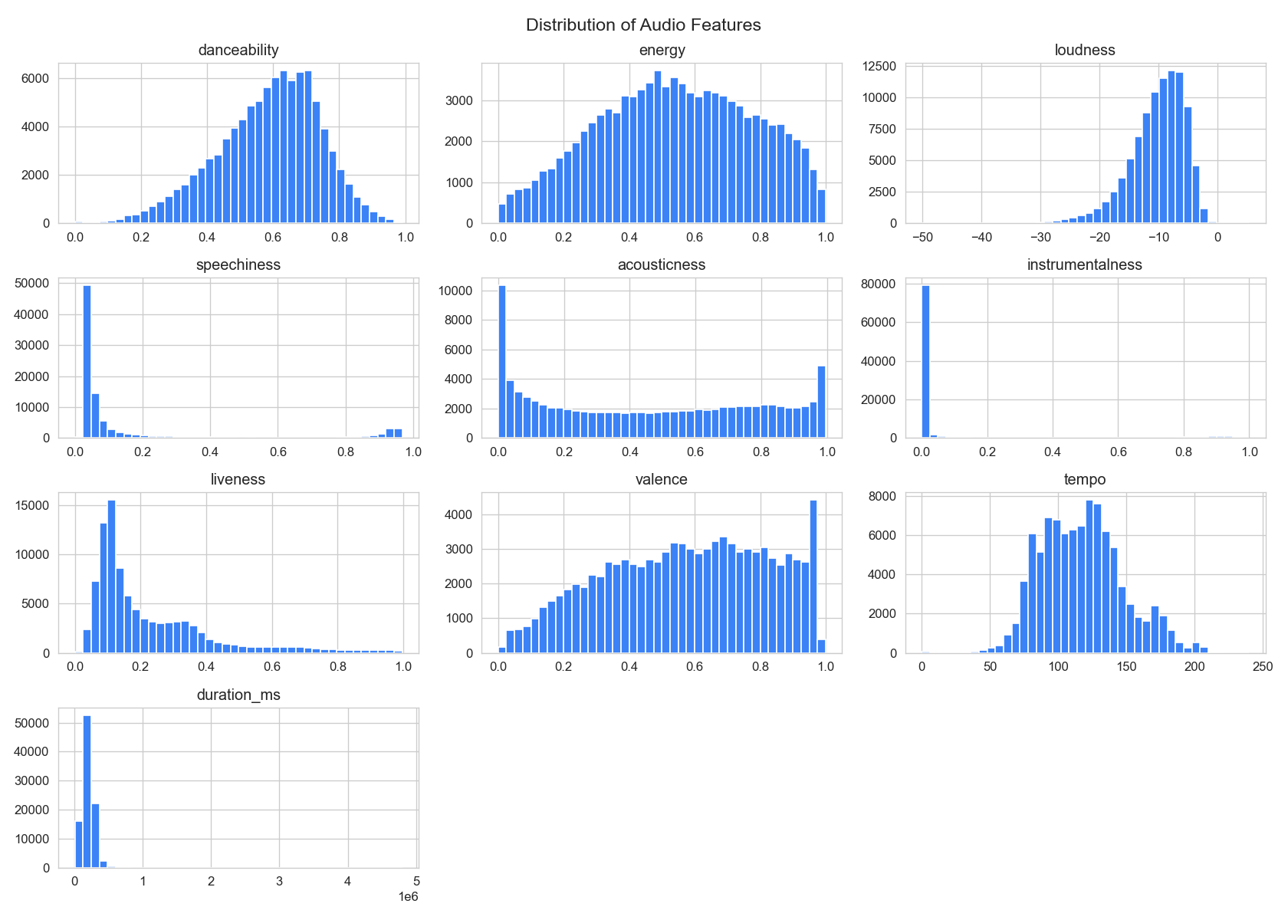
Figure 1 — Distributions of the ten audio features (94,098 songs).
- acousticness and instrumentalness are heavily skewed toward 0 — most tracks are produced, vocal music.
- loudness is negative (dB scale) and left-skewed; duration_ms has a long right tail (a few very long tracks).
- danceability, valence and tempo are roughly bell-shaped — a healthy spread for distance-based clustering.
- Outliers (tempo > 200 BPM, duration > 10 min) were kept: they are real songs and may legitimately form niche groups.
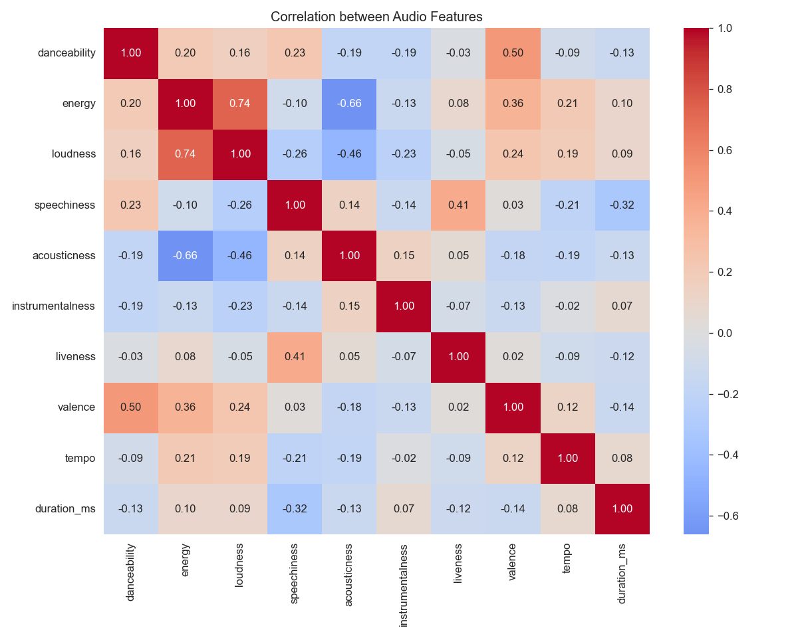
Figure 2 — Correlation between audio features.
- energy ↔ loudness: +0.73 — louder tracks are perceived as more energetic.
- energy ↔ acousticness: −0.66 — acoustic tracks are quieter and calmer.
- danceability ↔ valence: +0.50 — danceable tracks tend to sound happier.
The moderate correlations confirm the features carry overlapping but not redundant information; all ten were retained.

6. Choosing the Number of Clusters
K-Means was run for k = 2…10 (n_init = 10, random_state = 42). Inertia falls smoothly with an elbow around k = 3–4, and the silhouette score — the more decisive criterion — peaks clearly at k = 3.
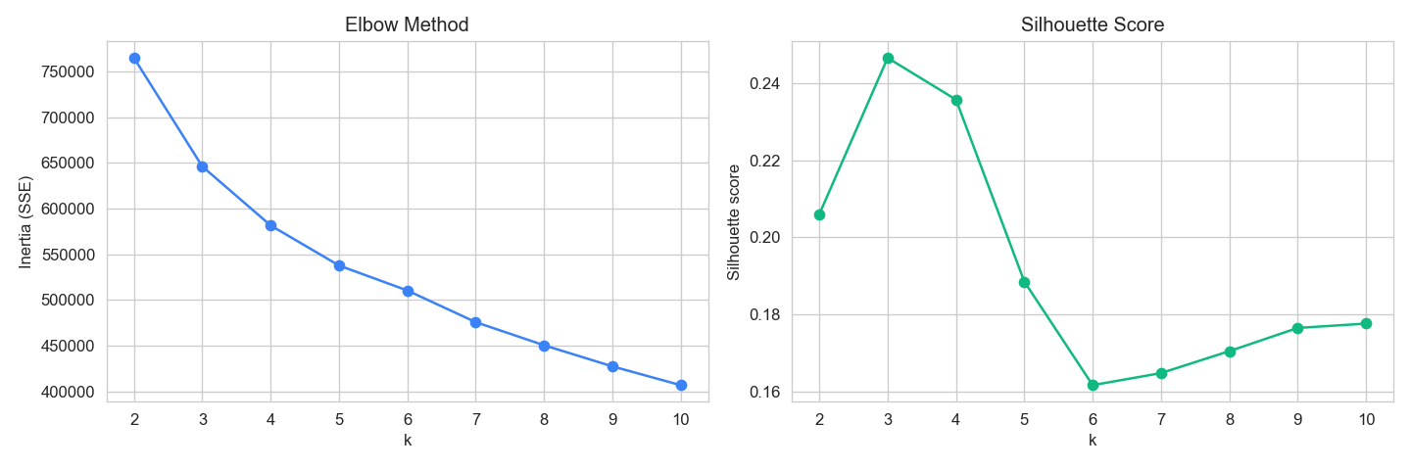
Figure 3 — Elbow method (left) and silhouette score (right) for k = 2…10.
k | Inertia (SSE) | Silhouette
2 | 764,689 | 0.2060
3 | 646,058 | 0.2465 ← best
4 | 581,565 | 0.2357
5 | 537,782 | 0.1885
6 | 510,477 | 0.1617
8 | 450,607 | 0.1705
10 | 406,951 | 0.1776

k = 3 was therefore selected for the final model.

7. Algorithm Comparison
Algorithm | Data used | Silhouette ↑ | Davies-Bouldin ↓ | Calinski-Harabasz ↑
K-Means (k=3) — FINAL | all 94,098 | 0.2465 | 1.5704 | 21,477
Hierarchical (Ward, k=3) | 3,000 sample | 0.2062 | 1.7771 | 571
DBSCAN (eps=1.0, min=10) | 20,000 sample | 0.0587 | 1.1144 | 577

DBSCAN found 9 dense clusters but flagged 6,041 of 20,000 points (30%) as noise — audio features form one continuous cloud with no sharp density gaps, so a density-based method fragments it. Its silhouette (computed excluding noise) is the weakest of the three. Hierarchical clustering confirmed the 3-group structure (see the dendrogram below) but is O(n²) in memory, so it cannot scale to the full dataset.
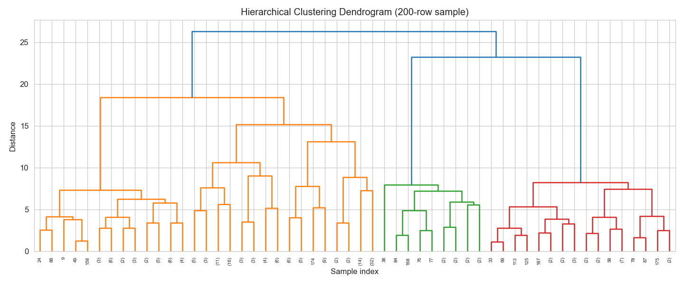
Figure 4 — Ward-linkage dendrogram (200-song sample): three main branches emerge.
K-Means wins on every practical axis: best silhouette, scales linearly to all 94,098 songs, assigns every track to a cluster (no unusable noise label), and produces the most interpretable profiles. It is the final model.

8. Final Cluster Analysis
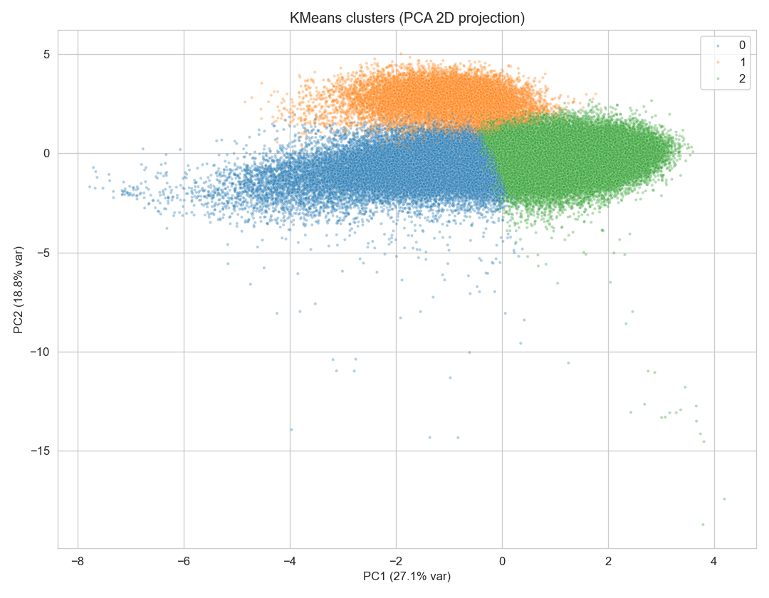
Figure 5 — PCA 2-D projection (45.9% of variance) of the three K-Means clusters.
Mean feature values per cluster (full table in outputs/cluster_profile.csv):
Feature | C0 · Acoustic/Chill | C1 · Speech | C2 · Happy/Upbeat
Songs (share) | 30,156 (32%) | 12,476 (13%) | 51,466 (55%)
danceability | 0.486 | 0.664 | 0.627
energy | 0.311 | 0.467 | 0.693
loudness (dB) | −13.2 | −13.4 | −7.6
speechiness | 0.060 | 0.831 | 0.075
acousticness | 0.749 | 0.585 | 0.259
instrumentalness | 0.167 | 0.001 | 0.050
liveness | 0.182 | 0.435 | 0.200
valence | 0.412 | 0.583 | 0.667
tempo (BPM) | 111.9 | 100.3 | 124.9
duration (min) | 3.7 | 1.6 | 3.8

Cluster 0 — Acoustic / Chill (32%)
High acousticness (0.75), the lowest energy (0.31) and valence (0.41), quiet at −13.2 dB. Ballads, singer-songwriter, classical and ambient material. Playlist fit: “Chill”, “Focus”, “Sleep”, “Acoustic Evening”.

Cluster 1 — Speech / Spoken-word (13%)
Extremely high speechiness (0.83) — an order of magnitude above the other clusters — with the shortest tracks (1.6 min on average) and elevated liveness (0.44). This is spoken-word, comedy skits, interludes, poetry and speech-heavy hip-hop. The model isolated non-musical audio without ever being told it exists — a strong sanity check that the clustering is real.

Cluster 2 — Happy / Upbeat (55%)
The mainstream heart of the catalogue: highest energy (0.69), valence (0.67) and tempo (125 BPM), and much louder than the rest (−7.6 dB). Pop, dance, rock and party tracks. Playlist fit: “Workout”, “Party”, “Good Vibes”, “Drive”.
A silhouette of ≈ 0.25 is typical for real-world audio data: songs form a continuum, not isolated islands. The value indicates modest but genuine structure, and the sharply contrasting cluster profiles above show the structure is meaningful.

9. Business Applications
- Playlist curation: Auto-generate mood playlists directly from the cluster column — zero manual curation.
- Song discovery: “More like this” = serve top tracks from the same cluster (demoed in the Streamlit app).
- Artist analytics: Artists can see which songs they sonically compete with inside their cluster.
- Market segmentation: Segment listeners by the cluster mix they stream and target promotions accordingly.
- Cold-start tagging: New releases get a cluster instantly via scaler.transform() + kmeans.predict() — no retraining needed.

10. Limitations & Future Work
- Mood labels are heuristic (rule-based on feature means), not learned from listener behaviour.
- K-Means assumes roughly spherical, equally sized clusters; real music taste is fuzzier — Gaussian Mixture Models would give soft assignments.
- DBSCAN was tuned lightly (single eps value) and only on a 20k sample.
- t-SNE / UMAP could reveal non-linear structure that PCA flattens.
- Adding lyric or artist embeddings would enrich the feature space beyond pure audio.

11. Conclusion
Using only ten audio features and no labels, the pipeline discovered three coherent, explainable groups covering all 94,098 songs — energetic mainstream tracks, quiet acoustic material, and spoken-word audio. K-Means (k = 3) outperformed DBSCAN and Hierarchical clustering on silhouette while scaling to the full catalogue and assigning every track a usable label. The exported dataset and Streamlit dashboard turn the model into something a product team could pilot immediately for playlists and recommendations.

12. Deliverables & How to Reproduce
Deliverable | File
Modular pipeline (preprocessing, clustering, evaluation, plots) | clustering.py
Labelled dataset — every song + cluster + mood label | outputs/songs_with_clusters.csv
Cluster profile (mean features per cluster) | outputs/cluster_profile.csv
Algorithm metric comparison | outputs/model_scores.csv
All plots (Figures 1–5) | outputs/plots/
Interactive dashboard (bonus) | app.py
Documentation | README.md · INTERVIEW_GUIDE.md · this report

Reproduce with: pip install -r requirements.txt → python clustering.py → streamlit run app.py

