TASK 1

SELECT FIRST_NAME FROM `employee_details`

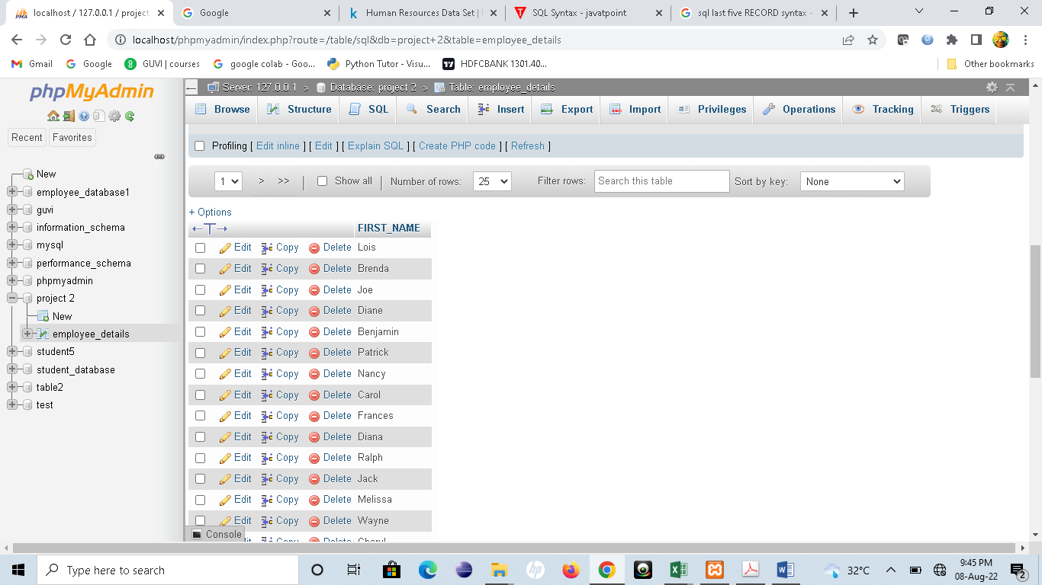

SELECT DISTINCT DEPARTMENT FROM `employee_details

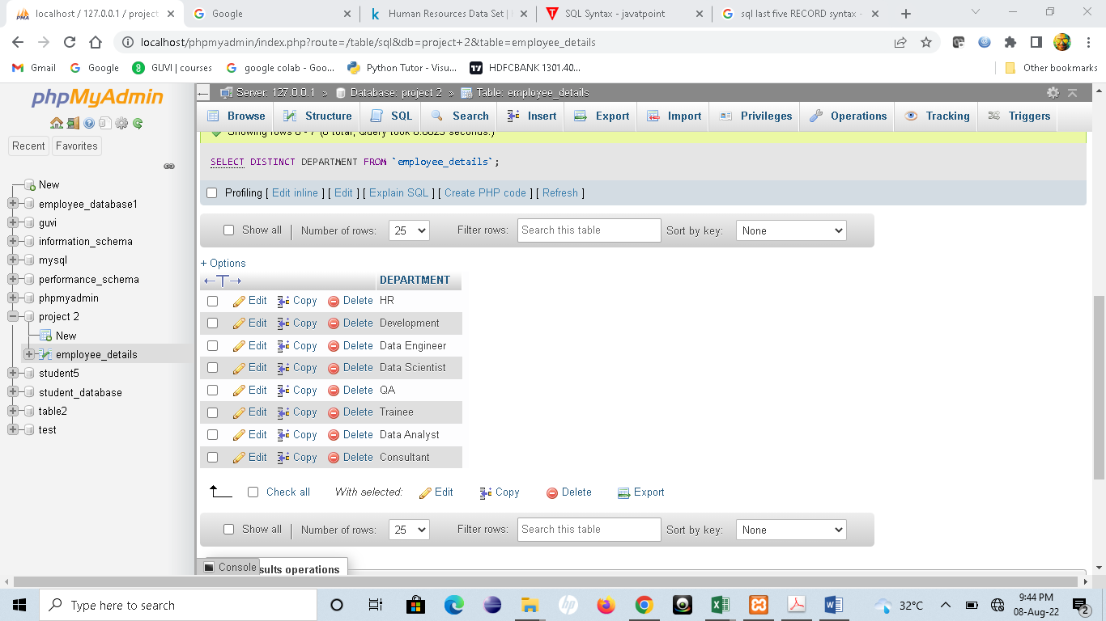

SELECT * FROM `employee_details` order by ID DESC LIMIT 5

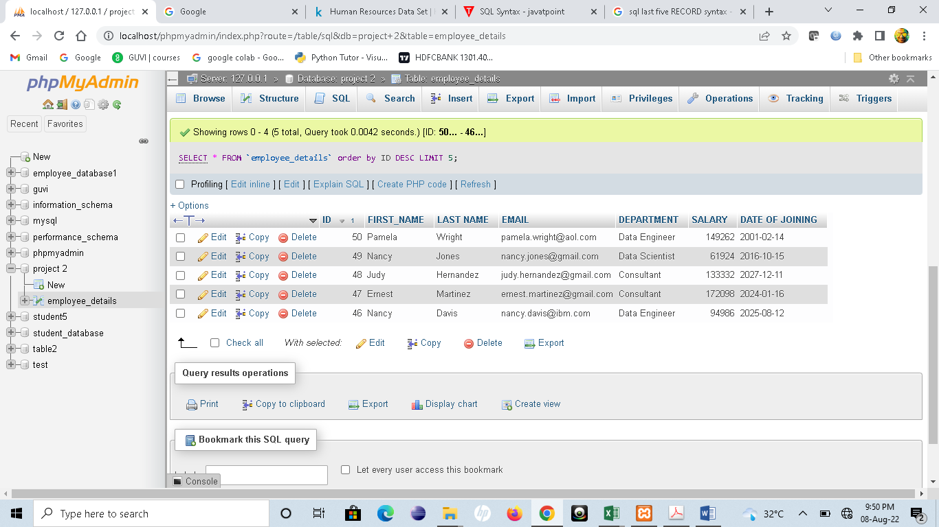

TASK 2

SELECT LEFT(FIRST_NAME,3) from `employee_details`

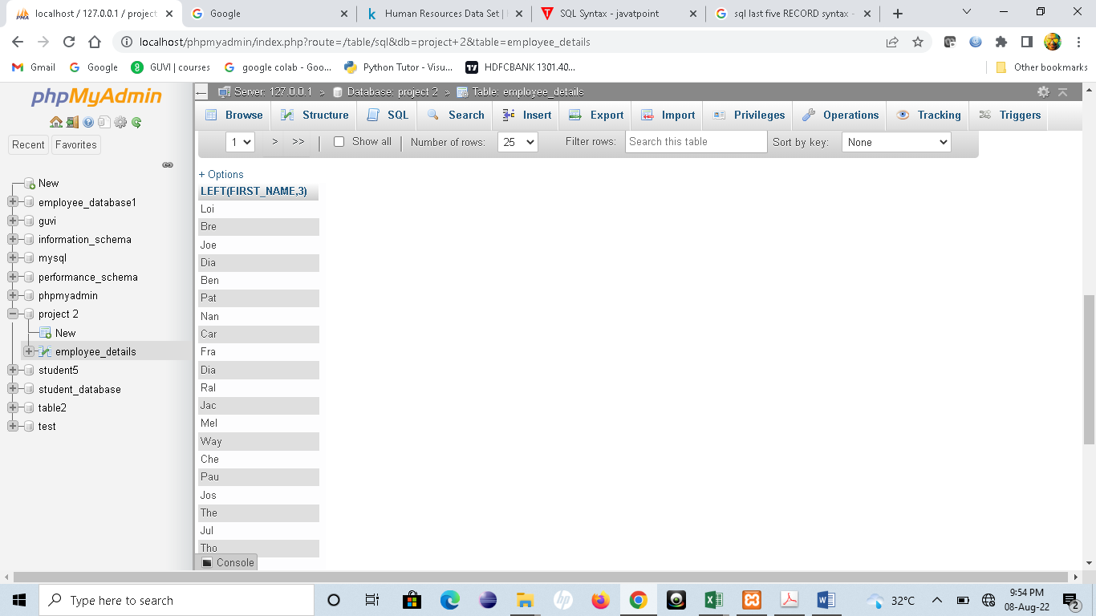

SELECT INSTR (FIRST_NAME, BINARY'a') FROM employee_details

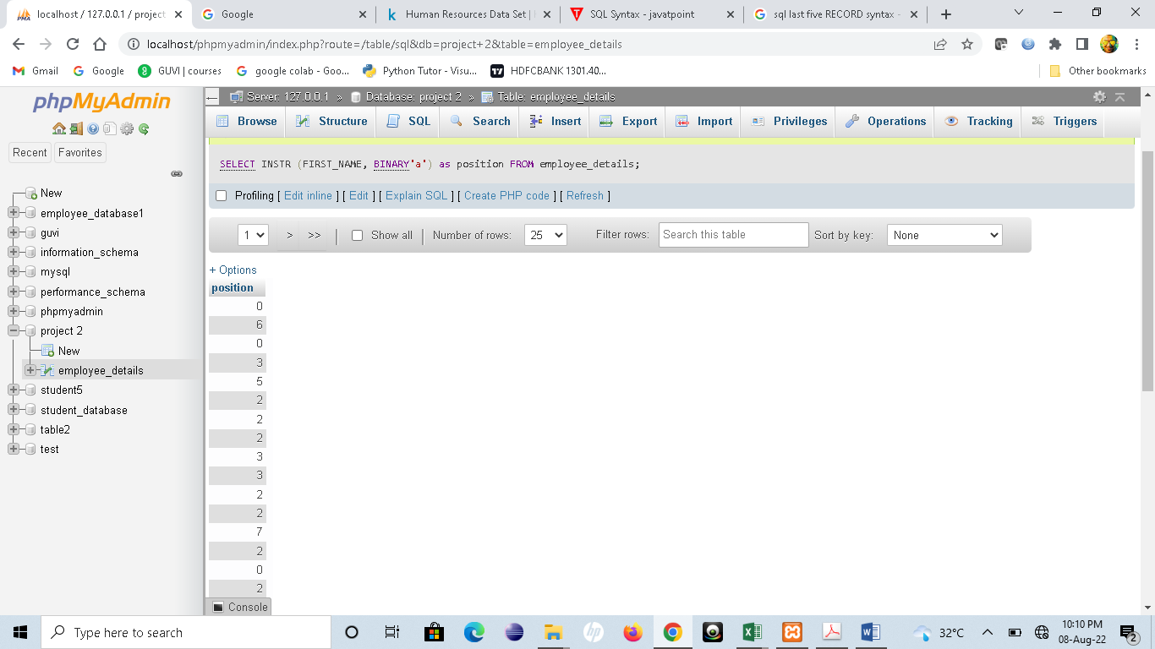

SELECT DEPARTMENT,MAX(SALARY) FROM employee_details GROUP BY DEPARTMENT

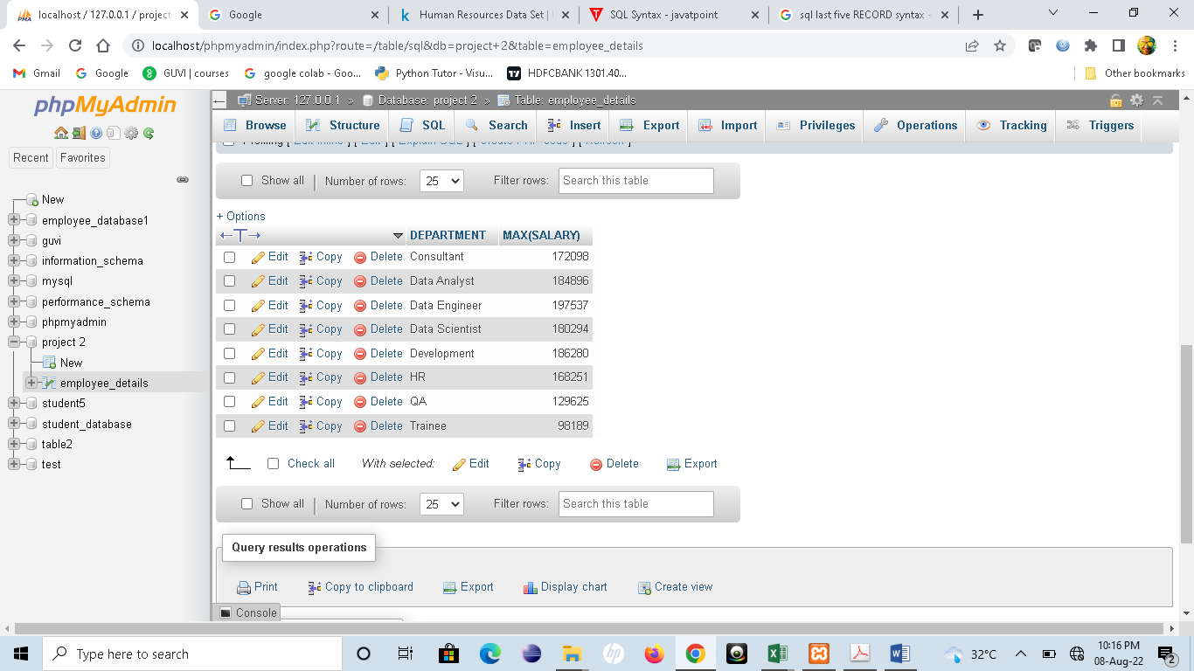

TASK 3

SELECT TRIM(FIRST_NAME) AS WITHOUT_SPACE FROM `employee_details`

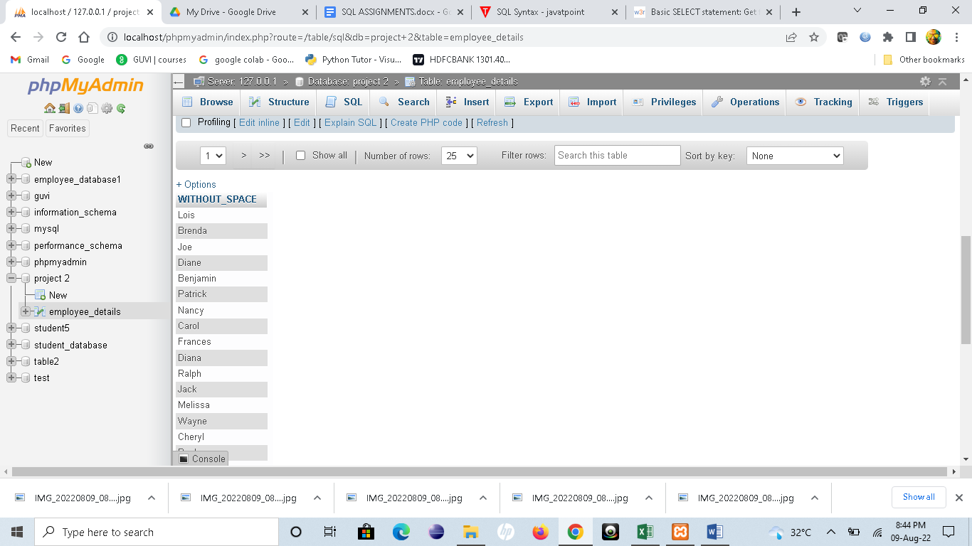

SELECT DISTINCT(length(DEPARTMENT)) as LENGTH FROM employee_details

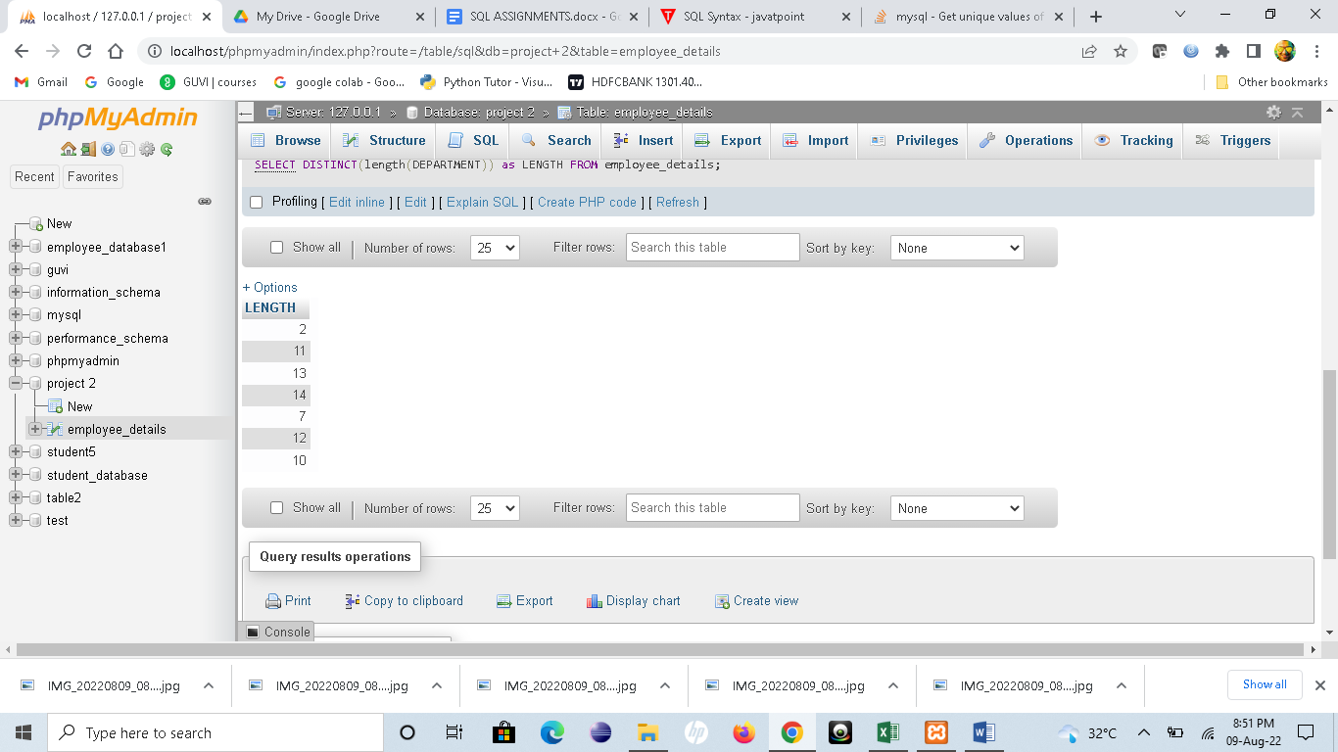

SELECT DISTINCT SALARY FROM employee_details ORDER BY SALARY DESC LIMIT 3,1

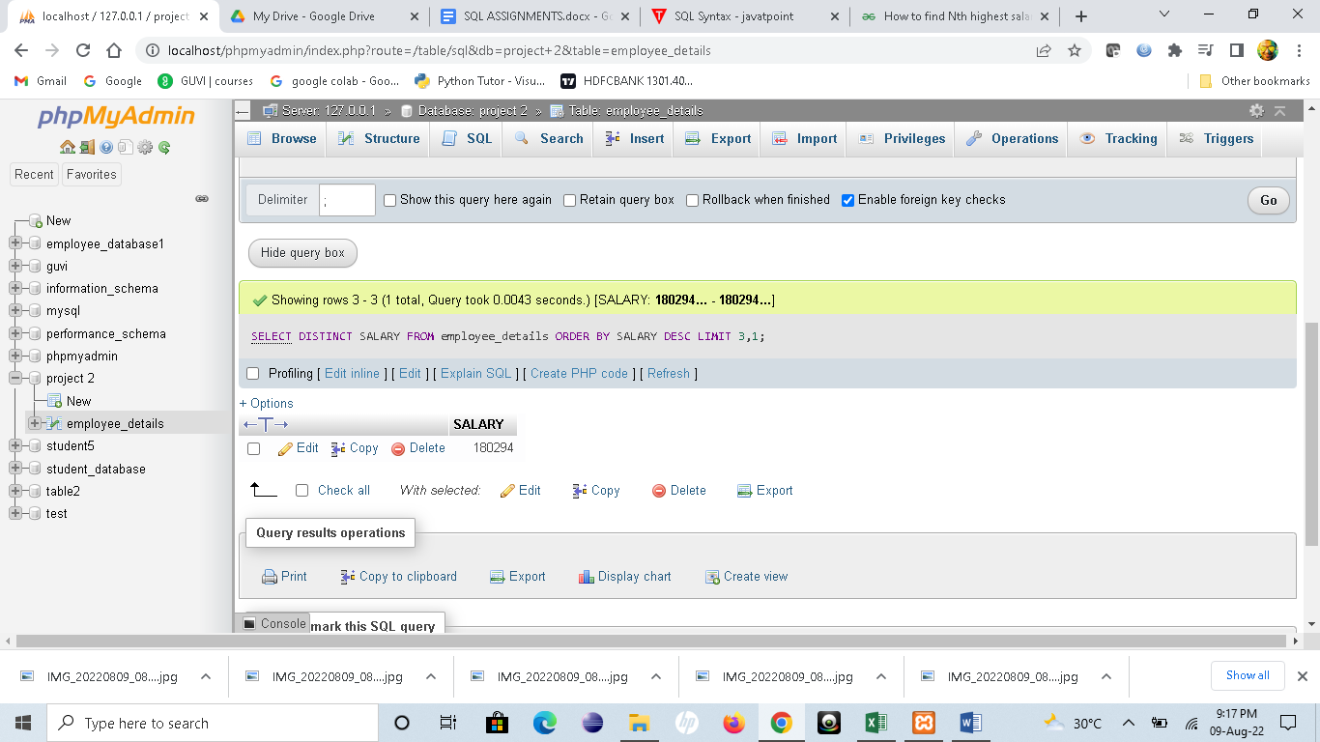

TASK 4

SELECT REPLACE(FIRST_NAME,'a','A') AS REPLACED FROM employee_details

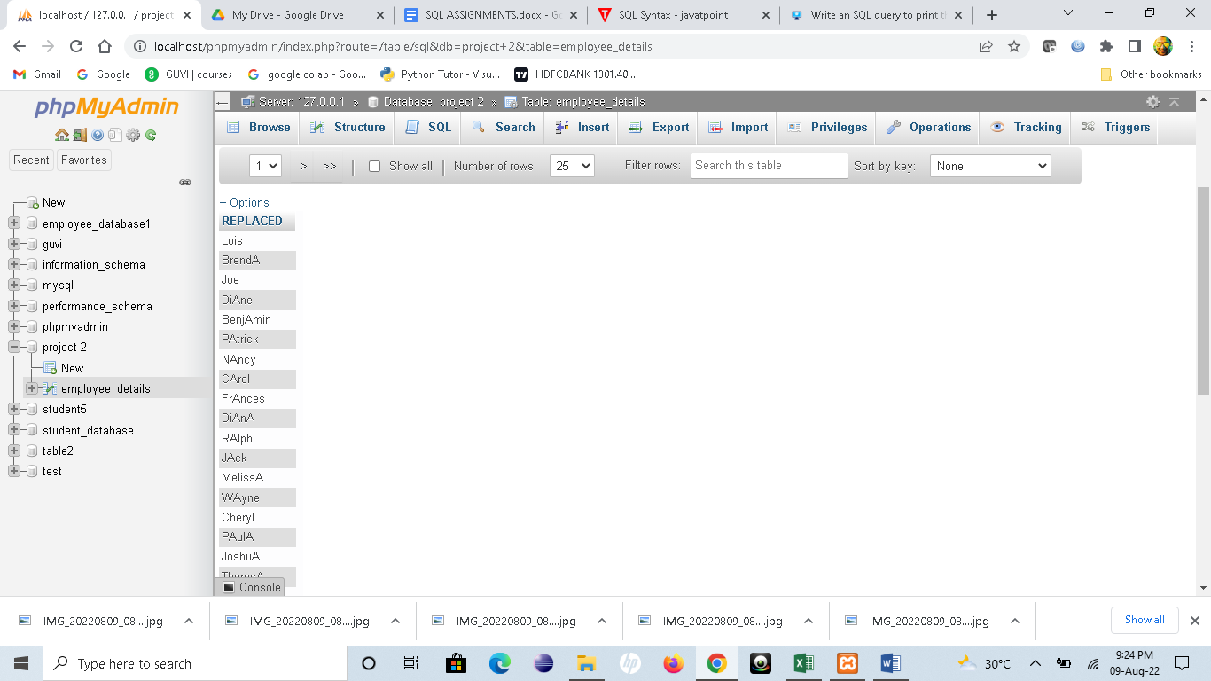

SELECT * FROM employee_details ORDER BY FIRST_NAME ASC ,DEPARTMENT DESC

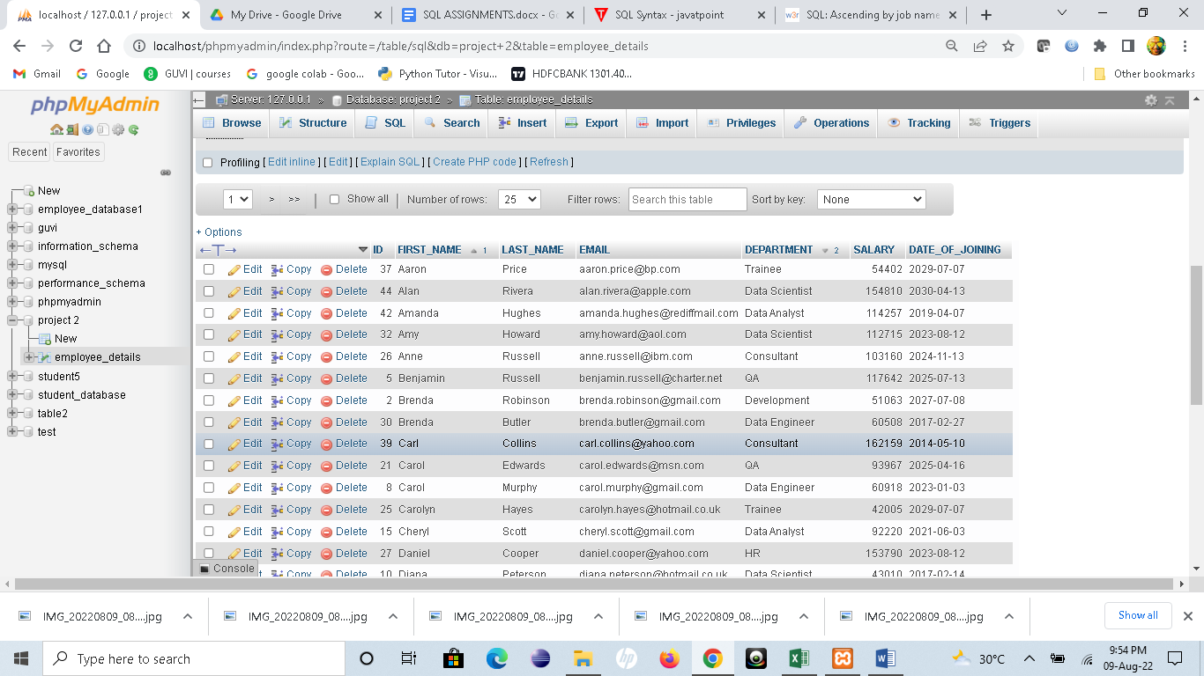

SELECT * FROM employee_details ORDER BY SALARY DESC

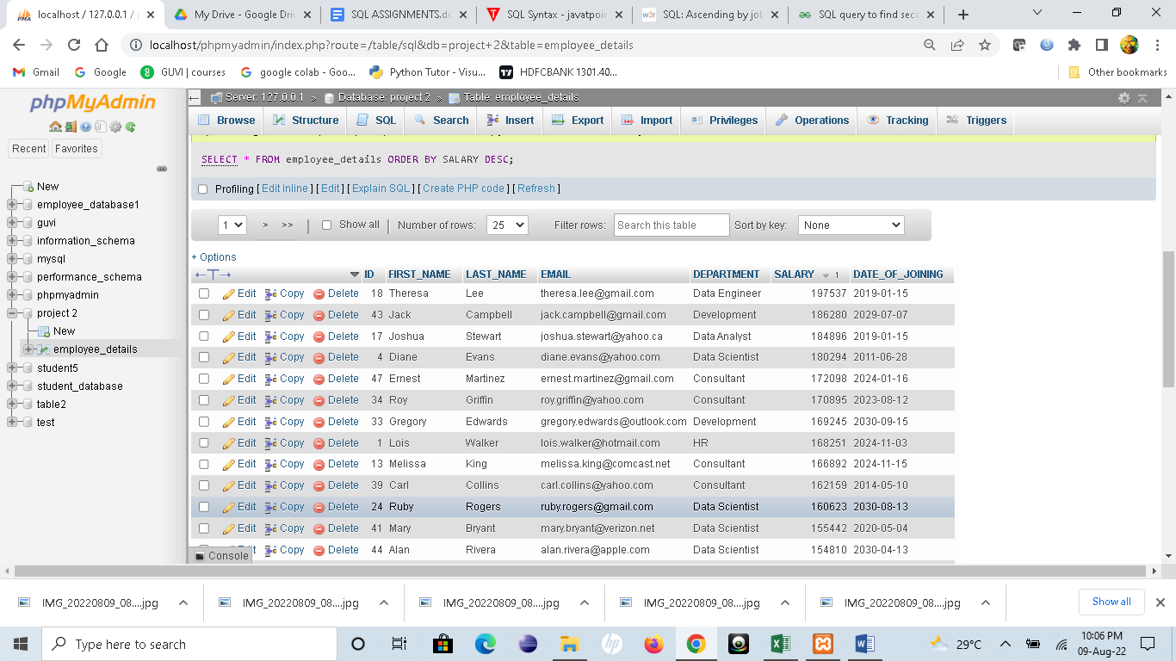

TASK 5

SELECT * FROM employee_details WHERE FIRST_NAME NOT IN ('lois','brenda')

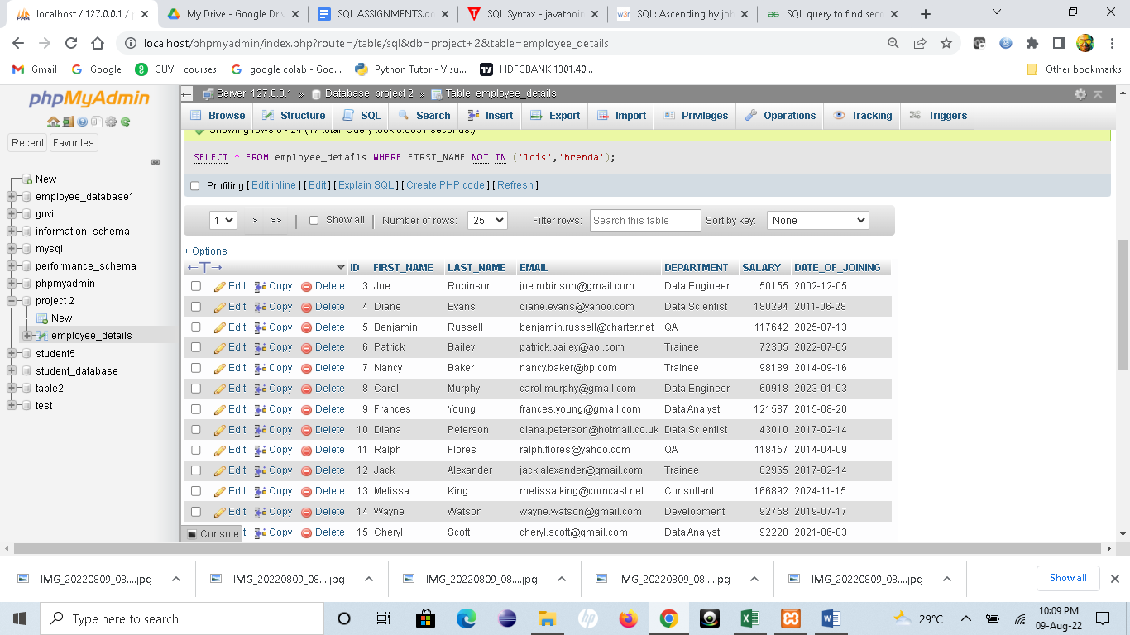

SELECT * FROM employee_details WHERE FIRST_NAME LIKE '_____h%'

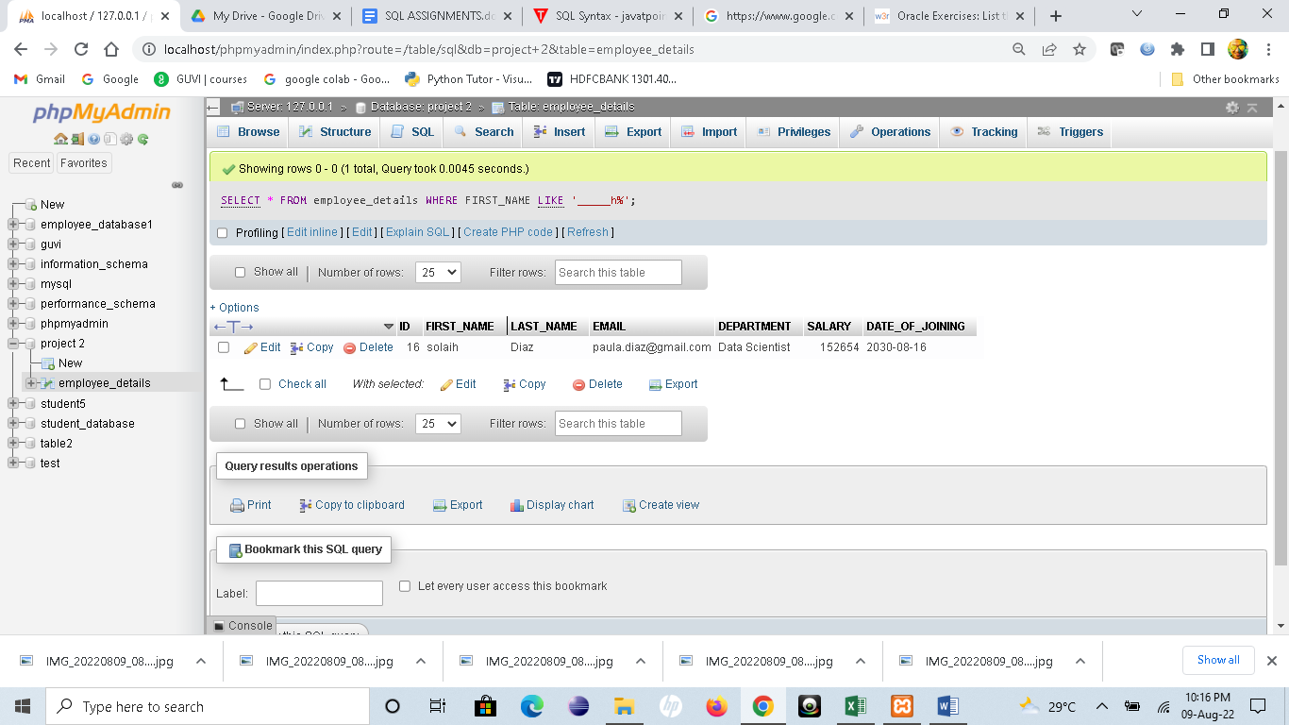

TASK 6

SELECT * FROM employee_details WHERE YEAR(DATE_OF_JOINING)=2021 and MONTH(DATE_OF_JOINING)=5

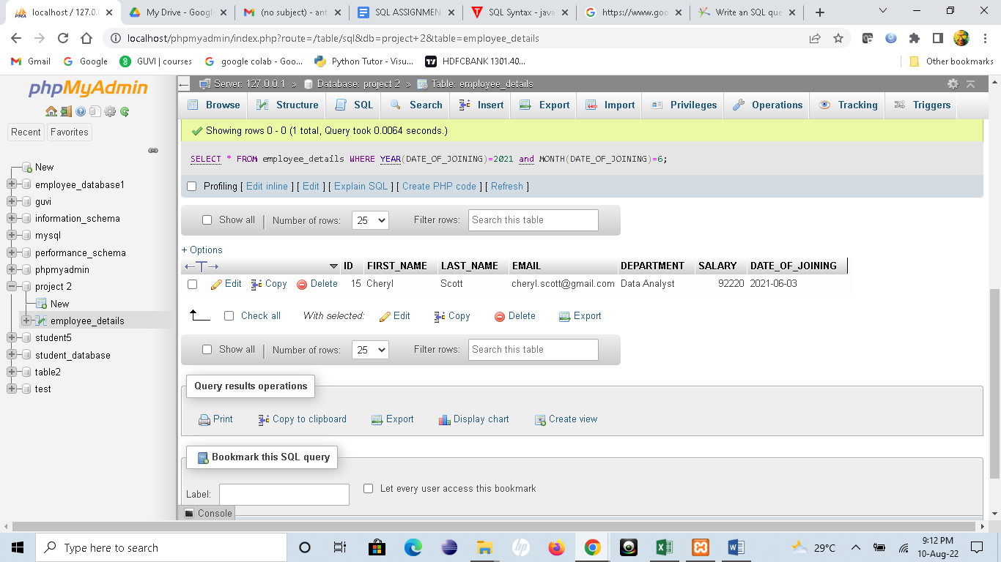

SELECT FIRST_NAME,COUNT(FIRST_NAME) AS COUNTED FROM employee_details GROUP BY FIRST_NAME HAVING COUNT(FIRST_NAME)>1

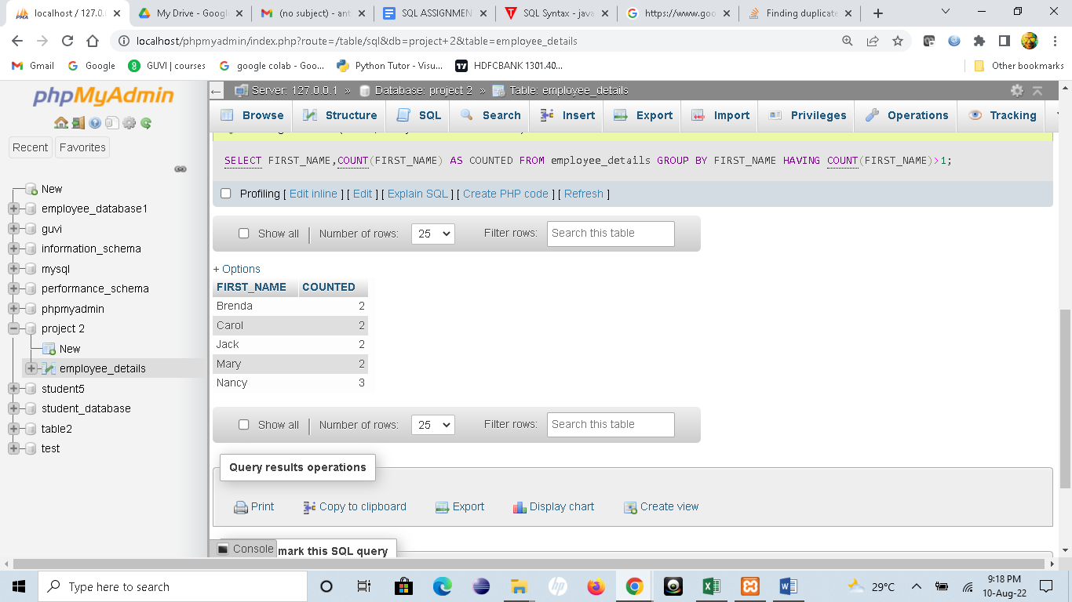

SELECT FIRST_NAME,LAST_NAME,DATE_OF_JOINING,COUNT(*) AS COUNTED FROM employee_details GROUP BY FIRST_NAME,LAST_NAME,DATE_OF_JOINING HAVING COUNT(*)>1

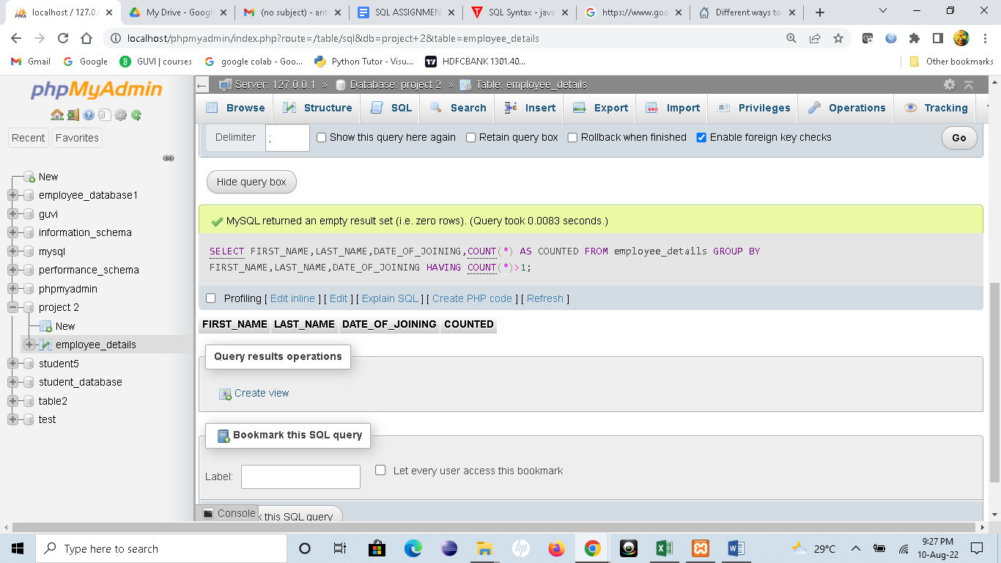

TASK 7

SELECT * FROM employee_details WHERE ID % 2 =1

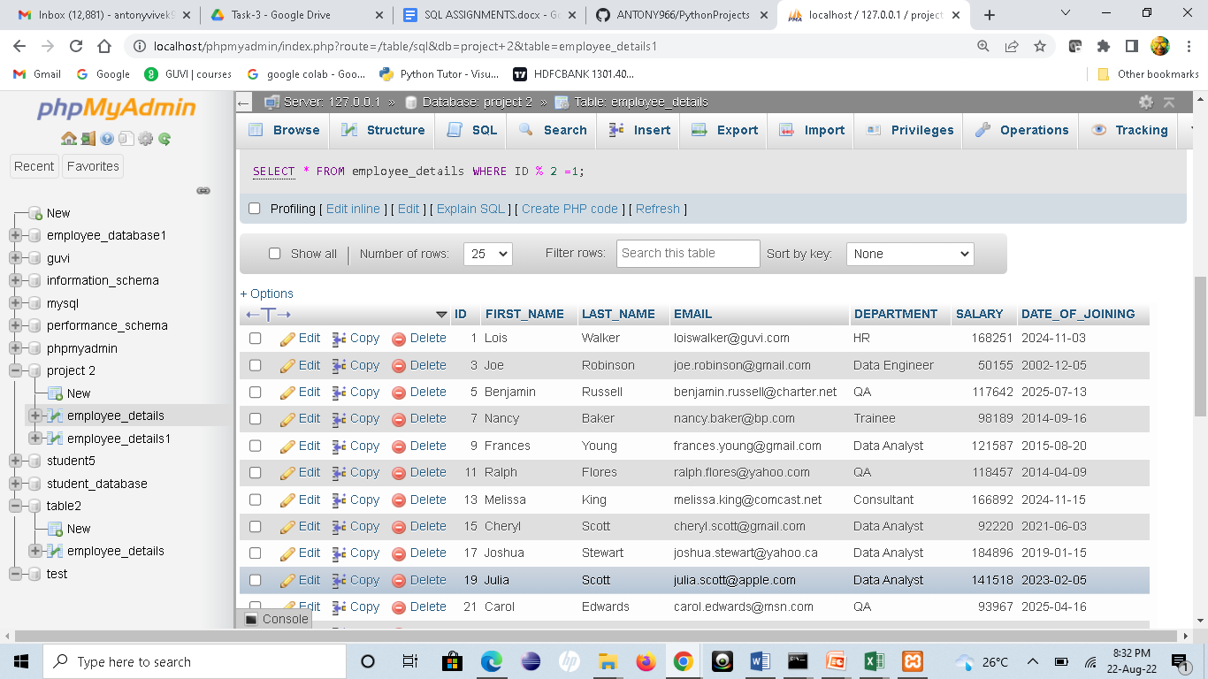

CREATE TABLE employee_details1 SELECT * FROM employee_details

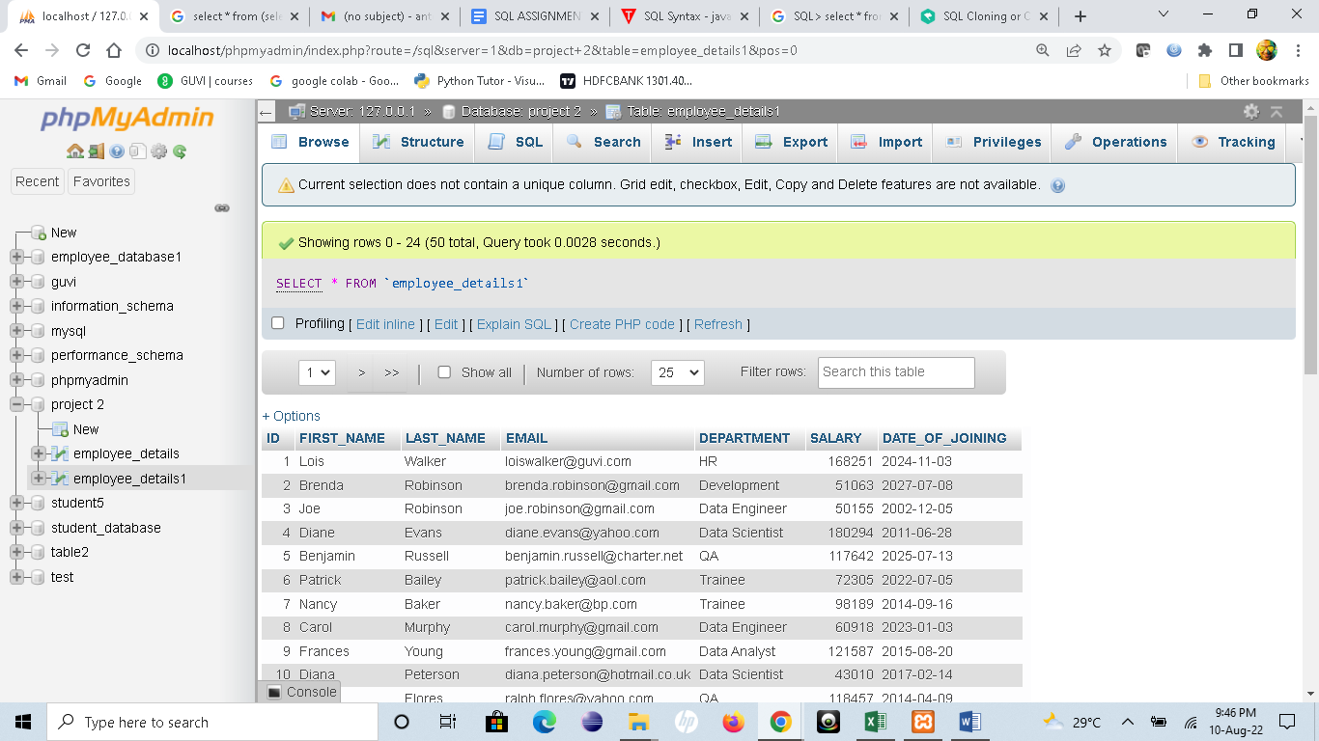

TASK 8

SELECT FIRST_NAME,LAST_NAME FROM `employee_details`

INTERSECT

SELECT FIRST_NAME,LAST_NAME FROM `employee_details1`

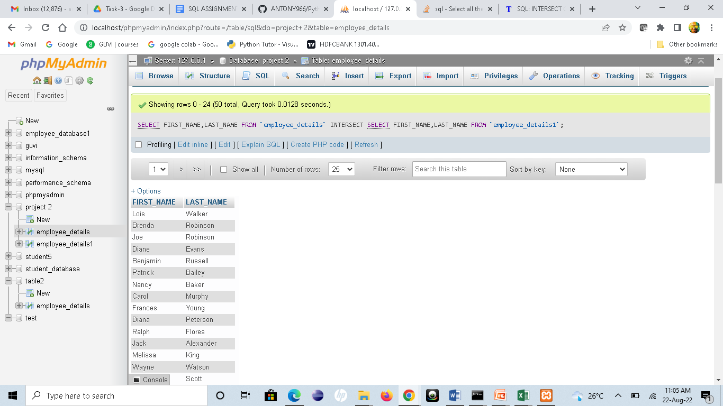

SELECT * FROM employee_details1 WHERE ID =((

SELECT ID FROM `employee_details` EXCEPT SELECT ID FROM `employee_details1`)

UNION

(SELECT ID FROM `employee_details1` EXCEPT SELECT ID FROM `employee_details`))

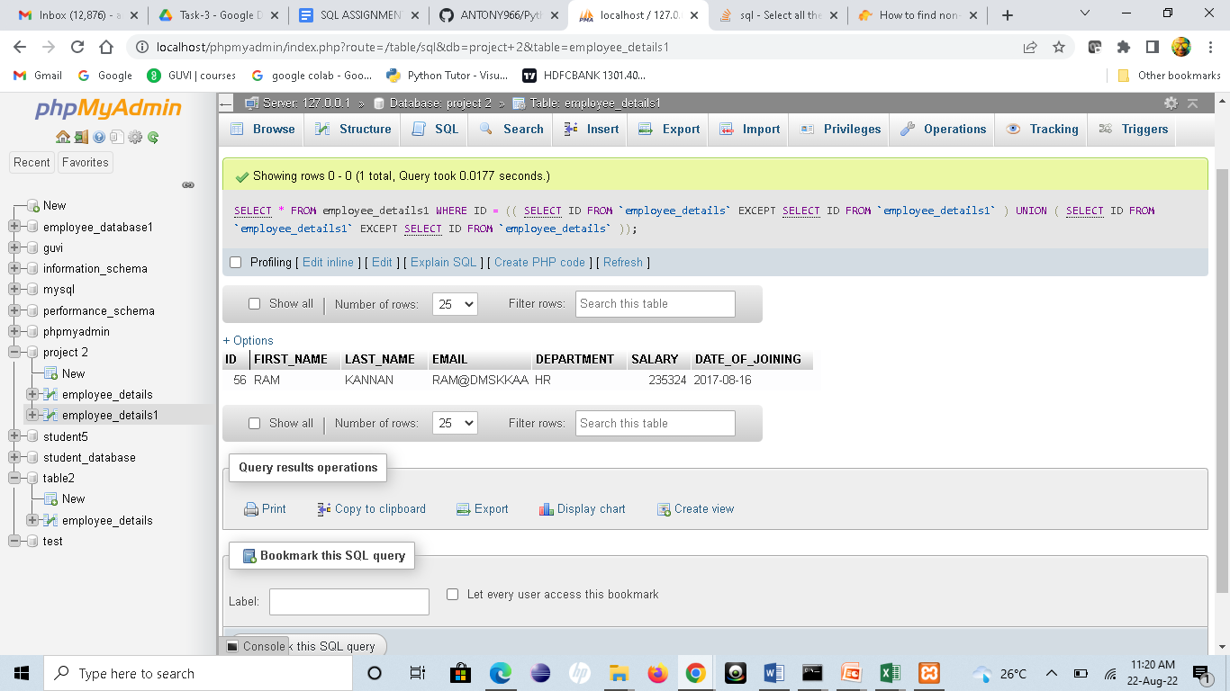

TASK 9

SELECT * FROM `employee_details` WHERE ID LIMIT 15

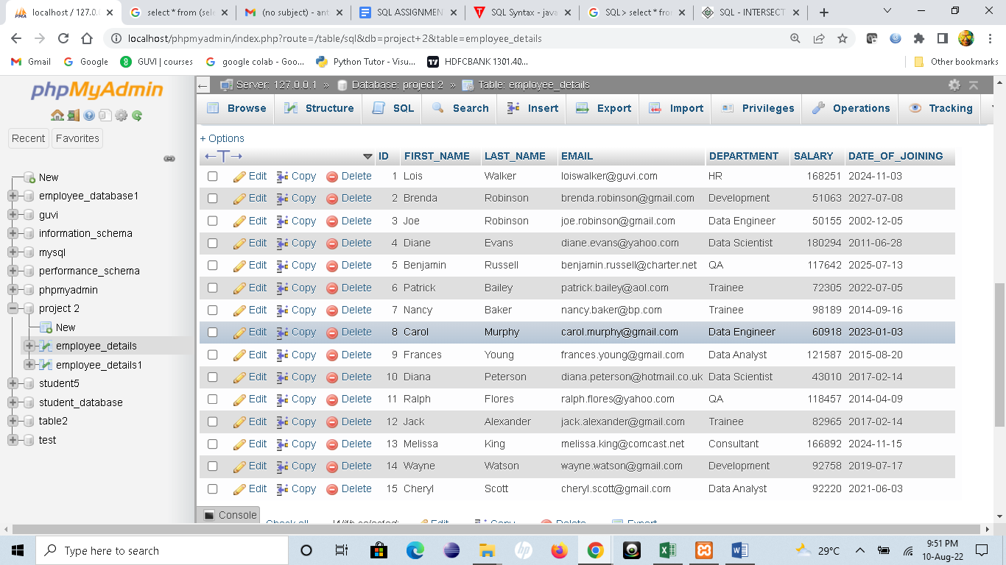

SELECT * FROM `employee_details` ORDER BY SALARY DESC LIMIT 9,1

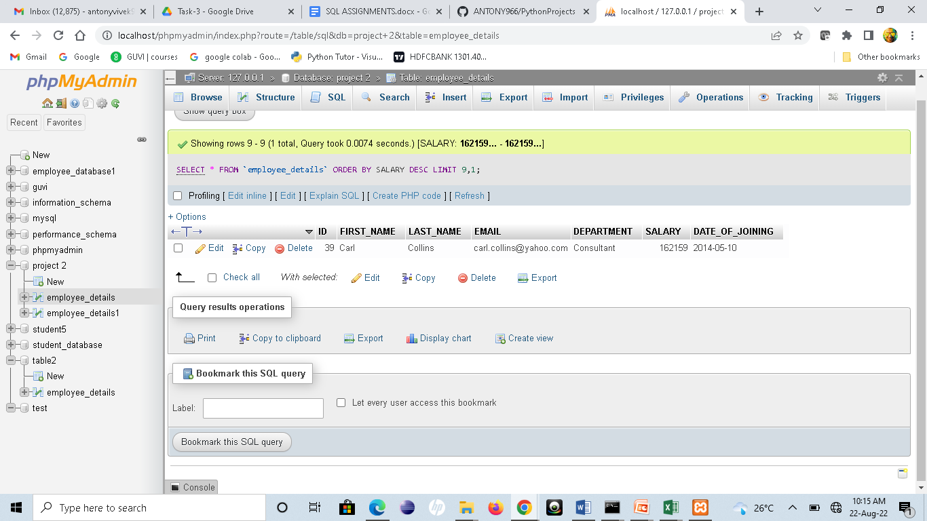

TASK 10

SELECT * FROM ( SELECT ROW_NUMBER() OVER (ORDER BY SALARY DESC) AS rownumber,Salary FROM employee_details ) AS foo WHERE rownumber = 5

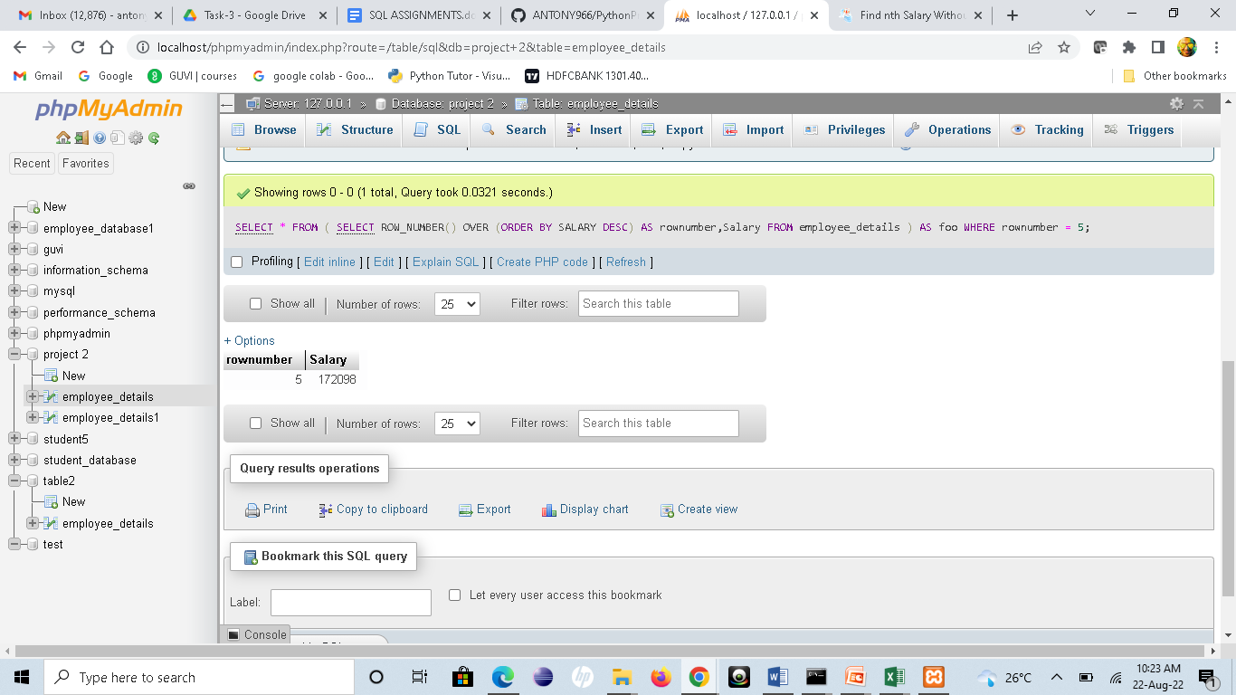

SELECT * FROM `employee_details` WHERE SALARY IN (SELECT SALARY FROM employee_details GROUP BY SALARY HAVING COUNT(*)>1)

