Pi 1 Model B (Revision 1.0)
So here is the Pi with its 26 way header in the top left of the board :
It consists of two rows of thirteen pins. Pin 1 is clearly marked on the board as “P1”. It is vital you are looking at the header the correct way round. Locate “P1” and compare the header to the diagram below :
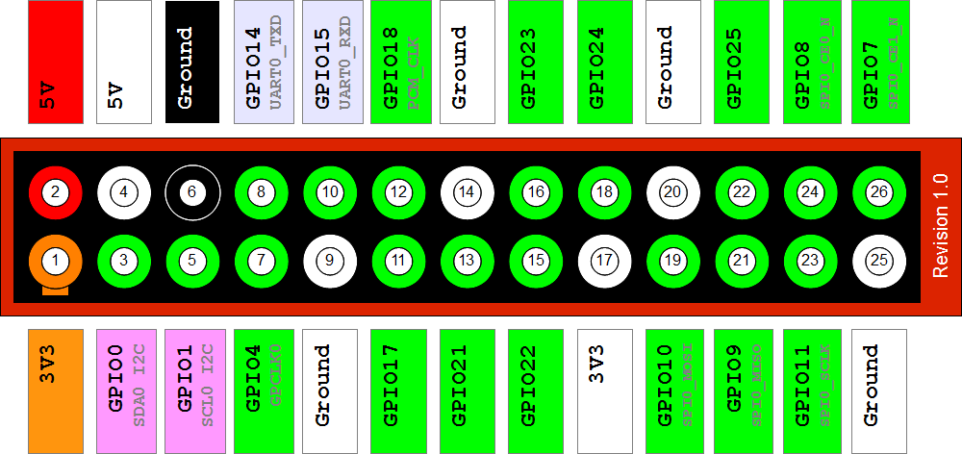
Raspberry Pi GPIO Layout – Pi 1 Model B Revision 1

Pi 1 Model A/B (Revision 2.0)
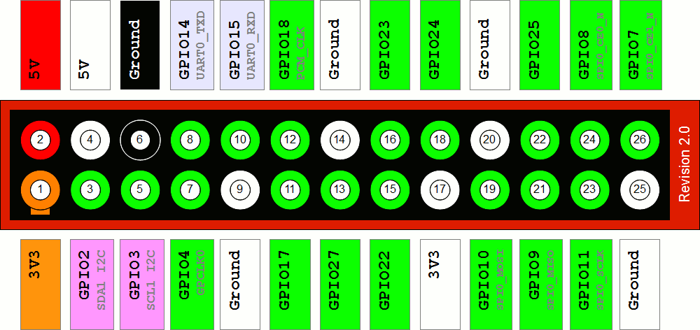
a Raspberry Pi GPIO Layout – Pi 1 Model A/B Revision 2

Pi 1 Model B+
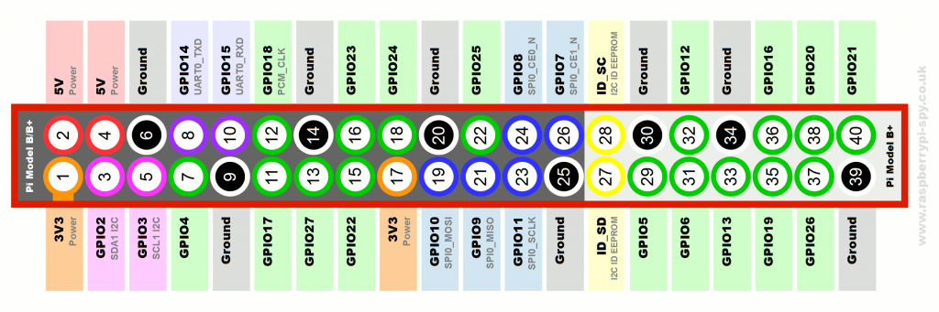
Raspberry Pi GPIO Layout – Pi 1 Model B+
The pin-out of the header on the Model B+ is described in more detail on my Model B+ GPIO page. It’s the same as the A+ and Pi 2.

Pi 1 Model A+
Raspberry Pi GPIO Layout – Pi 1 Model A+
The A+ has the same layout at the B+ and Pi 2.

Pi 2 Model B
Raspberry Pi GPIO Layout – Pi 2 Model B
The Pi 2 has the same layout at the A+ and B+.

Pi 3 Model B
Raspberry Pi GPIO Layout – Pi 3 Model B
The Pi 3 has the same layout at the Pi 1 Model A+, Pi 1 Model B+ and Pi 2 Model B.

To find out what board revisions you have take a look at my Guide to finding out your PCB revision number.
The white pins were previously “DNC” (Do Not Connect) as they were reserved for future use. It has now been confirmed their function will not be changed so the diagrams above show their permanent assignment.
The Pin marked “P1” is Pin 1 and provides 3.3V (50mA max). You can work out all the other pins from there. Note how the numbering works. Even numbers on the top row and odd numbers on the bottom row.
Labels – Clear as Mud
The labels above are the names of the pins on the Broadcom system chip to which the pin is physically connected. Much of the confusion around the GPIO is due to these labels, their relationship to the Broadcom labels and how they are referred to in your programs. To confuse things even more the GPIO pins are sometimes renamed with another set of numbers. In order to avoid damaging your Pi you need to be sure what pins you are connecting to other hardware and that your program is referring to the correct pins.
Power Pins
The header provides 5V on Pin 2 and 3.3V on Pin 1. The 3.3V supply is limited to 50mA. The 5V supply draws current directly from your microUSB supply so can use whatever is left over after the board has taken its share. A 1A power supply could supply up to 300mA once the board has drawn 700mA.
Basic GPIO
The header provides 17 Pins that can be configured as inputs and outputs. By default they are all configured as inputs except GPIO 14 & 15.
In order to use these pins you must tell the system whether they are inputs or outputs. This can be achieved a number of ways and it depends on how you intend to control them. I intend on using Python.
GPIO in Python
The easiest way to control the GPIO pins is using the RPi.GPIO Python library. Installing the library is easy if you follow my RPi.GPIO Installation Guide. Once installed using the pins is as easy as :
1  2  3  4  5  6  7  8  9  10  11  12  13  14 | import RPi.GPIO as GPIO  # Use GPIO numbers not pin numbers  GPIO.setmode(GPIO.BCM)  # set up the GPIO channels - one input and one output  GPIO.setup(7, GPIO.IN)  GPIO.setup(8, GPIO.OUT)  # input from GPIO7  input_value = GPIO.input(7)  # output to GPIO8  GPIO.output(8, True)
In this example we use GPIO7 (pin 26) and GPIO8 (pin 24). Python scripts that use the GPIO library must be run using sudo. i.e.
1 | sudo python yourscript.py
Pin Protection
Most of the pins in the header go directly to the Broadcom chip. It is important to carefully design the components you attach to them as there is a risk you will permanently damage your Pi. Short circuits and wiring mistakes could also ruin your day so double check everything. A multimeter is probably going to help a lot here as you can double check wiring before you connect to the Pi.
Circuits
Luckily there are some basic circuits that you can use to protect the pins and the cost of implementing them is minimal. Here are some links to circuits I have built :
Controlling an LED using a GPIO pin
I will post links to other circuits as I test them.

