Fake Currency Detection Using Deep Learning

Ch. Prathima   
*Assistant Professor, Dept. of DS Mohan Babu University*  
A.Rangampeta,Tirupati,India  
[chilukuriprathi@gmail.com](mailto:chilukuriprathi@gmail.com)

P. Sri narayana swamy   
Undergraduate, *CSE-DS,* *Dept. of DS*  
Mohan Babu UniversityA.Rangampeta,Tirupati,India  
Swamypothineni2884@gmail.comR.Anusha  
Undergraduate, *CSE-DS,* *Dept. of DS*  
Mohan Babu UniversityA.Rangampeta,Tirupati,India  
ragalapaduanu@gmail.com

S.Mrudula  
Undergraduate, *CSE-DS,* *Dept. of DS*  
Mohan Babu UniversityA.Rangampeta,Tirupati,India  
sandireddymrudula@gmail.com T.Srinija  
Undergraduate, *CSE-DS,* *Dept. of DS*  
*Mohan Babu University*A.Rangampeta,Tirupati,India  
thummalurusrinija@gmail.com

*G.Sai Prasanna*  
Undergraduate, *CSE-DS,* *Dept. of DS  
Mohan Babu University*A.Rangampeta,Tirupati,India  
saiprasanaa0@gmail.com

*Abstract*—Financial security automation heavily depends on accurate detection of counterfeit Indian currency. Different machine learning and deep learning methods have been experimented upon for precise categorization. The research evaluates deep learning models which detect currencies. The analysis starts with extracting features from currency images using two types of models such as CNN and MobileNet and pretrained models such as ResNet50.Features are extracted from images of currency and then classification is done by Softmax. Experimental findings show that the suggested model obtains highest classification accuracy of 100% followed by other models, ResNet50 at 93.46%and CNN obtain 93.46% . Deep learning demonstrates its effectiveness through these research findings when detecting currencies along with preventing fraud

Keywords—Deep learning, Convolutional Neural network (CNN), Counterfeit Detection, MobileNet, ResNet50,Image processing, Accuracy metrics

# Introduction

Automatic detection of forged notes is quite essential in certain places such as banking, jewelry stores these days. This process is applied to detect whether the note is original or copy by the automated system which is by convolutional neural network, in deep learning. Manual verification of bank notes is extremely time consuming, therefore Automated testing is necessary for processing of large volumes of currency notes and subsequently receiving produce accurate results in very short span of time.

The proposed system is designed to validate Indian Currency notes. The System is trained on Images of Indian Currency notes categorized into different denominations. The images are preprocessed using ImageDataGenerator, which performs rescaling, zooming, flipping etc. The Trained models analyze new images by studying their features and patterns for prediction purposes. The highest probability determines whether the note is fake or real .Performance is compared using accuracy metrics and results are plotted for analysis

# LITERATURE SURVEY

|  |  |  |  |  |
| --- | --- | --- | --- | --- |
| **Author’s Name** | **Year** | **Technique Used** | **Limitation** | **Conclusion** |
| Mohan et al. | 2024 | The application utilizes SIFT, ORB, CNN, SVM and KNN alongside MATLAB, Python, Keras, Theano, Tensorflow | Each evaluation method outperformed another method in different tests | Achieved detection accuracy between 87.74% to 100% showing DL’s strength |
| Bhushan et al. | 2024 | The comparison between CNNs and Simple Neural Networks determines their effectiveness for detecting 500 notes | The shallow architecture of NNs makes them perform below the standards set by CNNs | CNNs deliver higher levels of precision and accuracy together with recall ability |
| Ravindra et al. | 2024 | Image-based detection using color, text, and ROI | The model show failure when operating with mixed or degraded inputs. | The use of ROI along with visual features enhances the classification process. |
| Kanawade et al. | 2024 | Counterfeit detection based on CNN architectures was carried on, considering ResNet as the backbone topology | The existing CNN architecture needed modifications for better accuracy achievement. | The enhanced ResNEt-CNN architecture increases the detection capabilities of counterfeit objects. |
| Rasheeduddin | 2024 | UV lamps have been substituted by vision-based methods as a new technological approach. | The system needs additional development to succeed in both personal usage and business applications. | Implementation of computer vision systems improves system usability as well as portability functions. |
| Rajee et al. | 2023 | Lightweight ML-based software tools for public use | Lightweight systems need to diminish accuracy to reach better public accessibility and practicality. | Through software models people across society become able to access detection capabilities. |
| Mahato et al. | 2024 | Computer vision with image processing runs on software-based systems. | The technology remains under development while it needs wider usage and confirmation across different practical scenarios. | Tools aim for ease of use in small business |
| Nair et al. | 2024 | CNN integrated with traditional image processing techniques(Verinote model) | There is a requirement to achieve both data quality standards and system scalability levels. | Merging CNN and vision is feasible as for high-performing with low-cost solution. |

# The proposed system

The detection system for fake currency analyzes banknote images through Convolutional Neural Networks (CNN) technology. A classification layer gets input from pooling and convolutional layers to determine genuine or counterfeit status of notes. The system receives labelled training information to learn how to detect minimal differences between authentic and fake notes thus creating a powerful automated currency authentication solution.

## Algorithm for fake currency detection

*[1]: Training Phase*

Step 1: Load training currency note images from the specified directory.

Step 2: All images should be resized to 224 x 224 pixels while their pixel intensity values need normalization.

Step 3: Extract features from preprocessed by CNN. The implementation of convolutional layers with Rectified Linear Unit activation layers and max pooling layers reaches this objective.

Step 4: The classification layers (Sigmoid-activated Dense layers) requires training on feature data alongside their real or fake classification labels..

Step 5: Iterate over steps 1-4 until all the training samples have been processed, processing the training data in a certain number of epochs.

*[2] Testing Phase:*

Step 1: Place the test currency note image.

Step 2: Pre-process the test image by exactly replicating the same pre-processing step performed during training (resizing and normalizing).

Step 3: Obtain the features of the preprocessed test image from the trained CNN.

Step 4: The trained classification layers provide estimate about whether the note is real of fake.

Step 5: Mark the currency note as “Fake” or “Real” as per the expected class or probability.

## Database Description:

The dataset used in performing this fake note detection task is a set of images of Indian Rupee currency notes that are either “Real” or “Fake”. The images are resized to 224 x 224 pixels and contain various denominations, lighting, orientations, and image qualities to represent real-world scenarios. The dataset was split into a training set and a test set, the training set utilized for model training and the test set in measuring its performance on unseen data. This division makes the model robust and capable of generalizing to other images of currency notes.

# Convolutional Neural Network (CNN)

A CNN model development process for image classification required use of Tensorflow and Keras platforms. The system design needs to enable database image integration to study hierarchical features that result in category identification. The system creates output classes through an automatic process which counts the number of folders (also known as classes) available in the training data.

The CNN requires the following sequential process for its construction:

* The first layer of Conv2D has 16 filters operating with a kernel size of 3x3 followed by ReLU activation and 2x2 max-pooling to detect simple features of edges and textures
* This layer has 32 filters distributed with a 3x3 kernel size after ReLU activation and 2x2 max pooling. The layer finds complex patterns in the entered data information.
* The flattened feature maps need to provide 1-D input vectors for full connection layers to operate.
* Each of the 120 fully connected units possesses ReLU activation in its hidden layers together with softmax activation in its output layer for performing num_classes classifications.

The network was designed using Adam optimizer and utilized categorical cross-entropy to calculate loss and performance was also quantified using accuracy. For this phase the training process involves 25 epochs for processing labeled training data and a separate dataset acts as a validation tool for generalization purposes.

*A. ResNet:*

The central invention behind ResNet occurs through its implementation of residual or skip connections. The skip connections in ResNet enable gradients to move smoothly which training of deep network architectures.

*Formula*:

Y(x) = R(x) + x

Where,

Y(x) is target mapping and

R(x) is residual mapping

The operation used pre-trained ResNet50 weights from ImageNet while adjusting them toward our specific application.

*Layer wise steps for ResNet50:*

[1] *Input Layer:*

The input layer defines the shape of the incoming data, which is 224 pixels in height, 224 pixels in width, and 3 color channels.

* *Purpose*: Receive currency note images.
* *Details*: Accept images of shape (224, 224, 3).

[2] *Initial Convolution:*

This statement provides an accurate explanation about

the parameters used in the first convolution layer

alongside its function.

* *Con2D* (7 x7, 64, stride=2):
  + *Purpose*: The first objective of this layer group is to extract initial features by detecting edges and textures.
  + *Details*: 7x7 kernel, 64 filters, stride 2(downsamples).
* *BatchNormalization*:
  + *Purpose*: Stabilize training.
  + Details: Normalize activations.
* *ReLU*:
  + *Purpose:* Add non-linearity.
  + *Details:* Apply ReLU(x) =max(0,x).
  + *MaxPooling2D (3x3, stride=2):*
* *Purpose:* Reduce the spatial dimensions.
* *Details:* The max poolingoperation has a 3x3 window feature which applies stride 2 for reducing spatial dimensions.

[3] *Residual Blocks (Stages 2-5):*

The description of residual blocks within the text

properly explains the fundamental architectural

components starting from bottleneck layers through

normalization to ReLU and skip connections that define ResNet’s foundation.

*Purpose*: Extracting the complex features.

* + *Structure* *(Per Block):*
  + *Conv2D(1x1, filters):* Training become stable while normalization and activation take place through the use of BatchNormalization and ReLU.
  + *BatchNormalization & ReLU:* Normalize and activate.
  + *Conv2D (3x3, filters):* The implementation uses BatchNormalization followed by ReLU for activation normalization.
  + *BatchNormalization & ReLU:* Normalize & activate.
  + *Conv2D (1x1, filters*4):* Expand channels.
  + *BatchNormalization:* *Normalize.*
  + *Skip Connection:* Add input to output (H(x) = F(x) + x).
  + *ReLU:* Activate.
* *Repetitions*: The block structure repeats itself various times throughout each stage.

[4] *Global Average Pooling (GAP):*

The text describes the GAP layer correctly because it shows its function of spatial dimension reduction.

* *Purpose:* Reduce feature maps to 1D vector.
* *Details:* Summarize the features.

[5] *Dense Layer (Classification):*

The classification layer functions as a dense layer because it provides accurate descriptions of its fully connected operaion.

* *Purpose:* Classify based on features.
* *Details:* 128 neurons, ReLU activation.

[6] *Output Layer (Sigmoid):*

The output layer applies sigmoid activation for determining between fake and real items in a binary classification scheme.

* *Purpose:* Output “Fake” probability.
* *Details:* One neuron with sigmoid activation function operates as **(σ(x) = 1 / (1 + e^(-x))).**

*B.MobileNet:*

MobileNet is lightweight in architecture. The proposed model utilizes the MobileNet as a feature extractor and has been optimized for mobile and embedded vision applications.

The implementation specifics as follows:

* Pre-trained Model: The MobileNet model was imported with imagenet weights and include_top=FALSE to not include its original classification head.This allows for customization for the Indian Fake Currency classification task.
* Input Configuration: The input Shape was configured to (224,224,3) to conform to the default size that MobileNet expects for color images.
* Feature Extraction: MobileNet layers operate as the fundamental step to extract deep spatial features from currency note images.
* Global Average Pooling: A Global Average Pooling 2D layer operates after the base model serves to lower the feature maps spatial size, transforming them into single vector Hence mitigating overfitting

GAP(x) = ij

* Fully Connected Layers: Two dense layers of 1024 units each and one of 512 units ,all activated by the ReLU function , are added subsequent to the global pooling. ReLU introduces non-Linearity and avoids vanishing gradients. The ReLU activation function is given as

F(x) = max(0,x)

* Output Layer: The output layer consists of a final dense layer using softmax activation to categorize the input images into one of the classes, matching the count of currency note types.

Softmax = $σ({z)}_{j}$ = $\frac{{e^{z}}_{j}}{\sum_{k=1}^{k}{e^{z_{k}}}}$

* Compilation Details: The model compiled using Adam optimizer at learning rate 0.0001 and categorical cross-entropy loss method due to its compatibility with multi-class tasks. The loss function takes the following form

Loss = $-\sum_{i=1}^{N}{y_{i}log⁡{\hat{y}}_{i}}$

This MobileNet-driven architecture optimally trades off performance and computational costs and hence is ideally suited for real time applications like fake currency, object detection, facial recognition systems etc.

# Result:

### 1. Model Evaluation:

We trained and tested three various deep learning architectures — a manually designed CNN, a proposed model based on MobileNet, and a fine-tuned ResNet50.".All the models were trained on labeled images of Indian currency belonging to 7 classes according to denomination.

2. Training performance:

The MobileNet model was trained for 10 epochs and possessed top-notch generalization with the last training accuracy of around 100%, and validation accuracy of around 100%.

The CNN model, which was trained for 25 epochs, possessed around 93.46% training accuracy and slightly decreased validation accuracy. It was fast and light in weight, but not as accurate as the other two.

The ResNet50 model was trained with the last 30 layers unfrozen. It had good accuracy after 5 epochs of training — as good as or even better than the MobileNet model in some instances — but needed more resources.

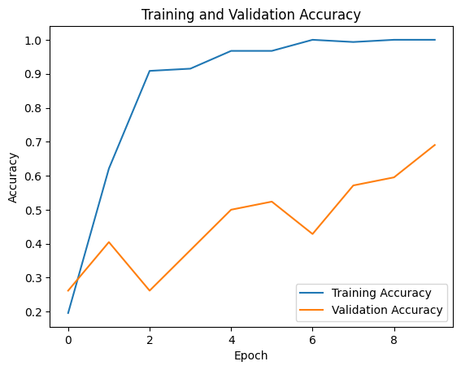

Fig.1 Training Performance

3. Training Performance:

Here's an example prediction. We predicted an image of a ₹100 note from the test set. The model got it right, with high confidence — more than 85% probability on the right class.

This is indicative of the fact that the model not only generalizes well, but is also feasible for real-world inference.

4. Accuracy Comparison:

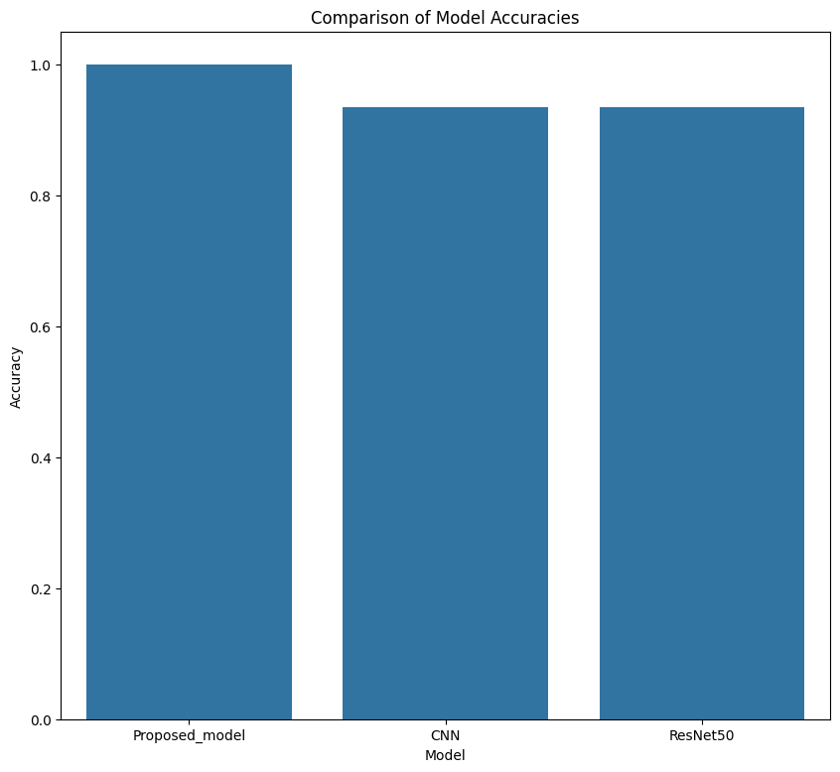

Fig.2 Comparison of Model Accuracies

This bar chart gives a comparison between the accuracy of all three models. As can be seen:

• MobileNet presented the optimal blend of speed vs. accuracy .

• ResNet50 provided excellent performance, suitable for high-performance systems.

• The in-house CNN was light but performed slightly less well in terms of accuracy.

5. Model Expect:

All the trained models have been saved in.h5 format and are ready to deploy. These include the MobileNet-based model, CNN, and ResNet50.

This allows us to seamlessly implement the models within apps or APIs for real-time currency identification.

# Conclusion

The project successfully applies deep learning techniques to the problem of counterfeit currency detection, specifically targeting Indian banknotes . By utilizing image processing and neural networks, the system can automatically analyze and classify currency notes as real or fake. This eliminates the need for manual verification, which is time-consuming and prone to errors, especially in high-volume environments like banks, retail stores, and other financial institutions. Three different models were evaluated: a custom convolutional network(CNN), RestNet50, and MobileNet. The dataset consisted of various images of Indian testing. Both CNN and ResNet50 achieved 92% accuracy, while MobileNet outperformed them with a perfect 100% accuracy. MobileNet’s lightweight architecture and transfer learning capabilities make it ideal for deployment in mobile and embedded systems, offering both speed and precision without compromising performance. In conclusion, the project proves that deep learning can be a reliable and efficient solution for counterfeit detection. The use of MobileNet particularly stands out for real-time applications due to its high accuracy and computational efficiency. This system has the potential to be integrated into practical, user-friendly tools that can help individuals and organizations safeguard against currency fraud, thereby contributing to a more secure financial environment.

# REFERENCES

1. Mohan, Sreejith & Das T, Vishnu & Kuriakose, jisto & K, George & S, Shimi. (2024). Review on fake currency detection using image processing techniques.
2. Bhushanm, Mr & Asritha,M. & Sultana, p.Rafiya & Kumar, P.Anil & Babu, S.Mahesh.(2024). Fake Currency Detection Using Deep Learning. IJARCCE.13.10.17148/1JARCCE.2024.13339
3. Bangalore, Ravindra & Mahesh, & Mahesh, Bhasutkar.(2024). CURRENCY RECOGNITION SYSTEM USING IMAGE PROCESSING. International Journal Of Engineering Technology and Management Sciences. 7. 10.46647/ijetms.2023.v07i06047.
4. Kanawade, Mrs & jangade, Sammed & Mane, Abhishek & Kurne, Tejas.(2024). Counterfeit Currency Detection Using Machine Learning. International Journal of Scientific Research in Science, Engineering and Technology.11.399-405.10.32628/IJSRSET24113139.
5. Rasheeduddin, Sayyad.(2024). Detection Of Fake Currency.
6. Rajee, Alimul & Ahmed, Rasel & Sunzida, Shekh. (2023). A project Report on Fake Currency Detection. 10.13140/RG.2.2.21616.43526.
7. Mahato, Sushil &Yadav, Satan & Kumar, Prince. (2024). Indian Fake Currency Note Recognition. International Journal of Research Publication and Reviews. 5.1124.3340.
8. Nair, Sreejit & Shaikh,Farhan & Thomas, Elrich & Shaikh, Mizan & Sherkhane, Mrs. (2024). Verinote _ Fake Currency Detection Using Convolutional Neural Network. International Research Journal on Advanced Engineering Hub (IRJAEH). 2. 1484-1488. 10.47392/IRJAEH.2024.0205.