EXPERIMENT 02
1. Particulars of Experiment
Case Study Title | UML Use Case Diagram for the Online Vehicle Rental System (OVRS)
Aim of Experiment | To identify the actors and the use cases of the Online Vehicle Rental System, and to construct a UML Use Case Diagram that shows which actor is able to perform which task (functional / behavioural view) within the system.
Problem Statement | The Online Vehicle Rental System (OVRS), as specified in its Software Requirements Specification, involves four distinct classes of users — Customer, Vehicle Owner, Parking Worker, and Administrator — each authorised to perform a different set of tasks on the platform. This experiment addresses the design of a UML Use Case Diagram that clearly depicts these actors, the tasks (use cases) available to each of them, and the mandatory sub-tasks that are always invoked along with a given task.
Author | Anuj Lulu
Section | A2
Roll Number | 33
Date of Compilation | July 26, 2026

2. Short Description of the UML Modeling View
A use case diagram represents the functional (behavioural) view of a system: it shows the actors — the external users or roles who interact with the system — and the use cases, which are the discrete tasks or units of functionality that the system performs on their behalf. Unlike a class diagram, which models the static structure of a system, a use case diagram captures who can do what, without describing the internal data or the sequence of steps involved.
For the OVRS, four actors are identified directly from the User Classes and Characteristics described in the SRS (Section 2.3): Customer, Vehicle Owner, Parking Worker, and Administrator. Each actor is represented using the standard UML actor symbol (a stick figure), placed outside the system boundary, and connected by association lines to the use cases — shown as ovals inside the system boundary rectangle labelled 'Online Vehicle Rental System (OVRS)' — that the actor is authorised to invoke.
The Customer can Book a Vehicle and Report an Accident / SOS; the Vehicle Owner can List a Vehicle and View the Escrow Balance & Payouts; the Parking Worker can Inspect & Clean an Asset and Complete the Hub Handover Setup; and the Administrator can Approve a Listing and Monitor the Emergency SOS Board. Two mandatory sub-tasks, Process Payment and Pay Security Deposit, are connected to their parent use cases through «include» relationships, since they are always executed as an inseparable part of Book Vehicle and List Vehicle respectively.
3. Justification of Specific Features Included in the Diagram
• Choice of actors: The four actors map directly and exhaustively onto the 'User Classes and Characteristics' of Section 2.3 of the SRS, so every external role that interacts with the OVRS is represented exactly once, with no actor left out and none invented.
• Human actor symbol: Each actor is drawn using the standard UML stick-figure notation. This visually separates external, human-driven roles from the system's own internal processing, and is the universally recognised convention for actors in a use case diagram.
• System boundary: A single rectangle labelled 'Online Vehicle Rental System (OVRS)' encloses every use case, making explicit which behaviour belongs to the system under design and which actors sit outside it.
• Reduced use-case set for clarity: The SRS's textual use-case description (Section 8.1) lists several additional tasks, such as Search & Filter Catalog and Moderate System Reviews. These were consolidated into, or omitted in favour of, the two most representative tasks per actor so that the diagram could be enlarged and kept legible, while still covering the primary responsibility of every actor.
• «include» over «extend»: Process Payment and Pay Security Deposit are modelled with «include» relationships rather than «extend», because the SRS states plainly that 'UC-1.0 (Book Vehicle) includes Process Payment' and 'UC-2.0 (List Vehicle) includes Pay Security Deposit' — that is, these sub-tasks are always performed as a required part of the parent use case, not as an optional or conditional variation.
4. UML Use Case Diagram (Model Export)
The diagram below is the exported use-case model for the OVRS, showing the four actors, the tasks each one can perform, the system boundary, and the «include» relationships described above.
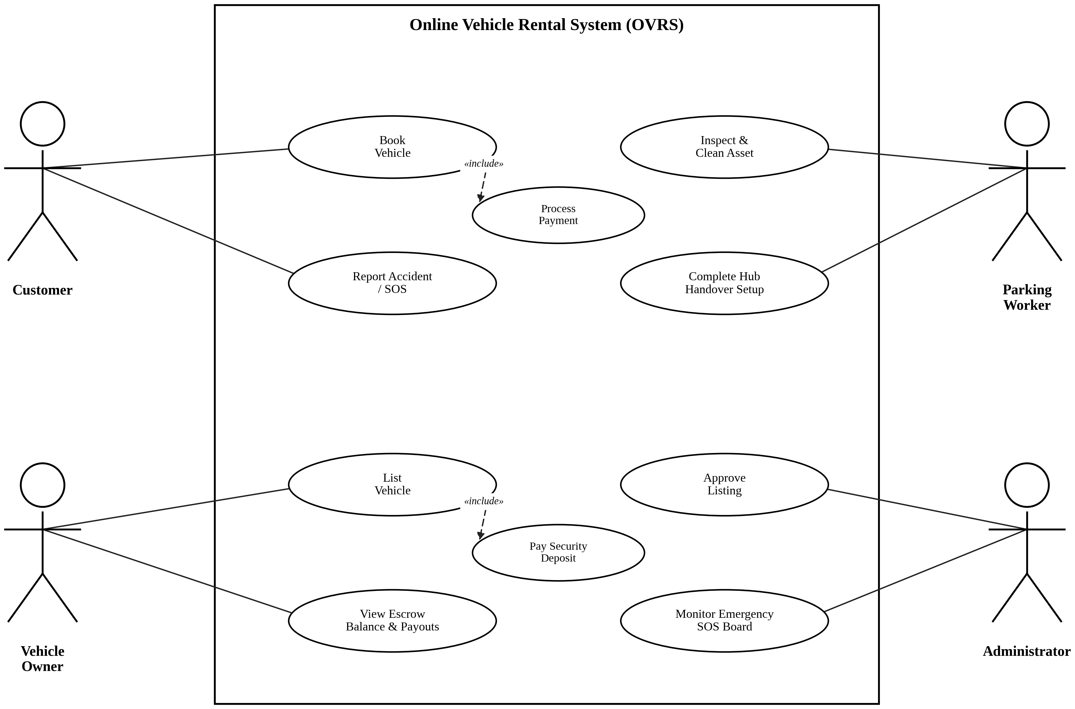
Fig. 1 — UML Use Case Diagram of the Online Vehicle Rental System (OVRS)

