**User Guide for Plant Disease Detection Application**

**Introduction**

This application allows users to upload images of plant leaves and receive predictions about potential diseases. It utilizes a trained Convolutional Neural Network (CNN) model to analyze the images and provide insights into plant health. This tool is designed for agricultural professionals, researchers, and anyone interested in plant disease management.

**How to Use the Application**

1. **Access the Application**: Open the Streamlit web application in your web browser.
2. 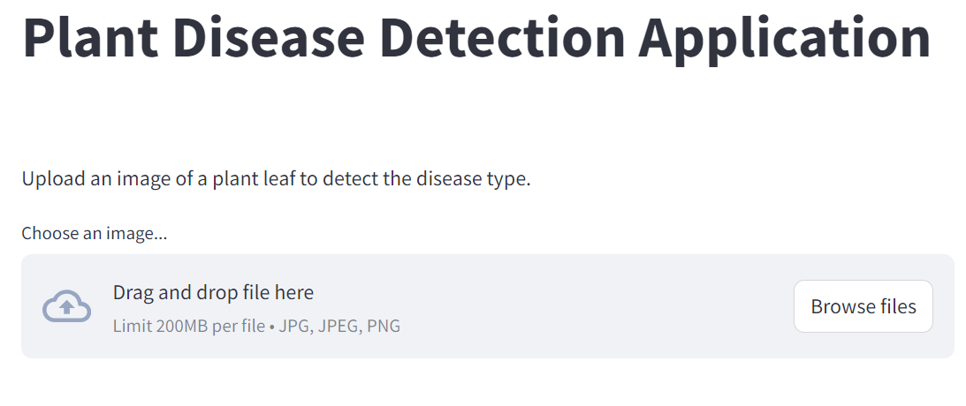**Upload an Image**: On the home page, you will see an option to **upload an image**.

*In the above image, click on the "Browse files" button to select a file from your device.*

1. **Select an Image File**:
   * A file dialog will appear. Choose an image of a plant leaf from your device.
   * Ensure the image is clear and focused for best results.
   * Supported formats include JPEG and PNG.
2. **Submit the Image**: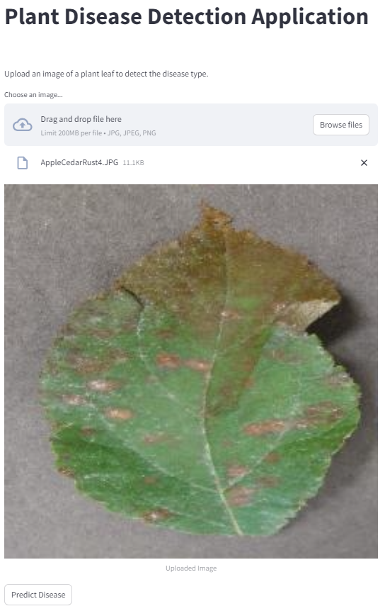 After selecting the image, you will see the uploaded image.

*In the above image, the uploaded image is displayed*

1. **Interpreting Predictions**

**i)Receive Prediction**:

* Now, click on the "Predict" button to receive a diagnosis.
* After clicking the "Predict" button, the application will analyze the image and display the predicted disease.

**ii)View Prediction Result**: The prediction results will show:

* + **Predicted Disease**: The application will display the name of the disease detected.
  + **Confidence Score**: This percentage indicates how certain the model is about the prediction. A higher score represents greater confidence in the diagnosis.

*In the above image, the predicted disease and confidence score are presented*

**Conclusion**

This user guide aims to provide a straightforward approach to using the Plant Disease Detection Application. By following the steps outlined above, users can efficiently upload images and interpret the model’s predictions to assist in plant health management.