LAB ASSIGNMENT 11.4
NAME :C.Anukya Reddy
H.NO : 2303A52452
BATCH : 42

TASK 1
Stack Implementation for Undo Operations (LIFO)
PROMPT:
Generate a clean Python Stack class with push, pop, peek, and is_empty methods, including docstrings and comments.
Explain why a stack is suitable for undo operations and suggest an alternative using collections.deque.
CODE:
Stack Class Implementation (List-Based)
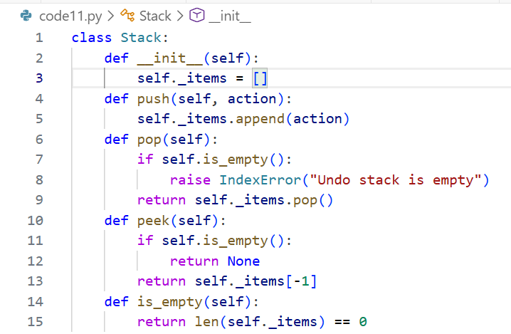

Alternative Implementation Using collections.deque
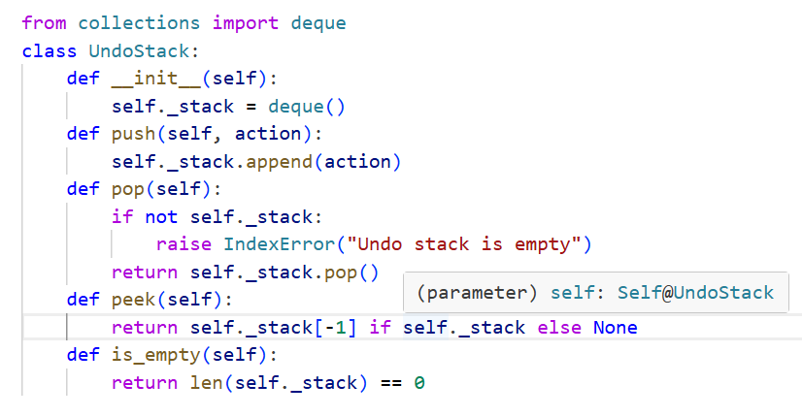
JUSTIFICATION:
Stacks enforce Last-In-First-Out (LIFO) behavior, which perfectly matches undo operations where the most recent action must be reversed first.
Using a list-based stack is simple and readable, but collections.deque offers faster append/pop operations from both ends.
Docstrings and comments improve clarity, making the class easier to maintain and extend in real projects.
Sample test cases validate correct LIFO behavior and ensure robustness in simulating text editor undo operations.

TASK 2
Queue for Customer Service Requests (FIFO)
PROMPT:
Implement a Python Queue class with enqueue, dequeue, and is_empty using a list, then optimize it with collections.deque.Review performance implications of list-based queues and explain why deque performs better for FIFO operations.
CODE:
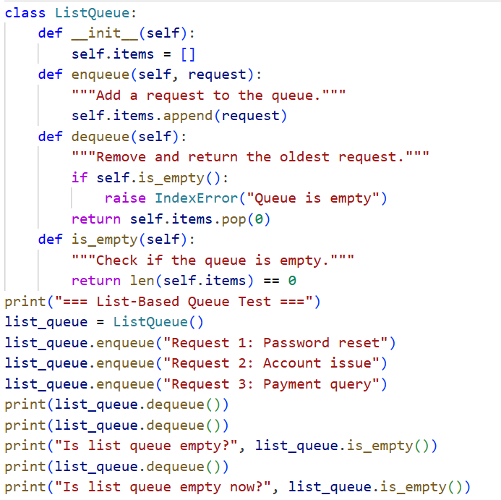
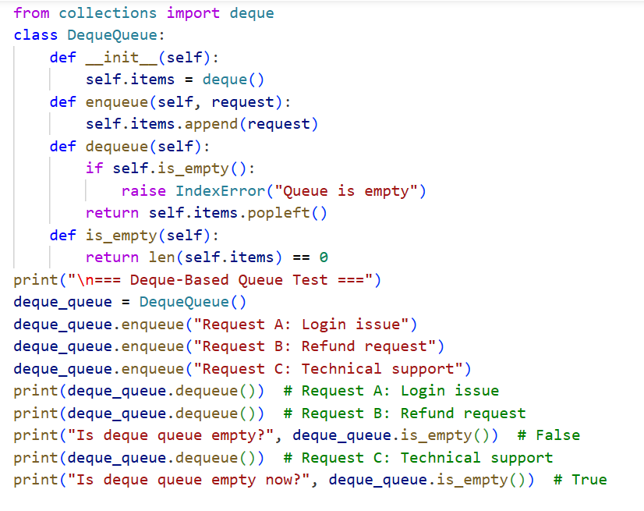

OUTPUT:
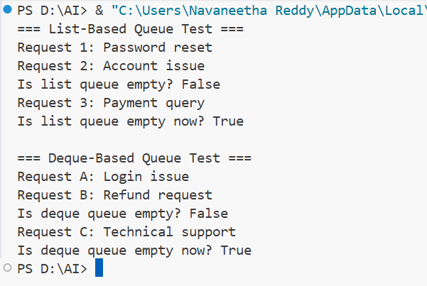
JUSTIFICATION:
List-based queues suffer from O(n) complexity for dequeue() because removing the first element requires shifting all others.
AI optimization with collections.deque ensures O(1) time for both enqueue and dequeue, making it ideal for large-scale customer service systems.
While lists are simpler and more readable for small datasets, deque provides significant performance gains in real-world scenarios.
This comparison highlights how AI-assisted reviews can guide teams toward efficient, scalable data structures without sacrificing clarity

TASK 3
Singly Linked List for Dynamic Playlist Management
PROMPT:
Implement a Python Singly Linked List with insert_at_end, delete_value, and traverse methods, including inline comments explaining pointer manipulation.
Ask AI to highlight tricky parts of insertion/deletion and suggest edge case test scenarios like empty list, single node, or deletion at head.
CODE:
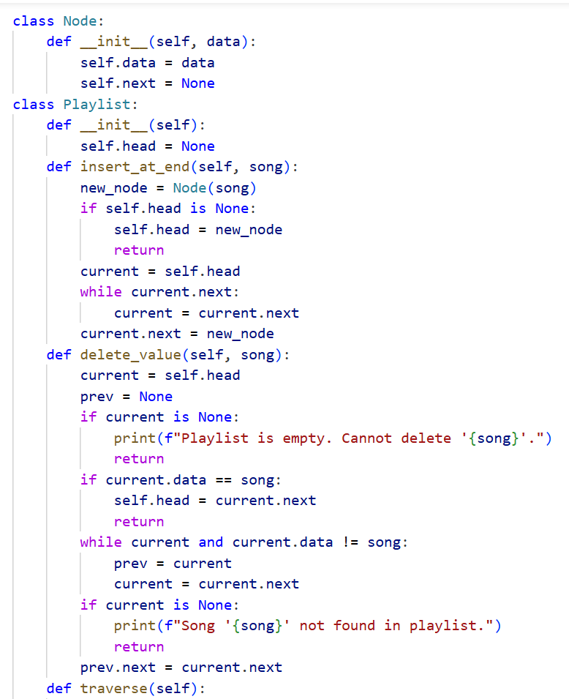
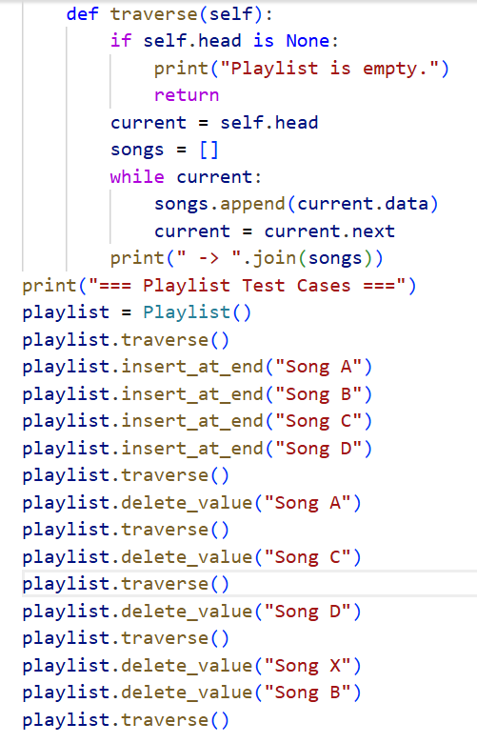
OUTPUT:
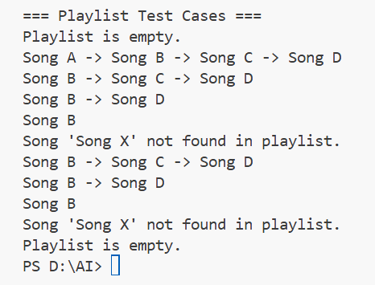

JUSTIFICATION:
Linked lists are ideal for dynamic playlists because they allow efficient insertion and deletion without shifting elements like arrays.
Pointer manipulation is tricky—especially updating next references when deleting nodes at the head or tail.
AI-generated inline comments clarify traversal and updates, making the code easier to maintain and debug.
Edge case tests (empty list, single node, deletion at head) ensure robustness and validate correct playlist behavior under all conditions.

TASK 4
Binary Search Tree for Fast Record Lookup
PROMPT:
Complete the partially written Node and BST classes by implementing insert, search, and inorder_traversal methods with meaningful docstrings.
Explain how BST improves search efficiency compared to linear search, including best-case and worst-case performance.
CODE:
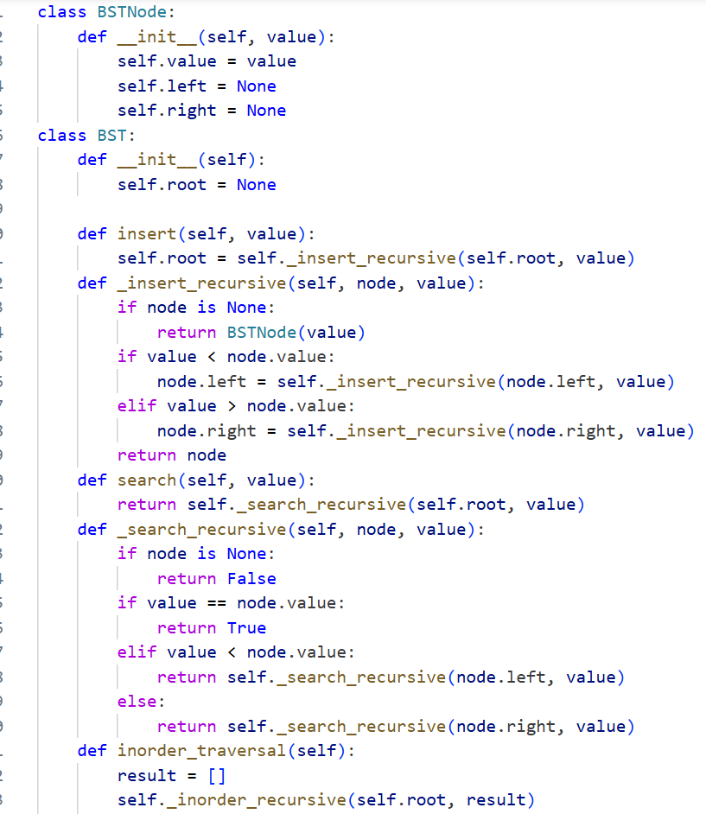
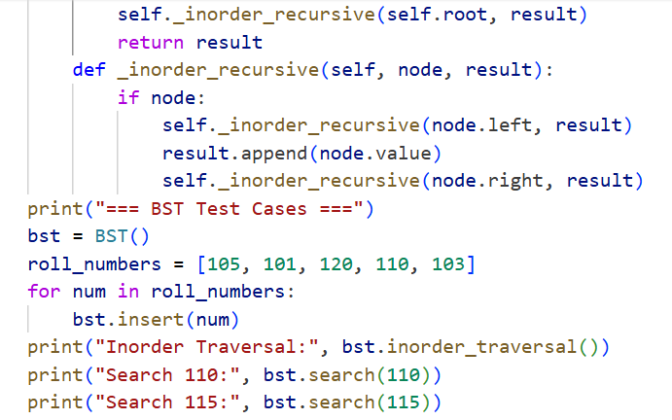
OUTPUT:
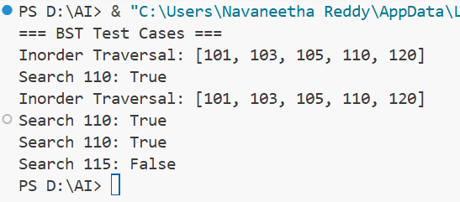
JUSTIFICATION:
BSTs organize data hierarchically, allowing O(log n) average-case search time compared to O(n) in linear search.
Insertion and search require careful pointer updates, which AI can complete cleanly with docstrings for clarity.
Inorder traversal ensures sorted output, validating correct BST structure.
Best case occurs with a balanced tree, while worst case (skewed tree) degrades to linear search, highlighting the importance of balancing techniques.

TASK 5
Graph Traversal for Social Network Connections
PROMPT:
Implement a graph using an adjacency list and add BFS for nearby connections and DFS for deep paths, with inline comments explaining traversal.Ask AI to compare recursive vs iterative DFS and suggest practical use cases for BFS versus DFS in social networks.
CODE:
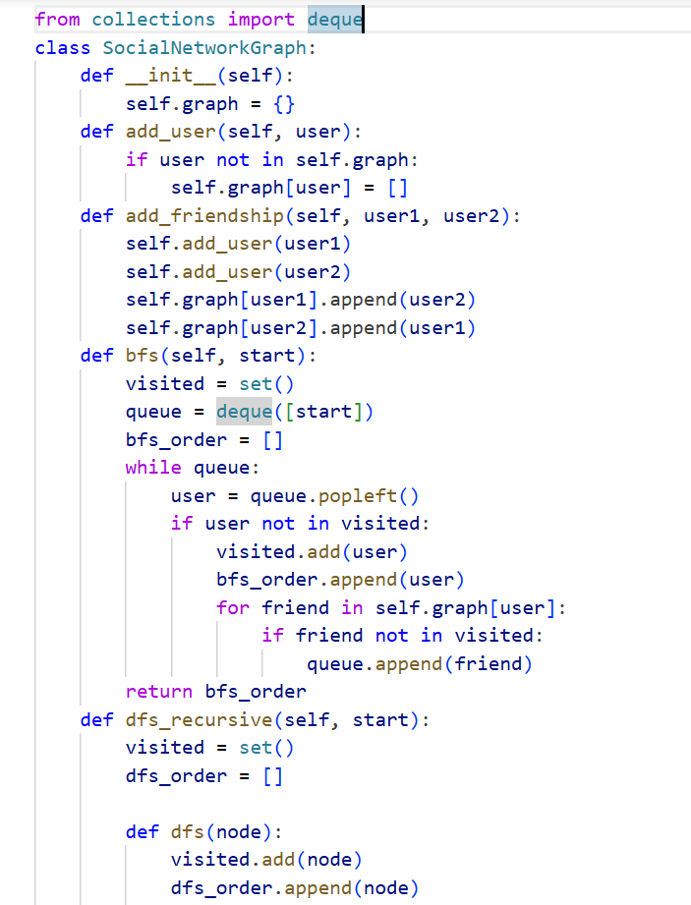
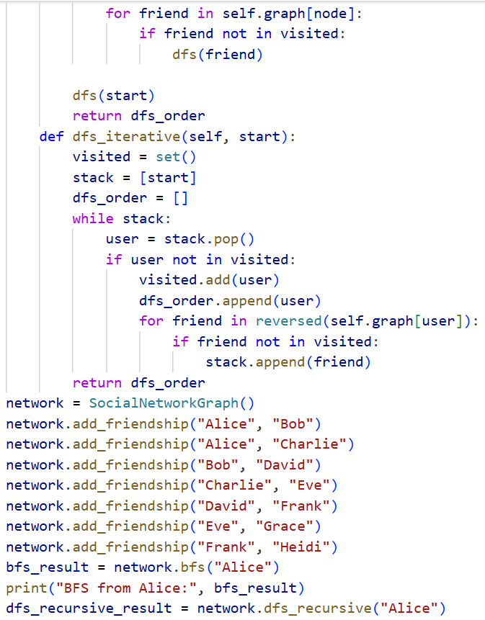
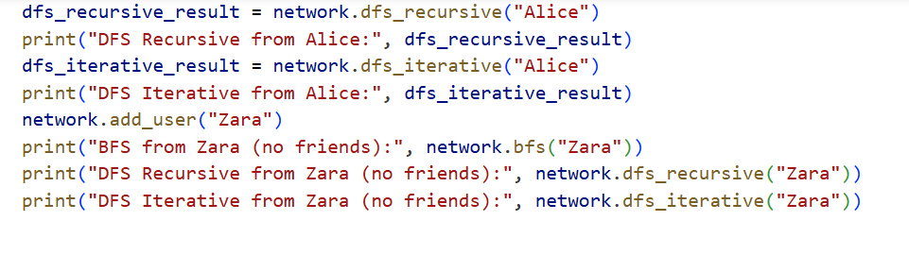

OUTPUT:
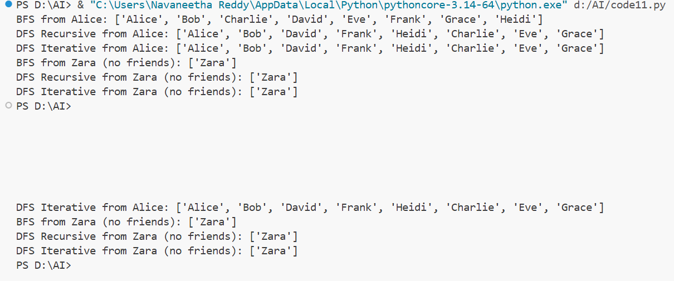
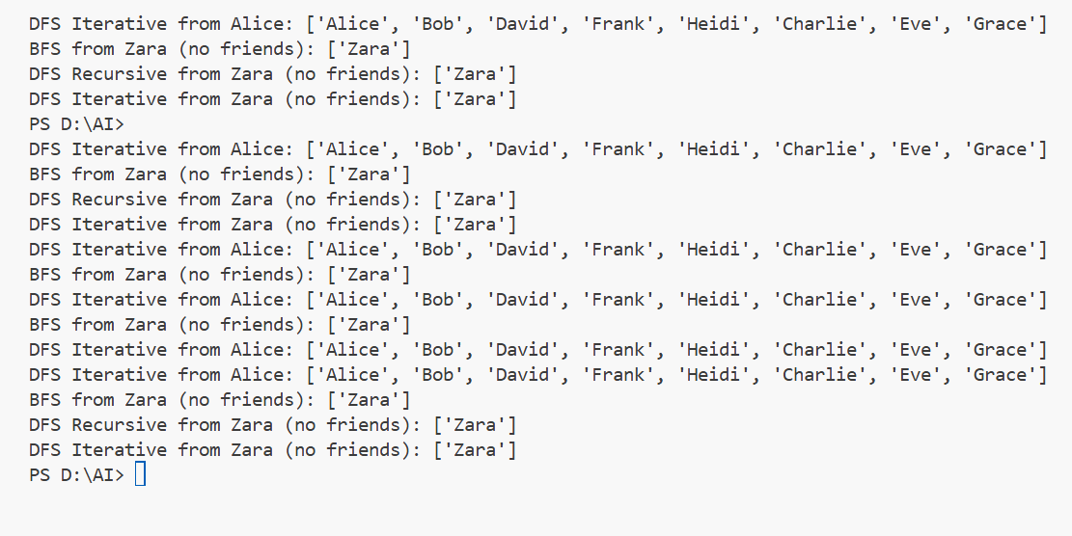
JUSTIFICATION:
Graphs model social networks naturally, where BFS explores closest friends first, ideal for finding immediate connections.
DFS dives deeper into paths, useful for discovering extended or hidden relationships.
Recursive DFS is simpler but risks stack overflow on large graphs, while iterative DFS with a stack is safer for scalability.
AI explanations clarify traversal logic and highlight when BFS (shortest path, friend suggestions) or DFS (exploring communities) is more effective

