ASSIGNMENT-12.3
NAME:C.ANUKYA REDDY
ROLL NO:2303A52452
BATCH NO:42
Task 1: Sorting Student Records for Placement Drive
Prompt:
Generate a Python program for SR University that stores student records (Name, Roll, CGPA), implements Quick Sort and Merge Sort to sort by CGPA in descending order, compares runtime for large datasets, and displays the top 10 students
Code:
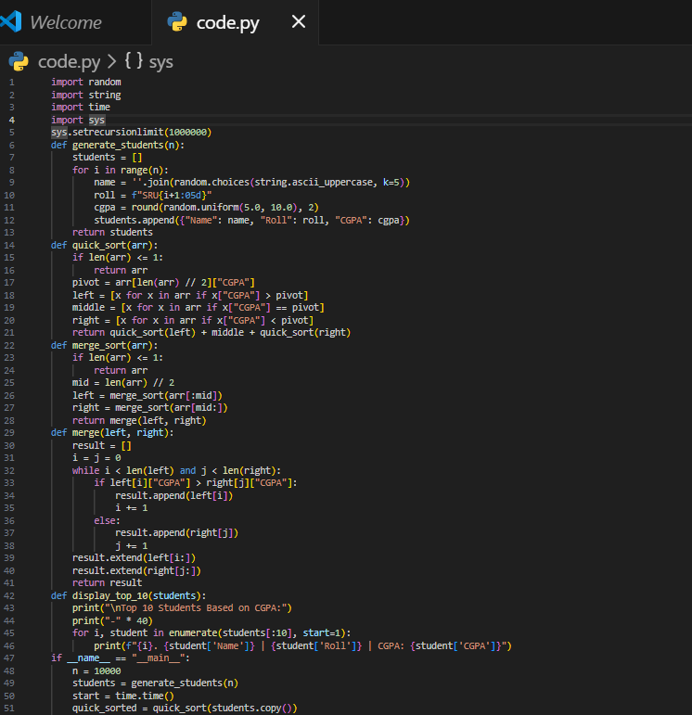
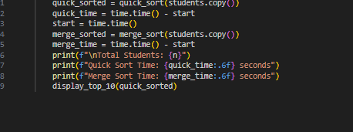
Output:
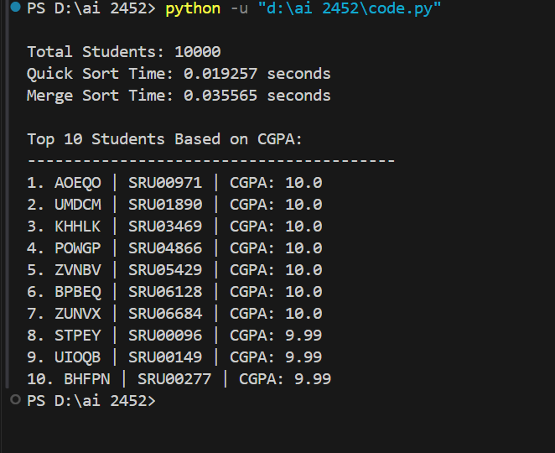
Justification:
This prompt ensures efficient candidate shortlisting by combining correct sorting logic, performance comparison, and clear identification of top-performing students.
Task 2: Implementing Bubble Sort with AI Comments
Prompt:
Generate a Python Bubble Sort implementation with clear inline comments explaining swapping, passes, early termination logic, and include time and space complexity analysis
Code:
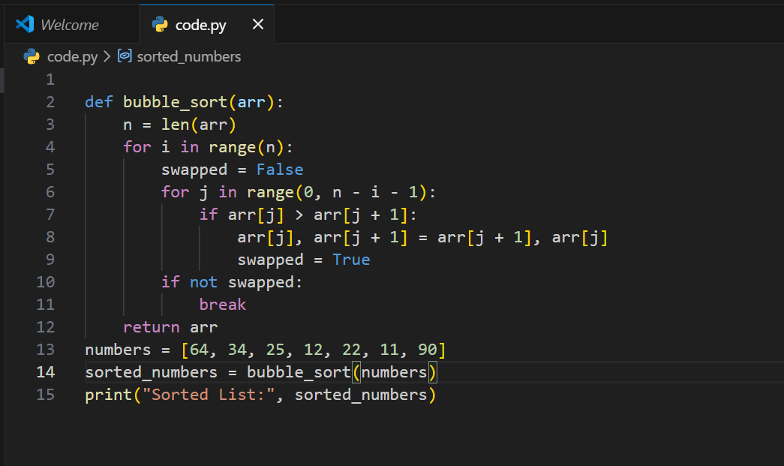
Output:
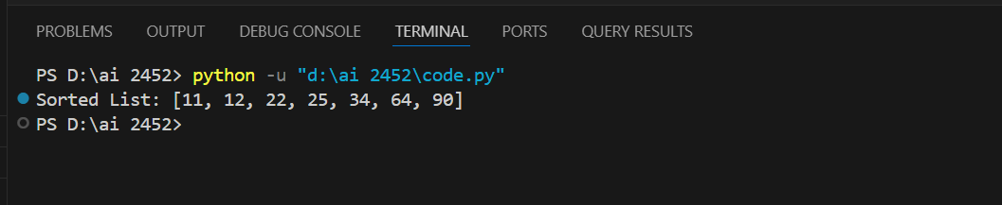
Justification:
This prompt ensures conceptual clarity by combining algorithm implementation, step-by-step explanation, and complexity understanding in a single structured response.
Task 3: Quick Sort and Merge Sort Comparison
Prompt: Complete the recursive implementations of Quick Sort and Merge Sort in Python, add proper docstrings explaining logic and complexities, and compare their performance on random, sorted, and reverse-sorted lists
Code:
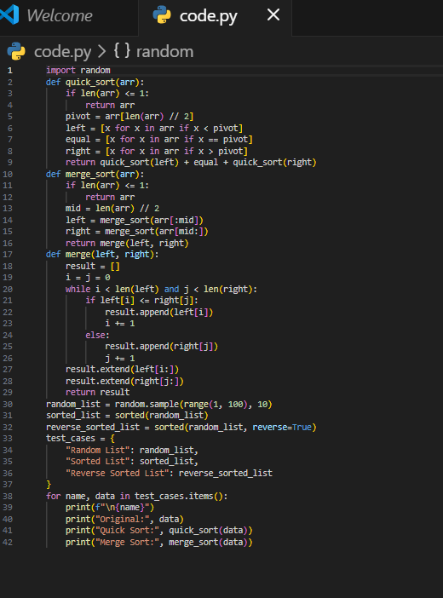
Output:
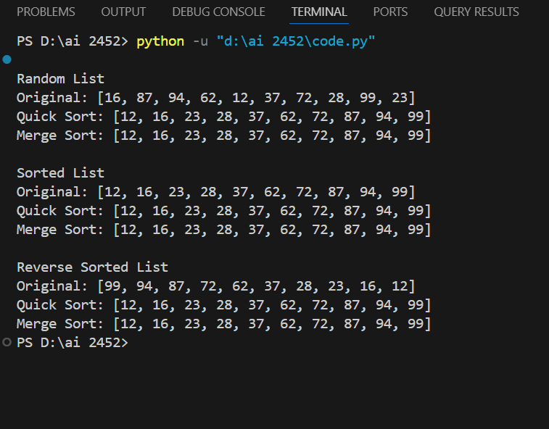
Justification:
This prompt ensures correct recursive implementation, conceptual clarity through documentation, and practical understanding via performance comparison across different input cases.

Task 4 (Real-Time Application – Inventory Management System)
Prompt:
Design a real-time Inventory Management System for thousands of products that efficiently supports search by ID/name and sorting by price/quantity, recommending optimal algorithms with justification and Python implementation.
Code:
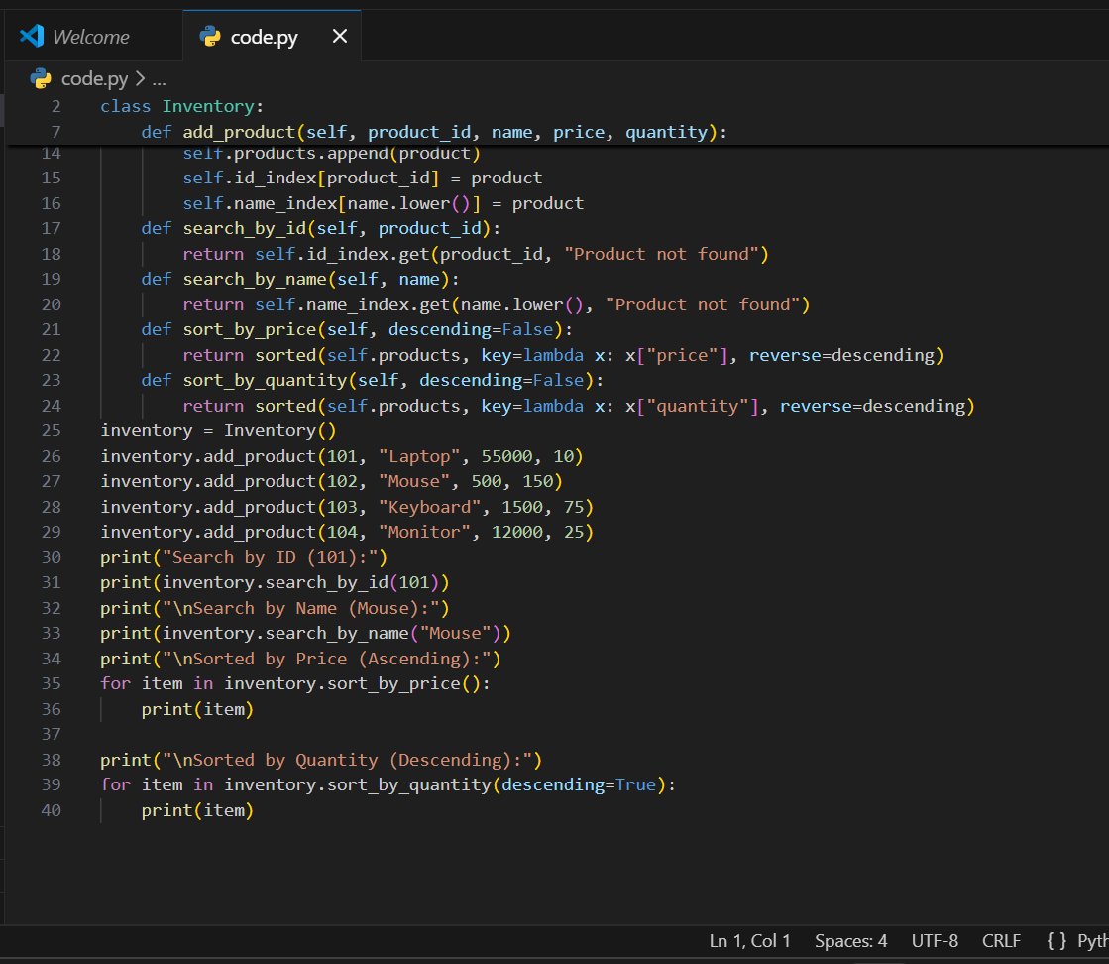
Output:
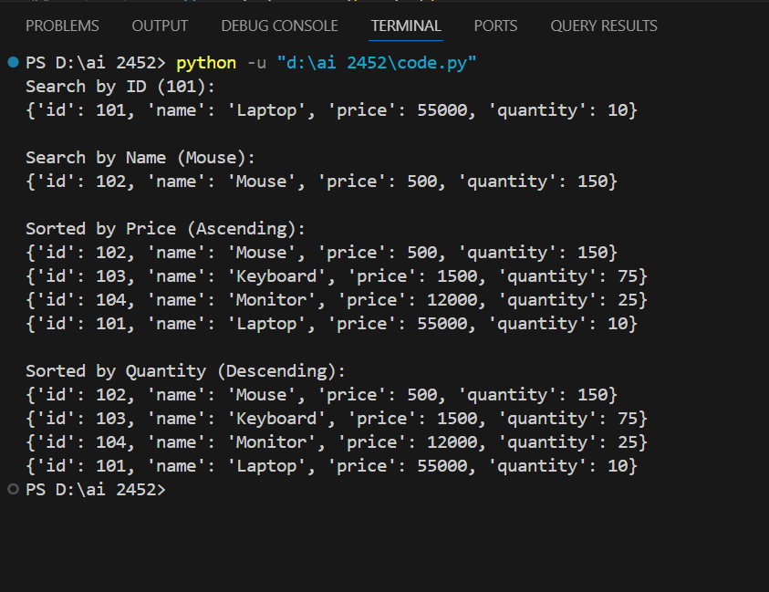
Justification:
Use Hash Tables for O(1) fast searches and Timsort (sorted()) for efficient O(n log n) stable sorting suitable for large, frequently updated datasets.
Task 5: Real-Time Stock Data Sorting & Searching
Prompt:
Design a real-time stock analysis system that simulates stock data, ranks stocks by percentage gain/loss using Heap Sort, enables instant stock lookup using Hash Maps, and compares performance with Python’s built-in sorted() and dict functions.
Code:
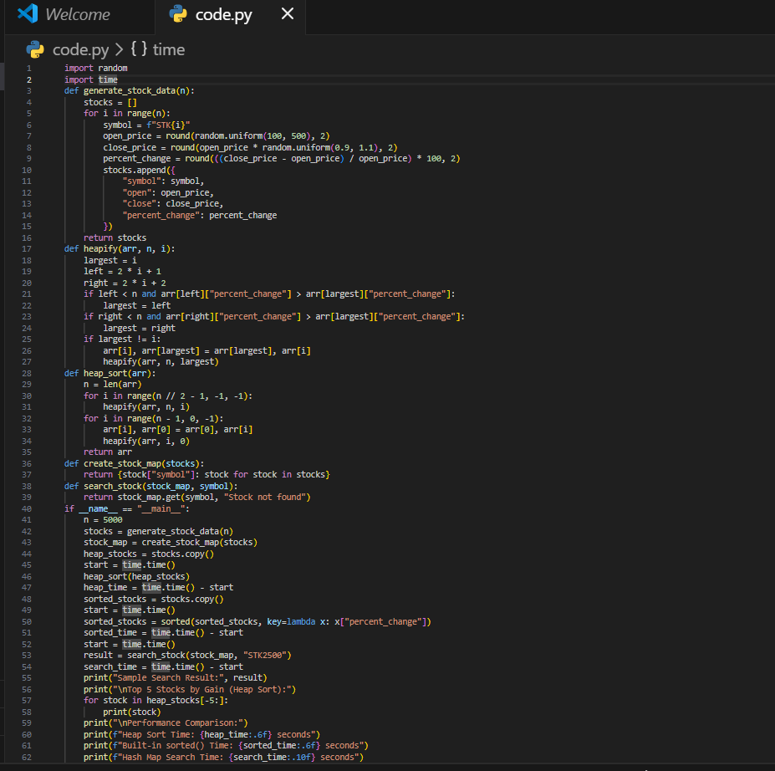
Output:
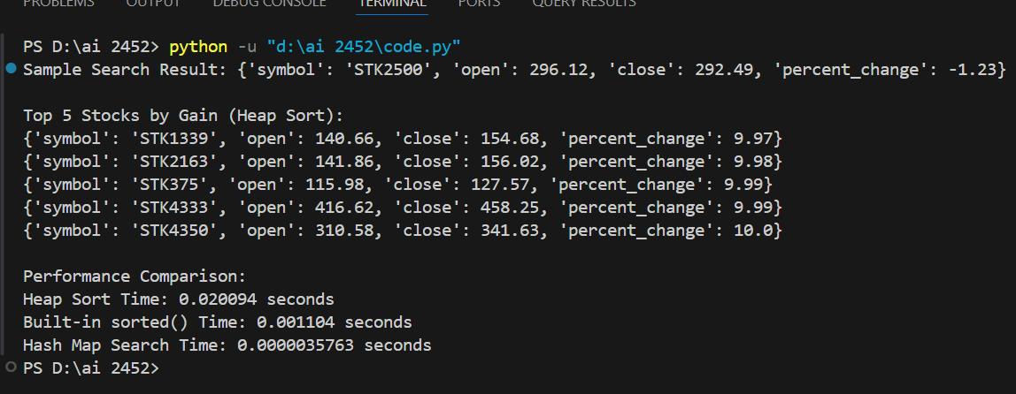
Justification:
Heap Sort guarantees O(n log n) worst-case sorting performance while Hash Maps provide O(1) constant-time stock lookup, making them efficient for large, real-time financial datasets.

