**DBMS LAB ASSIGNMENT**

**Name**: M.Anupama

**Roll No**: 19BCS123

1)Add, Modify and Delete Column using Alter Command.

🡪Adding column:

Before adding column(EmailID):

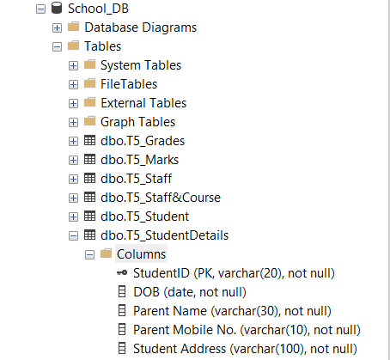

Query:

*USE School_DB;*

*ALTER TABLE T5_StudentDetails*

*ADD EmailID Varchar(255);*

OUTPUT:  
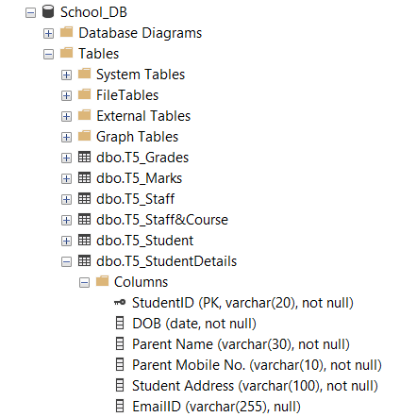

🡪Modifying column:

Query:

*USE School_DB;*

*ALTER TABLE T5_StudentDetails*

*ALTER COLUMN EmailID varchar(500);*

OUTPUT:

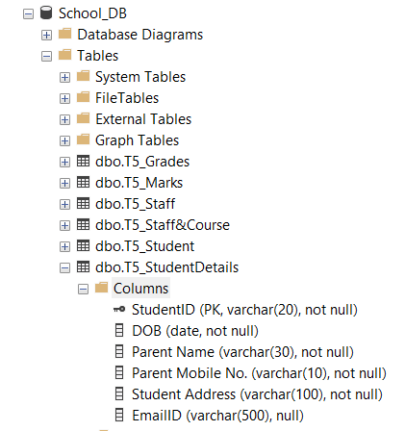

🡪Deleting column:

Query:

*USE School_DB;*

*ALTER TABLE T5_StudentDetails*

*DROP COLUMN EmailID;*

OUTPUT:

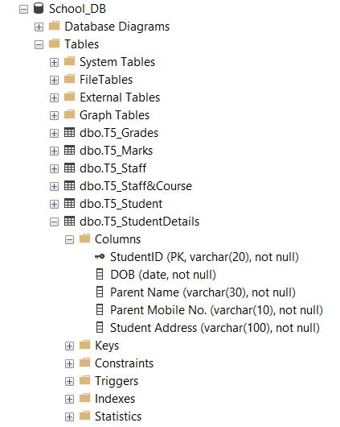

2) Insert 20 Employees Data into all the tables. Use all the 3 methods that I have showcased.

Query:

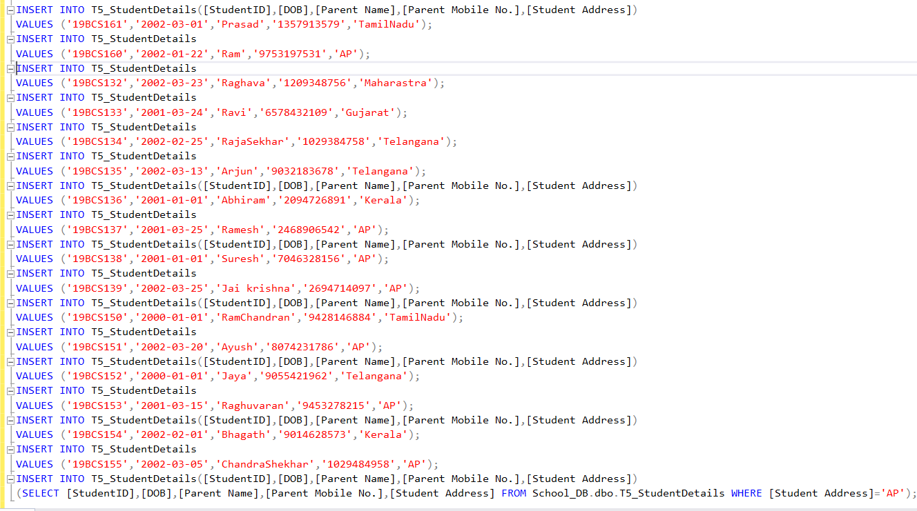

OUTPUT:

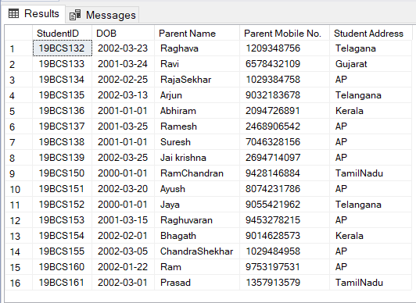

3) Show Violation of Primary Key, Unique Not Null and default key constraints through insertion.

🡪Violation of Primary key constraint:



In Table ***T5_StudentDetails***, ***StudentID*** is primary key.

Query:

*USE School_DB*

*INSERT INTO T5_StudentDetails([StudentID],[DOB],[Parent Name],[Parent Mobile No.],[Student Address])*

*VALUES ('19BCS123','2002-03-21','Venkateswarlu','9876543210','AP');*

*USE School_DB*

*INSERT INTO T5_StudentDetails([StudentID],[DOB],[Parent Name],[Parent Mobile No.],[Student Address])*

*/*VALUES ('19BCS123','2002-03-21','Venkateswarlu','9876543210','AP');*/*

*VALUES ('19BCS123','2002-03-21','Venkateswarlu','1234567890','AP');*

OUTPUT:

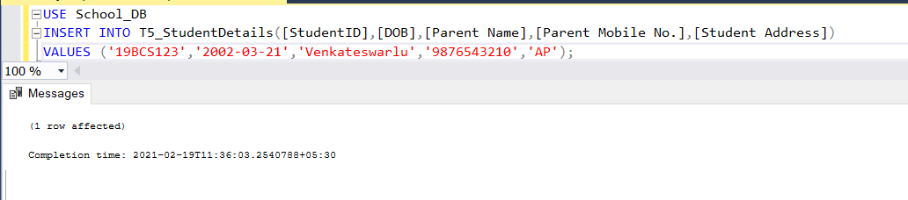

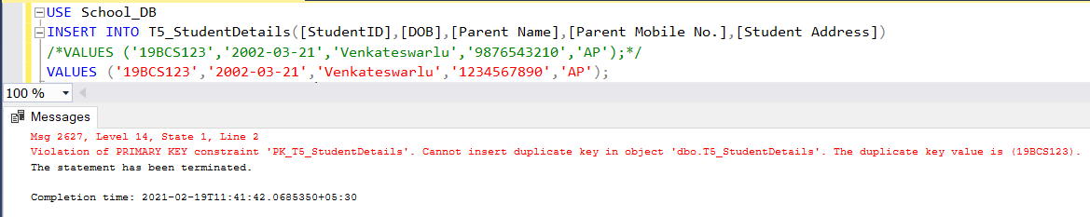

🡪Violation of Unique key constraint:

In Table ***T5_StudentDetails***, I have converted ***Parent Mobile No.*** key into unique by using the following query:

*ALTER TABLE T5_StudentDetails*

*ADD UNIQUE ([Parent Mobile No.]);*

Query:

*USE School_DB*

*INSERT INTO T5_StudentDetails([StudentID],[DOB],[Parent Name],[Parent Mobile No.],[Student Address])*

*VALUES ('19BCS130','2002-03-01','Prasad','1234567890','TamilNadu');*

*USE School_DB*

*INSERT INTO T5_StudentDetails([StudentID],[DOB],[Parent Name],[Parent Mobile No.],[Student Address])*

*/*VALUES ('19BCS130','2002-03-01','Prasad','1234567890','TamilNadu');*/*

*VALUES ('19BCS123','2002-03-21','Venkateswarlu','1234567890','AP');*

OUTPUT:

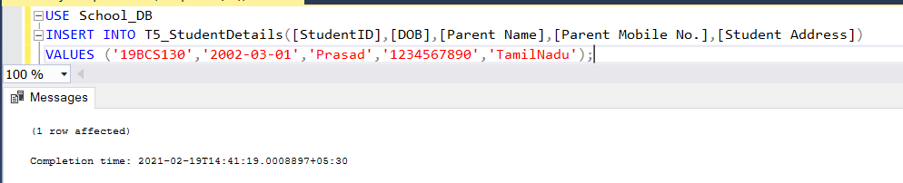

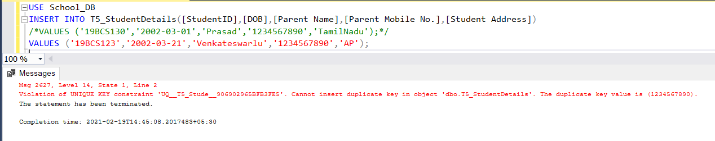

🡪Violation of NOT NULL constraint:

Query:

*INSERT INTO T5_Marks([StudentID],[CourseID],[CourseMarks])*

*VALUES('19BCS123',NULL,'80');*

OUTPUT:

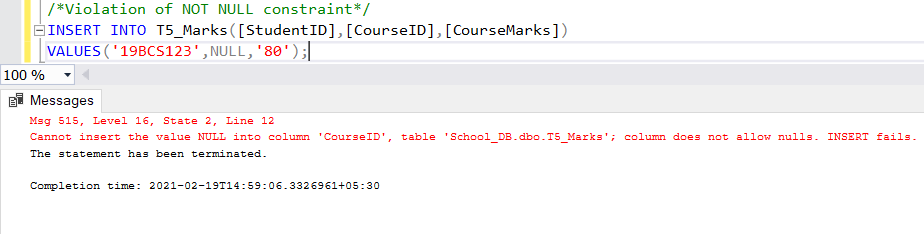

🡪Violation of default key constraint:

Query:

*ALTER TABLE T5_Student*

*ADD CONSTRAINT df_EmailID*

*DEFAULT '@iiitdwd.ac.in' FOR EmailID;*

*INSERT INTO T5_Student([StudentID],[First Name],[Last Name],[PH_No],[StudyYear],[CourseID])*

*VALUES ('19BCS123','Anupama','M','1234567890','2','cs210');*

*select * from T5_Student;*

OUTPUT:

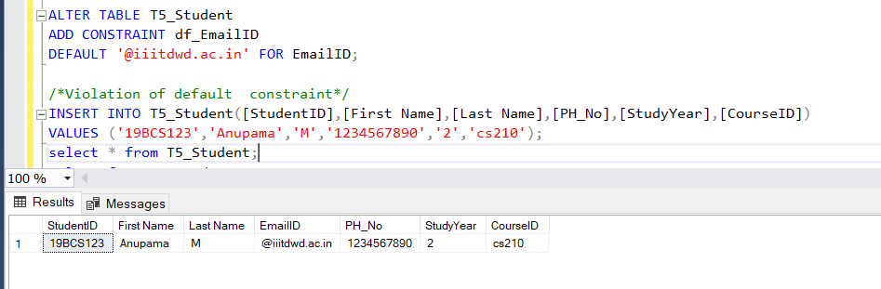

4) Insert tuples into the table and see how foreign key constraint works if you try to insert into dependent table first.

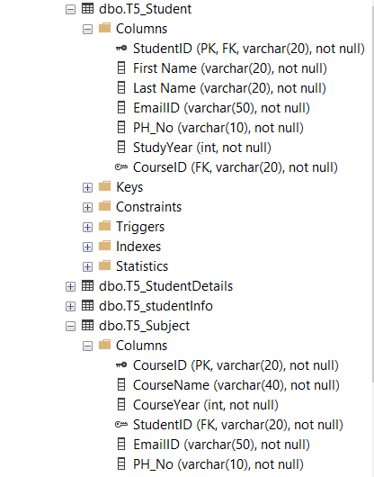

Here, ***StudentID*** column in ***T5_Subject*** table is dependent on ***StudentID*** column in ***T5_Student*** table.

Query:

*USE School_DB*

*INSERT INTO T5_Subject([CourseID],[CourseName],[CourseYear],[StudentID],[EmailID],[PH_No])*

*VALUES ('CS210','DBMS','2','19bcs123','19bcs123@iiitdwd.ac.in','9876543210');*

OUTPUT:



5) Show Violation of Foreign Key Constraint when you try to delete from a base table. If you get an error explain why deletion gives an error.

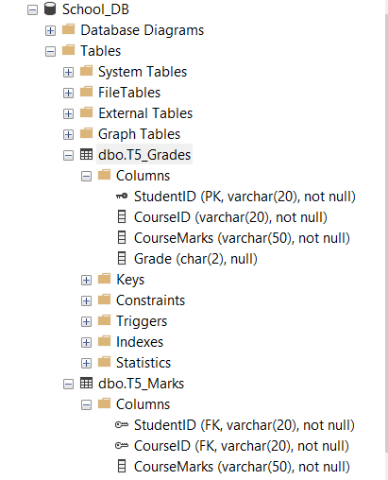

Here, ***StudentID*** column in ***T5_Marks*** table is dependent on ***StudentID*** column in ***T5_Grades*** table.

Query to delete column:

*USE School_DB*

*ALTER TABLE T5_Grades*

*DROP COLUMN StudentID;*

OUTPUT:

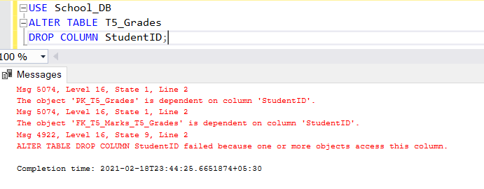

6) Try to update a non-existing entity data and check for error.

Query:

*USE School_DB*

*UPDATE T5_StudentDetails*

*SET [Student Address] = 'Telagana'*

*WHERE StudentID = '19BCS132'*

OUTPUT:

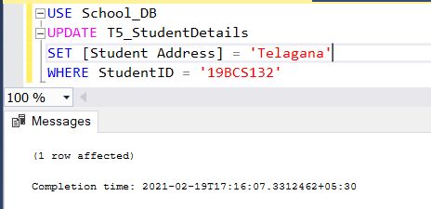

7) Add a column which has default value.

Query:

*ALTER TABLE T5_Student*

*ADD CONSTRAINT df_EmailID*

*DEFAULT '@iiitdwd.ac.in' FOR EmailID;*

*INSERT INTO T5_Student([StudentID],[First Name],[Last Name],[PH_No],[StudyYear],[CourseID])*

*VALUES ('19BCS123','Anupama','M','1234567890','2','cs210');*

*select * from T5_Student;*

OUTPUT:



8) 5 Simple Select queries to retrieve data from your database.

Query:

*USE School_DB*

*SELECT StudentID FROM T5_StudentDetails*

*WHERE[Student Address] = 'AP';*

*SELECT TOP 10 * FROM T5_StudentDetails;*

*SELECT StudentID FROM T5_StudentDetails*

*WHERE[Parent Name] = 'Arjun';*

*select * from T5_StudentDetails;*

OUTPUT:

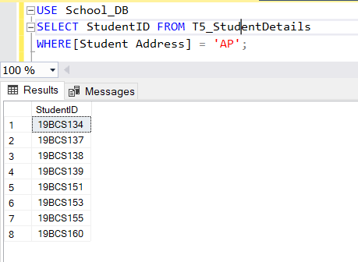

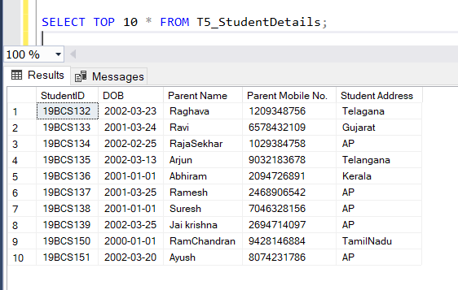

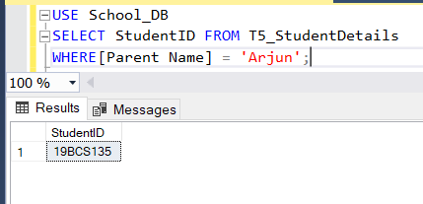

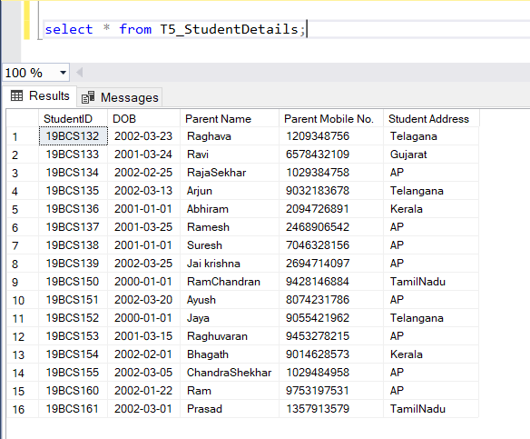

9) Show how Foreign key constraint effects Updating a dependent table when value is not existing and in Base table where the value is referred and you want to update it.