Procedure:

Step 1: State the hypotheses and identify the claim.

Step 2: Find the critical value in the right tail. Use Chi-square Table.

Step 3: Compute the test value. To compute the test value, first find the expected values. For each cell of the contingency table, use the formula to get the expected value.

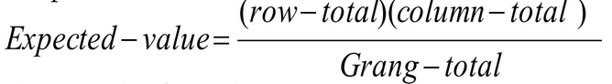

To find the test value, use the formula

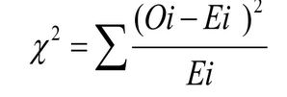

Step 4: Make the decision.

Step 5: Summarize the results.

Problem:

We selected three samples of 16 players in categories of matches played by them (i.e., low, medium, more based on the number) and noted the difference between their matches and innings (Difference) and categorized the value into null or nor null. At α=0.05, test the claim that the proportions of (difference of matches and innings)-category is same for all (matches)-category.

Solution:

H0: All proportions of (difference of matches and innings)-category are equal.

H1: All proportions are not equal.

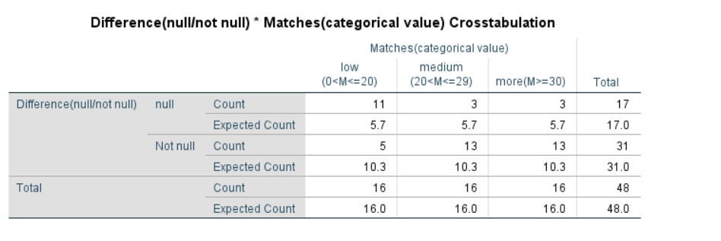

*Table: 1.0 - Table containing both observed and expected values (from SPSS)*

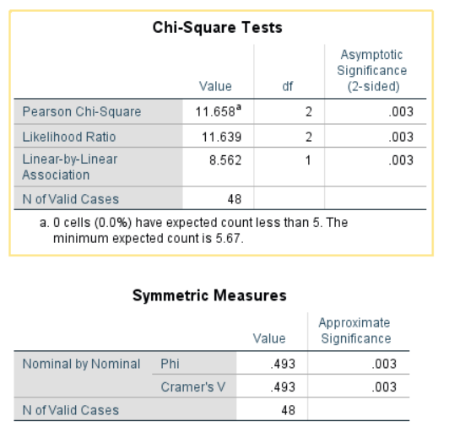

*Table: 1.1*

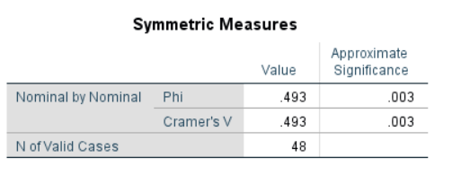

*Table: 1.2*

From table 1.1, we got chi-square value as 11.658

And α=0.05, degrees of freedom =2

From the chi-square value table, Critical value = 5.991

Here, critical value< calculated value.

Hence, the decision is to reject the null hypothesis.

Therefore, the conclusion is that all proportions of (difference of matches and innings)-category are not equal.

***Bar Graph to examine the relationship between matches and difference(between matches and innings):***

