Procedure :

Step 1: State the hypotheses and identify the claim.

Step 2: Find the critical value in the right tail. Use a Chi-square Table.

Step 3: Compute the test value. To compute the test value, first find the expected values.

For each cell of the contingency table, use the formula to get the expected value.

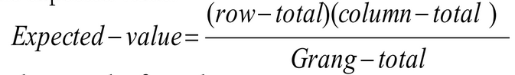

To find the test value, use the formula

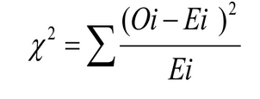

Step 4: Make the decision.

Step 5: Summarize the results.

Problem:

From the population of players in T20-WC batting dataset, a sample of 45 players have been selected and their corresponding matches and runs are noted down. At a level of significance 0.05, check whether there is any relationship between the Matches played by the player and runs scored by them.

Note: Matches are categorized into 3 categories and Runs scored are divided into 2 categories

Solution:

H0: There is no significant relationship between the Matches played by the player and runs scored by them.

H1: There is a significant relationship between the Matches played by the player and runs scored by them.

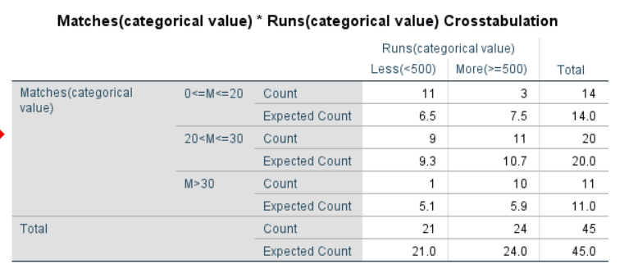

*Table: 1.0 - Table containing both observed and expected values (from SPSS)*

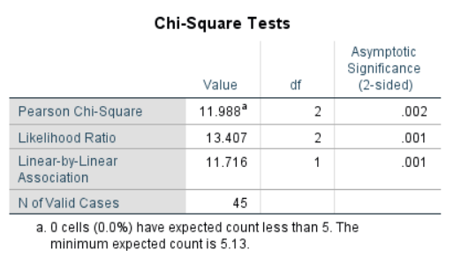

*Table: 1.1*

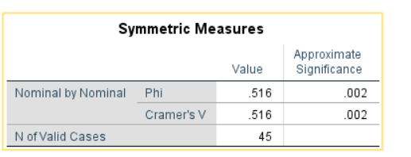

*Table: 1.2*

From table 1.1, we got chi-square value as 11.988

And α=0.05, degrees of freedom =2

From the chi-square value table, Critical value = 5.991

Here, critical value< calculated value.

Hence, the decision is to reject the null hypothesis.

Therefore, the conclusion is that there is a significant relationship between the Matches played by the player and runs did by them.

***Bar Graph to examine the relationship between matches and runs:***

