Procedure:

The Chi-Square Goodness-of-Fit Test

Step 1: State the hypotheses and identify the claim.

Step 2: Find the critical value. The test is always right-tailed.

Step 3: Compute the test value. Find the sum of the values.

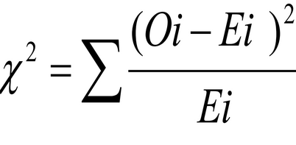

Step 4: Make the decision.

Step 5: Summarize the results.

Problem:

We are interested to see if the four categories {[0,10], (10,20], (20,30], (30, ∞)} of "Total No of Matches a player played". The chance of playing is equally distributed among the players. A sample of 49 players is selected, and the dataset is used. At α=0.05 Is there enough evidence to reject the claim that the frequencies in all categories are equal?

solution:

Step-1 : State the hypotheses and identify the claim.

H0 : there is equal frequency in all categories(claim)

H1 : Equal frequency doesn’t occurs.

Step-2 : Find the critical value.

The degrees of freedom are 3, and α=0.05.

Therefore, Critical value from Chi-square-Table value = 7.815

Step-3 ; Compute the test value.

From the output of the test in SPSS viewer, we have chi-square=16.388

Step-4 : Make the decision.

p-value = 0.001 and α=0.05

The decision is to reject the null hypothesis, since

7.815<16.388

Step-5 : Summarize the results.

There is enough evidence to reject the claim that there is equal frequency in all categories. The fit of equal frequencies is “not good enough.”

