Two samples :

This test is used to determine a specific sample size for two different approaches on samples in the same data set. In this case, we try to estimate the sum of sample sizes while comparing two means or proportions.

For two means :

Procedure :

1. Specify the standard deviation.

2. Specify the significance level and power of the test.

3. Specify the confidence interval and critical normal values.

4. Find the true difference.

5. Compute the sample size using the formula:

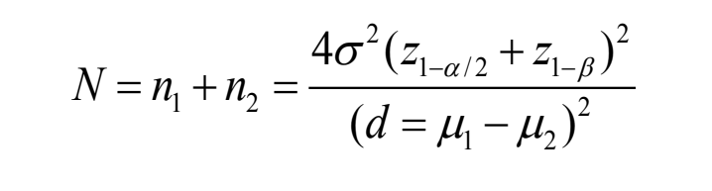

n1, n2 : sample sizes required for the two techniques

d : difference of means or proportions denoting accuracy of the estimate

Z : normal deviate reflecting type-1 error

α : significance level

1 − β : power of the test

6. Conclusion.

Problem :

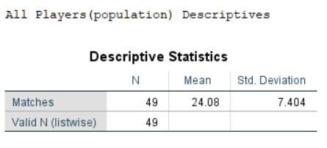

*Table -1.0*

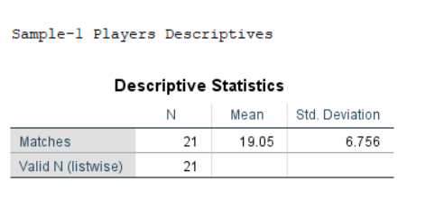

*Table -1.1*

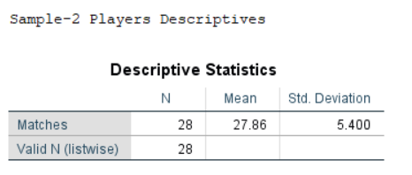

*Table -1.2*

Two samples of players and their respective No. of Matches played are collected from the population data and the standard deviation for the population data is 7.404 matches (from table-1.0). we have means of the samples as 19.05 and 27.86 matches respectively (from table-1.1,1.2). How large a sample would be needed for comparing these two samples with Power = 1- β = 0.90 and α=0.05?

Solution:

When σ = 7.404, β = 0.10, α = 0.05; z 1- α /2 = 1.96

Power = 1- β ; z 1- β= 1.282 , d = μ1- μ2= (19.05-27.86)

N = n1+n2 = [4* (7.404)2(1.96+1.282)2] **÷** (19.05-27.86)2

= 29.693 ≈ 30

Hence about 15 for each group (rounded value).

For two proportions :

Procedure :

1. Specify the proportions P1,P2.

2. Specify the significance level and power of the test.

3. Specify the confidence interval and critical normal values.

4. Find the true difference.

5. Compute the sample size using the formula:

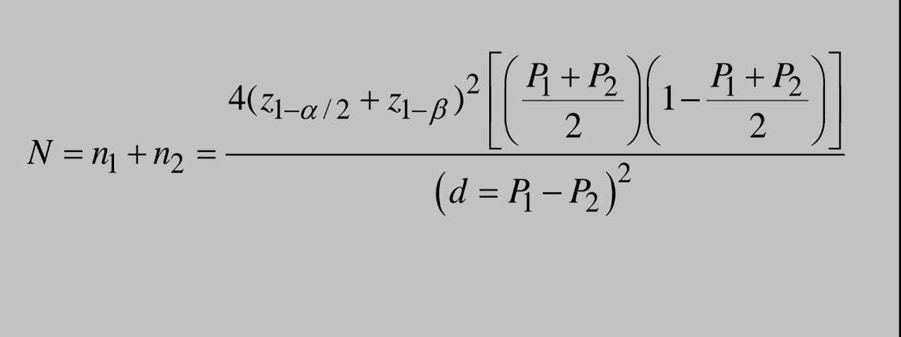

n1, n2 : sample sizes required for the two techniques

P1, P2 : proportions to be estimated

d : difference of means or proportions denoting accuracy of the estimate

Z : normal deviate reflecting type-1 error

α : significance level

1 − β : power of the test

6. Conclusion.

Problem :

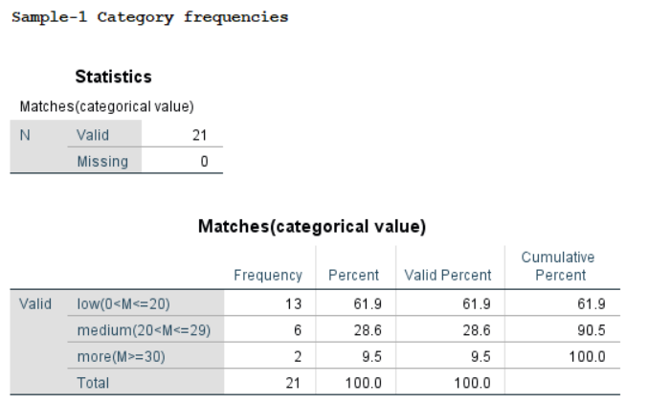

*Fig-2.0*

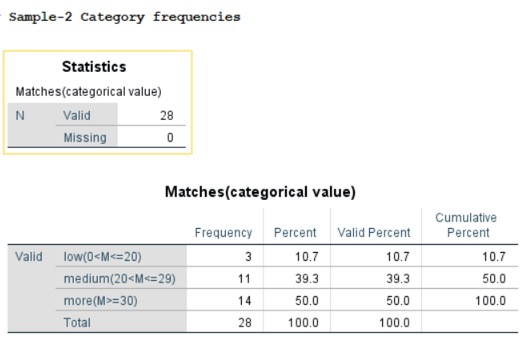

*Fig-2.1*

According to the descriptives from fig-2.0 and 2.1, we have 61.9% players(out of 21 players) of sample-1 have played less number of matches and 10.7% players(out of 28 players) of sample-2 have played less number of matches. How many players

should be included from each group to determine whether this difference is significant at a=0.05 if we wish to have β=0.1 chance of detecting the difference if it is real?

Solution:

Given, P1 = 0.619, P2 = 0.107, β = 0.10, α = 0.05; z 1- α /2 = 1.96

Power = 1- β ; z 1- β = 1.282

🡺(P1 + P2) / 2 = (0.619 + 0.107) / 2 = 0.363

Therefore,

N = n1+n2

= {4 * (1.96 + 1.282)2[ ( 0.363 ) * ( 1-0.363 ) ] } **÷ (** 0.619 - 0.107 )2

= 37.084 ≈ 38

Hence about 19 for each group (rounded value).