**Runs Test**

A runs test is a statistical approach for determining if a set of data is generated at random from a given distribution. The runs test investigates the occurrence of identical occurrences separated by distinct events.

Procedure:-

Step 1: State the hypotheses and identify the claim.

Step 2: Find the number of runs.

Note: When the data are numerical, find the median. Then

compare each data value with the median and classify it as

above or below the median. Other methods such as odd-even

can also be used.

Step 3: Find the critical value. Use Runs Table.

Step 4: Make the decision. Compare the actual number of runs

with the critical value.

Step 5: Summarize the results.

Question:-

A data set is provided to the president of the International Cricket Council(ICC) to check the randomness of the matches played by the players. Test the claim ,at 𝛂 = 0.05

Solution:-

H0: The Matches played by the players are in a random way(The claim)

H1: The Matches played by the players are not in a random way.

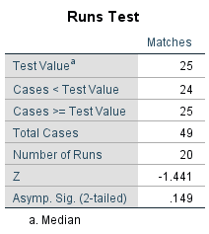

Table 1.0: Runs test of the given data with median

From the table 1.0 the median, n1 and n2 values are as follows

Median = 25  
 n1= 24( no of values less than median)  
 n2= 25( no of values greater than median)

And Number of Runs are 20

Since the n1 and n2 values are more than 20 , which is not covered in the critical value table , so we compare the Z value with ***Z***1-*α*/2( given 𝛂 = 0.05 , so according to the Z-table the ***Z***1-*α*/2  Value is 1.960)

From the table 1.0, |Z| =1.441

Here “|Z|< ***Z***1-*α*/2“

So the decision is not to rejects the null hypothesis(H0)

Therefore the conclusion is that the matches played by the players are in random way.