**Sign Test:**

The sign test for single samples is the simplest nonparametric test for determining the value of a median for a specific sample.

Procedure:-

Step 1: State the hypotheses and identify the claim.

Step 2: Find the critical value(s). For the single-sample test,

compare each value with the conjectured median. If the value

is larger than the conjectured median, replace it with a positive

sign. If it is smaller than the conjectured median, replace it

with a negative sign.

For the paired-sample sign test, subtract the after values from

the before values, and indicate the difference with a positive or

negative sign or 0, according to the value.

Check the data to see whether they support the null hypothesis.

If they do, do not reject the null hypothesis. If not, continue

with step 3.

Step 3: Compute the test value. Count the numbers of positive

and negative signs found in step 2, and use the smaller value as

the test value.

Step 4: Make the decision. Compare the test value with the

critical value in Table. If the test value is less than or equal to

the critical value, reject the null hypothesis.

Step 5: Summarize the results.

Question:-

The Cricket players say that the median for the number of innings they have played is 31 ,from the given data show whether there is enough evidence to reject the claim, at α= 0.05.

Solution:-

H0: The median of the innings played by them is equal to 31(The claim)

H1: The median of the innings played by them is not equal to 31

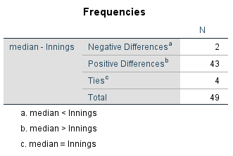

Table 1.0 : Negative and positive values for give data

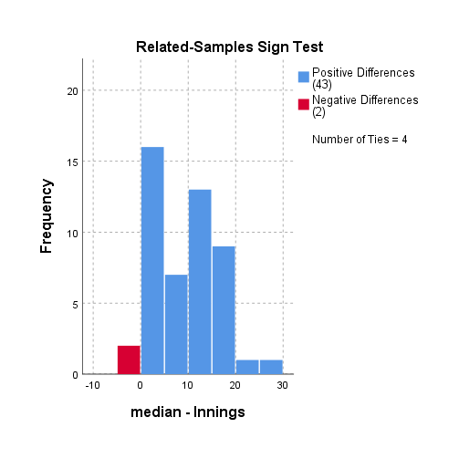

Bar graph for sign data

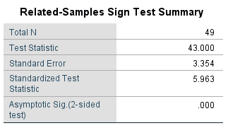

Table 1.1 : sign test summary

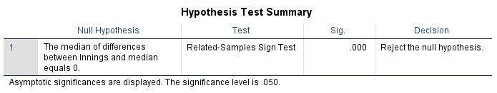

Table1.2: Hypothesis test summary

From Table 1.0   
No of negative signs=2  
No of positive signs =43

The negative value is not equal to the positive value.

From table 1.1

The asymptotic sig value is less than the significant level

I.e 0.00<0.05

From Table 1.2 , The decision is shown that to reject the null hypothesis

We can conclude that there is enough evidence to reject the claim that the median of innings played by the Cricket players is 31.