**Sign Test Paired**

The two-sample paired sign test is used to test the null hypothesis that the probability of a random value from the population of paired differences being above the specified value is equal to the probability of a random value being below the specified value.

Procedure:-

Step 1: State the hypotheses and identify the claim.

Step 2 Find the critical value(s).

For the paired-sample sign test, subtract the after values from

the before values, and indicate the difference with a positive or

negative sign or 0, according to the value.Use Sign-test Table

and n=total number of positive and negative signs.

Check the data to see whether they support the null hypothesis.

If they do, do not reject the null hypothesis. If not, continue

with step 3.

Step 3 Compute the test value. Count the numbers of positive

and negative signs found in step 2, and use the smaller value as

the test value.

Step 4 Make the decision. Compare the test value with the

critical value in Sign-test Table. If the test value is less than or

equal to the critical value, reject the null hypothesis.

Step 5 Summarize the results.

Note: If the sample size n is 26 or more, use Z-Table and the

following formula for the test value:

where

X =smaller number of + or - signs

n =sample size

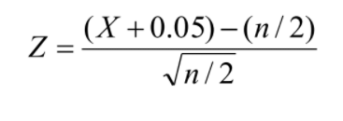

Question:-

There was a statement being spread all over the ICC that the cricket players have scored more strike rate after 2012 compared to the matches played before 2012. The director of ICC has decided to give a conclusion to this statement and collected the data of strike rate before 2012 and after 2012 of top 20 players.The data is given, At α=0.05 , can the director conclude that the strike rate is more after 2012?

Solution:-

H0:The strike rate is more after 2012. (The claim)

H1:The strike rate is less after 2012.

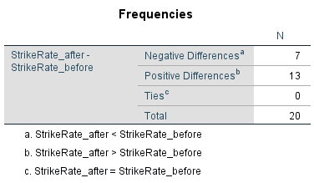

Table 1.0 Negative and Positive differences

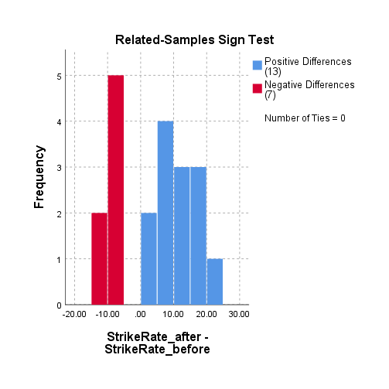

Graph: Bar graph for Negative and Positive differences

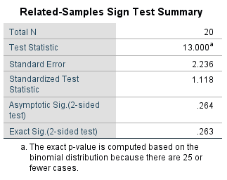

Table 2.0 Related samples for Sign Test

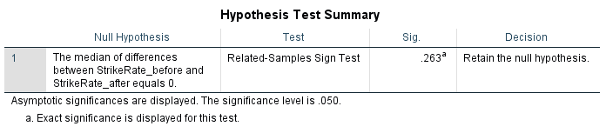

Table 3.0 Hypothesis test summary

From table 1.0

The negative differences are 7   
And the positive differences are 13

From table 2.0   
The exact significant value is 0.263

The significant level α=0.05

The exact significant value > the significant level

From table 3.0

The decision is taken as to “retain the null hypothesis”

We can conclude that there is enough evidence to Accept the claim , the statement is absolutely correct that the strike rate is more after 2012.