**Z-test for One Sample**

Procedure:

1. State the claim mathematically and verbally. Identify the null and alternative hypotheses.

2. Specify the level of significance.

3. Identify the degrees of freedom and sketch the sampling distribution.

4. Determine any critical values.

5. Determine any rejection region(s).

Question:

Among the Top Batsmen in T20WC (2007-2021), the average matches played by an individual is 30. In a sample of 10 Batsmen, the sample mean was 30.9 and Standard Deviation was 3.872. Is there enough evidence to support this claim at α = 0.05?

Answer:

Ho (Null Hypothesis): µ = 30 (Claim)

Ha (Alternate Hypothesis) : µ ≠ 30

Output:

T-Test (1 Sample)

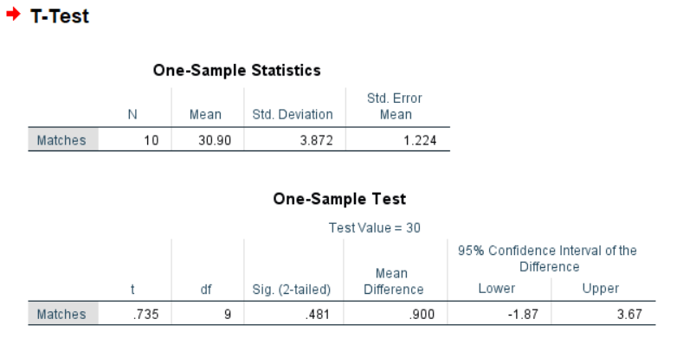

Conclusion:

At α = 0.05, the Critical Value in One-Sample T-Test with Degrees of Freedom 9 is 1.833. (Critical)

From the above T-Test conducted using SPSS, the obtained/calculated value is 0.481. (Calculated)

As Calculated value < Critical Value, at 5% Level of Significance, there’s not enough evidence to reject the claim that Average matches played by an individual is 30.

__________________________________________________________________