**T-test for Two Independent Samples**

Procedure:

1) State the research question.

2) State the statistical hypotheses.

Ho: µ1 ≥ µ2

Ha: µ1 < µ2

3) Set the decision rule.

α = 0.5

Df [Degrees of Freedom] = (n1 - 1) + (n2 - 1)

T(critical)

4) Calculate the test statistic.

5) Decide if the result is significant.

6) Interpret the obtained results.

Question:

Among the Top Batsmen in T20WC (2007-2021), in a Sample of 10 Batsmen, the Strike Rate of Players who have played greater than or equal to 32 matches is greater than or equal as the one’s played lesser than 32 matches. At α = 0.05, is there enough evidence to support this claim?

Answer:

µ1: The Strike Rate of Players who have played greater than or equal to 32 matches.

µ2: The Strike Rate of Players who have played less than 32 matches.

Ho: µ1 ≥ µ2

Ha: µ1 < µ2

Output:

T-Test (Independent Two Sample)

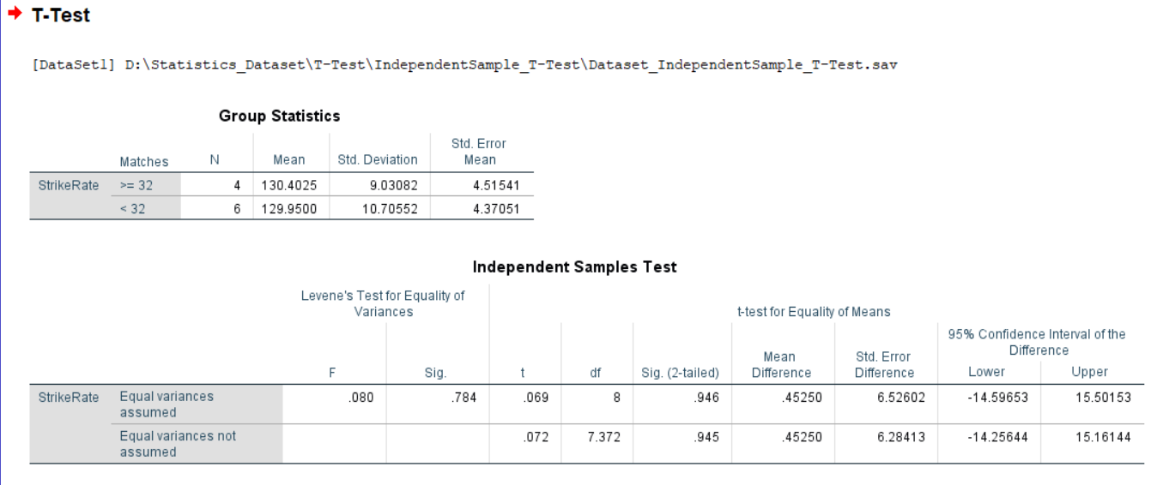

Conclusion:

At α = 0.05, the Critical Value in One-Sample T-Test with Degrees of Freedom 8 is 2.306. (Critical)

From the above T-Test conducted using SPSS, the obtained/calculated value is 0.69. (Calculated)

As Calculated value < Critical Value, at 5% Level of Significance, there’s not enough evidence to reject the claim that the Strike Rate of Players who have played greater than or equal to 32 matches is greater than or equal as the one’s played lesser than 32 matches.

__________________________________________________________________