**T-test for Two Paired Samples**

Procedure:

1) State the research question.

2) State the statistical hypotheses.

Ho: µD = 0

Ha: µD ≠ 0

3) Set the decision rule.

α = 0.5

Df [Degrees of Freedom] = number of difference scores - 1

T(critical)

4) Calculate the test statistic.

5) Decide if the result is significant.

6) Interpret the obtained results.

Question:

Among the Top Batsmen in T20WC (2007-2021), in a Sample of 10 Batsmen, the Runs and Matches of players have been paired and are considered to be similar. At α = 0.05, is there enough evidence to support this claim?

Answer:

µD: Paired values of Runs and Matches.

Ho: µD = 0

Ha: µD ≠ 0

Output:

T-Test (Paired Two Sample)

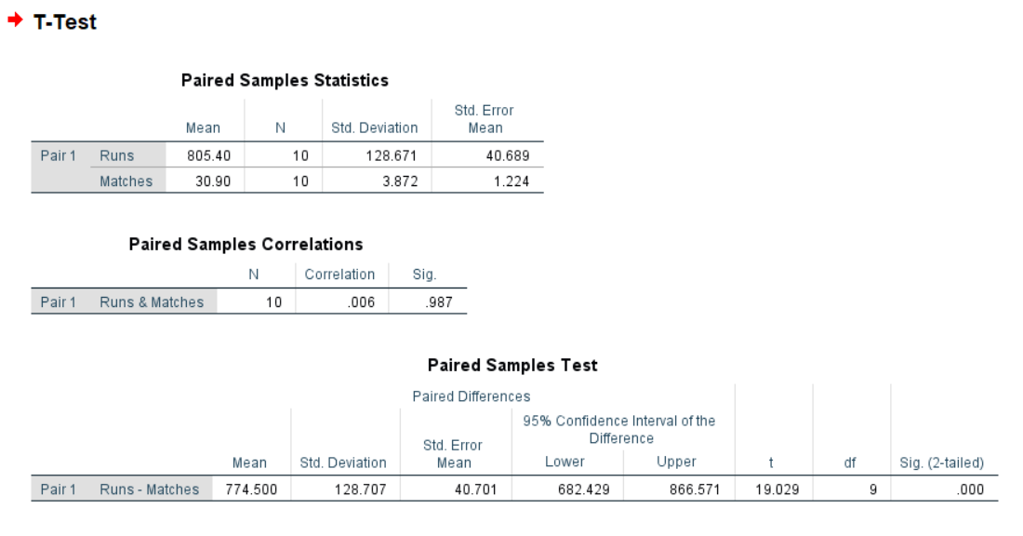

Conclusion:

At α = 0.05, the Critical Value in One-Sample T-Test with Degrees of Freedom 9 is 2.262. (Critical)

From the above T-Test conducted using SPSS, the obtained/calculated value is 19.029. (Calculated)

As Calculated value > Critical Value, at 5% Level of Significance, there’s enough evidence to reject the claim that the Runs and Matches of players which have been paired are considered to be similar.

__________________________________________________________________