**Mann-Whitney U Test**

**Definition:**

A popular nonparametric test to compare outcomes between two independent groups is the Mann-Whitney U test. The Mann-Whitney U test, sometimes called the Mann Whitney Wilcoxon Test or the Wilcoxon Rank Sum Test, is used to test whether two samples are likely to derive from the same population (i.e., that the two populations have the same shape). Some investigators interpret this test as comparing the medians between the two populations. In the Wilcoxon tests, the values of the data for both samples are combined and then ranked. If the null hypothesis is true—meaning that there is no difference in the population distributions—then the values in each sample should be ranked approximately the same.

**Procedure:**

Step 1: State the hypotheses and identify the claim.

Step 2: Find the critical value(s). Use Z-Table.

Step 3: Compute the test value.

1. Combine the data from the two samples, arrange the combined data in order, and rank each value.
2. Sum the ranks of the group with the smaller sample size.

(Note: If both groups have the same sample size, either one can be used.)

1. Use these formulas to find the test value.

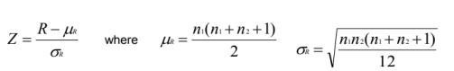

where, R: sum of ranks for smaller sample size (n1 or n2)

n1: First sample size

n2: Second sample size (n1 ≥ 10 and n2 ≥ 10)

(Note: If both samples are of same size, either size can be used as n1.)

Step 4: Make the decision.

Step 5: Summarize the results.

**Problem:**

The players are divided into two independent groups i.e., Group 1 and Group 2 based on the number of Innings played in their WC T20 (2007-21) Career. A study was conducted to see whether there is a difference in the distributions (number of innings played) between the two groups. At 95% confidence interval, can it be concluded that there is a difference?

**Solution:**

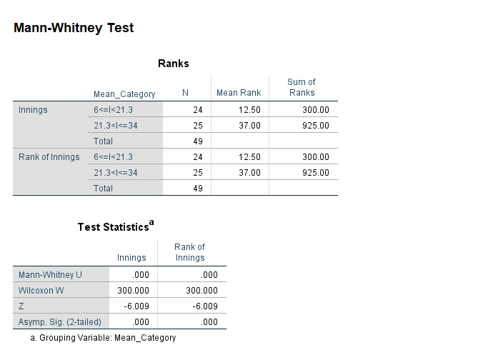

**Observation:**

Zcritical = -1.960

Zcalculated = -6.009

Zcalculated **<** Zcritical

Therefore, reject our null hypothesis.

**Conclusion:**

At 95% confidence interval, there is no evidence that there is a difference between number of innings played by the players in Group 1 and Group 2