Procedure:

Step 1: State the hypotheses and identify the claim.

Step 2: Find the critical value in the right tail. Use Chi-square Table.

Step 3: Compute the test value. To compute the test value of the

contingency table, use the formula to get the test value.

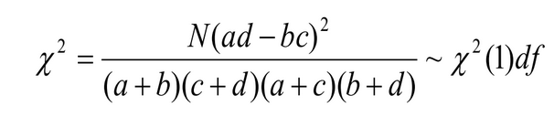

Step 4: Make the decision.

Step 5: Summarize the results.

Problem:

From the dataset given we can see the information of each player. And we are interested to find if there is any evidence of a relationship between difference-category value and the half centuries scored-category value. At α=0.05 level, is there evidence of a relationship?

Solution:

H0: There is no relationship between difference of matches and innings-category value and the half centuries scored-category value.

H1: There is a relationship between difference of matches and innings-category value and the half centuries scored-category value.

* The critical value at α=0.05 level with 1 degree of freedom is 3.841.

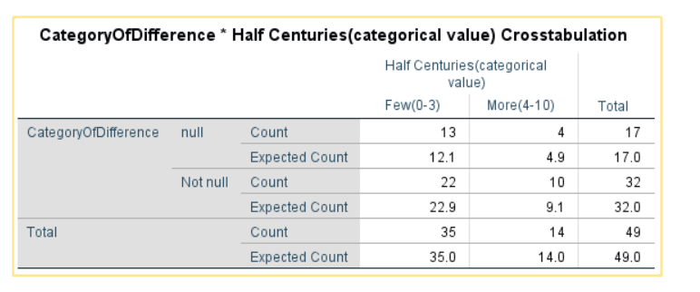

*Table: 1.0-Observed and expected values (from SPSS)*

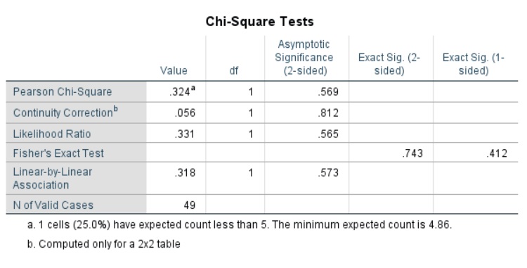

*Table: 1.1-Tests Statistics values (from SPSS)*

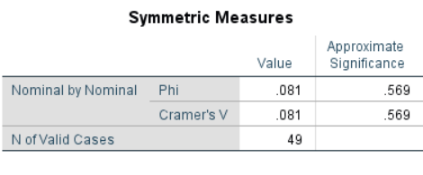

*Table: 1.2*

From Table 1.1, we got Chi-Square value as 0.324

Here, critical value> calculated value.

Hence, the decision is not to reject the null hypothesis.

Therefore, the conclusion is that there is no relationship between difference of matches and innings-category value and the half centuries scored-category value.

***Bar Graph to examine the relationship between difference-category (matches-innings) and Half centuries-category:***

