**Wilcoxon Signed-Rank Test**

**Definition:**

The Wilcoxon signed rank test (also called the Wilcoxon signed rank sum test) is a non-parametric test to compare data. The Wilcoxon signed rank test should be used if the differences between pairs of data are non-normally distributed.

**Procedure:**

Step 1: State the hypotheses and identify the claim.

Step 2: Find the critical value from Wilcoxon Signed-rank-Table.

Step 3: Compute the test value.

1. Make a table, as shown.

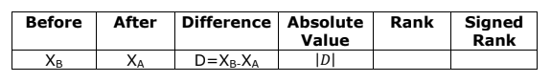

1. Find the differences (before-after), and place the values in the Difference column.
2. Find the absolute value of each difference, and place the results in the Absolute value column.
3. Rank each absolute value from lowest to highest, and place the rankings in the Rank column.
4. Give each rank a positive or negative sign, according to the sign in the Difference column.
5. Find the sum of the positive ranks and the sum of the negative ranks separately.
6. Select the smaller of the absolute values of the sums, and use this absolute value as the test value Ws.

Step 4: Make the decision. Reject the null hypothesis if the test value is less than or equal to the critical value.

Step 5: Summarize the results.

Note: When n≥30, use Z-Table and the test value

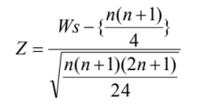

Where

n = number of pairs where difference is not 0

Ws = smaller sum in absolute value of signed ranks

**Problem:**

The top 15 players of WC T20 (2007-2021) were taken into observation. The runs scored by the top 15 players in the first half of their WC T20 career and in the second half of their WC T20 career were recorded into two different groups and compared. At α = 0.05, can it be concluded that there is a difference between the runs scored by the players in the 1st half and 2nd half of their careers.

**Solution:**

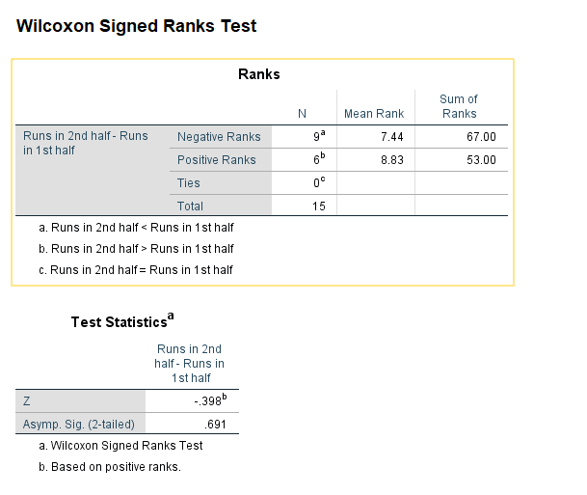

**Observation:**

α = 0.05 Wstab = 25

Here, total number of observations (n) = 15

Smaller of the absolute values of the sums (Ws) = 53

Here at α = 0.05 and Wstab = 25, Ws  > Wstab, we can’t reject our null hypothesis.

**Conclusion:**

At α = 0.05, it is evident that there is a significance difference in between the runs scored by top 15 players in the 1st half and 2nd half of their WC T20(2007-21) careers.