**NODEJS**

**1.It is an free and open source server environment.**

**2. javascript can be used on the server**

**3.A single language for both frontend and backend**

**4The basics of frontend and backend**

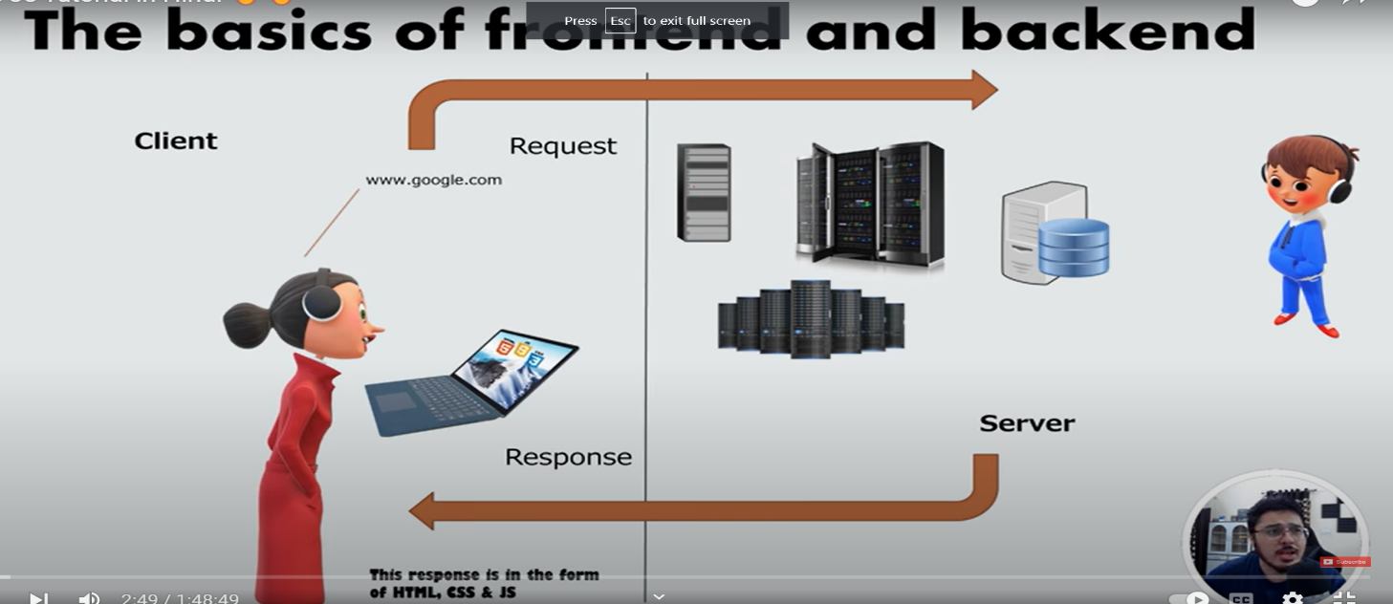

**server side-known as backend**

**5. nodejs is used for backend and it uses javascript.in node js u can**

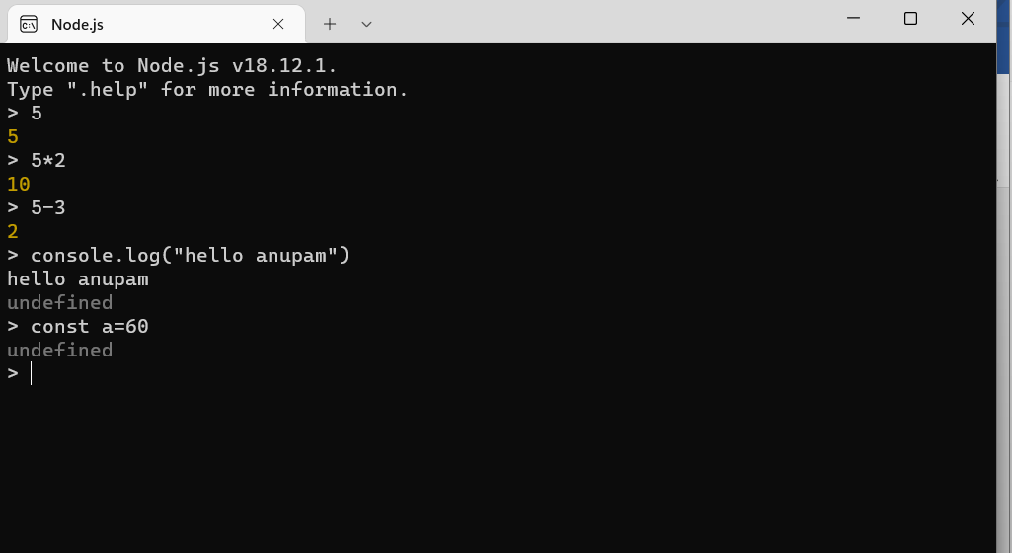

**Write the javascript.**

**6.Nodejs is run time environment which run on the server.**

**7.It works on asynchronous non-blocking I/O model .So nodejs is used for making chat application.**

**8.IN nodejs single thread can manage multiple connections.**

**npm commands**

**1.npm stands for node package manager**

**2. it manage node package**

**3.it is basically like pip which is used in python**

**4. basically npm is used for installing packages,**

**5.some common npm commands are given below- npm init- is used for creating package .json and isme aap ke project se related saari jankari di gayi hai(type author ,description and so on what u want.**

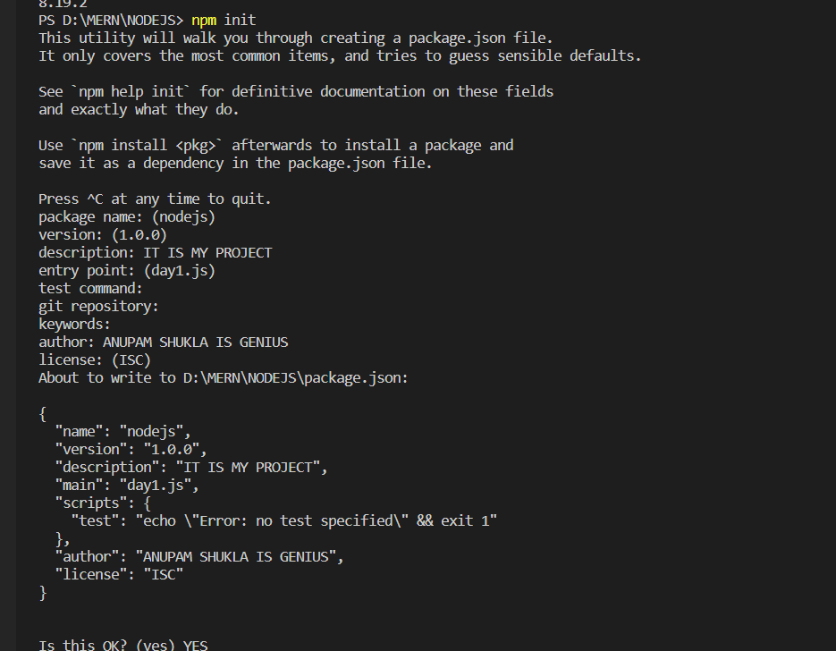

**6.for installing any package write npm i packagename in cmd or VS code terminal**

**OR we can also write npm install package name.**

**Eg- as we write** npm install express -–save express get installed

**7.node module get installed when u install the express**

**8.node module folder mei saari ki saari dependencies internet se download hoake aa jati hai**

**9. hum package koa globally bhi install kar sakte hai like**

**npm i -g nodemon**

**it means nodemon globally install hoa chuka ha now we can use it in any project.**

**nodemon file name in cmd then what ever we do changes and when we save it then it will be displayed automatically there.**

**10. installing npm install –save-dev nodemon.**

**When we do this then it get added as dev dependies in package.json**

**11. we can also uninstall the module for that we will write**

**npm unistall package name which we want to uninstall.**

**package-lock.json-it have full dependency tree.**

**package.json-it have dependencies as it is which we have added**

THIS BELOW IS NODE JS COMMON MODULE AND THERE IS ALSO

ES6 MODULE BUT WE WILL STUDY IT LATER

**HERE WE LEARN HOW TO TO IMPORT ONE FILE INTO ANOTHER**

**SUPPOSE EARLIER I HAVE CREATED FILE NAME OF day1.js and day2_import.js and now I want to import day2.js file into day1.js**

**EARLIER PIC OF DAY1.JS**

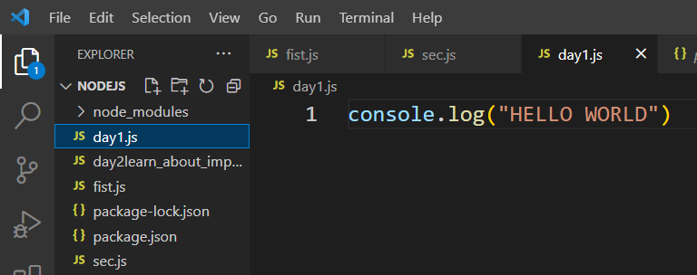

**DAY2.JS FILE PIC WHICH I WANT TO IMPORT IN DAY1.JS**

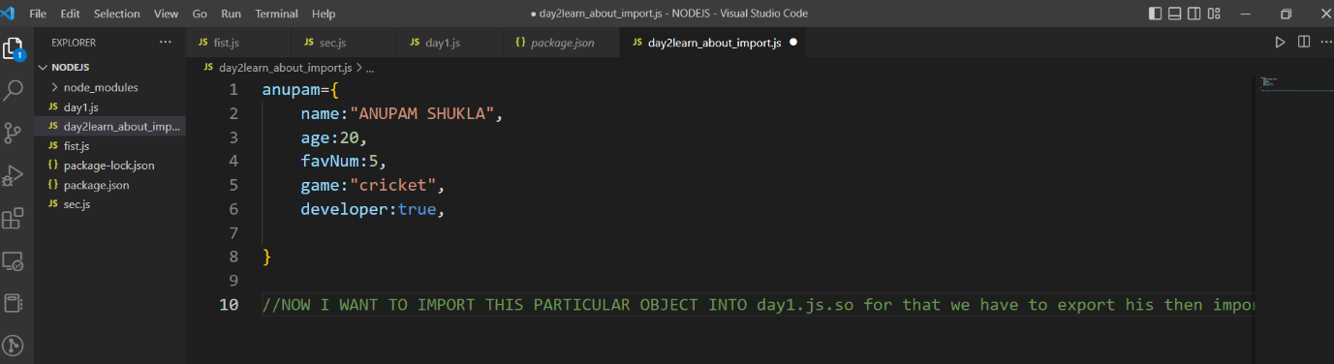

**AFTER**

**HERE WE WRITE EXPORT AT THE END FOR EXPORTING THE FILE(DAY2) IN DAY2 SO THAT WE CAN IMPORT IT IN THE DAY1**

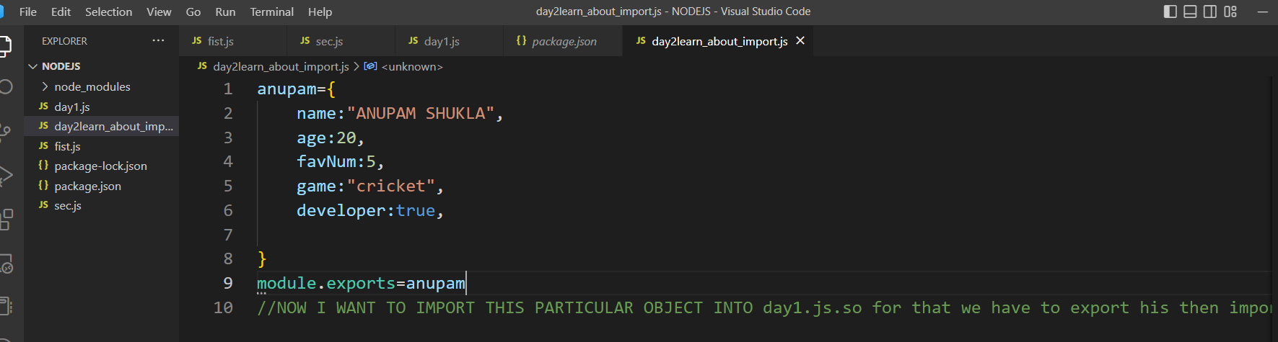

**DAY 1 FILE CODE WHERE WE IMPORTED THE DAY2FILE**

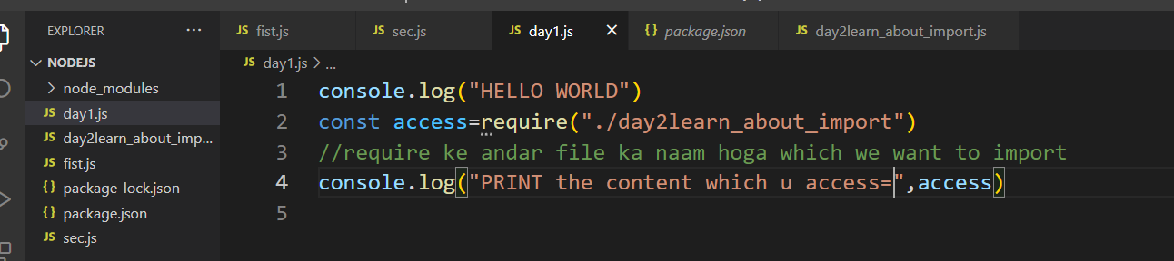

**OUTPUT EARLIER BEFORE IMPORT**



**OUTPUT AFTER THE IMPORT**

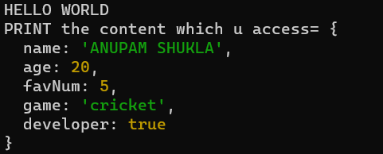

**MODULE WRAPPER FUNCTION**

**1.function(exports,require,module,_filename,_dirname)**

**Vaise node js automatically wrap kar deta hai , it is not necessary to wrap we can also wrap it if want otherwise we can’t wrap**

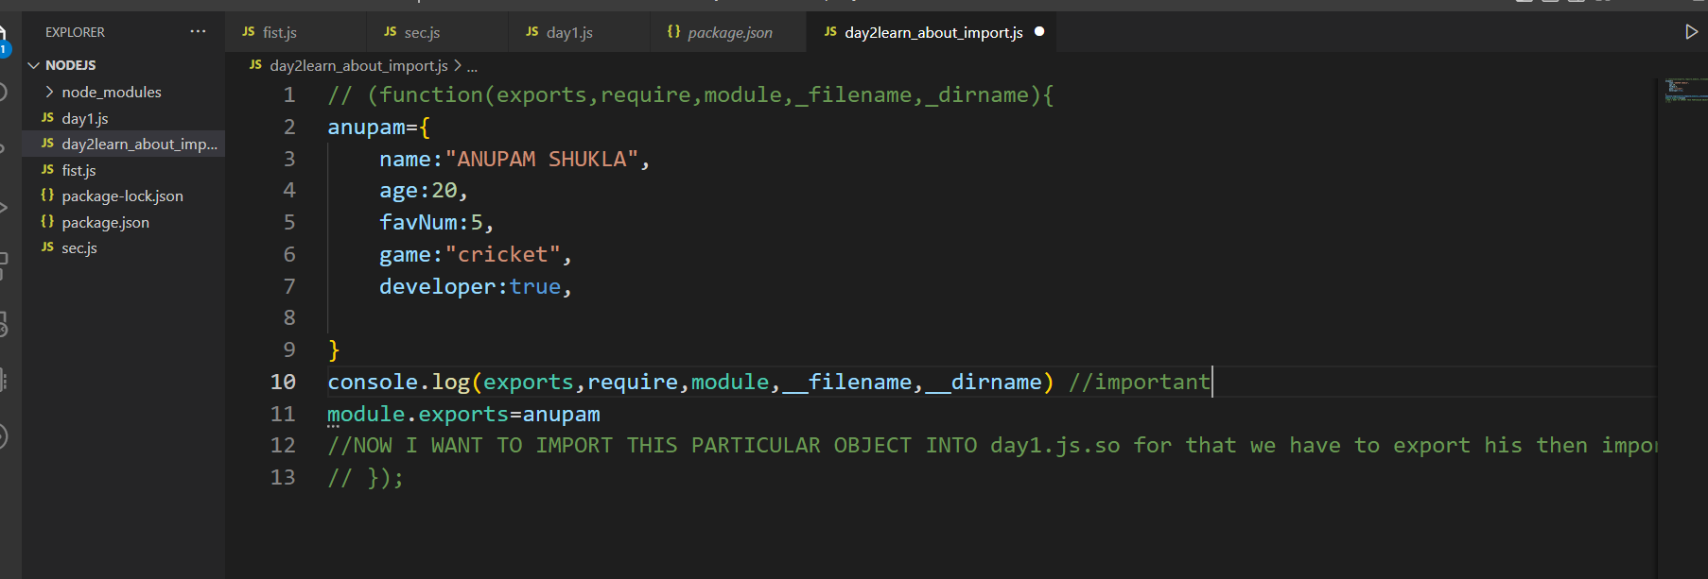

**Output**

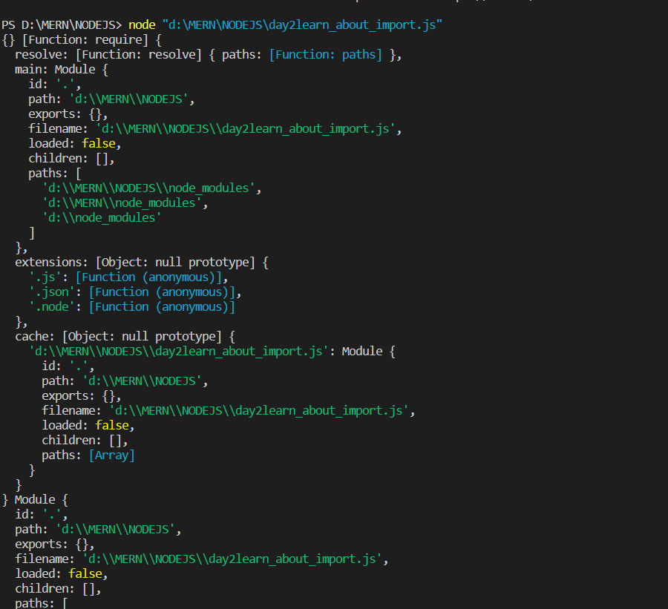

**OS MODULE FUNCTION**

1. Os built in function
2. Contain many operation in it
3. For using any operation we write os.operationname

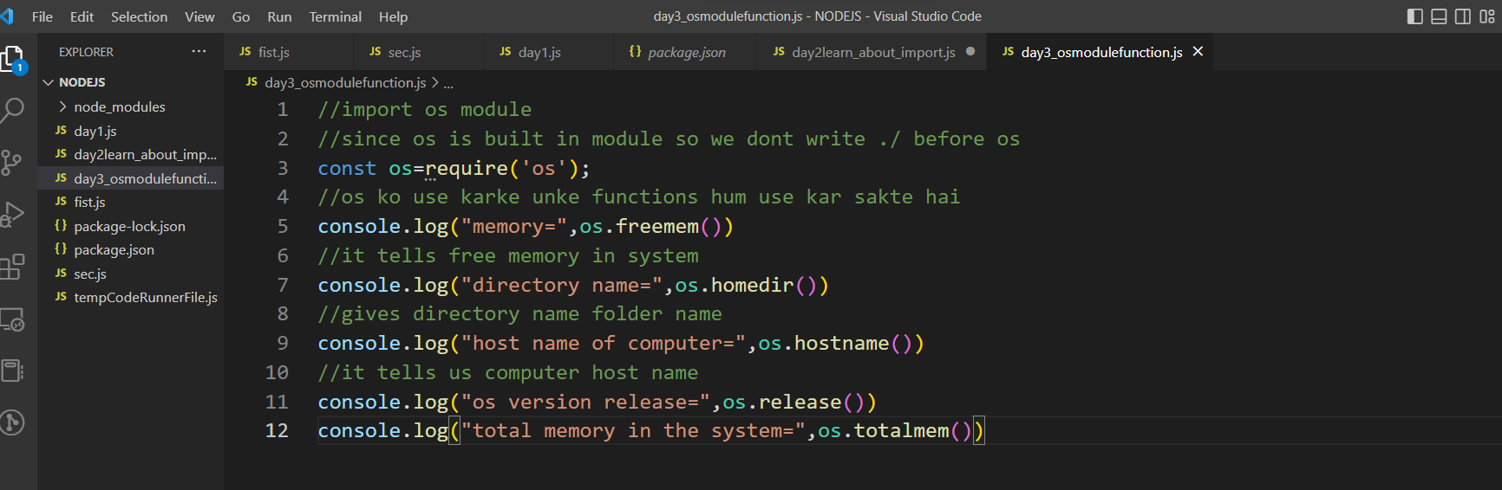

**PATH MODULE**

1. **There is no need to remember it u have to only open nodejs page and from there u see that**

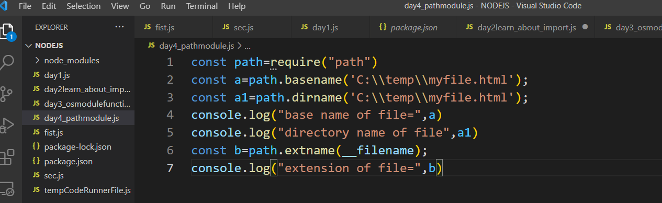

**Output**

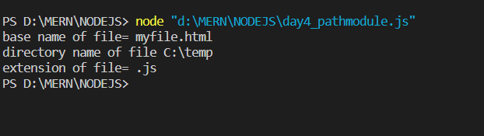

**FILE SYSTEM**

1.readfile facilitate for reading in any file

const fs=require('fs'); //importing file system

fs.readFile('a.txt','utf-8',(err,data)=>{

console.log(err,data)

})

//a.txt->joa file maine banaye hai uska naam hai joa tum banao vaha uska naam likh doa voa read kar lega

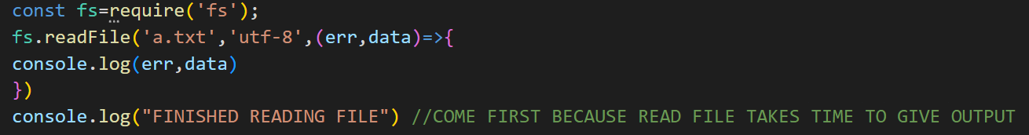

Output

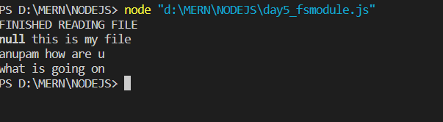

BUT WHEN WE USE SYNC THEN FINISHED READING FILE WILL COME FIRST

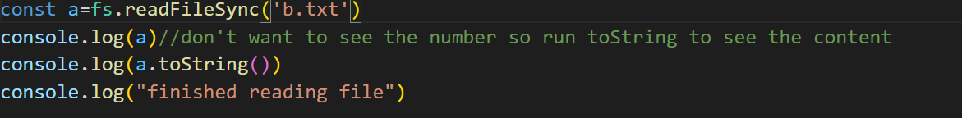

Output

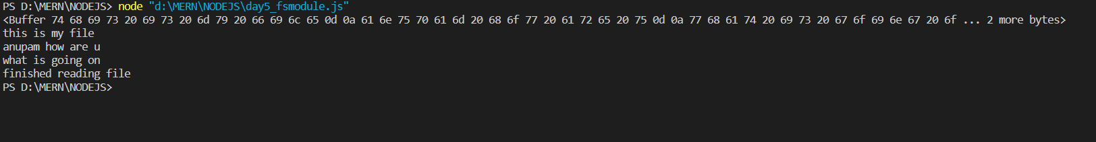

2)writefile facilitate for writing in any file the data which we write get automatically written in the file name which I have mentioned

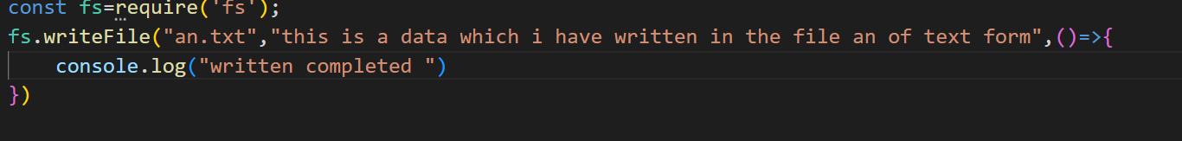

Output

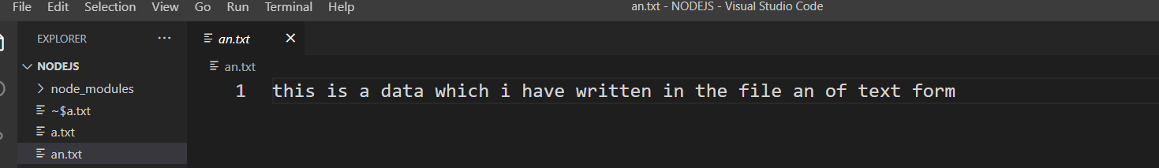

In this also sync concept is used

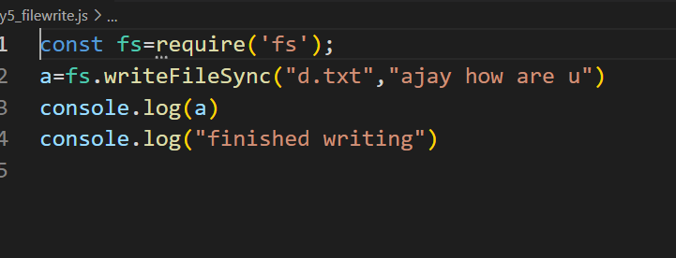

Output

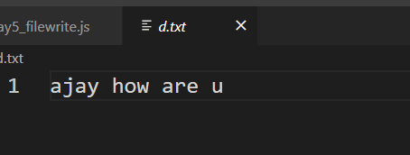

COMMON JS MODULE AND ECMA SCRIPT MODULE

COMMON JS MODULE

1.Importing

const circle = require('./circle.js');

ECMA SCRIPT MODULE

1.IMPORTING

import { addTwo } from './addTwo.mjs';

// addTwo.mjs

function addTwo(num) {

return num + 2;

}

export { addTwo };

The following example of an ES module imports the function from addTwo.mjs:

// app.mjs

import { addTwo } from './addTwo.mjs';

// Prints: 6

console.log(addTwo(4));

2.for using ecma script module u have to use .mjs extension and add type module in package.json

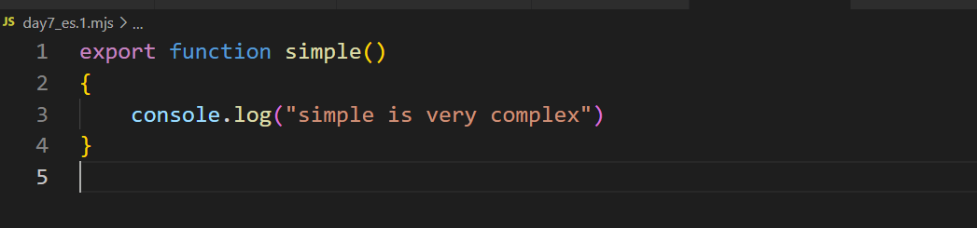

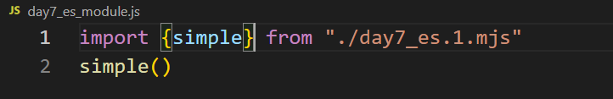

Using as

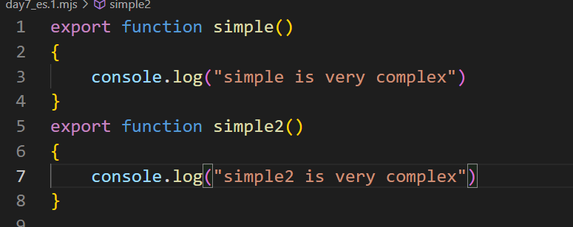

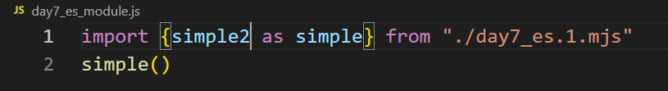

Output



*use kar ke hum har function import kar sakte hai joa banaye hai

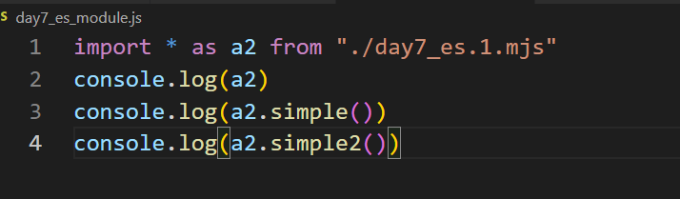

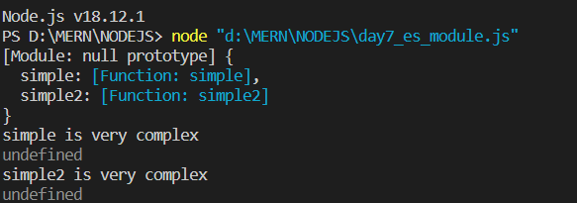

Agar hum kuch return karwate toa voa aata undefined ki jagah.

URL MODULE

**url se related information milte hai**

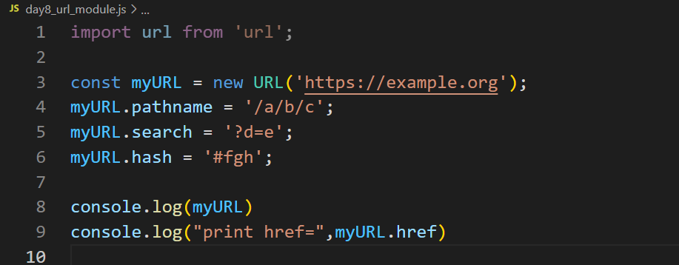

**Output**

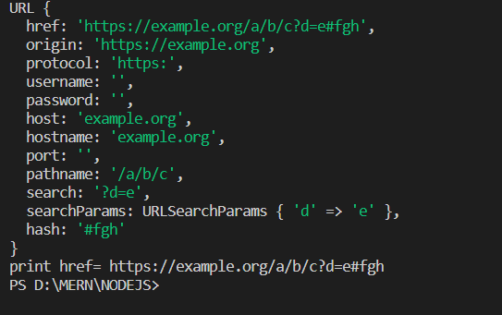

**Port number include kar doa 3000 then code will be**

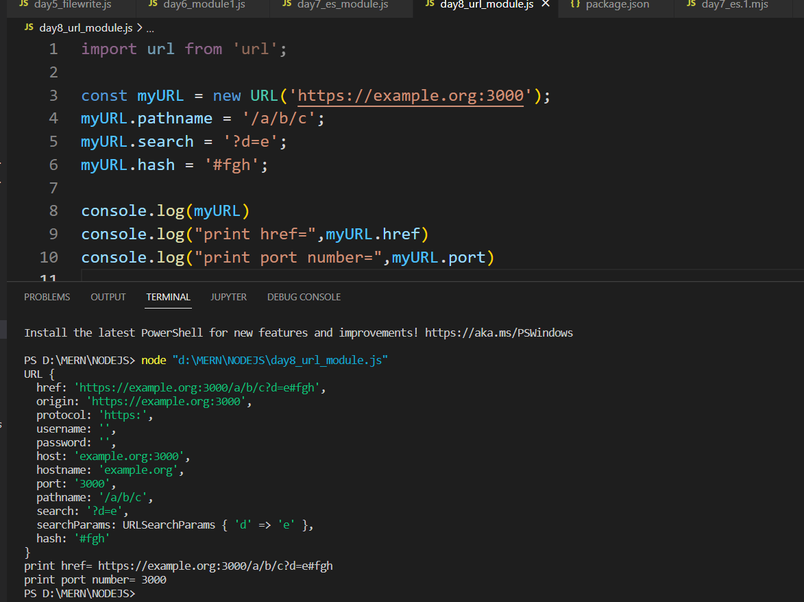

**EVENT DRIVEN ARCHITECTURE(events)**

1.nodejs architecture works on event driven architecture

2.it means hum kahi se bhi event fire kar sakte hai and phir ussai listen kar sakte hai.

const EventEmitter = require('events');

class MyEmitter extends EventEmitter {}

const myEmitter = new MyEmitter();

myEmitter.on('event', () => {

console.log('an event occurred!');

});

myEmitter.emit('event');

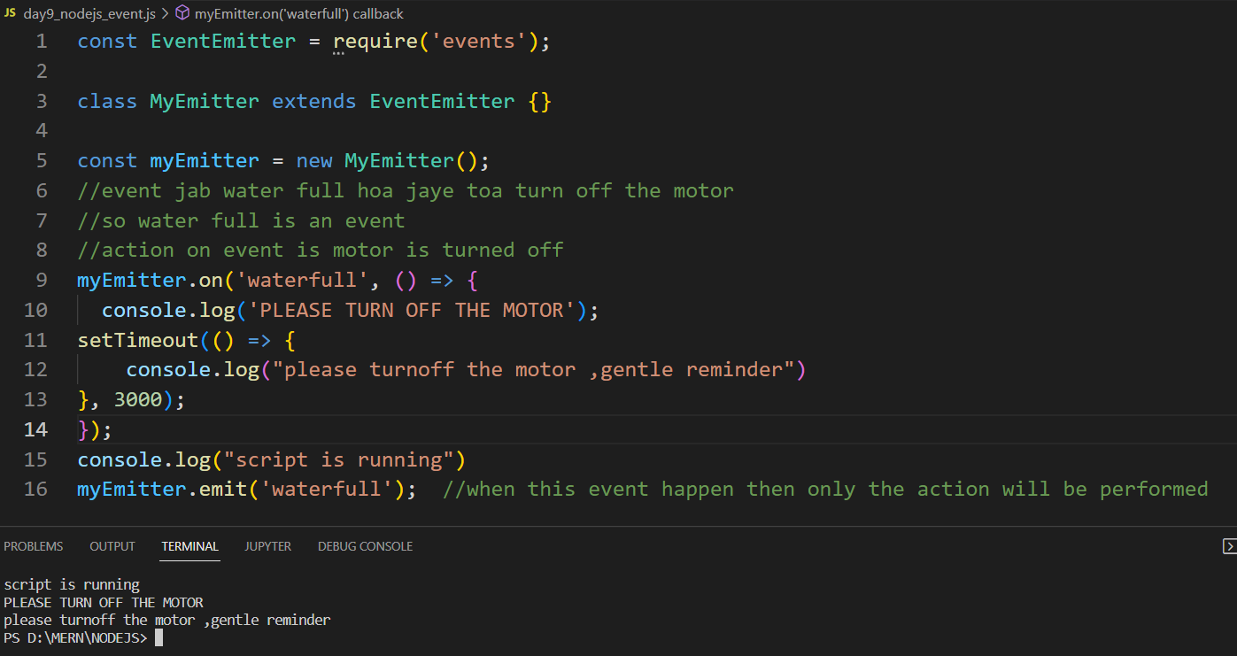

Set timeout use- it says jab saare tasks complete hoa gayege tab mai 3second ka reminder doonga

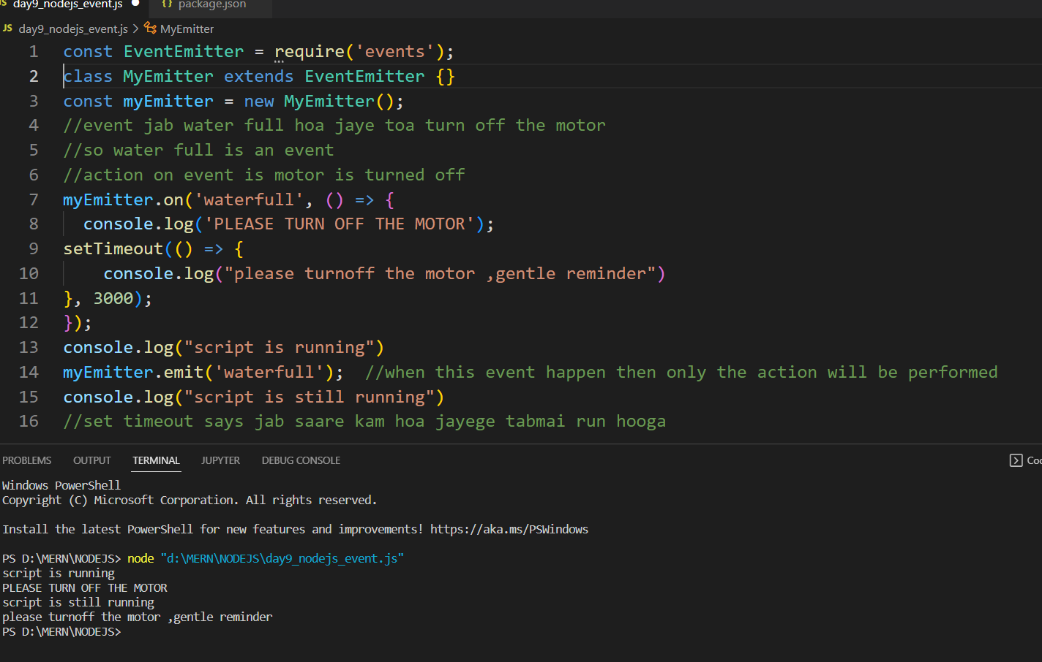

Jitney baar hum emit karege utni baar action perform hoga

HTTP MODULE

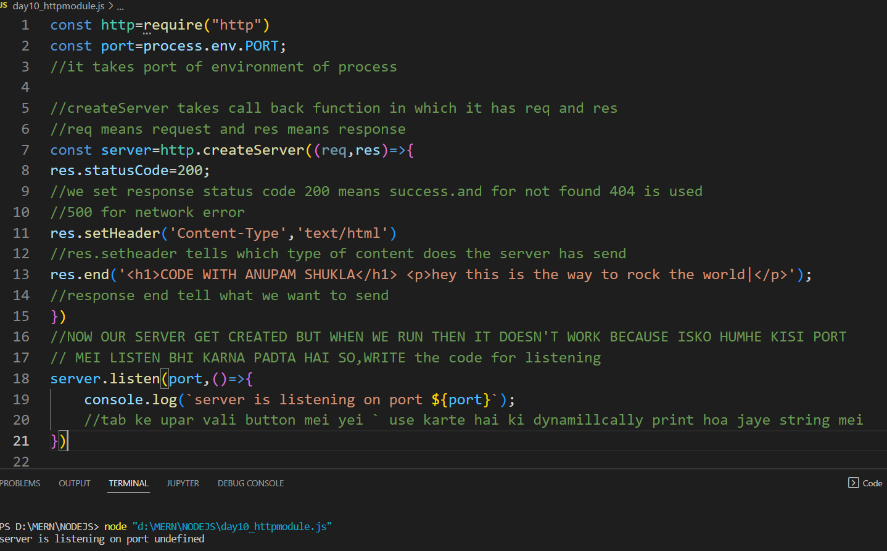

Server koa particular port mei listen karwan ke liye humhe particular port ko port env set karna padega

Eg – in this we are setting to port 3000

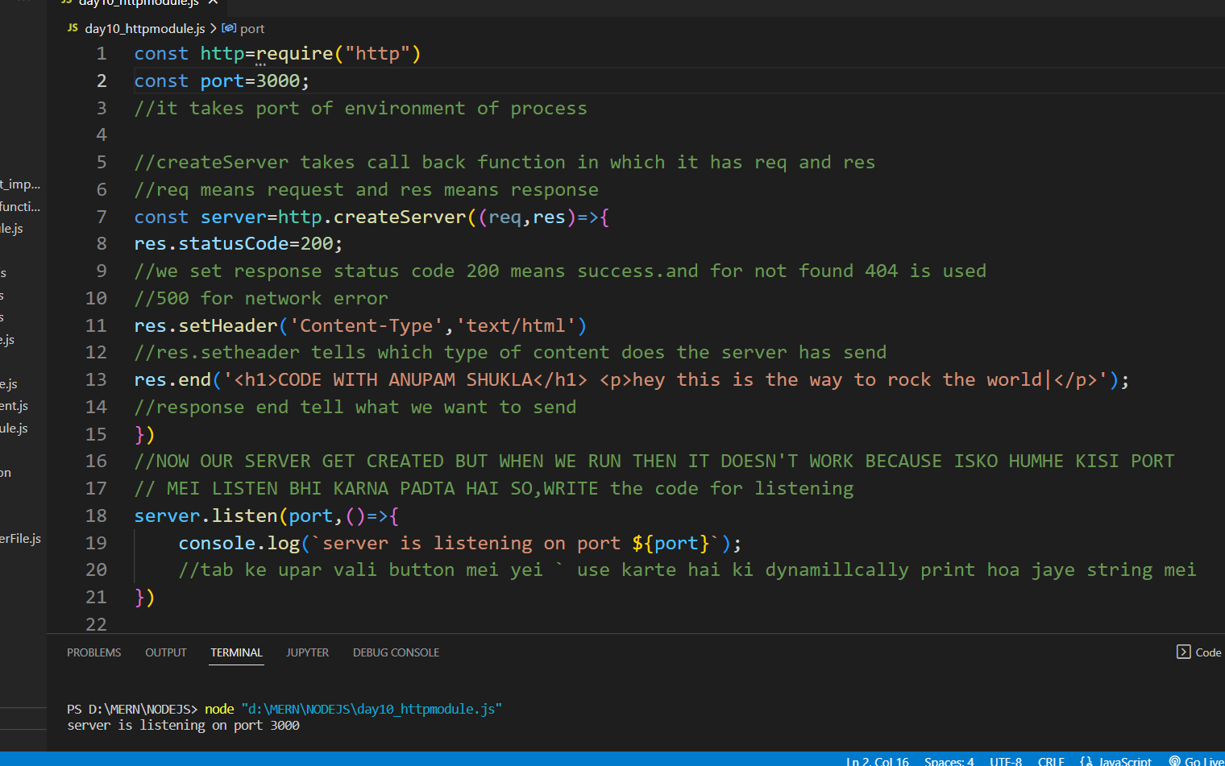

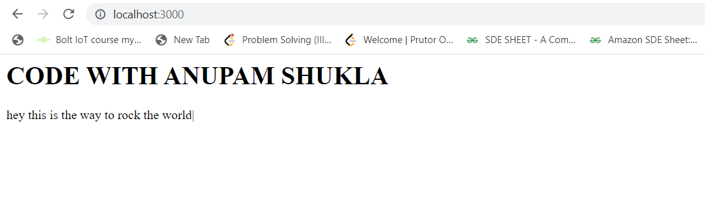

Console.log request printing after opening given local host

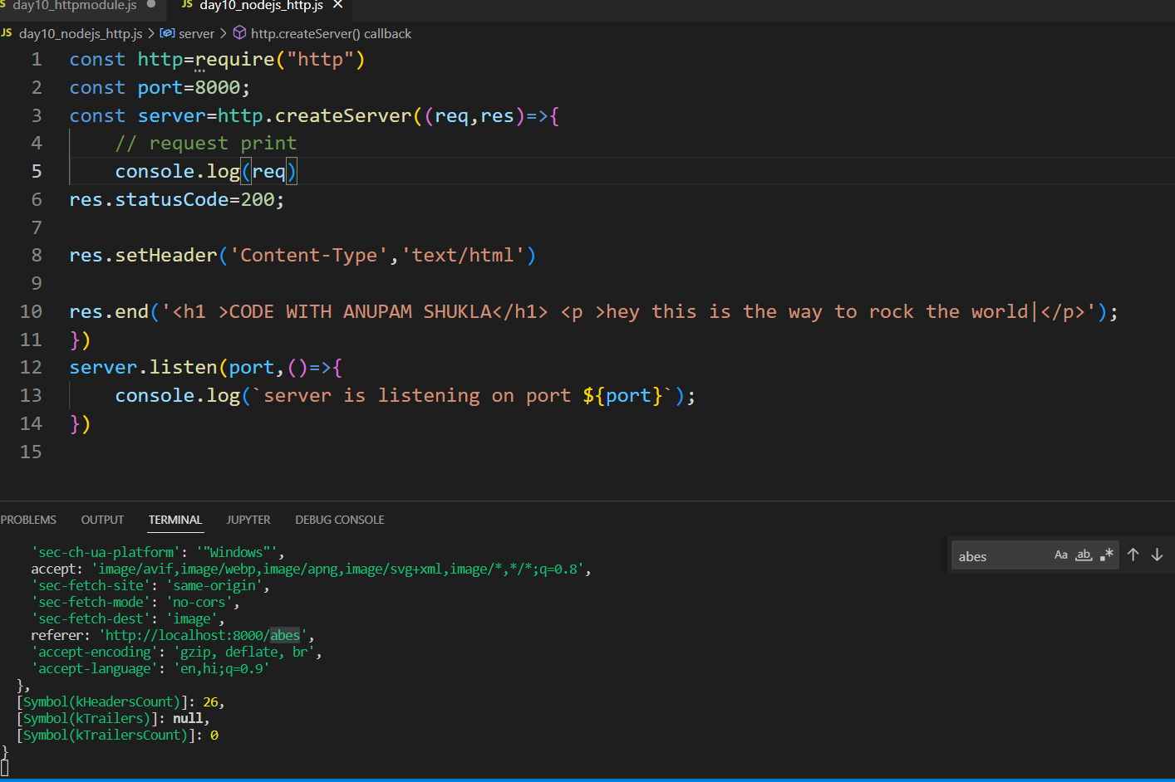

Console.log(req.url) printing joa hum local host open karke usmei aage dal rahe hai

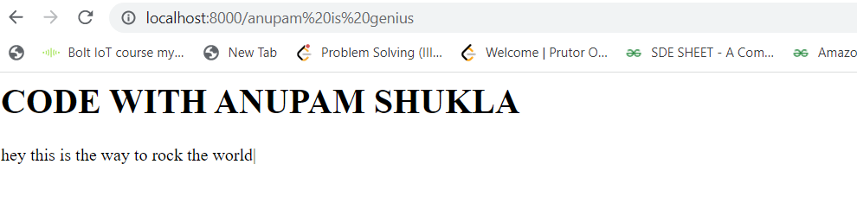

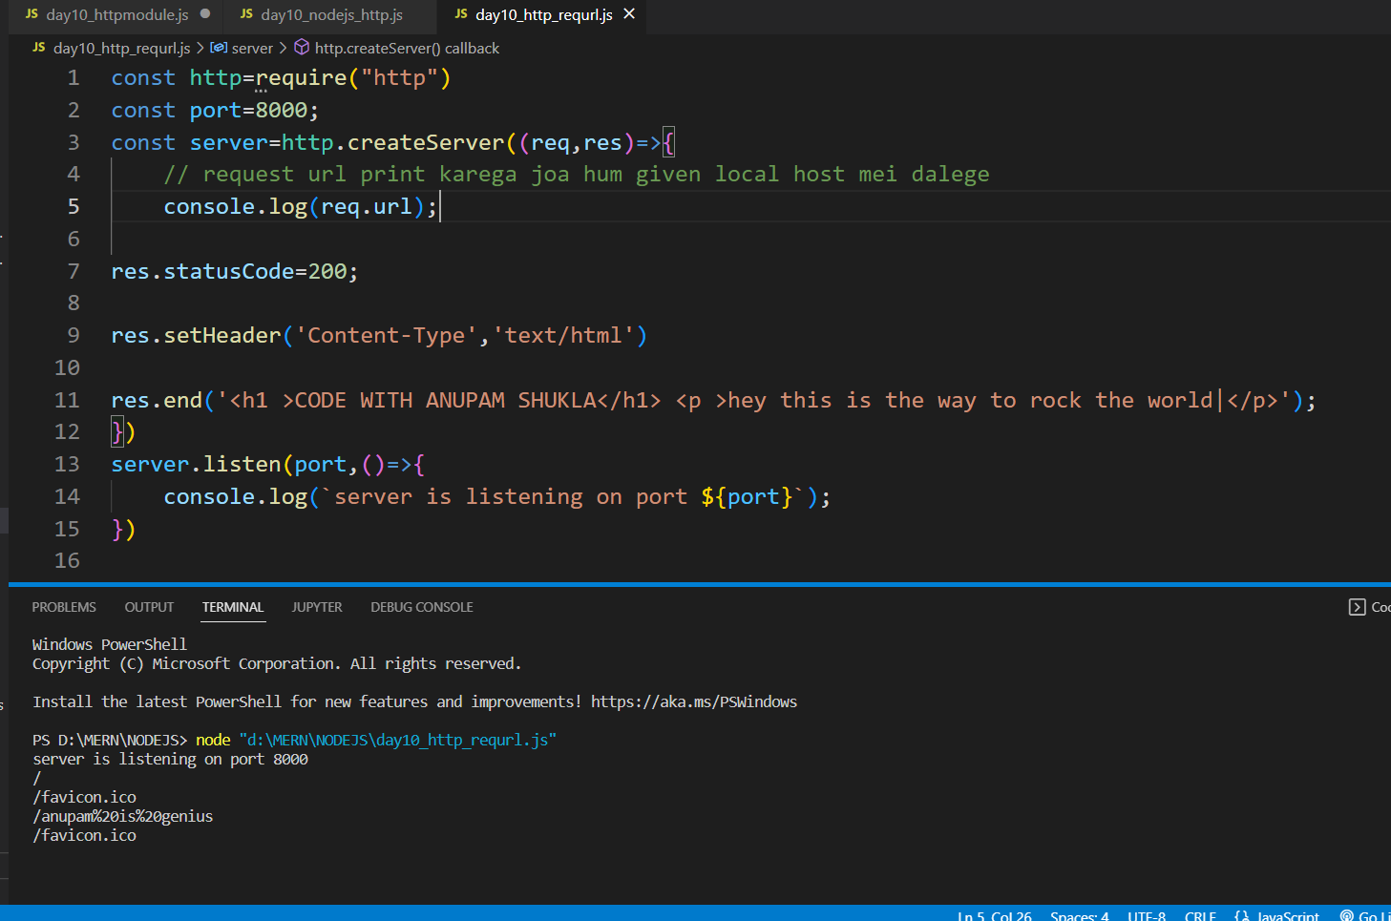

WEBSITE MAKING AND USING req.url concept

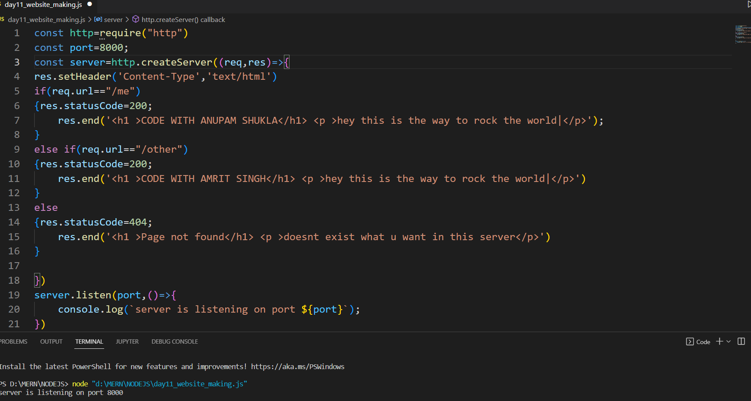

Outputs

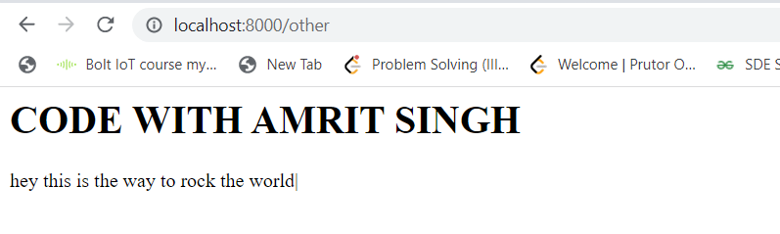

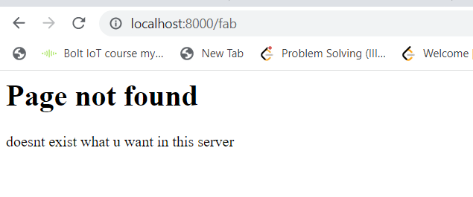

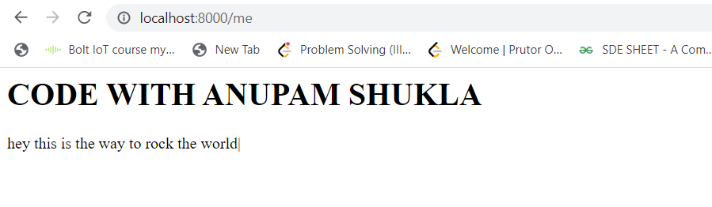

Humhe nodejs se aise website banani hahiye ki read file ki help se hum serve karege and static file server banayege

1. We made html file
2. Then we read that file in website .js code by using filereadsync option in fs(filesystem).
3. Variablename which store read file sync. to_sting() it is used to print the data of the file