JENKINS

Jenkins installations: dcoker installation: in the below github rep
https://github.com/iam-veeramalla/Jenkins-Zero-To-Hero/blob/main/README.md

SECURITY GROUPS:
by default ec2 instance doesnt allow the inbound traffic, we can set the allow all traffic by manually or allow certain port numbers traffic can be allowed , thosee port numbers can be edited in the inbound traffic rules.

Jenkins working
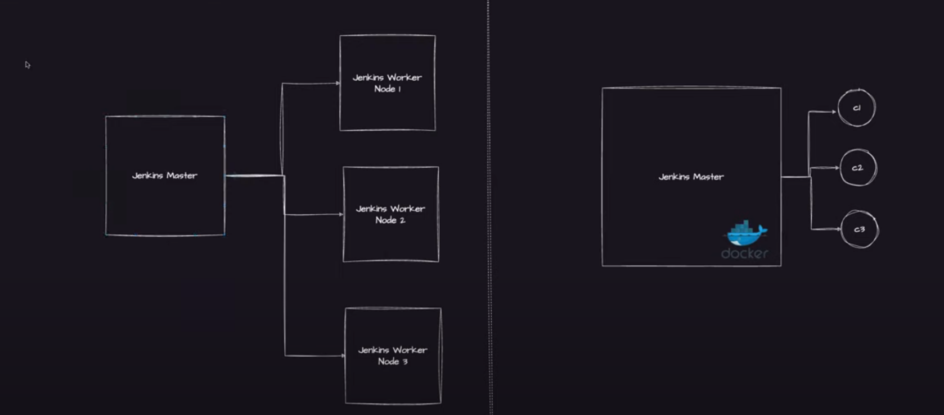
1jenkins master is not good for the purpose of load and dependency,
so in the projects people create 1 jenkins master and below that jenkins worker nodes.
RUNNING THE JENKINS PIPELINES ON THE DOCKER CONTAINER:
In resume we can explain that we have used docker as agent in our jenkins project setup , we found this as useful interms of cost , interms of effeciency and also spinning up and tearing down the docker containers.

BEST SUGGESTION TO GIVE IN ORGAINIZATION:
Container based approach for docker is best approach than the vm based approach.

HOW TO CONFIGURE DOCKER AS CONTIAINER AND USE DOCKER AS AGENT:
1.)Install docker where you have installed the jenkins.
2.) jenkins basically comes with the user called as jenkins user., so grant the access to the jenkins user and ubuntu user.
3.) docker isntallation creates a group called as docker group , adding the jenkins user and ubuntu iser to the docker group.

sudo apt update
sudo apt install docker.io

Sudo su -
usermod -aG docker jenkins #docker is the group #jenkins is user
usermod -aG docker ubuntu
systemctl restart docker

->docker typically run on the daaemon process which is not accessable to other processes
only root user can have the access to the daemon.

-> sometimes jenkins might not pick up the changes, so restart the jenkins by using below

http://127.0.0.1:8080/restart

SWITCHING TO JENKINS USER:

jenkins user is by default created by installing jenkins software.

su – jenkins

INSTALL THE DOCKER PLUGIN INSIDE THE JENKINS:

Jenkins should understand that whenever i am executing a job , I have to make sure if the user provides in the jenkins file to run a specific job in docker, we need to have the docker configured inside the jenkins.

Install the docker pipeline plugin in jenkins :

manage jenkins->add plugins - >docker pipeline

restart after install -> restart after every change in jenkins because some times the changes might not getting reflected.

JENKINS IS ALL ABOUT TAKING THE CODE FROM THE LOCAL DEVELOPEMENT OR ANY VERSION CONTROLLING SYSTEM AND DELIVERING IT TO ANY PRODUCTION OR STAGING ENVIRORNMENT WHERE AUTOMATING STAGES ARE INVOLVED IN BETWEEN.

EG : if there are 10 stages and our job is to automate the 10 stages in jenkins, so jenkins acts as an orchestrator.

DIAGRAM IMPORTANT FOR INTERVIEW:

EXPLAIN CI-CD PROCESS IN YOURS ORGANIZATION?

Declarative or scripted aproach : pipeline:

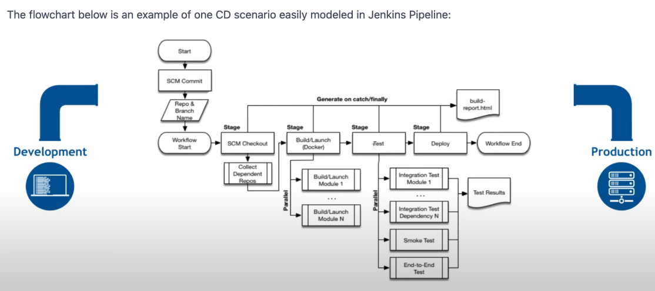
A SIMPLE JENKINS PIPELINE TO VERIFY THE DOCKER AGENT IS WORKING AS EXPECTED:

NEWPIPELINE:
DEFINITION : PIPELINE SCRIPT FOR SCM
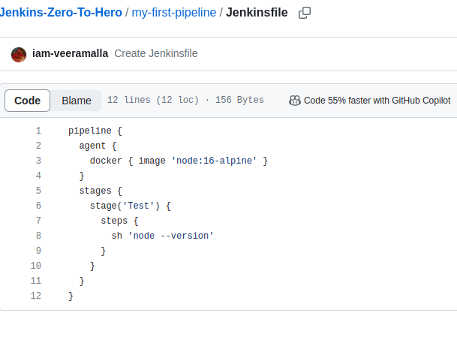

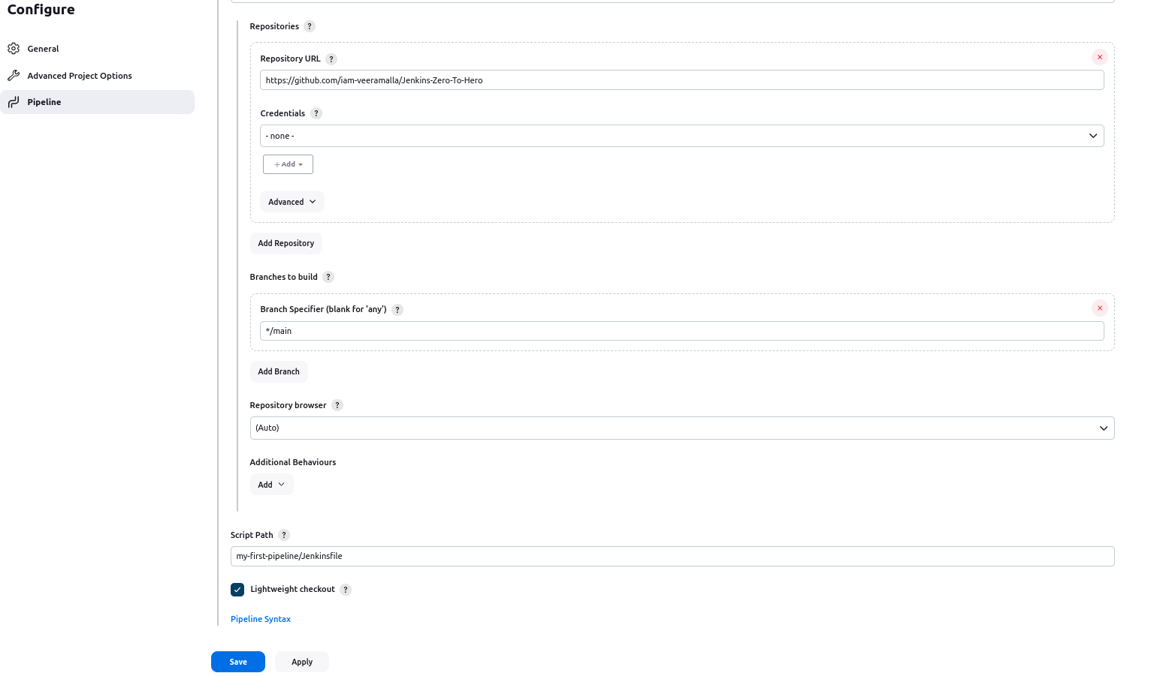

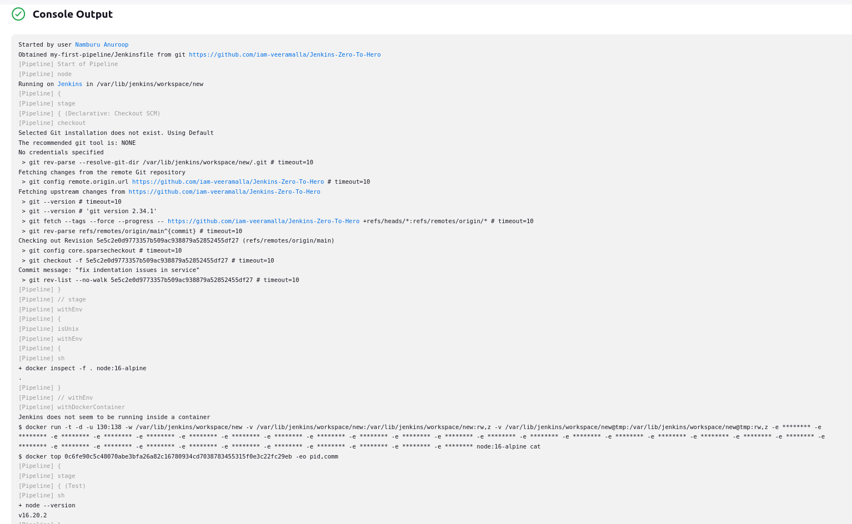

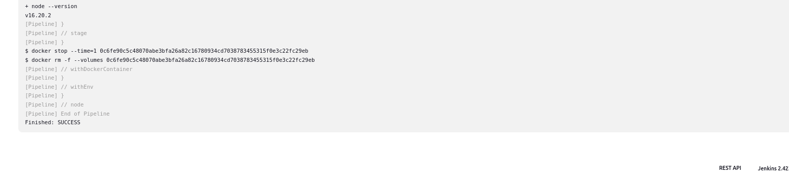
OUTPUT:

the jenkins job will fetch the output from the github, executes all the git commands,
after that it is pull an image called as node:16-alpine, it dint find then it created a docker image and executed a command calle node –version.after the complete pipeline execution , jenkins will say to delelte the docker container.

JENKINS DELELTING THE DOCKER CONTAINER IN THE OUTPUT:

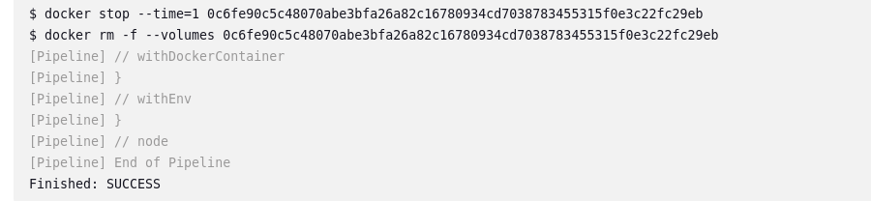
,
Jenkins requested docker to create a container, docker gace the container , as soon as the process gets done the container gets terminated, jenkins only used for the pipeline execution.

When there is a request from jenkins, then only the docker creates a container.

LOTS OF COST IS SAVED EFFECIENCY IS INCREASED , LIGHT WEIGHT:

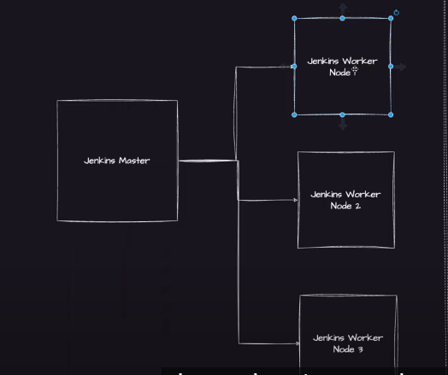
.
suppose the worker nodes are working on the cent os 7 and they need to be change to centos 8 , tomorrow , then there is a lots of work risk factor,any security related packages , dependencies should be updated , every thing is to be updated, so docker containers are preffered for the jenkins instead of other servers or nodes from the cloud infrastructure.

Multi Stage Multi Agent
Set up a multi stage jenkins pipeline where each stage is run on a unique agent. This is a very useful approach when you have multi language application or application that has conflicting dependencies.

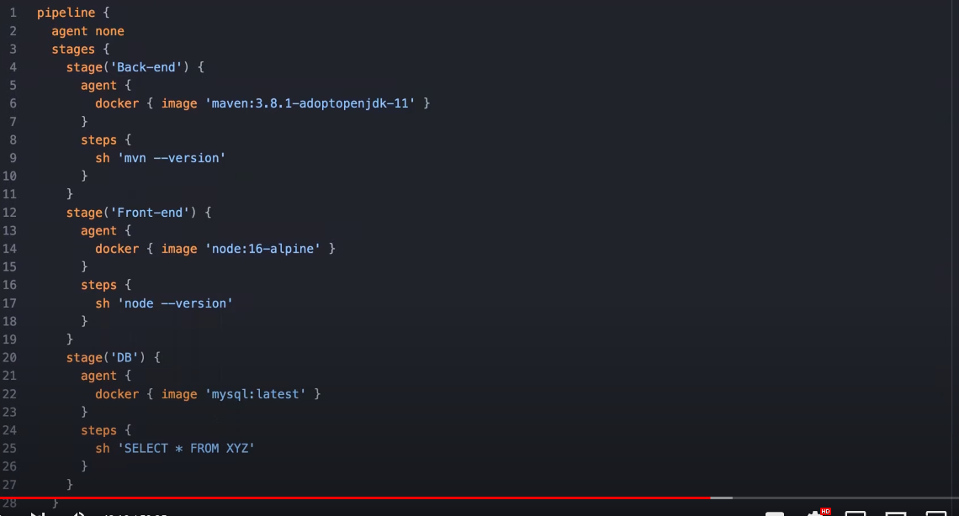
.
for eg:
database applications run on centos
frontend and backend applications run on ubuntu os.
In the above pipeline jenkins took multiple envirornments and gitves the output irrespective of envirornments.
2 containers are created in the above pipeline.

AFTER EXECUTING THE PIPELINE:BUILD:
-
>checking the execution from the ubuntu command line checking container is created and later on the container gets destroyed after the usage.

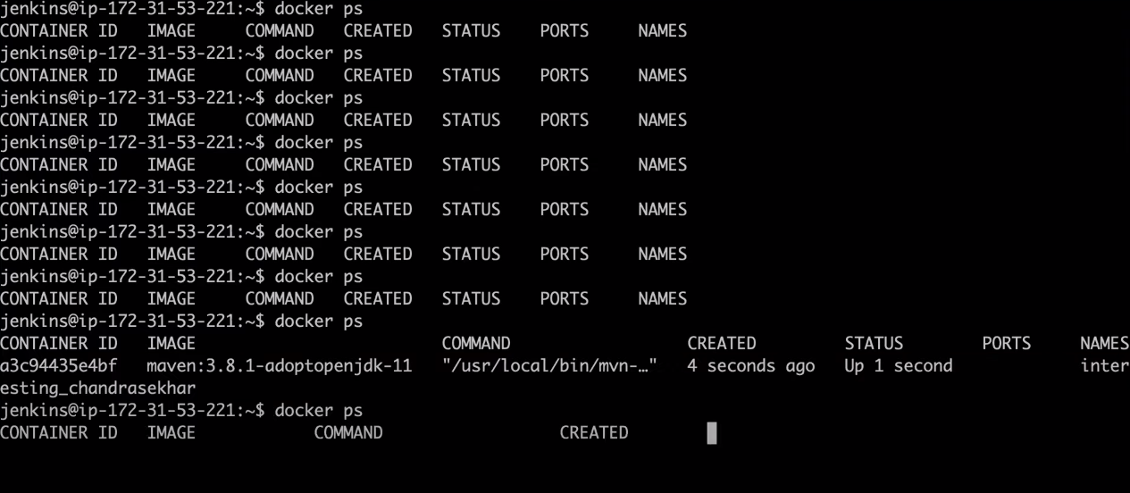
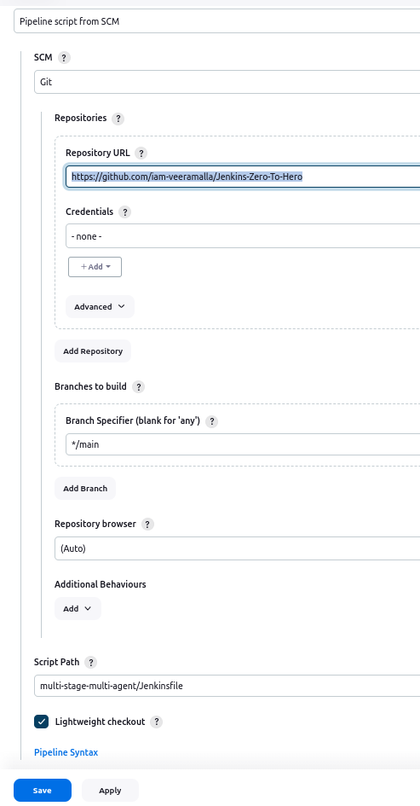
.

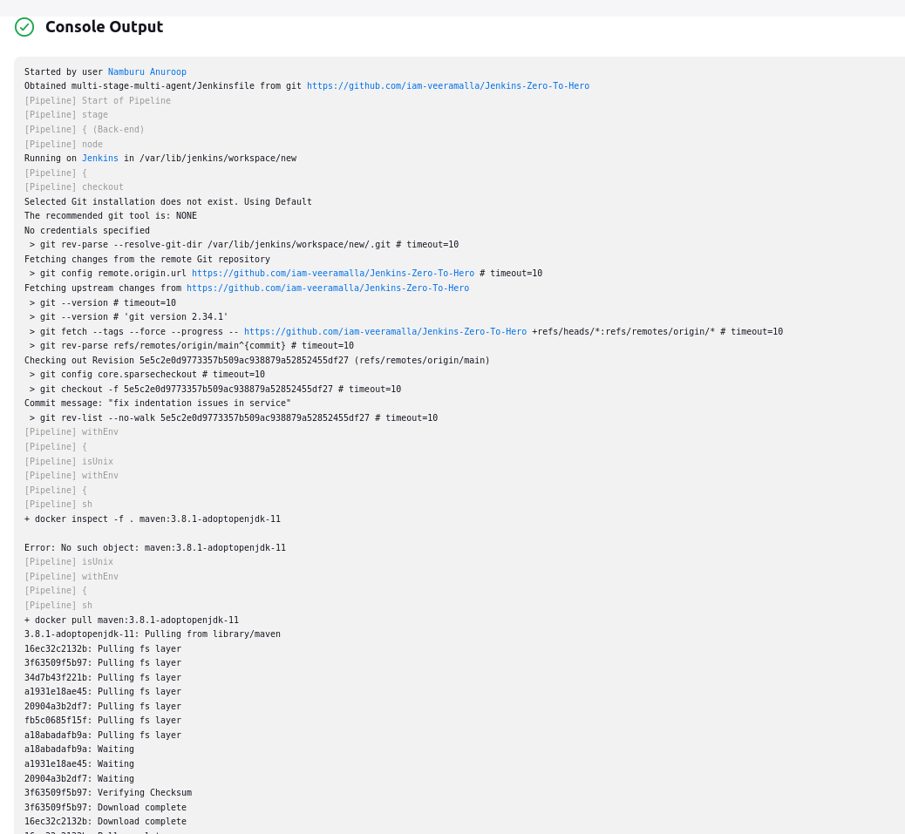
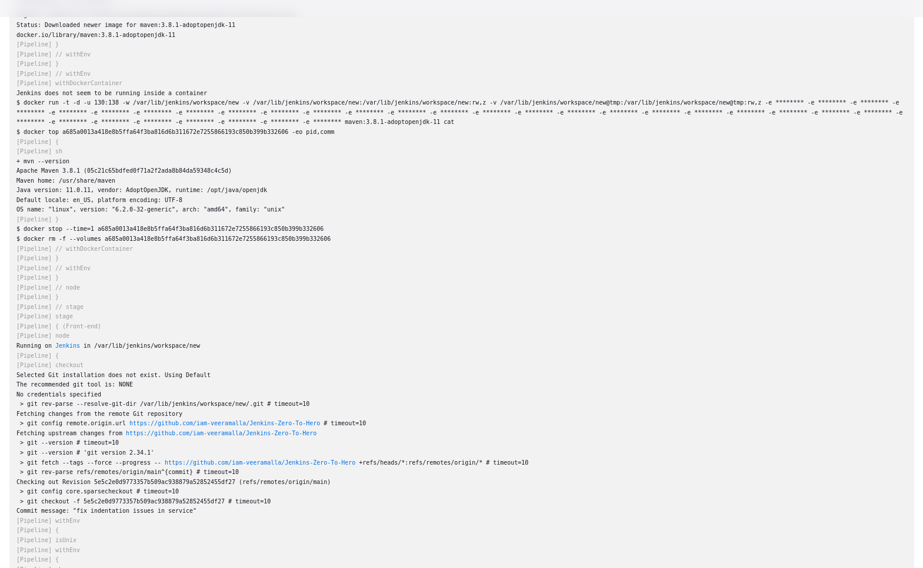
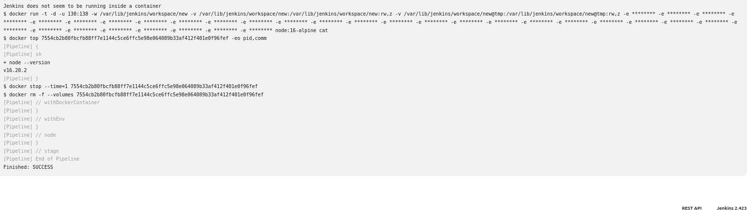
.

USE OF ARGOCD:
flux is also a continuos delivery tool.

ANSIBLE deploys what ever you are storing in the helm charts you are stroign in the deployment.yaml files, it just pick up and deploy into the kubernetes cluster.but if you are using ARGOCD, FLUX or SPINNAKER orany of the declarative continuous delivery tools or gitops tools they ensure the state is always the same.because they are kubernetes controllers.
They are actually deployed by kubernetes.

IMPLEMENT THE ENTRIRE THING IN JENKINS PIPELINE AND TO DEPLOY THAT ON TO KUBERNETES:

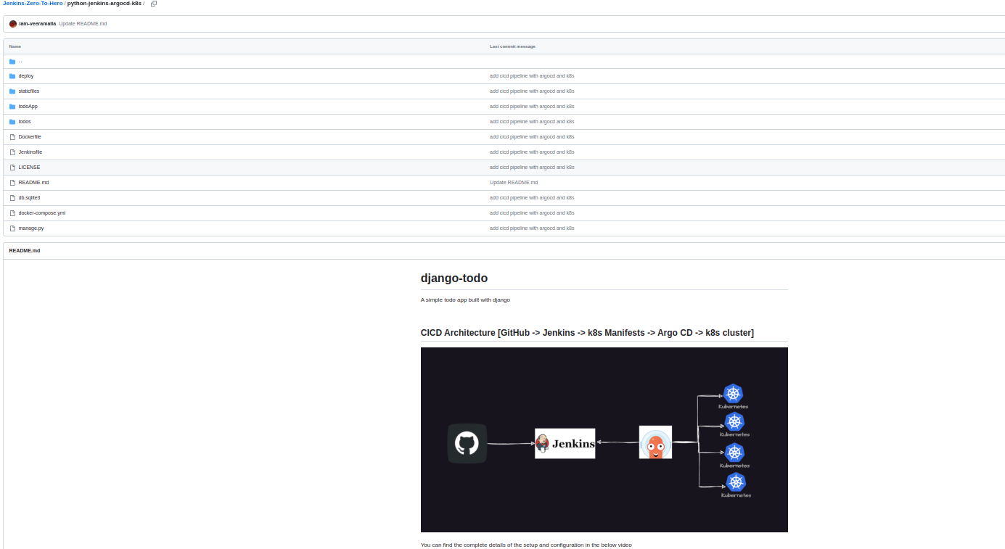
.
ARGOCD arrow towards the jenkins.

ATGOCD – for continuous delivery > ARGOCD will deploy the applicaltion into the kubernetes cluster.
JENKINS -> for continuos integration

ARGOCD

ARGOCD is a tool that will manifest out artifacts from your GIT repository whether it is helm charts,customized or plain kubernetes manifestt file and deploy it into the kubernetes aluster.

Provide yours github repositor , provide yours path , provide youurs kubernetes cluster url and the namespace where you want to deploy, ARGOCD will take all the changes and deploy.

AS a devops engineer we only need to write the jenkins file and a jenkins job , once you do yours end to end ci-cd pipeline is completed.

the positives of ARGOCD is , you no need to write a single peace of code.
ARGOCD is a tool that is based on the principles of GITOPS.
#You can put the helm charts, kubernetes manifest , every thing in the ARGO CD,
ARGOCD takes the manifest files and deploy it in to the kubernetes cluster.

Using minikube

#WE can set up the jenkins like when ever you make the changes in the code , the jenkins run the pipeline using a webhook.

While writing a pipelien use the pipe script from the SCM, wehn you do it you will having a track of every thing.

INTERVIEW :

JENKINS is using your continuos integration.
ARGOCD is used for continuos delivery.

REAL TIME CI-CD PROJECT : INTERVIEW
CONTINUOS DELIVERY MODEL TRHOUGH GITOPS
JENKINS WITH ARGOCD:

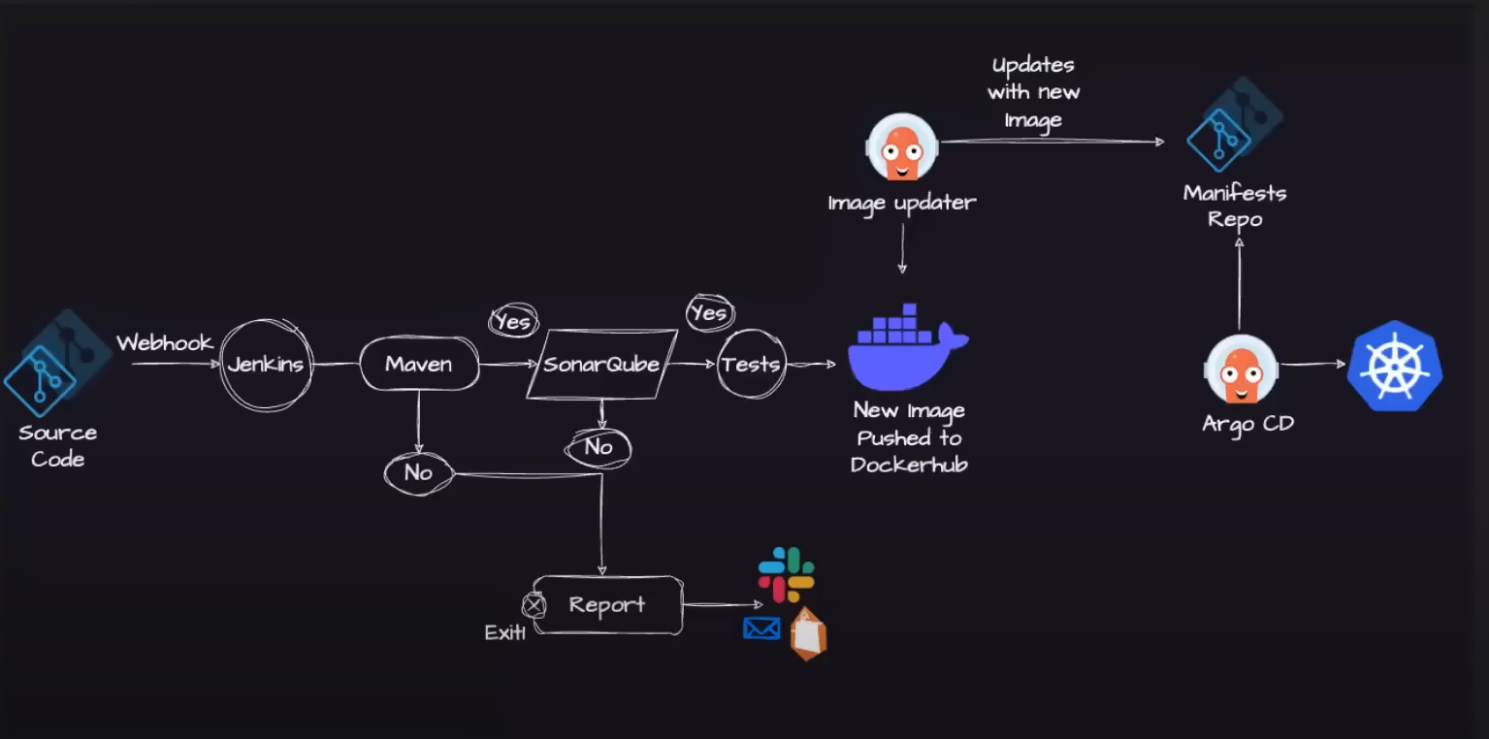
ONLY USE THE DECLARATIVE WAY OF APPROACH IN BUILDING GROOVY SCRIPT:

NOT EVERY THING IS DONE THROUGH JENKINS.
There are two git repositories
one for storing the source code
second one is to store the manifest files.
Flux or spinnaker tool is used in place of ARGOCD but ARGOCD is most widely used toold in the industry.
In the above architecture , after the docker is image is pushed we use the pull mechanism through the ARGOCD
Jenkins is only using the continuos integration.

Interview:
there is a developer commited a change in the git repository, how could jenkins pipeline get notified or triggered that user done a change in the git repository
-> we can do it by a webhook ->in jenkins there is a webhook url -> you can take the webhook url and add it in the github repository settings , there in actions you can set the webhook shoud trigger or commit , or the webhook should trigger on pull request. Or should be triggered in settings.

Eg: when ever developer creates a pull request or committed a file , git will send a notification to the jenkins and ask jenkins to start the pipeline.
-> suppose we are deploying a java application, we need to configure in jenkins -> we need to install maven plugin through configure system .
-------------------------------------------or else-
-> we can simply use the container archiitecture like docker agent , by using the docker agent we can skip the installations , configurations because docker images are directly available for these.
-> incase if the BULD fails , we can configure in jenkins that the jenkins send an emain notification to the user -> plugin name: email plugin,
-> we can send the slack , email notifications , teams notifications , aws using the APIS.
If the build passes , then it will go to the next stage

NEXT STAGE CONTINUOS INSPECTION: SONARQUBE
USED FOR SASHED AND DASHED TESTING

SonarQube is an open-source platform for continuous inspection of code quality. It is primarily used by software development teams to analyze and manage the quality of their codebase. SonarQube provides a wide range of tools and features to help developers and teams identify and fix code issues, track code quality over time, and ensure that their software meets coding standards and best practices.

-> Sonarqube checks the quality of the code , if found any security vulnerebulities , it can send a notification like email or slack or any to the developer.

NEXT STAGE: DOCKERIZING THE IMAGE:

-> Using the docker agent or using shell scripting we can give commands like docker build -> using docker build we get a docker image.

-> the docker image is transfered is sent to a docker registry or to a container registry
COMPANY USED REGISTRIES:

ECR
QUAY.IO
DOCKER HUB

--------------------------------------------till the above step continuos integration is done

BEST CONTIUOUS TOOLS AS THE GITOPS BASED TOOLS

ARGO IMAGE UPDATER:

the argo image updater continuosly monitor the docker hub or any container registries and when ever a new version is pushed , argo image updater directly update the git repository with the pod.yml , deply.yaml, helm charts

ARGOCD:

Then ARGOCD take the new pod.yaml, deployment.yml , helmcharts and deploy it to the kubernetes cluster.

-> There is a new commit created in your git repository created by ARGO IMAGE UPDATER.

IMPLEMENTING CI-CD PROCESS THROUGH JENKINS AND ARGO CD
IN GITHUB CAN THE JENKINS FILE BE IN ANY LOCATION?
YES
THE JENKINS FILE NAME CAN BE ANY THING , NO NAMING CONVENTION IS MENTIONED.
ONE OF THE GOOD WAY OF WRITING A JENKINS FILES IS USING DOCKER CONTAINERS AS AN AGENT
-> YOU CAN LESSER THE CONFIGURATION
-> ALL THE STAGES INSIDE THE JENKINS JOBS IN MULTIPLE STAGE IT KEEPS ON INCREASING THE COMPLEXITY OF SOURCE CODE.
WHEN WE USE VIRTUAL MACHINES FOR CREATING THE ENVIRORNMENT WHEN YOU DONT NEED THE USAGE OF THAT PARTICULAR SOFTARE ALSO THE EC2 KEEPS ON RUNNING,IF YOU USE THE AWS AUTOSCALRE AND JENKINS AUTOSCALER ALSO THEN ALSO YOU NEED TO DO MINIMUM CONFIGURATION , INORDER TO AVOID THE CONFIGURATION IT IS A GOOD PRACTICE TO INSTALL DOCKER PLUGIN AND USE THE CONTAINER ARCHITECTURE.
YOURS PIPELINE WILL EXECUTE ALL THE STAGES INSIDE THE DOCKER CONTAINER AND ONCE YOURS JENKINS PIPELINE IS DONE ,THE DOCKER CONTAINER GETS DELELTED AFTER PIPELINE EXECUTEION.
SO THAT THERE WILL BE A LOTS OF SPACE TO RUN THE OTHERR JENKINS JOBS.

YOU ARE CAHRGED FOR THE USED INSTANCES.

use t2 large – as soon as the building completes close the instance
Select the Docker pipeline plugin
after installing the docker plugin inside the jenkins:
install the sonar kube scanner in the jenkins .
INSTALL THE SONARKUBE IN YOUR EC2 SERVER
install the sonar qube in the same vpc which you created ec2 for using the jenkins to avoid ingress and vpc issues.

By default the sonar serverr starts on the port 9000.

got to sonarqube localhost:9000

set password -> create new password

-> got to mmyaccount top right -> security ->
generate token -> token name give jenkins
->copy the token id
goto the jenkins – manage jenkins – security – credentials – global – add credentials
- kind : secret text – paste the secret there
ID - SONARKUBE #you can give any id

NEXT STAGE IS IS DOCKER : you have to install docker loclally
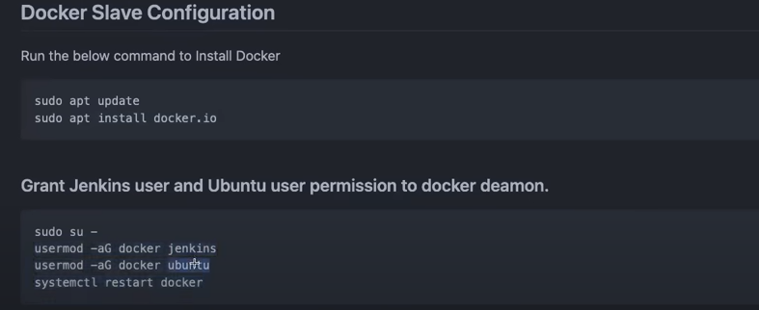

Goback and restart the jenkins, whenever you install plugins , we have installed docker pipeline plugin, sonar plugin

FINAL STEP KUBERNETES CLUSER AND ARGOCD:

ARGO CD can be done when the minicube cluster is done

ARGOCD is a kubernetes controller

