->In ubuntu to open a terminal the shortcut is ctrl + alt + t
->cat /etc/shells ->displays all the shells that support for your linux.
/bin/sh
/bin/bash
/usr/bin/bash
/bin/rbash
/usr/bin/rbash
/usr/bin/sh
/bin/dash
/usr/bin/dash
->code . Command will directly open the visual studio.
-> there are two types of variables in shell scripting
1. SYSTEM VARIABLES - > System variables, also known as environment variables, are predefined variables that are set by the operating system or system environment. These variables store information about the system configuration, user settings, and more. Some common system variables in Unix-like systems include:
  - PATH: Stores a list of directories where executable files are located. It determines which commands the shell can find and execute.
  - HOME: Stores the path to the user's home directory.
  - USER: Stores the username of the currently logged-in user.
  - SHELL: Specifies the default shell for the user.
  - PWD: Stores the current working directory.
You can access the values of these system variables in your shell script by prefixing them with a dollar sign ($), like this: $HOME or $PATH.
2. USER DEFINED VARIABLES -> User-defined variables are variables that you create and set within your shell script. These variables allow you to store and manipulate data specific to your script's requirements. To create a user-defined variable, you simply assign a value to a variable name.
-> read -p ‘username : ‘ user_var -> p refers to we can give the input in the same line in the runtime.
-> read -sp ‘password : ‘ pass_var ->here s refers to it , the input we type is not visible on the screen.
SCRIPT EG 1: HERE -a flag refers to , it stores the values in the array format.
-> #! /bin/bash
read -a names
echo “ name : {names[0]} , {names[1]} “
output:
enter names:
tom max
name : tom , max
SCRIPT EG 2 : Empty variable declaration
#!/bin/bash
echo “enter name”
read
echo “ name : $REPLY “
DESCRIPTION :
In the above code we did not declared any variable beside the read , $REPLY is the default variable where our input goes into it.
->PASS ARGUMENT TO A BASH SCRIPT : script name : hello.sh
SCRIP EG3:
#!/bin/bash
echo $1 $2 $3 “ > echo $1 $2 $3“
OUTPUT :
./hello.sh anu manu banu
here 0’th argument is ./hello.sh ,1,2,3 are anu,manu,banu.
SCRIPT EG4 :
#!/bin/bash
echo "$0 $1 $2 $3 > echo $1 $2 $3"
args=("$@")
echo "${args[0]} ${args[1]} ${args[2]} ${args[3]}"
DESCRIPTION:
args=("$@"): This line creates an array named args and assigns it the values of all the command-line arguments passed to the script ($@). This allows you to access the arguments as elements of an array.
OUTPUT:
./hello.sh anu manu banu
./args.sh anu banu manu > echo anu banu manu
anu banu manu
OUTPUT DESCRIPTION:
echo "${args[0]} ${args[1]} ${args[2]} ${args[3]}"
- ${args[0]} corresponds to the first element of the array, which is "anu."
- ${args[1]} corresponds to the second element of the array, which is "banu."
- ${args[2]} corresponds to the third element of the array, which is "manu."
- ${args[3]} corresponds to the fourth element of the array, which doesn't exist in this case.
SCRIPT5: PRINTING OUTPUT BY USING THE DEFAULT ARGUMENT $@:
#!/bin/bash
echo "$0 $1 $2 $3 > echo $1 $2 $3"
args=("$@")
#COMMENTED echo "${args[0]} ${args[1]} ${args[2]} ${args[3]}"#
echo $@
OUTPUT:
There is no change in the output compared to script5 , it prints the same ar1,arg2,arg3.
./args.sh anu banu manu > echo anu banu manu
anu banu manu
anu banu manu
SCRIPT6: PRINTING THE NUMBER OF ARGUMENTS PASSED IN THE SCRIPT BY USING A DEFAULT VARIABLE CALLED #:
#!/bin/bash
echo "$0 $1 $2 $3 > echo $1 $2 $3"
args=("$@")
echo "${args[0]} ${args[1]} ${args[2]} ${args[3]}"
echo $@
echo $#
OUTPUT:
./args.sh anu banu manu > echo anu banu manu
anu banu manu
anu banu manu
3
Expressions An expression can be: String comparison, Numeric comparison, File operators and Logical operators and it is represented by [expression]: String Comparisons:
---------------------------------
= compare if two strings are equal
!= compare if two strings are not equal -
n evaluate if string length is greater than zero
-z evaluate if string length is equal to zero
Examples:
[ s1 = s2 ] (true if s1 same as s2, else false)
[ s1 != s2 ] (true if s1 not same as s2, else false)
[ s1 ] (true if s1 is not empty, else false)
[ -n s1 ] (true if s1 has a length greater then 0, else false)
[ -z s2 ] (true if s2 has a length of 0, otherwise false)
-z refers to null.
Number Comparisons:
------------------------------------
-eq compare if two numbers are equal
-ge compare if one number is greater than or equal to a number
-le compare if one number is less than or equal to a number
-ne compare if two numbers are not equal
-gt compare if one number is greater than another number
-lt compare if one number is less than another number
Examples:
[ n1 -eq n2 ] (true if n1 same as n2, else false)
[ n1 -ge n2 ] (true if n1greater then or equal to n2, else false)
[ n1 -le n2 ] (true if n1 less then or equal to n2, else false)
[ n1 -ne n2 ] (true if n1 is not same as n2, else false)
[ n1 -gt n2 ] (true if n1 greater then n2, else false)
[ n1 -lt n2 ] (true if n1 less then n2, else false)
In shell scripting, `if` statements are used to perform conditional execution of code based on the evaluation of a condition. The choice between using `[ ]` (brackets) or `(( ))` (double parentheses) depends on the type of condition you want to evaluate.

USE OF square brackets [] and double paranthesis (()) in if condition:

1. **`[ ]` (Brackets) for String and File Tests:**

- Use `[ ]` (brackets) for performing string comparisons and file-related tests in `if` statements.

Examples:

- String comparison:
```bash
if [ "$var1" = "$var2" ]; then
echo "Strings are equal."
fi
```

- File existence check:
```bash
if [ -f "$file_path" ]; then
echo "File exists."
fi
```

2. **`(( ))` (Double Parentheses) for Arithmetic Expressions:**

- Use `(( ))` (double parentheses) for evaluating arithmetic expressions in `if` statements.

Examples:

- Arithmetic comparison:
```bash
if (( num1 > num2 )); then
echo "num1 is greater than num2."
fi
```

- Arithmetic operations:
```bash
if (( result = num1 + num2 )); then
echo "The sum is $result."
fi
```
3.
[[]] (Double Brackets):
Double brackets, [[]], are an enhanced version of single brackets and are often used for more complex conditional expressions. They provide extended functionality, including pattern matching and logical operators (&&, ||) without needing to escape them. They are also more forgiving with variables that may be unset or empty. Here's an example:
bashCopy code
if [[ "$string" == "hello" && "$number" -gt 10 ]]; then
echo "Both conditions are true"
fi
In this example, we're checking if the string is "hello" and the number is greater than 10.
In summary:
- Use [ ] for basic string and numeric comparisons in shell scripts.
- Use [[]] for more complex conditional expressions, pattern matching, and logical operators.
- Use (( )) for arithmetic comparisons and calculations involving numeric values
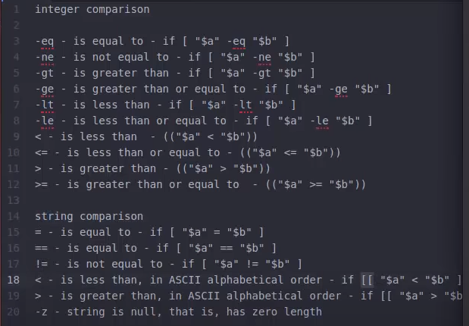
CHECKS IF THE FILE GIVEN BY THE USER IS EXISTS OR NOT:
SCRIPT6:
#!/bin/bash
echo -e "enter the file name : \c"
read file_name
if [ -e $file_name ]
then
echo "$filename found"
else
echo "$filename notfound"
fi
OUTPUT:
./filecheck.sh
enter the file name : cbbad
cbbad not found.
DESCRIPTION:
echo -e "enter the file name : \c"
Without the -e option, echo treats backslashes and the letters that follow them just like regular characters. But when you use -e, echo knows to look for these escape sequences and do what they represent. For instance, if you have \n in your text, it will actually start a new line.
In summary, the echo -e line in your script is used to print a prompt to the user asking them to enter a file name. The -e option is used to enable the interpretation of escape sequences, and \c is used to prevent the newline character so that the cursor remains on the same line, making it convenient for the user to input text.
Here, filename should be replaced with the actual name of the file you want to check. The -e flag, in this context, is used to test whether the file exists in the current directory.
There are several other flags that can be used with the [ ] test command to perform various file-related checks. Some common ones include:
- -f: Checks if the file is a regular file (not a directory or a special file).
- -e – checks whether the file exists or not.
- -d: Checks if the file is a directory.
- -s: Checks if the file is not empty (has a size greater than zero).
- -r: Checks if the file is readable.
- -w: Checks if the file is writable.
- -x: Checks if the file is executable.
- -L: Checks if the file is a symbolic link.
- -S: Checks if the file is a socket.
- -p: Checks if the file is a named pipe (FIFO).
Here's an example of how you can use some of these flags:
bashCopy code
if [ -f filename ]; then
echo "The file 'filename' exists and is a regular file."
fi

if [ -d directoryname ]; then
echo "The directory 'directoryname' exists."
fi
You can combine these flags in various ways to perform more complex file checks within your Bash scripts.

SCRIPT 7:
HOW TO APPEND OUTPUT TO END OF THE TEXT FILE:
#!/bin/bash
echo -e "enter the file name : \c"
read filename
if [ -f $filename ]
then
if [ -w $filename ]
then
echo "type some text data , to quit press ctrl+d"
cat >> $filename
else
echo " the file do not have write permission"
fi
else
echo "$filename not exists"
fi
OUTPUT:
./appendtoopeof.sh
enter the file name : text
type some text data, to quit press ctrl+d.
hi how are you
USE OF DIFFERNCT WAYS AND OPERATIOR – a AND &&:
&& operation can be used as -a flag
eg: -a
age = 20
if [ ‘$age’ -eq 20 ] && [‘$sex’ -eq ‘m’ ]
if [ ‘$age’ -eq 20 -a ‘$sex’ -eq ‘m’ ]
eg: && - we need to use double square brackets for this
if [[ ‘$age’ -eq 20 && ‘$sex’ -eq ‘m’ ] ]
USE OF DIFFERENT WAYS OF OR OPERATIOR – o AND ||:
age=60
if [“$age” -gt 18 ] || [ “$age” -lt 30]
if [“$age” -gt 18 -o “$age” -lt 30]
if [[“$age” -gt 18 || “$age” -lt 30]]

SHELL SCRIPT TO PERFORM ARITHEMATIC OPERATIONS:
SCRIPT8: for arithematic operation we will use double paranthesis.
#!/bin/bash
num1 = 20
num2 = 5
echo $(( num1 + num2))

INSTEAD OF USING DOUBLE PARANTHESIS WE CAN USE expr :

#!/bin/bash
num1 = 20
num2 = 5
echo $( expr $num1 + $num2)
echo $( expr $num1 * $num2)

OUTPUT:
25
expr : syntax error
#We are getting the syntax error because expr treats * as a special character not a multipy operator , To avoid that we backslash \ escape character.

#!/bin/bash
num1 = 20
num2 = 5
echo $( expr $num1 + $num2)
echo $( expr $num1 \* $num2)

SCRIPT9: bc command :
#! /bin/bash
num1 = 20.5
num2 = 5
#bc command does the basic arithematic operations the command on the left handseide gives the output or prints the 20.5+5 using echo will transfer to the bc command using the pipe symbol. bc does all the arithematic operations.
echo "20.5+5" | bc
echo "20.5-5" | bc
echo "20.5*5" | bc
echo "scale=2;20.5/5" | bc
#scale is a function used in divisons that will scale the decimal points.
#here in the above line it will set upto two decimal points after point.
echo "scale=20;20.5/5" | bc
#here the scale function will set upto 20 decimal points , it will set upto 20 z
eros after point eg: 4.10000000000000000000
echo "20.5%5" | bc

script 10 : bc command with -l flag :

#! /bin/bash
num1 = 20.5
num2 = 5
#bc command does the basic arithematic operations the command on the left handseide gives the output or prints the 20.5+5 using echo will transfer to the bc command using the pipe symbol. bc does all the arithematic operations.
echo "20.5+5" | bc
echo "20.5-5" | bc
echo "20.5*5" | bc
echo "scale=2;20.5/5" | bc
#scale is a function used in divisons that will scale the decimal points.
#here in the above line it will set upto two decimal points after point.
echo "scale=20;20.5/5" | bc
#here the scale function will set upto 20 decimal points , it will set upto 20 z
eros after point eg: 4.10000000000000000000
echo "20.5%5" | bc
num = 4
#sqrt is a mathematical function , bc caluculator doesnt give output for this one , to enable and use the function we have to use a flag -l.
echo "scale=2;sqrt($num)" | bc -l
echo "scale=2;3^3" | bc -l

script 11: using CASES :

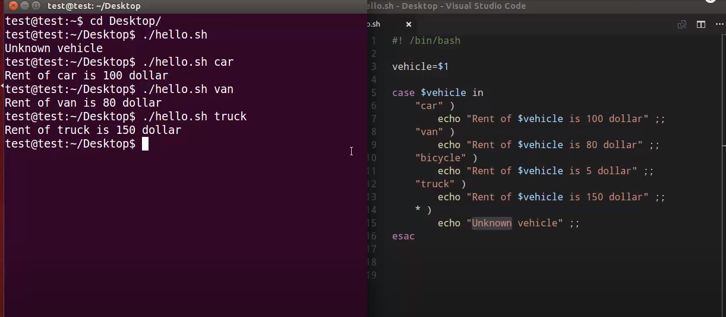
* IS THe WILD CARD IN LINUX , IT IS THE DEFAULT CONDITION.

SCRIPT-12 : CASE STATEMENT EXAMPLE TO FIND WHETHER IT WAS A-Z or a-z or 1-0 or any other special character or any string:

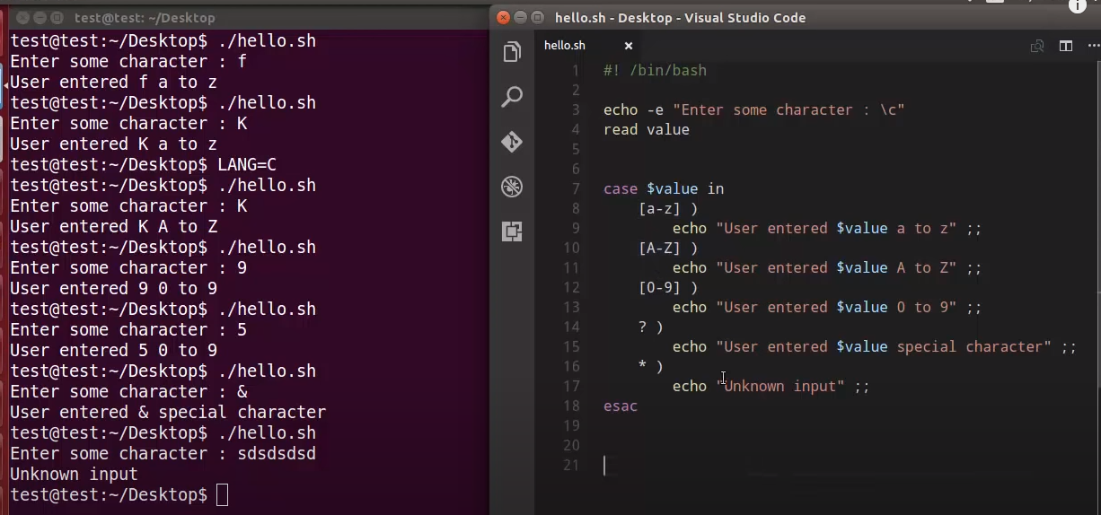

Here “?” refers to any of the special character.
* refers to if we gave any string instead of giving a character it will display output as unkowkn input.

ARRAY VARIABLES:
In shell scripting, you can work with arrays and manipulate strings in various ways. Here, we'll cover both arrays and some common string operations within shell scripts:

**1. Arrays:**

Arrays in shell scripting allow you to store multiple values in a single variable. You can access and manipulate these values individually or collectively. Bash, for example, provides support for indexed arrays.

**Declaring an array:**
```bash
my_array=("apple" "banana" "cherry")
```
**Accessing array elements:**
```bash
echo ${my_array[0]} # Prints "apple"
echo ${my_array[1]} # Prints "banana"
```
**Iterating through an array:**
```bash
for item in "${my_array[@]}"; do
echo "Fruit: $item"
done
```
**String Manipulation:**
You can manipulate strings using various shell constructs:
**Concatenating strings:**
```bash
str1="Hello, "
str2="World!"
result="$str1$str2" # Concatenates str1 and str2
echo $result
```
**Substring extraction:**
```bash
string="Hello, World!"
substring="${string:0:5}" # Extracts "Hello" from position 0 with a length of 5 characters
echo $substring
```
**Replacing a substring:**
```bash
string="Hello, World!"
new_string="${string/World/Universe}" # Replaces "World" with "Universe"
echo $new_string
```
**String length:**
```bash
string="Hello, World!"
length=${#string} # Calculates the length of the string
echo "Length: $length"
```

**Splitting strings into arrays:**
```bash
csv="apple,banana,cherry"
IFS=',' read -ra fruits <<< "$csv" # Splits the string into an array using ',' as the delimiter
echo ${fruits[0]} # Prints "apple"
echo ${fruits[1]} # Prints "banana"
```
These are some of the basic operations for working with arrays and manipulating strings in shell scripts. Depending on your specific needs, you can use these techniques to process data effectively within your scripts.
SCRIPT 13: arrayvariables.sh
#! /bin/bash
os=('ubuntu' 'windows' 'kali')
echo "${os[@]}"
echo "${os[0]}"
echo "${!os[@]}" # prints the index positions of an array
echo "${#os[@]}" # prints the lenght of an array
#Adding values to array basing on index positions
os[0]='[mac]'
#Adding array elements preceding the length of the array, eg: in the above array length is 3 and i want to add at position number 6
os[6]='debian' # printhe value debian at the 6th position and null will be assigned in the position 3 to 5 where as arrray start from zero.
# To remove an element from an Array
unset os[2]
#Arrays in strings
string=asdfghjkl
echo "${string[@]}"
echo "${string[0]}" # the whole string is attached to the oth position.
echo "${string[1]}" # in the first postion there is nothing , op is empty.
echo "${#string[@]}" # prints the length of the string as 1.
echo "${#string}" # This will correctly output 15
output:
root@ubuntu-IdeaPad-3-15ITL6:/home/ubuntu/shellscripts# ./arrayvariables.sh
ubuntu windows kali
ubuntu
0 1 2
3
asdfghjkl
asdfghjkl

1
9
While loops in the shell scripting:
script : 14 while.sh
#! /bin/bash
#while loops
n=10
while [ $n -le 116 ] #while (($n <= 116}
do
echo "$n"
n=$((n+1))
done
output:
prints from 1 to 116 numbes.
script : 15
#! /bin/bash
#while loops
n=10
while [ $n -le 116 ] #while (($n <= 116}
do
echo "$n"
((n++) #((n++) or ((++n)) can be used.
done
output:
prints from 1 to 116 numbes.

The expressions `count++` and `++count` are both used for incrementing a variable in shell scripting (e.g., Bash), but they behave differently:

1. **Post-increment (`count++`):**

- The `count++` expression is a post-increment operation.
- It increments the value of `count` by 1 after its current value is used in the surrounding expression.
- This means that the current value of `count` is returned, and then `count` is incremented.
- Here's an example:

```bash
count=5
result=$count
count++
echo "Result: $result" # Output: Result: 5
echo "Count: $count" # Output: Count: 6
```
- In this example, `count` is first assigned to `result`, so `result` contains the original value of `count` (5). Afterward, `count` is incremented by 1.

2. **Pre-increment (`++count`):**

- The `++count` expression is a pre-increment operation.
- It increments the value of `count` by 1 before its current value is used in the surrounding expression.
- This means that the incremented value of `count` is returned.
- Here's an example:
```bash
count=5
count++
result=$count
echo "Result: $result" # Output: Result: 6
echo "Count: $count" # Output: Count: 6
```
- In this example, `count` is incremented by 1 first, and then the incremented value is assigned to `result`.
In summary:
- `count++` is a post-increment operation that returns the current value and then increments.
- `++count` is a pre-increment operation that increments first and then returns the new value.
The choice between post-increment and pre-increment depends on whether you want to use the current value of the variable before or after the increment operation.
USE SLEEP IN WHILE CONDITION:
#SLEEP IN while loops
SCRIPT 16: vim whilesleep.sh
#! /bin/bash
n=10
while [ $n -le 116 ]
do
echo "$n"
n=$((n+1))
sleep 5 # the execution will pause of 5 seconds and come back to # terminal.
Done
USE GNOME IN WHILE LOOP TO DISPLAY THE N NUMBER OF TERMINALS:
SCRIPT 17: vim opentemnl2ruwhile.sh
#! /bin/bash
a=1
while(($a<=3))
do
((a++))
gnome-terminal &
done

USE XTERM IN WHILE LOOP TO DISPLAY THE N NUMBER OF TERMINALS:
SCRIPT 18: vim xtermusingwhile.sh
! /bin/bash
a=1
while(($a<=3))
do
((a++))
xterm &
done
READ A FILE CONTENT IN BASH:
1.) input redirection
2.) using cat and pipe operations.
3.) IFS- using Interal Feild Separator
SCRIPT 19 : vim readfiles.sh
# while loops using input redirections (<)
#! /bin/bash
# 1stway - input redirection
while read input
do
echo $input
done < bc.sh # the input redirection (<) reads the file and display the content in the file as output.
READ FILES USING CAT AND PIPE OPERATIONS:
SCTIPT20: vim readfilesusingcatnwhile.sh
#! /bin/bash
# while loops
ls
echo -e "which files would you like to open : \c"
read value
cat $value | while read input
# the output of the readdinput.sh will be read by the read command and stored in the input variable.
do
echo $input
done

READ FILES USING IFS , INPUT REDIRECTION (<) , AND USING WHILE LOOP:

#! /bin/bash

# read files using IFS internal feild seperator
ls
echo -e "enter the file name : \c"
read input
while IFS= read -r line #give one line space after equalto or use ' ' , the IFS use the given space as the separator.
# we are not assigning read to IFS , we are assigning ' ' to tthe IFS.
do
echo $line
done < $input
EXPLANATION:
Certainly, I'll explain how to use the Internal Field Separator (IFS) properly in Bash.

The IFS is a special variable in Bash that determines how the `read` command splits lines of text into fields. By default, IFS is set to space, tab, and newline characters, which means that `read` will split lines into words based on these characters. However, you can change the value of IFS to use a different delimiter or to disable field splitting entirely.

Here's how to use IFS properly:

1. **Changing IFS Temporarily:**
- You can change the value of IFS temporarily for a specific `read` operation. For example, to read lines delimited by commas (CSV format), you can set IFS to a comma before the `read` command:
```bash
IFS=',' read -ra fields <<< "apple,banana,cherry"
```
In this example, IFS is set to a comma, and the `read` command splits the input string into an array (`-a` option), storing each field in the `fields` array.

2. **Disabling Field Splitting:**
- If you want to read an entire line as a single field without any splitting, set IFS to an empty value before the `read` command:
```bash
IFS= read -r line
```
In this case, the entire line will be stored in the `line` variable.

3. **Restoring IFS:**
- After using a modified IFS, it's a good practice to reset it to its default value (space, tab, newline) to avoid unexpected behavior in subsequent commands. You can do this by assigning IFS back to its default value:
```bash
IFS=$' \t\n' # Reset IFS to default space, tab, newline
```
Here's an example that demonstrates the use of IFS to read and split lines based on a custom delimiter (colon):

```bash
#!/bin/bash

# Sample input string with colons as delimiters
input="Alice:Bob:Charlie"

# Set IFS to colon before reading
IFS=':' read -ra names <<< "$input"

# Iterate through the fields
for name in "${names[@]}"; do
echo "Name: $name"
done

# Reset IFS to default
IFS=$' \t\n'
```

In this script, IFS is temporarily set to a colon, and the `read` command splits the input string into an array named `names`. Then, we iterate through the array to print each name. Finally, we reset IFS to its default value.
Remember that modifying IFS affects the behavior of subsequent `read` commands, so be cautious and reset it when you're done with your specific requirements.
The `-r` option is used with the `read` command in Bash to interpret backslashes (`\`) in the input as literal characters, preventing them from escaping special characters. It is particularly useful when you want to read input that may contain escape sequences, such as backslashes followed by another character.

Here's why you might use the `-r` option with `read`:

1. **Escaping Backslashes:** By default, when you don't use the `-r` option, the `read` command interprets backslashes as escape characters. For example, if you have an input string like `"Hello\nWorld"`, without `-r`, `read` would interpret `\n` as a newline character. In contrast, with `-r`, it would treat `\n` as two separate characters: a backslash and an "n."

2. **Preserving Special Characters:** When you use `-r`, you can preserve the input exactly as it is, including any special characters or escape sequences. This is important when you're dealing with data where the literal representation of backslashes and other escape sequences is crucial.

Here's an example to illustrate the difference:

```bash
# Without -r, backslashes are interpreted
$ echo "Hello\nWorld" | while read line; do echo "$line"; done
Hello
World

# With -r, backslashes are treated as literal characters
$ echo "Hello\nWorld" | while IFS= read -r line; do echo "$line"; done
Hello\nWorld
```

In the first example (without `-r`), the `read` command interprets `\n` as a newline character, resulting in two separate lines of output. In the second example (with `-r`), `\n` is treated as a literal sequence, preserving the input as-is.

In many cases, you'll want to use `-r` when reading input to ensure that you maintain the integrity of the data, especially when dealing with file paths, regular expressions, or any content that includes backslashes or escape sequences.
DIFFERENCE BETWEEN WHILE AND UNTIL LOOPS:
- While Loop:
  - Condition: In a while loop, the loop continues executing as long as the specified condition evaluates to true (exit status 0). In other words, it executes the loop block while the condition is true.
  - Example: The loop executes while the condition is met.
bashCopy code
while [ condition ]; do
# Loop commands
done
- Until Loop:
  - Condition: In an until loop, the loop continues executing as long as the specified condition evaluates to false (exit status non-zero). It executes the loop block until the condition becomes true.
  - Example: The loop executes until the condition is met.
bashCopy code
until [ condition ]; do
# Loop commands
done
SCRIPT 21 : vim until.sh
#! /bin/bash
# until loops
n=1
until [ $n -gt 10 ] #(($n > 10)) also can be used
do
echo $n
((n++))
done
OUTPUT:
prints all the numbr till 10.

SCRIPT 22: vim for_loops.sh
#! /bin/bash
for i in 1 2 3 4 5
do
echo $i
done
echo "printing sequence using for loop "
for i in {1..10}
do
echo $i
done
echo "printing sequence adding two"
for i in {0..10..2} # here it will print 0 2 4 6 adds every 2 numbers from 0
do
echo $i
done
echo " printing the lesser version numbers than the bash version"
#FOR LOOP IN BASH VERSION
a=$(echo "${BASH_VERSION}" | cut -c 1) #this line prints only the first character of the bash version and store it in a variable
for((i=0;i<a;i++))
do
echo $i
done
echo "other way of printing the lesser version than bash version"
# using : colon operator
# Store the first character of the BASH_VERSION variable in a file 'a'
echo "${BASH_VERSION:0:1}" > a
# Read the value stored in the file 'a' and store it in a variable 'a_value'
a_value=$(cat a)
# Use a for loop to print numbers from 0 to 'a_value'
for ((i = 0; i < a_value; i++))
do
echo "$i"
done
#SCRIPT23 : FOR LOOPS EXECUTED WITH COMMANDS:
vim for_loop_with_commands.sh
#! /bin/bash
for command in ls pwd date
do
echo "-------------------$command-------------------"
$command
done
# printing only the direcotry names in the current working dirctory.
# * refers to all the files in the current working dirEctory
for item in *
do
if [ -d $item ]
then
echo -e "the name of the direcotries are : \c"
echo $item
fi
done
# if your directory name consits spaces eg: my directory 1 instead of Y_directory_1 , the bash getts confused whether it is a single file or multiple filesand it will display an error, in that case remove that file and try.
OUTPUT:
-------------------ls-------------------
1 github-user,reposinfogatherr.sh
9 if-esle.sh
a if.sh
appendoptoenof.sh nodehealth.sh
args.sh opentemnl2ruwhile.sh
arrayvariables.sh readfilecontentinbash.sh
aws_resource_tracker.sh readfiles.sh
bc.sh readfilesusingcatnwhile.sh
dby3n5nor15.sh readfileusingIFS.sh
dir until.sh
filecheck.sh while.sh
first.sh while,sleep.sh
for_loops.sh wordcount.sh
for_loop_with_commands.sh xtermusingwhile.sh
for.sh
-------------------pwd-------------------
/home/ubuntu/shellscripts
-------------------date-------------------
Sunday 10 September 2023 08:22:29 PM IST
the name of the direcotries are : dir
SELECT LOOP:
Select gives the list of values as a menu.
Selelct loop can also be used with the case statements.
SCRIPT 24 : vim select.sh
#! /bin/bash
select name in hari ravi raju tom
do
echo "$name selelctedi"
break
done
# select with the case statements
select name in abhi vasu dev maari
do
case $name in
abhi )
echo "abhi selected" ;;
vasu )
echo "vasu selected" ;;
dev )
echo "dev selelcted" ;;
maari )
echo "maari selected" ;;
* ) #default case
echo "error please provide the no between 1..4"
esac
done
BREAK:
SCRIPT 25:
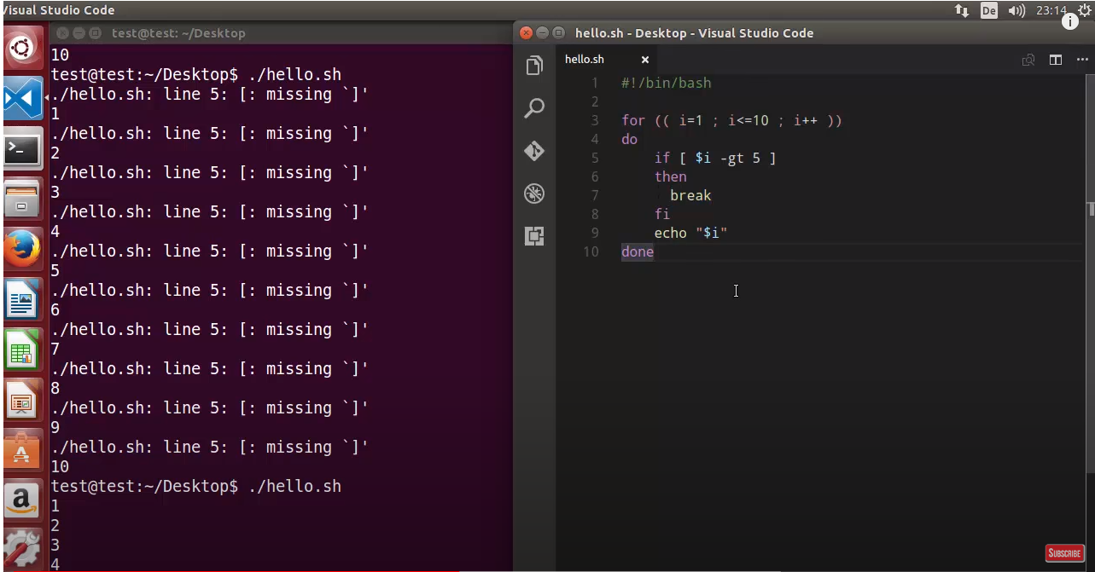

CONTINUE:
SCRIPT:26:
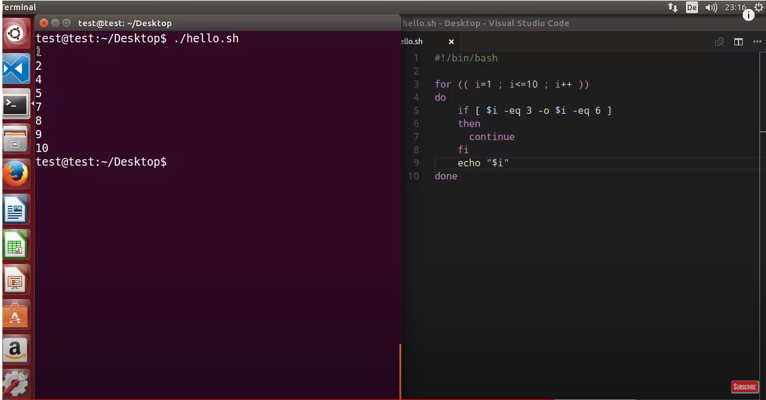
FUCNTIONS IN SHELL SCRIPTING:
The function declaration can be done in any sequence , the output always depends the function calling.
SCRIPT:27: vim functions.sh
#! /bin/bash
function Hello(){
echo " hello "
}
quit () {
exit
}
quit
Hello
echo "food"
OUTPUT:
The script directly quits because we have called the quit function earlier.
SCRIPT:28:
#! /bin/bash
function Hello(){
echo " hello "
}
quit () {
exit
}
Hello
quit
echo "food"
OUTPUT:
The script prints only hello and quits and doesnt print food , because after Hello function we have called quit.
SCRIPT:29:
#! /bin/bash
function Hello(){
echo " hello "
}
quit () {
exit
}
Hello
echo "food"
quit
OUTPUT:
hello
food

HOW TO PASS ARGUMENTS INSIDE THE FUNCTIONS:
SCRIPT:28:
#! /bin/bash
function print(){
echo $1
}
quit () {
exit
}
print hello #here $1 takes the hello string and prints the hello in output.
Print world # again calling the function and printing the world in output.
echo "food"
quit
OUTPUT:
hello
world
FOOD
CALLING THE FUNCTIONS IN A SEQUENCE :
SCRIPT:29
#! /bin/bash
function print(){
echo $1 $2 $3
}
quit () {
exit
}
print hello world again # here hello takes $1 , world takes $2, again takes $3
echo "food"
quit
OUTPUT:
hello world again
food
USING OF VARIABLES IN A FUCNTION:
In shell scripting, variables can be either global or local, depending on how and where they are defined.
SCRIPT:30: vim local_variabl.sh
#! /bin/bash
function print(){
name=$1
echo "the name is $name"
}
name="tom"
echo "my name is $name"
print max
echo "food"
OUTPUT:
my name is tom
the name is max
food
Here's a step-by-step explanation of the output:
- "my name is tom" is printed because of the echo statement that uses the name variable.
- "the name is max" is printed because of the print function call with the argument "max".
- "food" is printed as it is a static string in the script and will always be printed.
Keep in mind that the function print takes an argument name and uses it within the function, but it does not modify the global name variable defined outside the function.
UNDERSTANDING THE LOCAL VARIABLE:
SCRIPT:31: vim local_variable.sh
#! /bin/bash
function print(){
name=$1
echo " the name is $name"
}
name="tom"
echo " the name is $name : Before"
print max
echo " the name is $name : After"
OUTPUT:
the name is tom : Before
the name is max
the name is max : After
AFTER USING THE LOCAL COMMAND:
SCRIPT:32: vim local_variable.sh
#! /bin/bash
function print(){
local name=$1
echo " the name is $name"
}
name="tom"
echo " the name is $name : Before"
print max #As we have assigned the value to the local variable name so it changed to max in the output.
echo " the name is $name : After"
OUTPUT:
the name is tom : Before
the name is max
the name is tom : After

USING THE LOCAL VARIABLE IN FUNCTION USING TWO $1 ARGUMENTS:
SCRIIPT:33:vim fucntion_examples.sh
#!/bin/bash
usage() {
echo "You need to provide an argument:"
echo "Usage: $0 file_name"
}
if_file_exists() {
local file="$1"
[[ -f "$file" ]] && return 0 || return 1
}
if [[ $# -eq 0 ]]; then
usage
else
if if_file_exists "$1"; then
echo "File found"
else
echo "File not found"
fi
fi
EXPLANATION :
There are two occurrences of $1, but they serve different purposes:
- The first $1:
  - This $1 represents the first command-line argument passed to the script.
  - It is used as an argument to the if_file_exists function.
  - The purpose is to pass the filename provided as an argument to the function for checking if the file exists.
- The second $1:
  - This $1 is inside the if_file_exists function.
  - It represents the first argument passed to the function, which is the filename passed when calling the function.
  - It is used to assign the filename to the file local variable within the function so that it can be checked for existence using [[ -f "$file" ]].
In summary, the first $1 is used to pass the filename from the script's command-line arguments to the function, and the second $1 inside the function is used to reference that filename within the function's scope. They have different roles and represent the same value—the filename passed to the script—but they are used in different contexts.
OUTPUT:
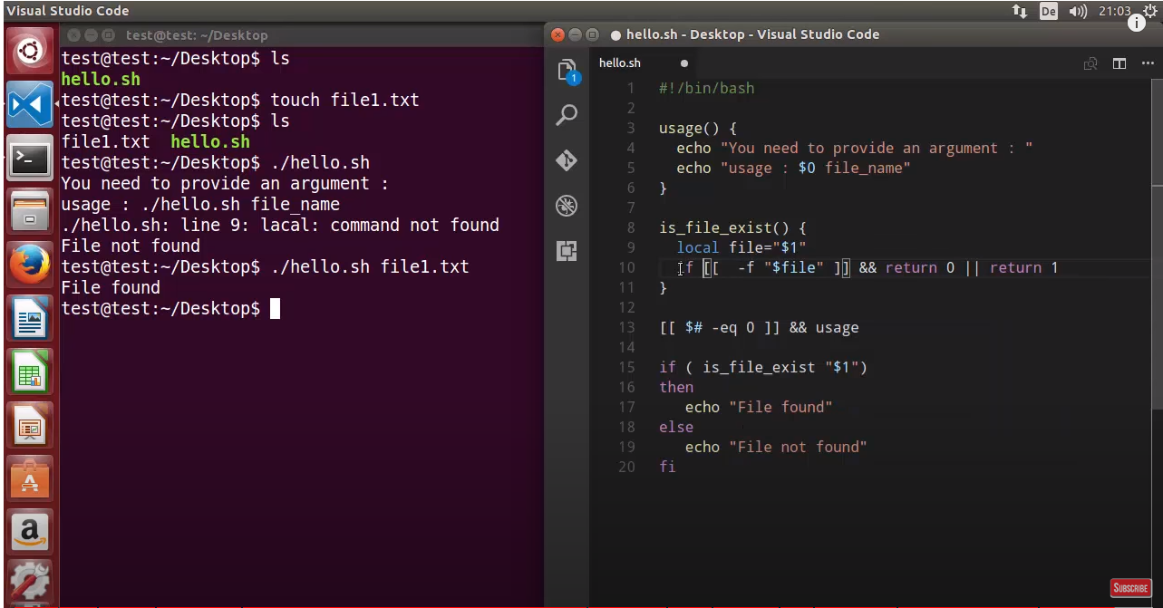
READ_ONLY VARIABLE:
if any variable is assigned to read only variable then we can not reassign to that variable.
SCRIPT:34: vim readonly_command.sh
#! /bin/bash
var=31
readonly var
var=50
OUTPUT:
Ubuntu@ubuntu-IdeaPad-3-15ITL6:~/shellscripts$ ./readonly_command.sh
./readonly_command.sh: line 7: var: readonly variable
SCIRPT:35:
#! /bin/bash
var=31
readonly var
var=50
echo "var => $var"
OUTPUT:./readonly_command.sh
./readonly_command.sh: line 7: var: readonly variable
var => 31

FUNCTIONS READ ONLY
In order to make the fucntions read only we need to add another flag called as -f flag.
SCRIPT:36: vim readonly_command.sh
#! /bin/bash
var=31
readonly var
var=50
echo "var => $var"
hello() {
echo "hello world"
}
readonly -f hello
hello() { # overriding the function again.
echo "hello world again"
}
OUTPUT:
./readonly_command.sh
./readonly_command.sh: line 7: var: readonly variable
var => 31
./readonly_command.sh: line 19: hello: readonly function

# if the variable or a function is read only we can not override those.
SCRIPT:37:vim readonly_command.sh
#! /bin/bash
var=31
readonly var
var=50
echo "var => $var"
hello() {
echo "hello world"
}
readonly -f hello
hello() {
echo "hello world again" # overriding the function again.
}
readonly #gives all the readonly default variablesbuilt-in inside bash
readonly -p #also gives the same result same as readonly.
readonly -f # gives the result of all readonly built in functions in system.
OUTPUT:
./readonly_command.sh
./readonly_command.sh: line 7: var: readonly variable
var => 31
./readonly_command.sh: line 19: hello: readonly function
declare -r BASHOPTS="checkwinsize:cmdhist:complete_fullquote:extquote:force_fignore:globasciiranges:hostcomplete:interactive_comments:progcomp:promptvars:sourcepath"
declare -ar BASH_VERSINFO=([0]="5" [1]="1" [2]="16" [3]="1" [4]="release" [5]="x86_64-pc-linux-gnu")
declare -ir EUID="1000"
declare -ir PPID="31446"
declare -r SHELLOPTS="braceexpand:hashall:interactive-comments"
declare -ir UID="1000"
declare -r var="31"
declare -r BASHOPTS="checkwinsize:cmdhist:complete_fullquote:extquote:force_fignore:globasciiranges:hostcomplete:interactive_comments:progcomp:promptvars:sourcepath"
declare -ar BASH_VERSINFO=([0]="5" [1]="1" [2]="16" [3]="1" [4]="release" [5]="x86_64-pc-linux-gnu")
declare -ir EUID="1000"
declare -ir PPID="31446"
declare -r SHELLOPTS="braceexpand:hashall:interactive-comments"
declare -ir UID="1000"
declare -r var="31"
hello ()
{
echo "hello world"
}
declare -fr hello

USAGE OF TRAP COMMAND IN THE SCRIPT:
The trap command provides the script to captures an interrupt (signal) and then clean it up within the script. First the signals described in the original POSIX.1-1990 standard. Signal Value Action Comment
1 2 3 4 5 6 7 8 9 -----------------> refes to signal values
-------------------------------------------------------------------------------------------
SIGHUP 1 Term Hangup detected on controlling terminal or death of controlling process
SIGINT 2 Term Interrupt from keyboard
SIGQUIT 3 Core Quit from keyboard
SIGILL 4 Core Illegal Instruction
SIGABRT 6 Core Abort signal from abort(3)
SIGFPE 8 Core Floating-point exception
SIGKILL 9 Term Kill signal
SIGSEGV 11 Core Invalid memory reference
SIGPIPE 13 Term Broken pipe
SIGALRM 14 Term Timer signal from alarm(2)
SIGTERM 15 Term Termination signal
SIGUSR1 30,10,16 Term User-defined signal 1
SIGUSR2 31,12,17 Term User-defined signal 2
SIGCHLD 20,17,18 Ign Child stopped or terminated
SIGCONT 19,18,25 Cont Continue if stopped
SIGSTOP 17,19,23 Stop Stop process
SIGTSTP 18,20,24 Stop Stop typed at terminal
SIGTTIN 21,21,26 Stop Terminal input for background process
SIGTTOU 22,22,27 Stop Terminal output for background process
SCRIPT 38:
#! /bin/bash
echo " pid is $$"
while (( Count < 10))
do
sleep 10
(( COUNT ++ ))
echo $COUNT
done
exit 0
# our script is printing numbers sequentialy, it was interrupted by pressing ctr
l+c.
#ctrl+c is called as interrupt signal
#aslo called as SIGINT
#ctrl+z also interrups the script
#command # $kill -9 pid will also stop the script.
OUTPUT:
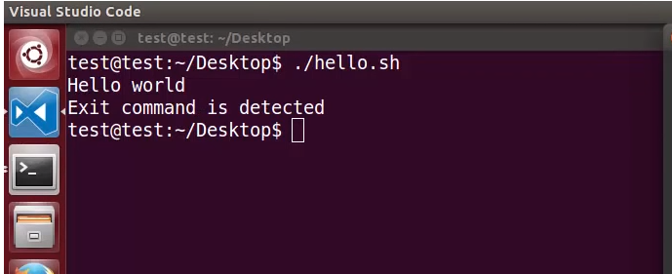
SCRIPT39: using sigint signal in the script:
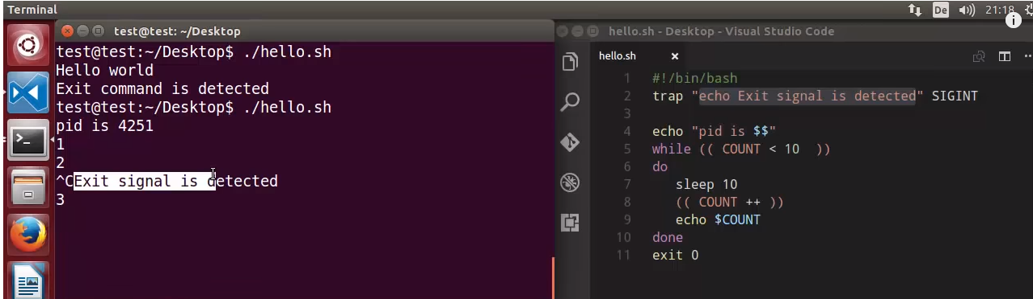

SCRIPT 40:
Trap command can not catch the SIGSTOP and SIGKILL signals. These two signals are the exceptions for the trap command.
#do not use these commands when you dont wat to stop execution.
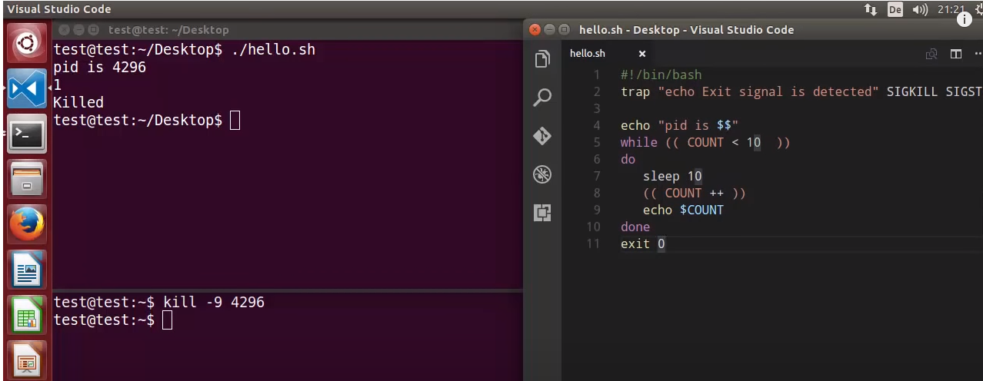
SCRIPT:41:
The below script is designed, if the file is interrupte by using ctrl+c or ctrl+z or kill -9 pid commands then the file.txt will be deleted.
#trap can trap multiple signals.
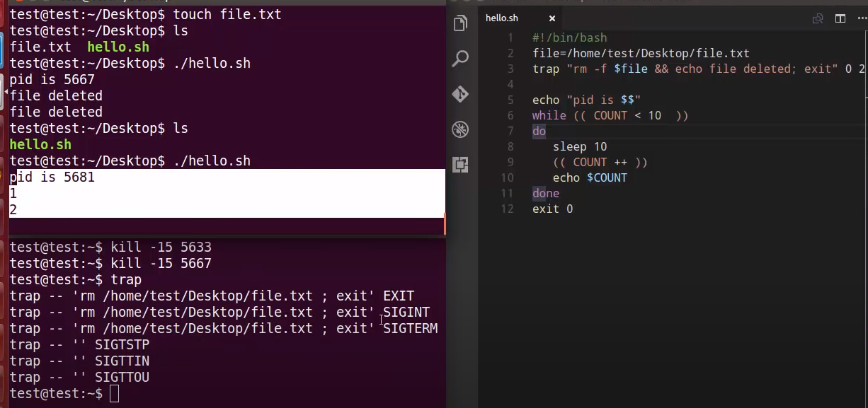
During the exection if you used the trap command it give you what are the signals that are added in the script.HOW CAN WE REMOVE THE TRAPS:
we can remove the traps by using the command line using the command.
- minus is to remove the traps 0 2 15 are values for the traps.
$ trap – 0 2 15
$trap #check by using the trap command.
HOW TO DEBUG A BASH SCRIPT:
SCRIPT:42:
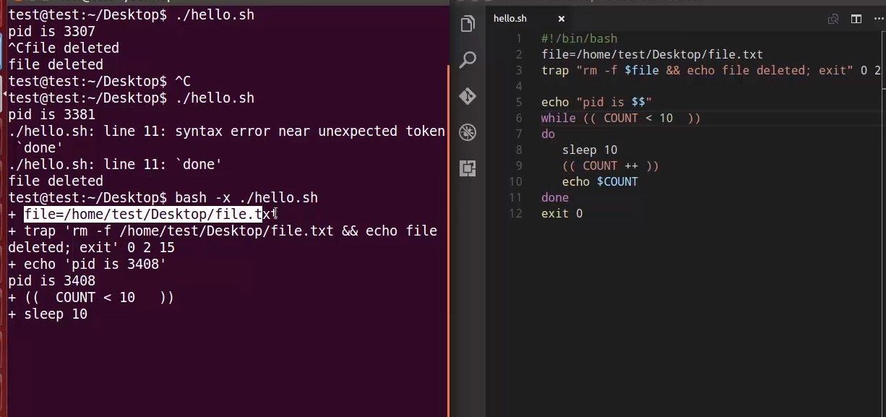
.
there is a syntax error in the 11’th line.
To get the accurate error we use the debug mode in the cli:
$ bash -x scriptname
SCRIPT:43:
#! /bin/bash -x -> in the script will open a debug mode.
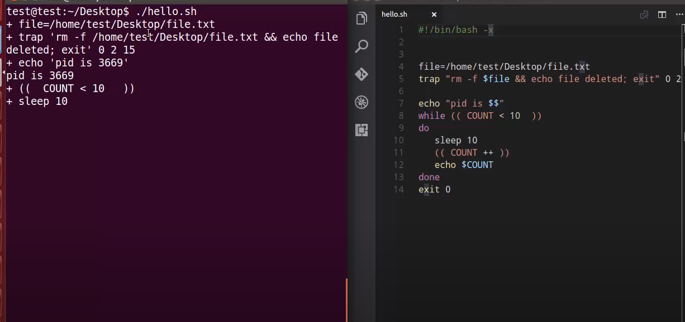
.
SCRIPT:44: USING SET -X
SET -X
COMMANDS
SET +X
IT WILL DEBUG TILL THE AREA.
