->In ubuntu to open a terminal the shortcut is ctrl + alt + t
->cat /etc/shells ->displays all the shells that support for your linux.
/bin/sh
/bin/bash
/usr/bin/bash
/bin/rbash
/usr/bin/rbash
/usr/bin/sh
/bin/dash
/usr/bin/dash
->code . Command will directly open the visual studio.
-> there are two types of variables in shell scripting
1. SYSTEM VARIABLES - > System variables, also known as environment variables, are predefined variables that are set by the operating system or system environment. These variables store information about the system configuration, user settings, and more. Some common system variables in Unix-like systems include:
  - PATH: Stores a list of directories where executable files are located. It determines which commands the shell can find and execute.
  - HOME: Stores the path to the user's home directory.
  - USER: Stores the username of the currently logged-in user.
  - SHELL: Specifies the default shell for the user.
  - PWD: Stores the current working directory.
You can access the values of these system variables in your shell script by prefixing them with a dollar sign ($), like this: $HOME or $PATH.
2. USER DEFINED VARIABLES -> User-defined variables are variables that you create and set within your shell script. These variables allow you to store and manipulate data specific to your script's requirements. To create a user-defined variable, you simply assign a value to a variable name.
-> read -p ‘username : ‘ user_var -> p refers to we can give the input in the same line in the runtime.
-> read -sp ‘password : ‘ pass_var ->here s refers to it , the input we type is not visible on the screen.
SCRIPT EG 1: HERE -a flag refers to , it stores the values in the array format.
-> #! /bin/bash
read -a names
echo “ name : {names[0]} , {names[1]} “
output:
enter names:
tom max
name : tom , max

SCRIPT EG 2 : Empty variable declaration
#!/bin/bash
echo “enter name”
read
echo “ name : $REPLY “
DESCRIPTION :
In the above code we did not declared any variable beside the read , $REPLY is the default variable where our input goes into it.
->PASS ARGUMENT TO A BASH SCRIPT : script name : hello.sh
SCRIP EG3:
#!/bin/bash
echo $1 $2 $3 “ > echo $1 $2 $3“
OUTPUT :
./hello.sh anu manu banu
here 0’th argument is ./hello.sh ,1,2,3 are anu,manu,banu.
SCRIPT EG4 :
#!/bin/bash
echo "$0 $1 $2 $3 > echo $1 $2 $3"
args=("$@")
echo "${args[0]} ${args[1]} ${args[2]} ${args[3]}"
DESCRIPTION:
args=("$@"): This line creates an array named args and assigns it the values of all the command-line arguments passed to the script ($@). This allows you to access the arguments as elements of an array.
OUTPUT:
./hello.sh anu manu banu
./args.sh anu banu manu > echo anu banu manu
anu banu manu
OUTPUT DESCRIPTION:
echo "${args[0]} ${args[1]} ${args[2]} ${args[3]}"
- ${args[0]} corresponds to the first element of the array, which is "anu."
- ${args[1]} corresponds to the second element of the array, which is "banu."
- ${args[2]} corresponds to the third element of the array, which is "manu."
- ${args[3]} corresponds to the fourth element of the array, which doesn't exist in this case.

SCRIPT5: PRINTING OUTPUT BY USING THE DEFAULT ARGUMENT $@:
#!/bin/bash
echo "$0 $1 $2 $3 > echo $1 $2 $3"
args=("$@")
#COMMENTED echo "${args[0]} ${args[1]} ${args[2]} ${args[3]}"#
echo $@
OUTPUT:
There is no change in the output compared to script5 , it prints the same ar1,arg2,arg3.
./args.sh anu banu manu > echo anu banu manu
anu banu manu
anu banu manu
SCRIPT6: PRINTING THE NUMBER OF ARGUMENTS PASSED IN THE SCRIPT BY USING A DEFAULT VARIABLE CALLED #:
#!/bin/bash
echo "$0 $1 $2 $3 > echo $1 $2 $3"
args=("$@")
echo "${args[0]} ${args[1]} ${args[2]} ${args[3]}"
echo $@
echo $#
OUTPUT:
./args.sh anu banu manu > echo anu banu manu
anu banu manu
anu banu manu
3

Expressions An expression can be: String comparison, Numeric comparison, File operators and Logical operators and it is represented by [expression]: String Comparisons:
---------------------------------
= compare if two strings are equal
!= compare if two strings are not equal -
n evaluate if string length is greater than zero
-z evaluate if string length is equal to zero
Examples:
[ s1 = s2 ] (true if s1 same as s2, else false)
[ s1 != s2 ] (true if s1 not same as s2, else false)
[ s1 ] (true if s1 is not empty, else false)
[ -n s1 ] (true if s1 has a length greater then 0, else false)
[ -z s2 ] (true if s2 has a length of 0, otherwise false)
-z refers to null.
Number Comparisons:
------------------------------------
-eq compare if two numbers are equal
-ge compare if one number is greater than or equal to a number
-le compare if one number is less than or equal to a number
-ne compare if two numbers are not equal
-gt compare if one number is greater than another number
-lt compare if one number is less than another number
Examples:
[ n1 -eq n2 ] (true if n1 same as n2, else false)
[ n1 -ge n2 ] (true if n1greater then or equal to n2, else false)
[ n1 -le n2 ] (true if n1 less then or equal to n2, else false)
[ n1 -ne n2 ] (true if n1 is not same as n2, else false)
[ n1 -gt n2 ] (true if n1 greater then n2, else false)
[ n1 -lt n2 ] (true if n1 less then n2, else false)
In shell scripting, `if` statements are used to perform conditional execution of code based on the evaluation of a condition. The choice between using `[ ]` (brackets) or `(( ))` (double parentheses) depends on the type of condition you want to evaluate.

USE OF square brackets [] and double paranthesis (()) in if condition:

1. **`[ ]` (Brackets) for String and File Tests:**

- Use `[ ]` (brackets) for performing string comparisons and file-related tests in `if` statements.

Examples:

- String comparison:
```bash
if [ "$var1" = "$var2" ]; then
echo "Strings are equal."
fi
```

- File existence check:
```bash
if [ -f "$file_path" ]; then
echo "File exists."
fi
```

2. **`(( ))` (Double Parentheses) for Arithmetic Expressions:**

- Use `(( ))` (double parentheses) for evaluating arithmetic expressions in `if` statements.

Examples:

- Arithmetic comparison:
```bash
if (( num1 > num2 )); then
echo "num1 is greater than num2."
fi
```

- Arithmetic operations:
```bash
if (( result = num1 + num2 )); then
echo "The sum is $result."
fi
```
3.
[[]] (Double Brackets):
Double brackets, [[]], are an enhanced version of single brackets and are often used for more complex conditional expressions. They provide extended functionality, including pattern matching and logical operators (&&, ||) without needing to escape them. They are also more forgiving with variables that may be unset or empty. Here's an example:
bashCopy code
if [[ "$string" == "hello" && "$number" -gt 10 ]]; then
echo "Both conditions are true"
fi
In this example, we're checking if the string is "hello" and the number is greater than 10.
In summary:
- Use [ ] for basic string and numeric comparisons in shell scripts.
- Use [[]] for more complex conditional expressions, pattern matching, and logical operators.
- Use (( )) for arithmetic comparisons and calculations involving numeric values

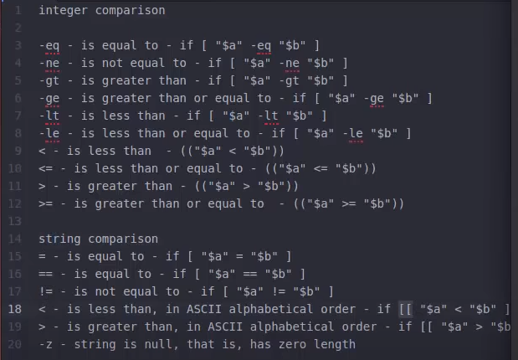
SCRIPT6:
CHECKS IF THE FILE GIVEN BY THE USER IS EXISTS OR NOT:
#!/bin/bash
echo -e "enter the file name : \c"
read file_name
if [ -e $file_name ]
then
echo "$filename found"
else
echo "$filename notfound"
fi
OUTPUT:
./filecheck.sh
enter the file name : cbbad
cbbad not found.
DESCRIPTION:
echo -e "enter the file name : \c"
Without the -e option, echo treats backslashes and the letters that follow them just like regular characters. But when you use -e, echo knows to look for these escape sequences and do what they represent. For instance, if you have \n in your text, it will actually start a new line.
In summary, the echo -e line in your script is used to print a prompt to the user asking them to enter a file name. The -e option is used to enable the interpretation of escape sequences, and \c is used to prevent the newline character so that the cursor remains on the same line, making it convenient for the user to input text.
Here, filename should be replaced with the actual name of the file you want to check. The -e flag, in this context, is used to test whether the file exists in the current directory.
There are several other flags that can be used with the [ ] test command to perform various file-related checks. Some common ones include:
- -f: Checks if the file is a regular file (not a directory or a special file).
- -e – checks whether the file exists or not.
- -d: Checks if the file is a directory.
- -s: Checks if the file is not empty (has a size greater than zero).
- -r: Checks if the file is readable.
- -w: Checks if the file is writable.
- -x: Checks if the file is executable.
- -L: Checks if the file is a symbolic link.
- -S: Checks if the file is a socket.
- -p: Checks if the file is a named pipe (FIFO).
Here's an example of how you can use some of these flags:
bashCopy code
if [ -f filename ]; then
echo "The file 'filename' exists and is a regular file."
fi

if [ -d directoryname ]; then
echo "The directory 'directoryname' exists."
fi
You can combine these flags in various ways to perform more complex file checks within your Bash scripts.

SCRIPT 7:
HOW TO APPEND OUTPUT TO END OF THE TEXT FILE:
#!/bin/bash
echo -e "enter the file name : \c"
read filename
if [ -f $filename ]
then
if [ -w $filename ]
then
echo "type some text data , to quit press ctrl+d"
cat >> $filename
else
echo " the file do not have write permission"
fi
else
echo "$filename not exists"
fi
OUTPUT:
./appendtoopeof.sh
enter the file name : text
type some text data, to quit press ctrl+d.
hi how are you
USE OF DIFFERNCT WAYS AND OPERATIOR – a AND &&:
&& operation can be used as -a flag
eg: -a
age = 20
if [ ‘$age’ -eq 20 ] && [‘$sex’ -eq ‘m’ ]
if [ ‘$age’ -eq 20 -a ‘$sex’ -eq ‘m’ ]
eg: && - we need to use double square brackets for this
if [[ ‘$age’ -eq 20 && ‘$sex’ -eq ‘m’ ] ]
USE OF DIFFERENT WAYS OF OR OPERATIOR – o AND ||:
age=60
if [“$age” -gt 18 ] || [ “$age” -lt 30]
if [“$age” -gt 18 -o “$age” -lt 30]
if [[“$age” -gt 18 || “$age” -lt 30]]

SHELL SCRIPT TO PERFORM ARITHEMATIC OPERATIONS:
SCRIPT8: for arithematic operation we will use double paranthesis.
#!/bin/bash
num1 = 20
num2 = 5
echo $(( num1 + num2))

INSTEAD OF USING DOUBLE PARANTHESIS WE CAN USE expr :

#!/bin/bash
num1 = 20
num2 = 5
echo $( expr $num1 + $num2)
echo $( expr $num1 * $num2)

OUTPUT:
25
expr : syntax error
#We are getting the syntax error because expr treats * as a special character not a multipy operator , To avoid that we backslash \ escape character.

#!/bin/bash
num1 = 20
num2 = 5
echo $( expr $num1 + $num2)
echo $( expr $num1 \* $num2)

SCRIPT9: bc command :
#! /bin/bash
num1 = 20.5
num2 = 5
#bc command does the basic arithematic operations the command on the left handseide gives the output or prints the 20.5+5 using echo will transfer to the bc command using the pipe symbol. bc does all the arithematic operations.
echo "20.5+5" | bc
echo "20.5-5" | bc
echo "20.5*5" | bc
echo "scale=2;20.5/5" | bc
#scale is a function used in divisons that will scale the decimal points.
#here in the above line it will set upto two decimal points after point.
echo "scale=20;20.5/5" | bc
#here the scale function will set upto 20 decimal points , it will set upto 20 z
eros after point eg: 4.10000000000000000000
echo "20.5%5" | bc

script 10 : bc command with -l flag :

#! /bin/bash
num1 = 20.5
num2 = 5
#bc command does the basic arithematic operations the command on the left handseide gives the output or prints the 20.5+5 using echo will transfer to the bc command using the pipe symbol. bc does all the arithematic operations.
echo "20.5+5" | bc
echo "20.5-5" | bc
echo "20.5*5" | bc
echo "scale=2;20.5/5" | bc
#scale is a function used in divisons that will scale the decimal points.
#here in the above line it will set upto two decimal points after point.
echo "scale=20;20.5/5" | bc
#here the scale function will set upto 20 decimal points , it will set upto 20 z
eros after point eg: 4.10000000000000000000
echo "20.5%5" | bc

num = 4

#sqrt is a mathematical function , bc caluculator doesnt give output for this one , to enable and use the function we have to use a flag -l.
echo "scale=2;sqrt($num)" | bc -l
echo "scale=2;3^3" | bc -l

script 11: using CASES :

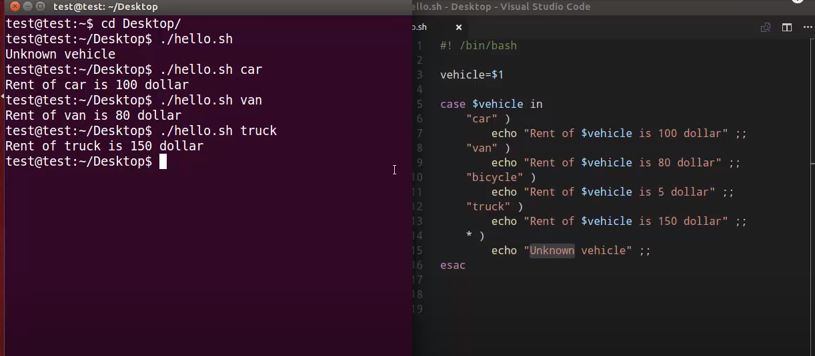
* IS THe WILD CARD IN LINUX , IT IS THE DEFAULT CONDITION.

SCRIPT-12 : CASE STATEMENT EXAMPLE TO FIND WHETHER IT WAS A-Z or a-z or 1-0 or any other special character or any string:

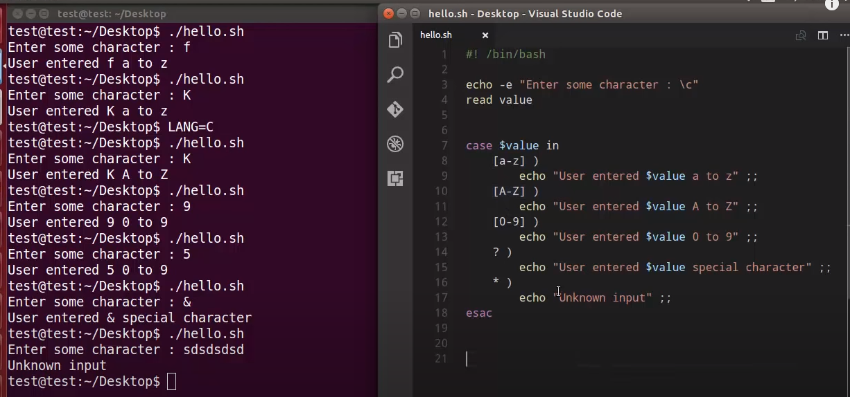

Here “?” refers to any of the special character.
* refers to if we gave any string instead of giving a character it will display output as unkowkn input.

ARRAY VARIABLES:
In shell scripting, you can work with arrays and manipulate strings in various ways. Here, we'll cover both arrays and some common string operations within shell scripts:

**1. Arrays:**

Arrays in shell scripting allow you to store multiple values in a single variable. You can access and manipulate these values individually or collectively. Bash, for example, provides support for indexed arrays.

**Declaring an array:**
```bash
my_array=("apple" "banana" "cherry")
```
**Accessing array elements:**
```bash
echo ${my_array[0]} # Prints "apple"
echo ${my_array[1]} # Prints "banana"
```
**Iterating through an array:**
```bash
for item in "${my_array[@]}"; do
echo "Fruit: $item"
done
```
**String Manipulation:**
You can manipulate strings using various shell constructs:
**Concatenating strings:**
```bash
str1="Hello, "
str2="World!"
result="$str1$str2" # Concatenates str1 and str2
echo $result
```
**Substring extraction:**
```bash
string="Hello, World!"
substring="${string:0:5}" # Extracts "Hello" from position 0 with a length of 5 characters
echo $substring
```
**Replacing a substring:**
```bash
string="Hello, World!"
new_string="${string/World/Universe}" # Replaces "World" with "Universe"
echo $new_string
```
**String length:**
```bash
string="Hello, World!"
length=${#string} # Calculates the length of the string
echo "Length: $length"
```

**Splitting strings into arrays:**
```bash
csv="apple,banana,cherry"
IFS=',' read -ra fruits <<< "$csv" # Splits the string into an array using ',' as the delimiter
echo ${fruits[0]} # Prints "apple"
echo ${fruits[1]} # Prints "banana"
```
These are some of the basic operations for working with arrays and manipulating strings in shell scripts. Depending on your specific needs, you can use these techniques to process data effectively within your scripts.
SCRIPT 13: arrayvariables.sh
#! /bin/bash
os=('ubuntu' 'windows' 'kali')
echo "${os[@]}"
echo "${os[0]}"
echo "${!os[@]}" # prints the index positions of an array
echo "${#os[@]}" # prints the lenght of an array
#Adding values to array basing on index positions
os[0]='[mac]'
#Adding array elements preceding the length of the array, eg: in the above array length is 3 and i want to add at position number 6
os[6]='debian' # printhe value debian at the 6th position and null will be assigned in the position 3 to 5 where as arrray start from zero.
# To remove an element from an Array
unset os[2]
#Arrays in strings
string=asdfghjkl
echo "${string[@]}"
echo "${string[0]}" # the whole string is attached to the oth position.
echo "${string[1]}" # in the first postion there is nothing , op is empty.
echo "${#string[@]}" # prints the length of the string as 1.
echo "${#string}" # This will correctly output 15

output:
root@ubuntu-IdeaPad-3-15ITL6:/home/ubuntu/shellscripts# ./arrayvariables.sh
ubuntu windows kali
ubuntu
0 1 2
3
asdfghjkl
asdfghjkl

1
9
While loops in the shell scripting:
script : 14 while.sh
#! /bin/bash
#while loops
n=10
while [ $n -le 116 ] #while (($n <= 116}
do
echo "$n"
n=$((n+1))
done
output:
prints from 1 to 116 numbes.
script : 15
#! /bin/bash
#while loops
n=10
while [ $n -le 116 ] #while (($n <= 116}
do
echo "$n"
((n++) #((n++) or ((++n)) can be used.
done
output:
prints from 1 to 116 numbes.

The expressions `count++` and `++count` are both used for incrementing a variable in shell scripting (e.g., Bash), but they behave differently:

1. **Post-increment (`count++`):**

- The `count++` expression is a post-increment operation.
- It increments the value of `count` by 1 after its current value is used in the surrounding expression.
- This means that the current value of `count` is returned, and then `count` is incremented.
- Here's an example:

```bash
count=5
result=$count
count++
echo "Result: $result" # Output: Result: 5
echo "Count: $count" # Output: Count: 6
```
- In this example, `count` is first assigned to `result`, so `result` contains the original value of `count` (5). Afterward, `count` is incremented by 1.

2. **Pre-increment (`++count`):**

- The `++count` expression is a pre-increment operation.
- It increments the value of `count` by 1 before its current value is used in the surrounding expression.
- This means that the incremented value of `count` is returned.
- Here's an example:

```bash
count=5
count++
result=$count
echo "Result: $result" # Output: Result: 6
echo "Count: $count" # Output: Count: 6
```
- In this example, `count` is incremented by 1 first, and then the incremented value is assigned to `result`.
In summary:
- `count++` is a post-increment operation that returns the current value and then increments.
- `++count` is a pre-increment operation that increments first and then returns the new value.
The choice between post-increment and pre-increment depends on whether you want to use the current value of the variable before or after the increment operation.
USE SLEEP IN WHILE CONDITION:
#SLEEP IN while loops
SCRIPT 16: vim whilesleep.sh
#! /bin/bash
n=10
while [ $n -le 116 ]
do
echo "$n"
n=$((n+1))
sleep 5 # the execution will pause of 5 seconds and come back to # terminal.
Done
USE GNOME IN WHILE LOOP TO DISPLAY THE N NUMBER OF TERMINALS:
SCRIPT 17: vim opentemnl2ruwhile.sh
#! /bin/bash
a=1
while(($a<=3))
do
((a++))
gnome-terminal &
done

USE XTERM IN WHILE LOOP TO DISPLAY THE N NUMBER OF TERMINALS:
SCRIPT 18: vim xtermusingwhile.sh
! /bin/bash
a=1
while(($a<=3))
do
((a++))
xterm &
done
READ A FILE CONTENT IN BASH:
1.) input redirection
2.) using cat and pipe operations.
3.) IFS- using Interal Feild Separator
SCRIPT 19 : vim readfiles.sh
# while loops using input redirections (<)
#! /bin/bash
# 1stway - input redirection
while read input
do
echo $input
done < bc.sh # the input redirection (<) reads the file and display the content in the file as output.
READ FILES USING CAT AND PIPE OPERATIONS:
SCTIPT20: vim readfilesusingcatnwhile.sh
#! /bin/bash
# while loops
ls
echo -e "which files would you like to open : \c"
read value
cat $value | while read input
# the output of the readdinput.sh will be read by the read command and stored in the input variable.
do
echo $input
done

READ FILES USING IFS , INPUT REDIRECTION (<) , AND USING WHILE LOOP:

#! /bin/bash

# read files using IFS internal feild seperator
ls
echo -e "enter the file name : \c"
read input
while IFS= read -r line #give one line space after equalto or use ' ' , the IFS use the given space as the separator.
# we are not assigning read to IFS , we are assigning ' ' to tthe IFS.
do
echo $line
done < $input
EXPLANATION:
Certainly, I'll explain how to use the Internal Field Separator (IFS) properly in Bash.

The IFS is a special variable in Bash that determines how the `read` command splits lines of text into fields. By default, IFS is set to space, tab, and newline characters, which means that `read` will split lines into words based on these characters. However, you can change the value of IFS to use a different delimiter or to disable field splitting entirely.

Here's how to use IFS properly:

1. **Changing IFS Temporarily:**
- You can change the value of IFS temporarily for a specific `read` operation. For example, to read lines delimited by commas (CSV format), you can set IFS to a comma before the `read` command:
```bash
IFS=',' read -ra fields <<< "apple,banana,cherry"
```
In this example, IFS is set to a comma, and the `read` command splits the input string into an array (`-a` option), storing each field in the `fields` array.

2. **Disabling Field Splitting:**
- If you want to read an entire line as a single field without any splitting, set IFS to an empty value before the `read` command:
```bash
IFS= read -r line
```
In this case, the entire line will be stored in the `line` variable.

3. **Restoring IFS:**
- After using a modified IFS, it's a good practice to reset it to its default value (space, tab, newline) to avoid unexpected behavior in subsequent commands. You can do this by assigning IFS back to its default value:
```bash
IFS=$' \t\n' # Reset IFS to default space, tab, newline
```
Here's an example that demonstrates the use of IFS to read and split lines based on a custom delimiter (colon):

```bash
#!/bin/bash

# Sample input string with colons as delimiters
input="Alice:Bob:Charlie"

# Set IFS to colon before reading
IFS=':' read -ra names <<< "$input"

# Iterate through the fields
for name in "${names[@]}"; do
echo "Name: $name"
done

# Reset IFS to default
IFS=$' \t\n'
```

In this script, IFS is temporarily set to a colon, and the `read` command splits the input string into an array named `names`. Then, we iterate through the array to print each name. Finally, we reset IFS to its default value.
Remember that modifying IFS affects the behavior of subsequent `read` commands, so be cautious and reset it when you're done with your specific requirements.
The `-r` option is used with the `read` command in Bash to interpret backslashes (`\`) in the input as literal characters, preventing them from escaping special characters. It is particularly useful when you want to read input that may contain escape sequences, such as backslashes followed by another character.

Here's why you might use the `-r` option with `read`:

1. **Escaping Backslashes:** By default, when you don't use the `-r` option, the `read` command interprets backslashes as escape characters. For example, if you have an input string like `"Hello\nWorld"`, without `-r`, `read` would interpret `\n` as a newline character. In contrast, with `-r`, it would treat `\n` as two separate characters: a backslash and an "n."

2. **Preserving Special Characters:** When you use `-r`, you can preserve the input exactly as it is, including any special characters or escape sequences. This is important when you're dealing with data where the literal representation of backslashes and other escape sequences is crucial.

Here's an example to illustrate the difference:

```bash
# Without -r, backslashes are interpreted
$ echo "Hello\nWorld" | while read line; do echo "$line"; done
Hello
World

# With -r, backslashes are treated as literal characters
$ echo "Hello\nWorld" | while IFS= read -r line; do echo "$line"; done
Hello\nWorld
```

In the first example (without `-r`), the `read` command interprets `\n` as a newline character, resulting in two separate lines of output. In the second example (with `-r`), `\n` is treated as a literal sequence, preserving the input as-is.

In many cases, you'll want to use `-r` when reading input to ensure that you maintain the integrity of the data, especially when dealing with file paths, regular expressions, or any content that includes backslashes or escape sequences.
DIFFERENCE BETWEEN WHILE AND UNTIL LOOPS:
- While Loop:
  - Condition: In a while loop, the loop continues executing as long as the specified condition evaluates to true (exit status 0). In other words, it executes the loop block while the condition is true.
  - Example: The loop executes while the condition is met.
bashCopy code
while [ condition ]; do
# Loop commands
done
- Until Loop:
  - Condition: In an until loop, the loop continues executing as long as the specified condition evaluates to false (exit status non-zero). It executes the loop block until the condition becomes true.
  - Example: The loop executes until the condition is met.
bashCopy code
until [ condition ]; do
# Loop commands
done
SCRIPT 21 : vim until.sh
#! /bin/bash
# until loops
n=1
until [ $n -gt 10 ] #(($n > 10)) also can be used
do
echo $n
((n++))
done
OUTPUT:
prints all the numbr till 10.

