CC1-TESTING

NAME : ANUPRIYA.C

REG : 727721EUAI004

1. CODE

package com.example.demo.testing;

import org.openqa.selenium.By;

import org.openqa.selenium.WebDriver;

import org.openqa.selenium.WebElement;

import org.openqa.selenium.edge.EdgeDriver;

import io.github.bonigarcia.wdm.WebDriverManager;

public class CC1 {

public static void main(String[] args) {

// **TODO** Auto-generated method stub

WebDriverManager.*edgedriver*().setup();

WebDriver driver=new EdgeDriver();

driver.get("https://www.saucedemo.com/");

driver.manage().window().maximize();

WebElement user = driver.findElement(By.*id*("user-name"));

user.sendKeys("standard_user");

WebElement pass = driver.findElement(By.*id*("password"));

pass.sendKeys("secret_sauce");

WebElement login = driver.findElement(By.*id*("login-button"));

login.click();

driver.findElement(By.*xpath*("//*[@id=\"add-to-cart-sauce-labs-backpack\"]")).click();

String cartCount = driver.findElement(By.*xpath*("/html/body/div/div/div/div[1]/div[1]/div[3]/a/span")).getText();

driver.findElement(By.*xpath*("/html/body/div/div/div/div[1]/div[1]/div[3]/a")).click();

String product = "Sauce Labs Backpack";

driver.findElement(By.*xpath*("//*[@id=\"checkout\"]")).click();

driver.findElement(By.*xpath*("//*[@id=\"first-name\"]")).sendKeys("ANU");

driver.findElement(By.*xpath*("//*[@id=\"last-name\"]")).sendKeys("PRIYA");

driver.findElement(By.*xpath*("//*[@id=\"postal-code\"]")).sendKeys("12345");

driver.findElement(By.*xpath*("//*[@id=\"continue\"]")).click();

System.***out***.println("Name of the product: " + driver.findElement(By.*xpath*("/html/body/div/div/div/div[2]/div/div[1]/div[3]/div[2]/a/div")).getText());

System.***out***.println("Price of the product: " + driver.findElement(By.*xpath*("/html/body/div/div/div/div[2]/div/div[1]/div[3]/div[2]/div[2]/div")).getText());

}

}

CONSOLE

~~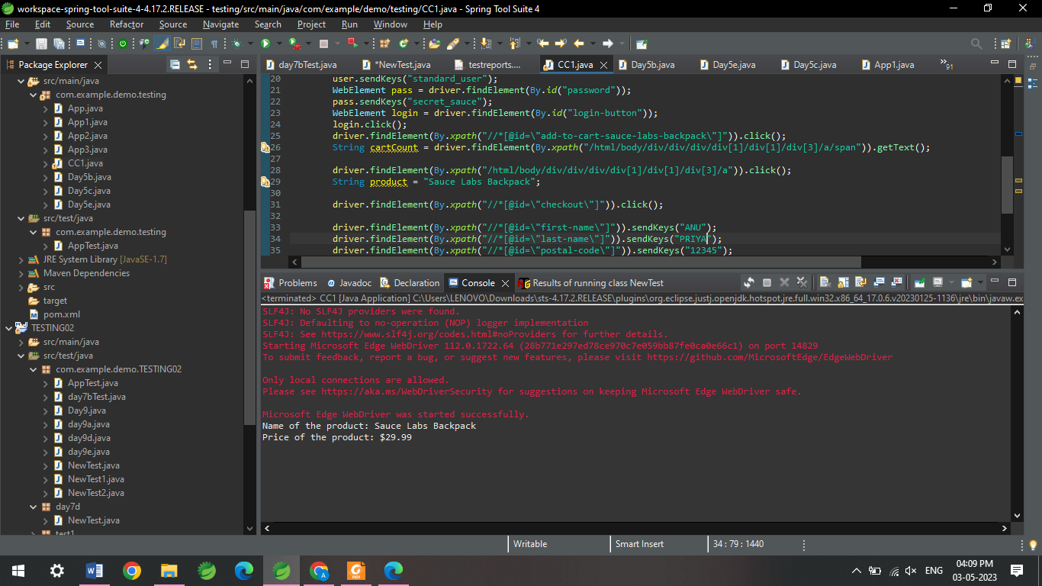~~

1. CODE
2. package com.example.demo.testing;
3. import org.openqa.selenium.By;
4. import org.openqa.selenium.WebDriver;
5. import org.openqa.selenium.WebElement;
6. import org.openqa.selenium.edge.EdgeDriver;
7. import io.github.bonigarcia.wdm.WebDriverManager;
8. public class CC1B{
9. public static void main(String[] args) throws InterruptedException {
10. WebDriverManager.*edgedriver*().setup ();
11. WebDriver driver=new EdgeDriver();
12. driver.get ("https://www.saucedemo.com/");
13. driver.manage().window().maximize() ;
14. WebElement txtBoxl=driver.findElement(By.*xpath*("//*[@id=\"user-name\"]"));
15. txtBoxl.sendKeys("standard_user");
16. WebElement txtBox2=driver.findElement(By.*xpath*("//*[@id=\"password\"]"));
17. txtBox2.sendKeys("secret_sauce");
18. driver.findElement(By.*xpath*("//*[@id=\"login-button\"]")).click();
19. String t1=driver.findElement(By.*xpath*("//*[@id=\"item_4_title_link\"]/div")).getText();
20. System.***out***.println(t1);
21. driver.findElement(By.*xpath*("//*[@id=\"header_container\"]/div[2]/div/span/select")).click();
22. driver.findElement(By.*xpath*("//*[@id=\"header_container\"]/div[2]/div/span/select/option[2]")).click();
23. String t2=driver.findElement(By.*xpath*("//*[@id=\"item_3_title_link\"]/div")).getText();
24. System.***out***.println(t2);
25. System.***out***.println("filter (A-Z and Z-A) used smoothly");
26. driver.findElement(By.*xpath*("//*[@id=\"header_container\"]/div[2]/div/span/select")).click();
27. driver.findElement(By.*xpath*("//*[@id=\"header_container\"]/div[2]/div/span/select/option[3]")).click();
28. String t3=driver.findElement(By.*xpath*("//*[@id=\"inventory_container\"]/div/div[1]/div[2]/div[2]/div")).getText();
29. System.***out***.println(t3);
30. driver.findElement(By.*xpath*("//*[@id=\"header_container\"]/div[2]/div/span/select")).click();
31. driver.findElement(By.*xpath*("//*[@id=\"header_container\"]/div[2]/div/span/select/option[4]")).click();
32. String t4=driver.findElement(By.*xpath*("//*[@id=\"inventory_container\"]/div/div[1]/div[2]/div[2]/div")).getText();
33. System.***out***.println(t4);
34. System.***out***.println("filter (low price- high price and high price - low price )used smoothly");
35. Thread.*sleep*(5000);
36. }
37. }

CONSOLE:

