**SYSTEM REQUIREMENT SPECIFICATION**

**FOR**

**ONLINE SHOPPING COMPLEX**

INTRODUCTION :

In this 800 acres of campus here at NIT-T , we have only one Shopping Complex.

Many hostels are too far from it, making it difficult for students from these hostels to come up to the Shopping Complex everytime they are in need of something.

The Solution : “ Online Shopping Complex ”

The simple idea of this Project is to make this Shopping Complex , **centralized** and **easily accessable** by ALL.

The Online Shopping Complex will provide a user friendly interface for students to order their products which will be delivered at their respective hostels within a given time-frame.

EXISTING SYSTEM:

The only way to purchase any product is to go upto the shop and buy it manually . There are **no online provisions**. Sometimes this can be tiring and hectic , especially when the hostels are too far away in the campus.

DRAWBACKS OF THE EXISTING SYSTEM

1. TIME CONSUMING
2. TIRING

NEW SYSTEM:

1. The system is all about converting the Shopping System from manual to online.
2. Students can order products online from their hostels.
3. The products will be delivered at their respective hostels.
4. Administrator can ADD, REMOVE or EDIT product details.
5. Students/ Customers can write Feedback.
6. Administrator adds delivery reports to the Database.

SYSTEM REQUIREMENT SPECIFICATIONS:

The USERS

1. General Public
2. Student (customer)
3. Administrator [ currently not added ]

GENERAL PUBLIC , can use the system to view the products, their prices and quantity. They cannot purchase any item.

STUDENTS , can view and purchase products. They can also give Feedback.

ADMINISTRATOR , can add, edit and delete products. He can view daily sell and maintain deliveries.

DATA FLOW DIAGRAMS:

GENERAL USER

DATABASE

REQUESTS

SERVER

ADMIN.

STUDENT / CUSTOMER

CONTEXT ANALYSIS DIAGRAM

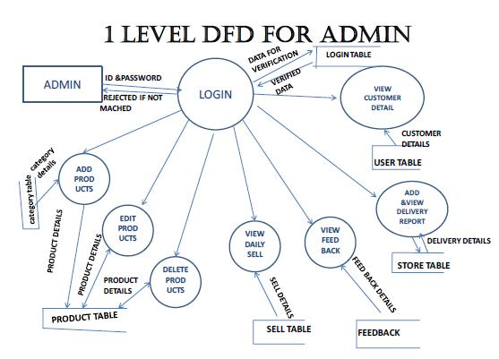

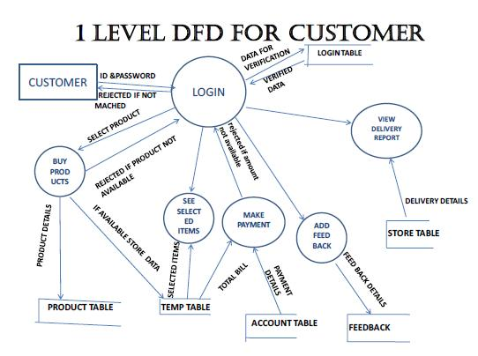

**ER DIAGRAM:**

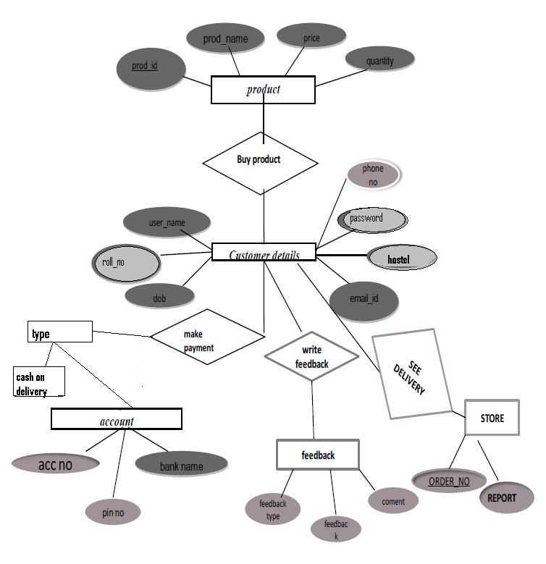

DATABASE DESIGN:

A database design is a collection of stored data organized in such a way that the data requirements are satisfied by the database. The general objective is to make information access easy, quick, inexpensive and flexible for the user.

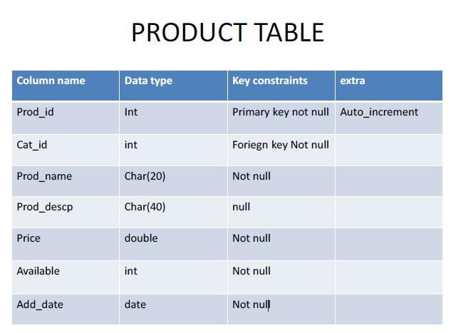

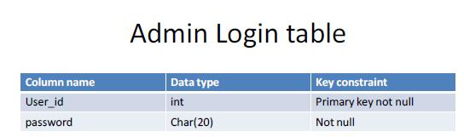

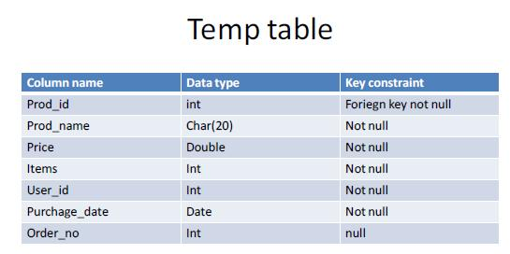

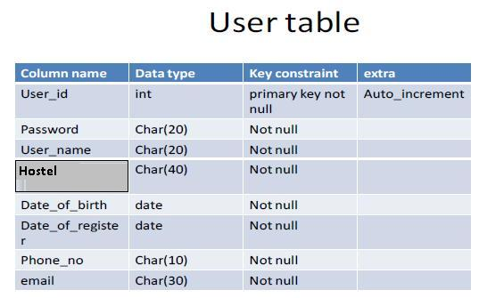

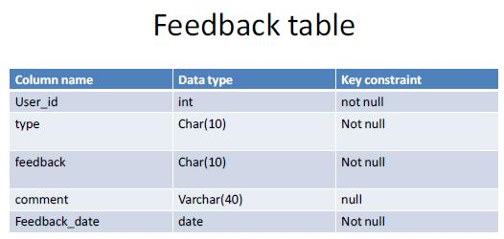

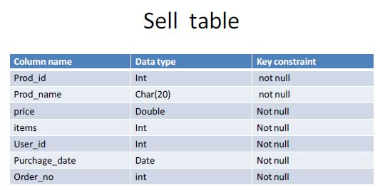

UNIFIED MODELLING LANGUAGE (UML) DIAGRAMS:

**USE CASE DIAGRAMS:**

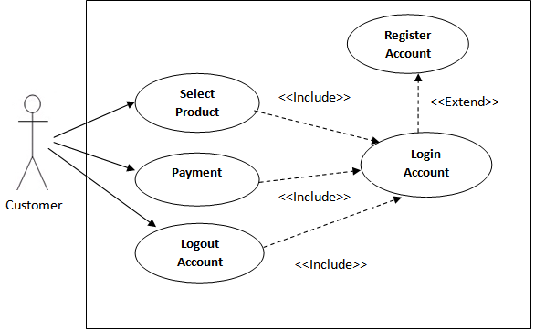

**Log-in account**

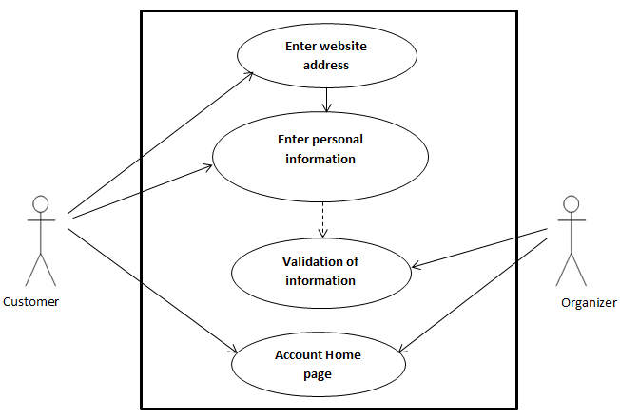

**Select Products**

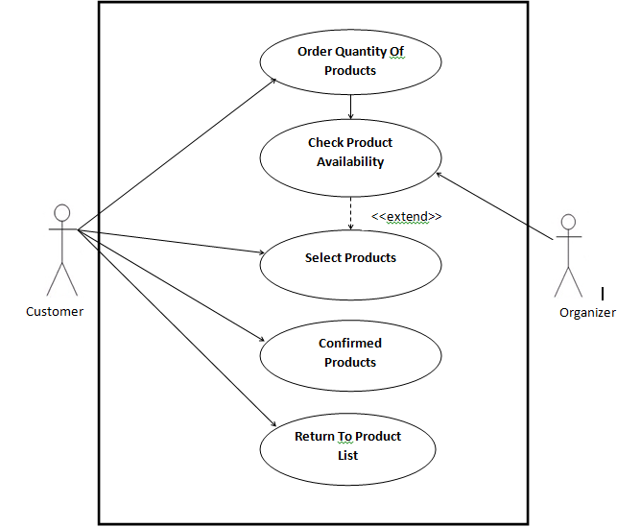

**Payment:**

**Cash on Delivery**

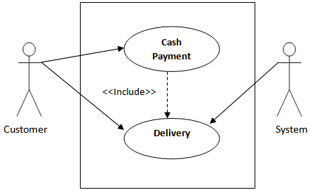

**Logout account**

