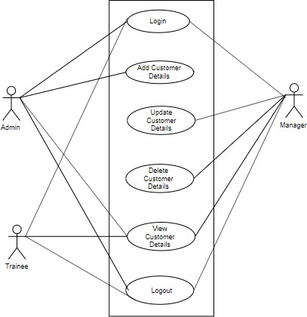
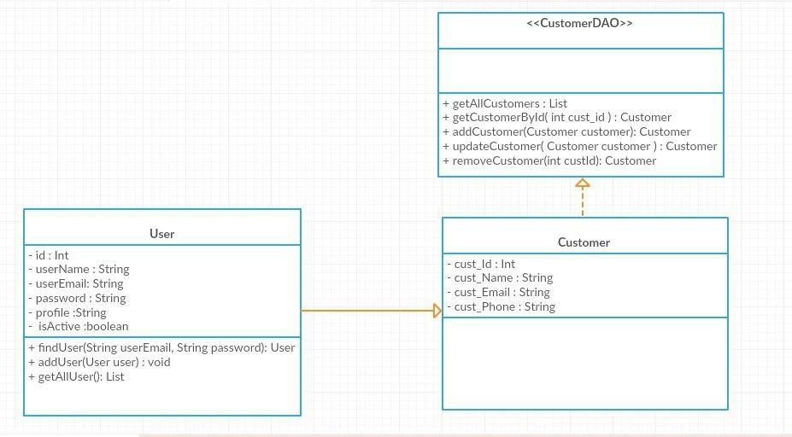

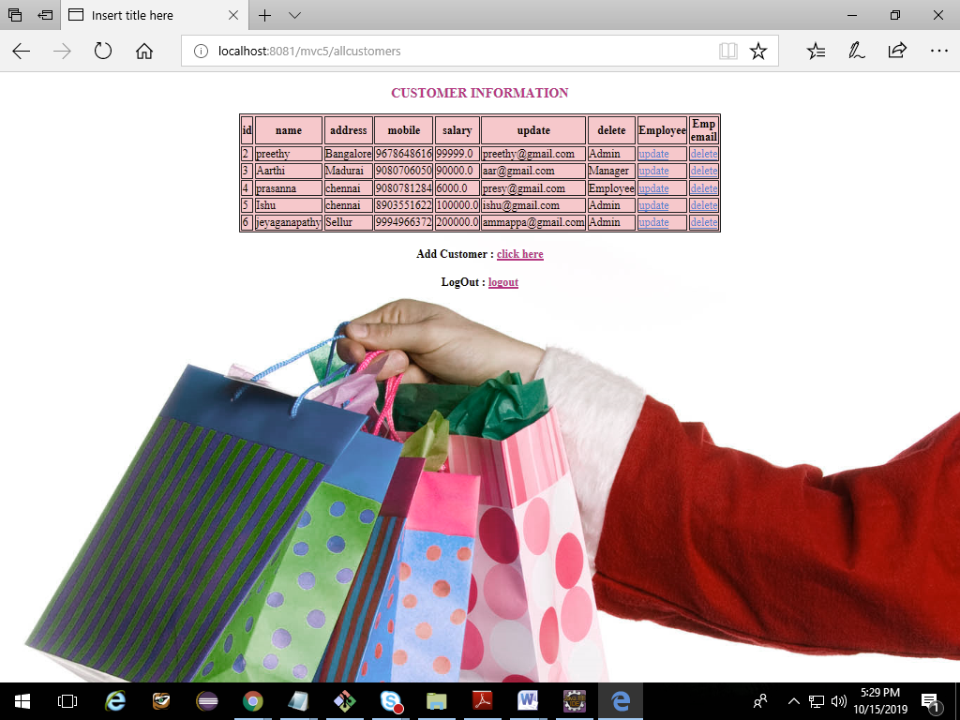
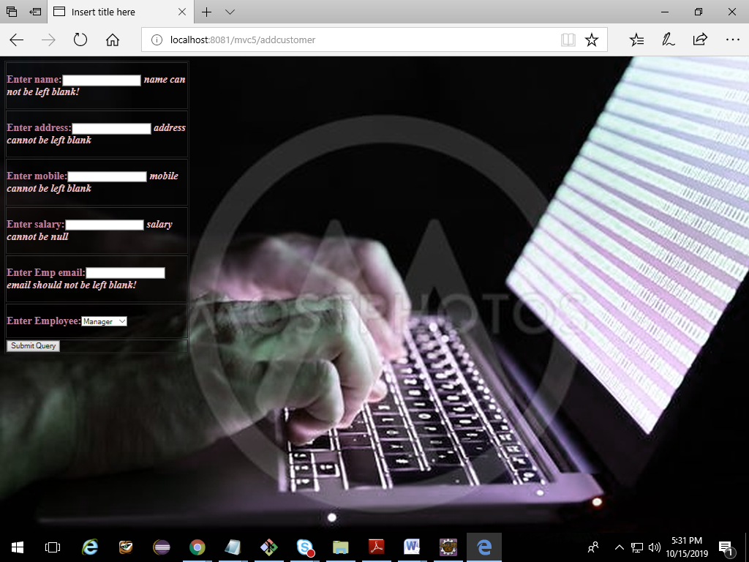
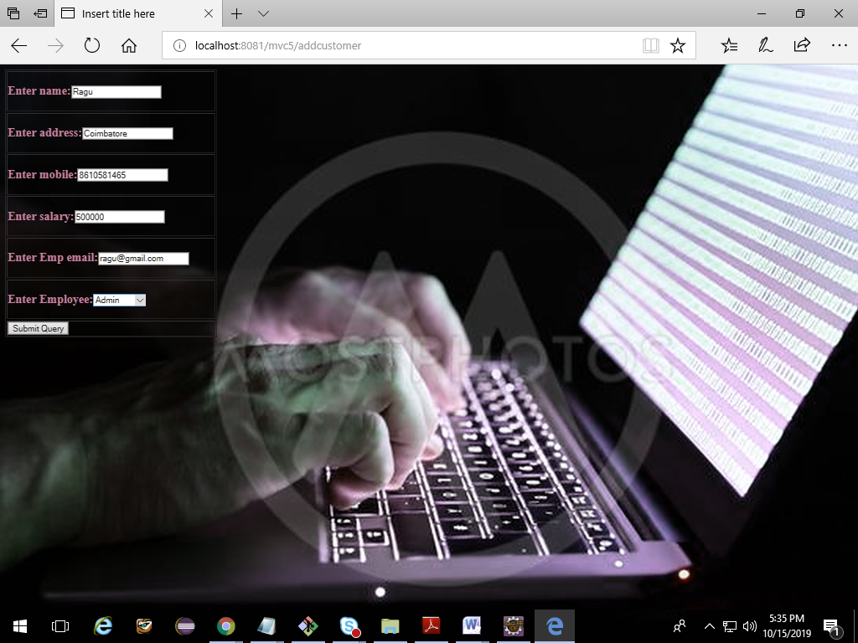
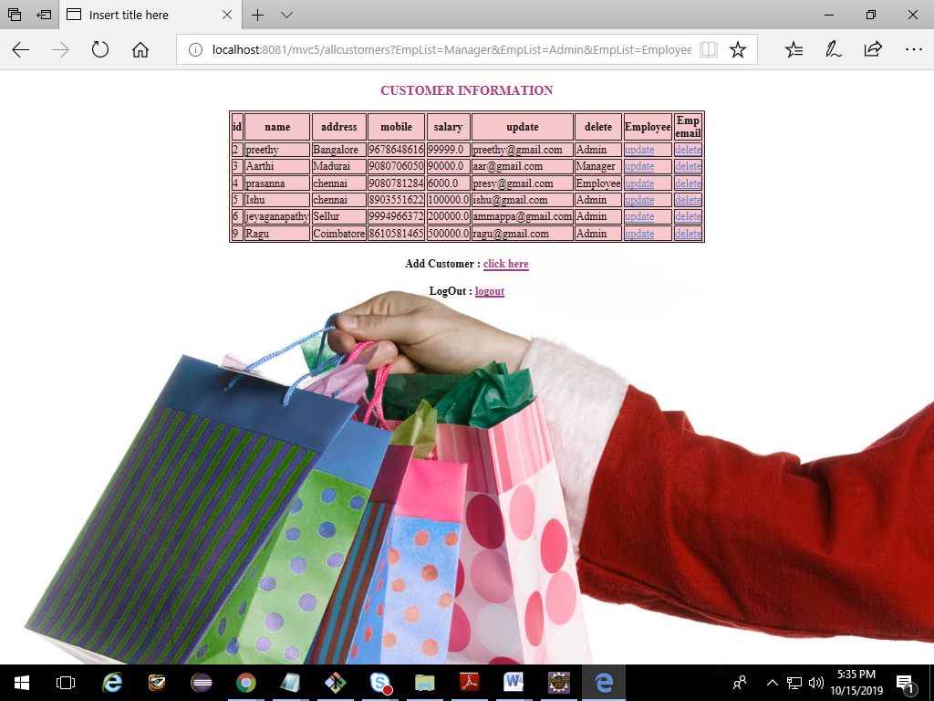
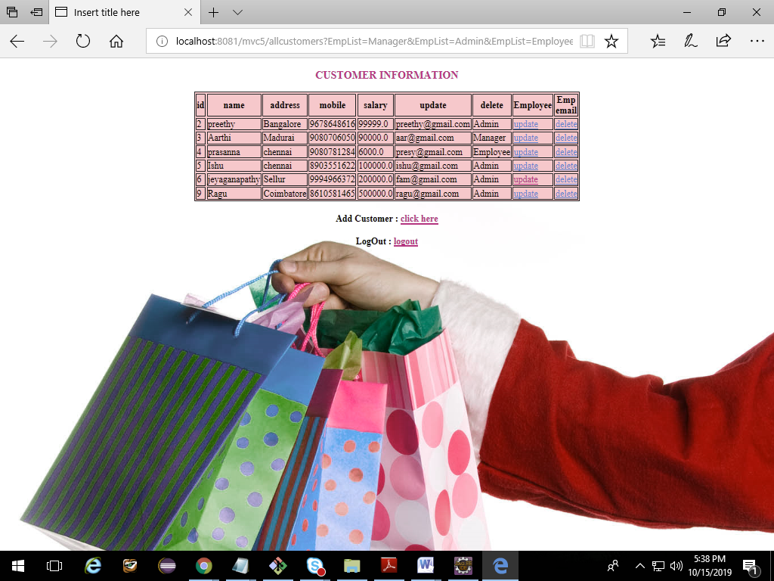
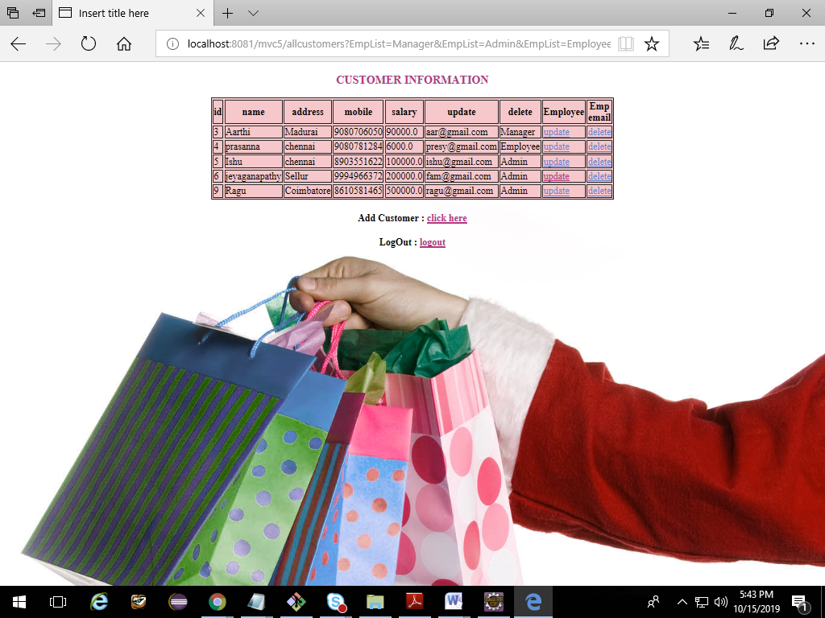
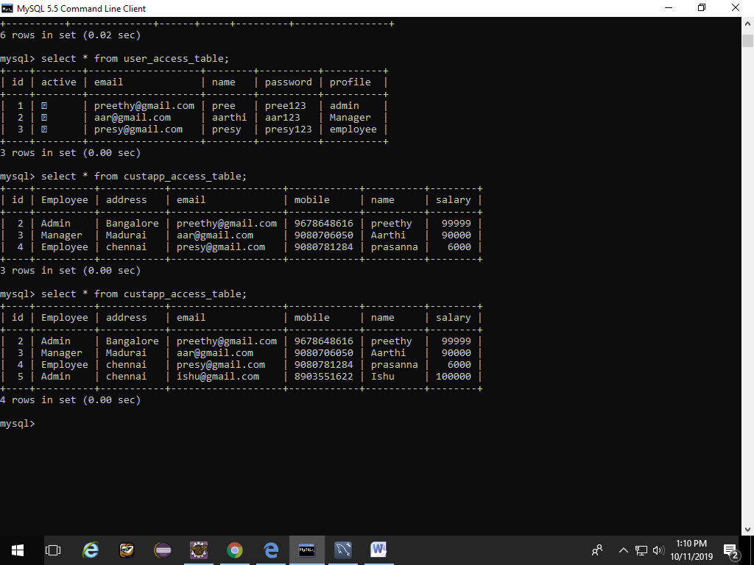

CUSTOMER MANAGEMENT SYSTEM
(CRUD OPERATIONS)

SUBMITTED BY
M.Anusha
(SAP-Id-51820783)

TABLE OF CONTENTS

CHAPTER.NO | TITLE
1 | ABSTRACT
2 | PROJECT DOCUMENTATION  - PROJECT MANAGEMENT PLAN  - REQUIREMENT SPECIFICATIONS  - ANALYSIS  - DESIGN  - IMPLEMENTATION
3 | FIGURES  - USE CASE DIAGRAM  - CLASS DIAGRAM  - SCREENSHOTS
4 | CONCLUSION

ABSTRACT

A Customer Application System is created which comprise an MVC application that stores and displays data using Spring and Hibernate Framework and MYSQL Server Local DataBase. It also customize create, read, update, delete (CRUD) code that the MVC scaffolding automatically creates Controllers and Views for this application.
2. PROJECT DOCUMENTATION
  - Project Management Plan

Customer Management System aims to insert,update,delete and list the customer details.The system deals with three user profiles-Admin, Manager, Employee where admin can perform login and also can insert and view all the customer details, manager can add ,delete,update and view the details whereas employee can only view the customer details.

Requirements Specifications

The main requirement of the system is to manage the customer details.

Analysis

Customer Management System aims to manage the details of the customer. It consists of mainly four functionalities:

Adding Customer Details:
Adding the customer details by administrator and manager. Details includes Customer Name, Email_id, Mobile number, Address.

Updating the Customer Details:
Manager can update the details of customer.

Deleting the Customer Details:
Manager can delete the customer record.

Viewing the Customer Details:
Administrator,Manager and employee can view the customer details.

Design

Backend database of Customer Management System is hibernate. It consists of two relational tables:users and customers
User Entity:

This entity contains the properties:name,username,password,email,profile of the user and the boolean flag isactive. Username and password is used to login to the system.
User profiles can be administrator,employee and manager.

Implementation

The system is implemented using spring framework and hibernate. Front end of the system is implemented by Bootstrap.
Login Module:
User logs into the system using username and password. He/She views the system according to his profile.

3.FIGURES

  - Use Case Diagram:

  - Class Diagram
  - SCREENSHOTS

- User can Login with his credentials which include Email and Password

2. Pre-existing Customer details in database

3.Adding customer Details to the database

4.Customer details are added

5. Updating name,address and email address in the Customer details where customer_id=4

6. Deleting the Customer with id=2

7.Screenshots of Tables ( Users_table and Customer_table) in Database

4.Conclusion

The Customer Management Application is designed to manage the details of the customer, which gives the provision to add, update, remove and view the customer details as per the status of the user profile.

