**LABCYCLE-2**

**Submitted By**

**Anushree**

**S1 MCA**

**Roll No: 139**

**LABCYCLE 2**

**AIM:** Create a HTML page to explain the use of various predefined functions in a string and math object in java script.

**PROGRAM CODE:**

|  |  |
| --- | --- |
| CO2-Q1 | <html>  <head>  <title>predefining</title>  </head>  <body>  <script>  var num=Math.abs(-16)  document.write("absolute value",+num);  var str="My name is Anushree";  document.write("<br>")  document.write("char at 0 is:"+str.charAt(0));  var c=50.65  var x=Math.ceil(c)  document.write("<br>ceil value of no is:"+x);  var lw="web programming";  document.write("<br>to upper"+lw.toUpperCase());  var power=Math.pow(3,2);  document.write("<br>power of the given number is"+power);  </script>  </body>  </html> |

**Result:**

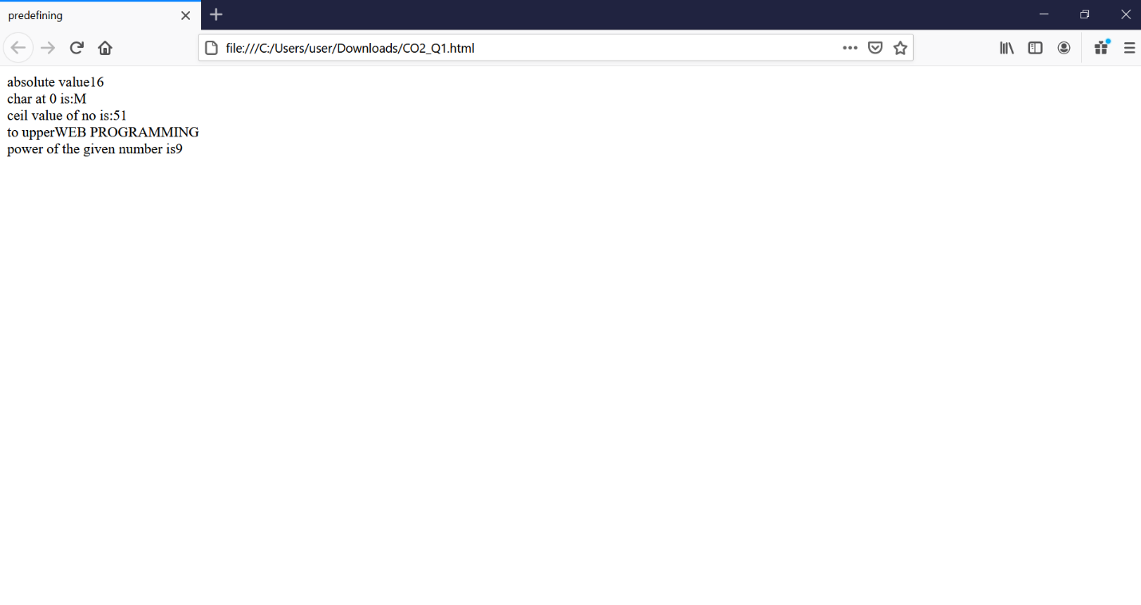

**LABCYCLE 1**

**AIM:** Demonstrate a registration form using HTML

**PROGRAM CODE:**

|  |  |
| --- | --- |
| CO2-Q2 | <html>  <head>  <script language="javascript">  function day_title(day_name)  {  document.write("<td align=center width=35 bgcolor=lightpink><b>"+day_name+"</b></td>");  }  function fill_table(month,month_len)  {  day=1;  document.write("<table border=1 cellspacing=3 cellpadding=3%>");  document.write("<td colspan=7 align=center bgcolor=red><b>"+month+" "+year+"</b><tr>");  day_title("Sun");  day_title("Mon");  day_title("Tue");  day_title("Wed");  day_title("Thu");  day_title("Fri");  day_title("Sat");  document.write("</tr><tr>");  for(var i=1; i<start_day;i++)  {  document.write("<td>");  }  for(var i=start_day; i<8;i++)  {  document.write("<td align=center bgcolor=lightyellow>"+day+"</td>");  day++;  }  document.write("<tr>");  while(day<=month_len)  {  for(var i=1; i<=7 && day<=month_len;i++)  {  document.write("<td align=center bgcolor=lightyellow>"+day+"</td>");  day++;  }  document.write("<tr>");  start_day=i;  }  document.write("</tr></table><br>");  }  year=prompt("enter 4 digit year ",2016);  today=new Date("January 1, "+year);  start_day=today.getDay()+1;  fill_table("January", 31);  if (year%4==0)  fill_table("February", 29);  else  fill_table("February", 28);  fill_table("March", 31);  fill_table("April", 30);  fill_table("May", 31);  fill_table("June", 30);  fill_table("July", 31);  fill_table("August", 31);  fill_table("September", 30);  fill_table("October", 31);  fill_table("November", 30);  fill_table("December", 31);  </script>  </head>  </html> |

**Result:**

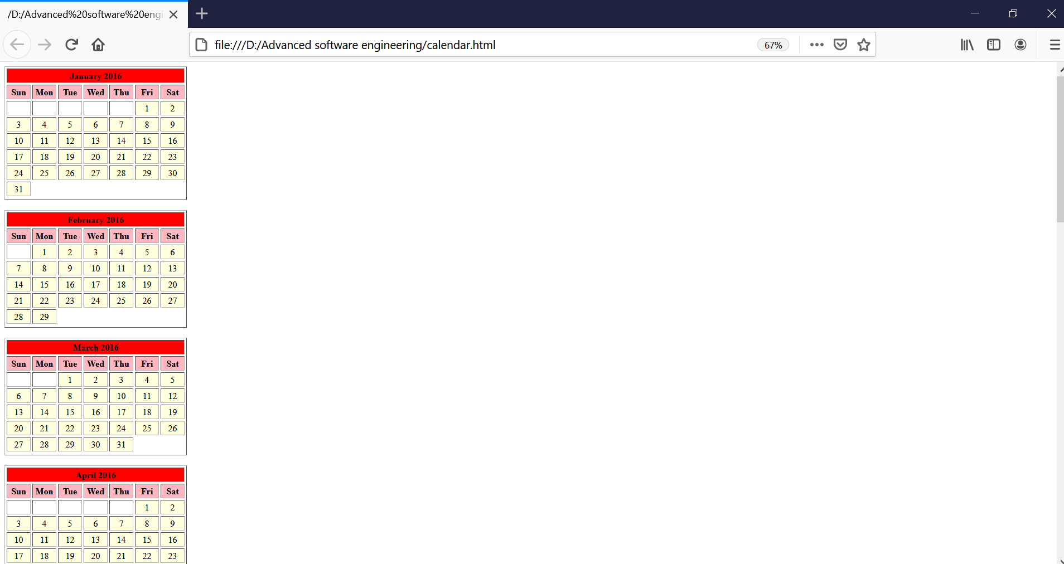

**LABCYCLE 1**

**AIM:** Create a HTML registration form and to validate the form using JavaScript code.

**PROGRAM CODE:**

|  |  |
| --- | --- |
| CO2-Q3 | <html>  <head>  <title>Registration Form</title>  </head>  <body>  <br><br>  <center>  <form name="frmRegistration" method="post" action="action.php">  <table border="0" width="800" align="center">  <tr><th colspan=2>Registration  Form</th></tr>  <tr><td>Username</td>  <td><input type="text" name="userName" value"></td> </tr>  <tr><td>First Name</td>  <td><input type="text" name="firstName" value"></td>  </tr>  <tr><td>Last Name</td>  <td><input type="text" name="lastName" value"></td>  </tr>  <tr><td>Password</td>  <td><input type="password" name="password" value=""></td>  </tr>  <tr><td>Confirm Password</td>  <td><input type="password" name="confirm_password" value=""></td>  </tr>  <tr><td>Email</td>  <td><input type="text" name="userEmail" ></td>  </tr>  <tr><td>Gender</td>  <td><input type="radio" name="gender" id="gender" value="Male" > Male  <input type="radio" name="gender" id="gender" value="Female"> Female  </td> </tr>  <tr>  <td></td>  <td><input type="checkbox" name="terms"> I accept Terms and  Conditions</td>  </tr>  <tr><th colspan=2>  <div><input type="submit" name="submit" value="Register" ></div>  </th></tr>  </table>  </form>  </body>  </html> |

**Result:**

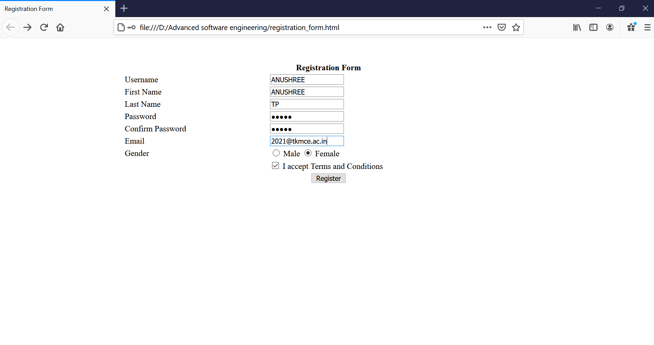

**LABCYCLE 2**

**AIM:** Evaluating JavaScript Event Handling for every click of a button to change the background color of a HTML page.

**PROGRAM CODE:**

|  |  |
| --- | --- |
| CO2-Q4 | <html>  <head>  <script type="text/javascript">  function get_random_color() {  var color = '#';  for (var i = 0; i < 6; i++ )  {  color += Math.round(Math.random())*6;  }  document.body.style.background= color;  }  </script>  </head>  <body onclick="get_random_color()">  <h1>Click me to change my color!</h1>  </body>  </html> |

**RESULT:**

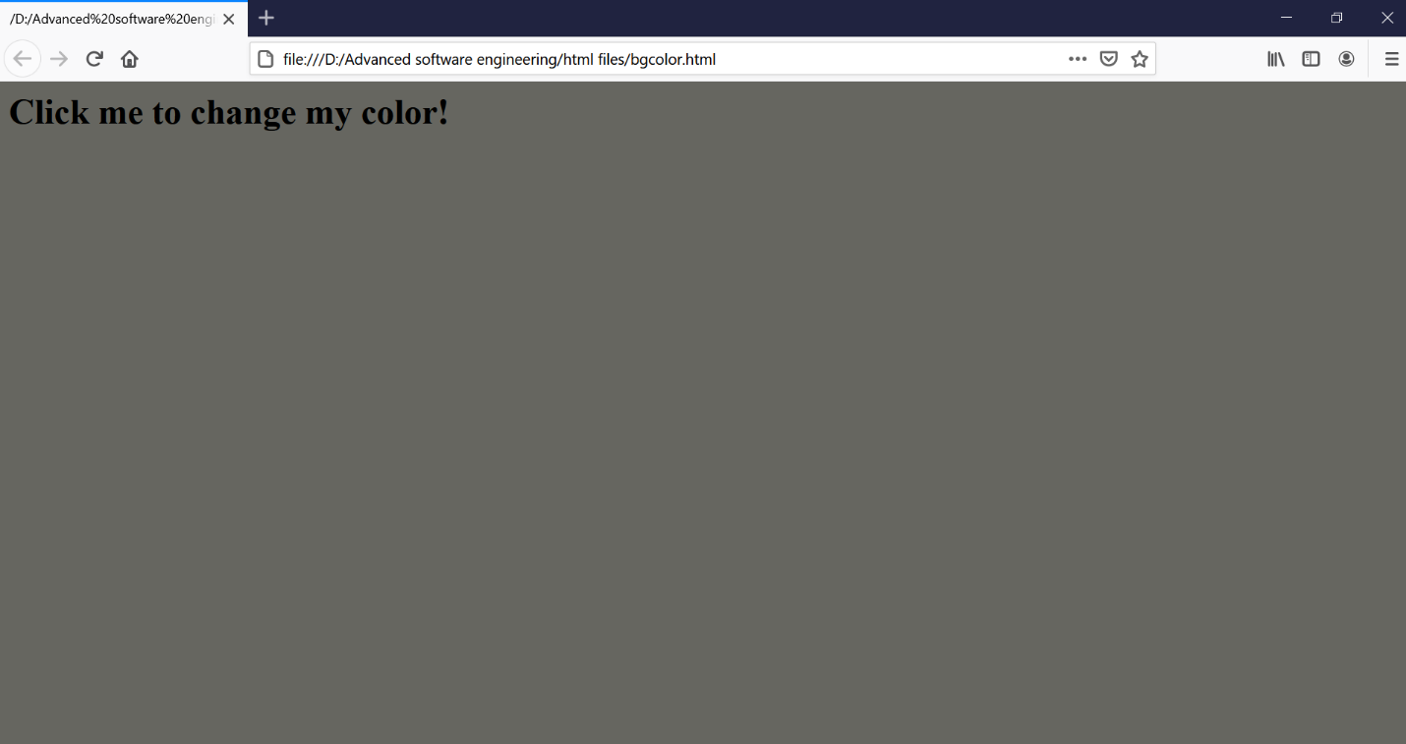

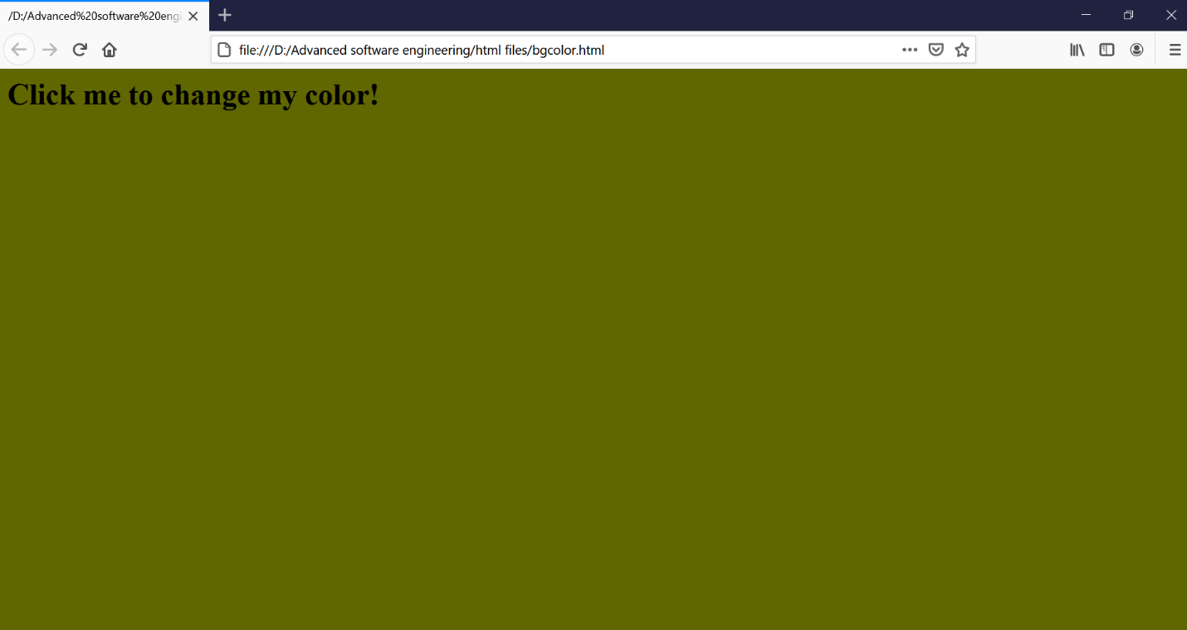

**LABCYCLE 2**

**AIM:** Create a HTML page to display a new image and text when the mouse comes over the existing content in the page using JavaScript Event Handling.

**PROGRAM CODE:**

|  |  |
| --- | --- |
| CO2-Q5 | <html>  <head>  <script language="javascript">  function preload()  {  topon=new Image(100,50);  topon.src="http://tkmce.ac.in/wp-content/themes/tkm/images/tkmce_logo.png";  topoff=new Image(260,280);  topoff.src="http://tkmce.ac.in/wp-content/uploads/2014/09/founder.png";  }  function myMouseOn(n)  {  preload();  imageON=eval(n+"on.src");  document.images[n].src=imageON;  }  function myMouseOff(n)  {  imageOFF=eval(n+"off.src");  document.images[n].src=imageOFF;  }  </script>  </head>  <body >  <h1> Demo for mouse over</h1>  <a href="#" onMouseOut="myMouseOff('top')"; onMouseOver="myMouseOn('top')";>  <img src="https://s3.amazonaws.com/images.seroundtable.com/google-rainbow-texture-1491566442.jpg" alt="Show Next" name="top">  </a>  </body>  </html> |

**Result:**

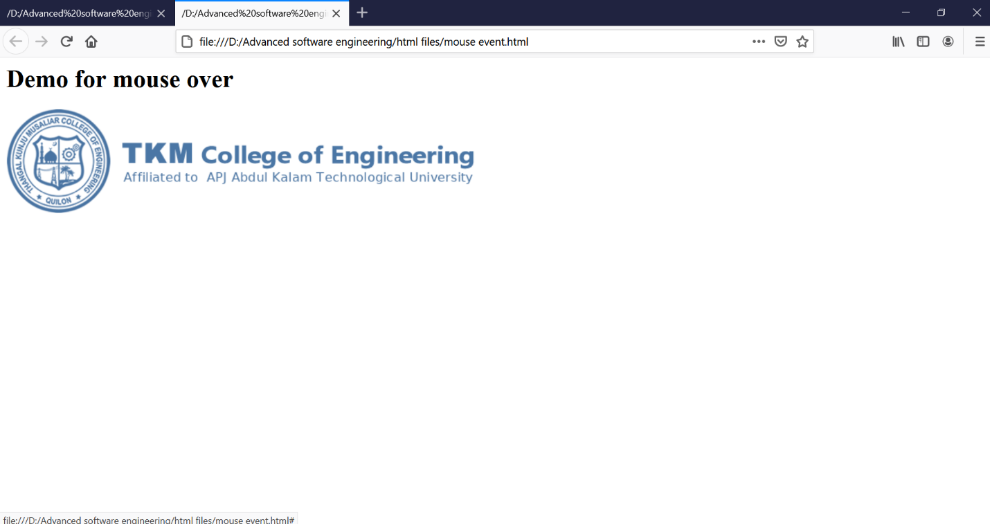

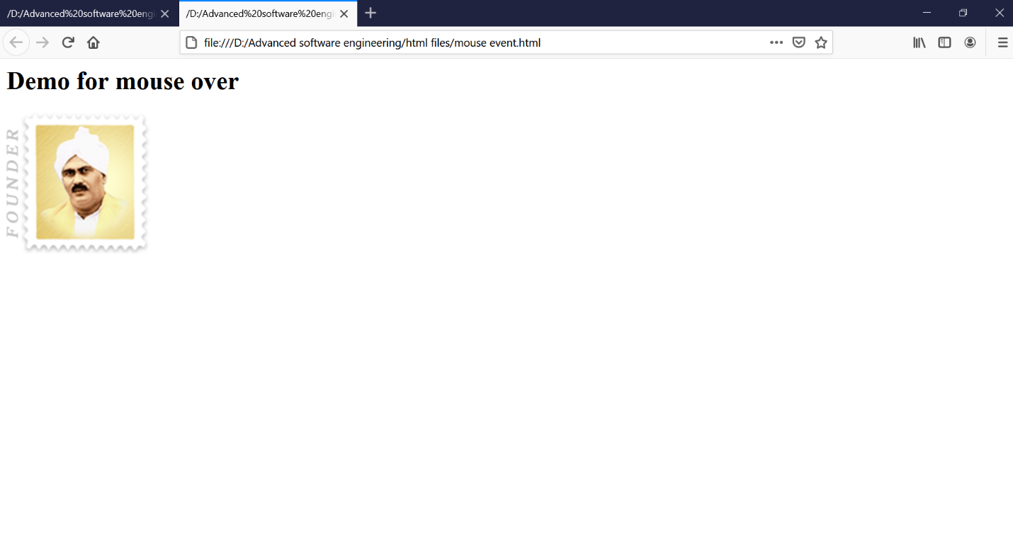

**LABCYCLE 2**

**AIM:** Create a HTML page to show online exam using JavaScript.

**PROGRAM CODE:**

|  |  |
| --- | --- |
| CO2-Q6 | <html>  <head>  <title>Exam</title>  <script language="javascript">  function exam(form)  {  var i=0;  if(form.one[2].checked)  i=i+1;  if(form.three[0].checked)  i=i+1;  if(form.four[0].checked)  i=i+1;  if(form.five[1].checked)  i=i+1;  window.alert("Thank You For Taking This Online Exam!!!! Your Score is: "+i);  }  </script>  </head>  <body bgcolor=silver>  <form onSubmit="exam(this)">  <center><h1><blink>WELCOME TO ONLINE EXAM FORM</blink></h1></center>  <p>  <h1>1)Which is platform independent language</h1>  <input type="radio" name="one" value="c++">  <label>c++</label>  <input type="radio" name="one" value="c">  <label>c</label>  <input type="radio" name="one" value="java">  <label>java</label>  <input type="radio" name="one"value="basic">  <label>BASIC</label>  </p>  <p>  <h1>2) Which is class of all class in java</h1>  <input type="radio" name="three" value="object">  <label>Object</label>  <input type="radio" name="three" value="math">  <label>Math</label>  <input type="radio" name="three" value="system">  <label>System</label>  <input type="radio" name="three" value="graphic">  <label>Graphic</label> </p>  <p>  <h1>3)Frame package is in which package</h1>  <input type="radio" name="four" value="awt">  <label>AWT</label>  <input type="radio" name="four" value="applet">  <label>Applet</label>  <input type="radio" name="four" value="lang">  <label>Lang</label>  <input type="radio" name="four" value="swing">  <label>Swing</label>  </p>  <p>  <h1>4)Java does not support</h1>  <input type="radio" name="five" value="inheritance">  <label>Inheritance</label>  <input type="radio" name="five" value="multiple inheritance">  <label>Multilple inheritance</label>  <input type="radio" name="five" value="polymorphism">  <label>Polymorphism</label>  <input type="radio" name="five" value="encryption">  <label>Encryption</label>  </p>  <p><center>  <input type="submit" value="Submit">  <input type ="reset" value="Reset">  </center></p>  </body>  </html> |

**Result:**

