🩺
Book a Doctor
A Full-Stack Healthcare Appointment Booking Platform
Project Documentation — MERN Stack
Prepared by
Anvesh Gudipalli — Team Lead
Kunasani Sravani — Team Member
Parisi Rahul — Team Member
Seelam Rukmini — Team Member
Geethika Viri Mahitha Singidi — Team Member

GitHub Repository: github.com/ANVESH-77/book-a-doctor
Live Demo: book-a-doctor-ruddy.vercel.app

1. Introduction
Project Title: Book a Doctor
Team Members:
Name | Role
Anvesh Gudipalli | Team Lead
Kunasani Sravani | Team Member
Parisi Rahul | Team Member
Seelam Rukmini | Team Member
Geethika Viri Mahitha Singidi | Team Member

Team ID:

2. Project Overview

Purpose
Book a Doctor is a full-stack healthcare appointment booking platform that connects patients with trusted healthcare providers. It allows patients to browse doctors, schedule appointments, upload medical documents, and receive real-time notifications, while doctors can manage their appointments and admins can approve doctors and monitor overall platform activity.

Features
- Authentication — JWT-based signup/login for patients, doctors, and admins
- Doctor Browsing — search and filter doctors by name or specialization
- Appointment Scheduling — patients book appointments; doctors confirm, decline, or complete them
- Secure Document Uploads — patients attach files (PDF, images, Word docs) to their appointments
- Notifications — in-app notifications for appointment status changes
- Admin Panel — approve doctors, manage users, and view platform-wide statistics

3. Architecture

Frontend
The frontend is built with React.js and React Router for client-side navigation. Axios (configured via a shared instance in src/api/axios.js) handles all HTTP communication with the backend REST API, and a React Context (AuthContext) manages the authenticated user's session and JWT token across the app. A PrivateRoute component guards role-restricted pages (patient, doctor, admin), and a shared Navbar adapts its links based on login state and role.

Backend
The backend is built with Node.js and Express.js, exposing a REST API under /api. It is organized into routes (auth, doctors, appointments, notifications, admin), Mongoose models, and middleware for authentication (JWT verification), role-based authorization, and file uploads (Multer). CORS, JSON body parsing, and request logging (Morgan) are configured centrally in server.js, along with a global error handler and a 404 fallback.

Database
MongoDB is used as the primary datastore, accessed through Mongoose schemas. The schema design follows four core collections:
- User — name, email, hashed password, role (patient / doctor / admin), phone, avatar, isActive
- Doctor — linked 1:1 to a User; specialization, qualifications, experienceYears, bio, consultationFee, clinicAddress, weekly availability slots, rating, isApproved
- Appointment — references a patient (User) and a doctor (Doctor); date, timeSlot, reason, status (pending / confirmed / completed / cancelled), uploaded documents, notes
- Notification — linked to a User; message, type (appointment / system / reminder), isRead flag, and an optional reference to the related appointment

4. Setup Instructions

Prerequisites
- Node.js v18 or later
- MongoDB (running locally, or a MongoDB Atlas connection string)

Installation
1. Backend setup:
cd backend
npm install
cp .env.example .env
# edit .env with your MongoDB URI and JWT secret
npm run dev
The API runs at http://localhost:5000
2. Frontend setup:
cd frontend
npm install
cp .env.example .env
npm start
The app runs at http://localhost:3000
3. Creating accounts:
- Register as a patient to browse and book doctors.
- Register as a doctor to get a doctor profile (requires admin approval before appearing in search results).
- To create an admin, register a user normally, then manually update their role field to "admin" in MongoDB (e.g. via mongosh or MongoDB Compass), since there is no public admin signup for security reasons.

5. Folder Structure

Client (frontend/)
frontend/
├── public/
└── src/
├── api/ # Axios instance (axios.js)
├── context/ # AuthContext.js — auth state & JWT
├── components/ # Navbar.js, PrivateRoute.js
├── pages/ # Home, Login, Register, DoctorList,
│ # DoctorDetail, PatientDashboard,
│ # DoctorDashboard, AdminDashboard,
│ # Notifications
└── styles/ # index.css

Server (backend/)
backend/
├── config/ # db.js — MongoDB connection
├── models/ # User, Doctor, Appointment, Notification
├── middleware/ # auth.js (protect/authorize), upload.js
├── routes/ # authRoutes, doctorRoutes, appointmentRoutes,
│ # notificationRoutes, adminRoutes
├── uploads/ # Uploaded documents (created at runtime)
└── server.js # App entry point

6. Running the Application
Frontend: npm start (run inside the client/frontend directory)
Backend: npm start, or npm run dev for auto-reload with nodemon (run inside the server/backend directory)
Once both servers are running, the frontend (http://localhost:3000) communicates with the backend API (http://localhost:5000) over HTTP, configured via the REACT_APP_API_URL environment variable.

7. API Documentation
All endpoints are prefixed with /api. Protected endpoints require an Authorization: Bearer <token> header, obtained from the login or register response.
Method | Endpoint | Description
POST | /api/auth/register | Register a new user (patient / doctor / admin)
POST | /api/auth/login | Login and receive a JWT
GET | /api/auth/me | Get the current logged-in user
GET | /api/doctors | Browse / search approved doctors (public)
GET | /api/doctors/:id | Get a single doctor's profile
PUT | /api/doctors/profile/update | Doctor updates their own profile
PUT | /api/doctors/:id/approve | Admin approves a doctor
GET | /api/doctors/admin/all | Admin lists all doctors, including unapproved
POST | /api/appointments | Patient books an appointment
GET | /api/appointments/my | Patient views their own appointments
GET | /api/appointments/doctor | Doctor views their appointments
PUT | /api/appointments/:id/status | Doctor/Admin updates an appointment's status
POST | /api/appointments/:id/documents | Patient uploads a document to an appointment
DELETE | /api/appointments/:id | Patient cancels an appointment
GET | /api/notifications | Get the current user's notifications
PUT | /api/notifications/:id/read | Mark a notification as read
PUT | /api/notifications/read-all | Mark all notifications as read
GET | /api/admin/users | Admin lists all users
PUT | /api/admin/users/:id/deactivate | Admin deactivates a user
GET | /api/admin/appointments | Admin lists all appointments
GET | /api/admin/stats | Admin dashboard statistics
GET | /api/health | Health check endpoint
Example — POST /api/auth/login
// Request body
{ "email": "patient@example.com", "password": "secret123" }
// Response
{
"token": "<jwt>",
"user": { "id": "...", "name": "...", "email": "...", "role": "patient" }
}

8. Authentication
Authentication is handled with JSON Web Tokens (JWT):
- On register or login, the backend signs a JWT containing the user's ID (jsonwebtoken), using a secret key and expiry defined by JWT_SECRET / JWT_EXPIRES_IN in the environment file (default expiry: 7 days).
- Passwords are never stored in plain text — they are hashed with bcryptjs (via a Mongoose pre-save hook) before being saved, and excluded from query results by default (select: false).
- The frontend stores the returned token (via AuthContext) and attaches it as an Authorization: Bearer <token> header on subsequent requests.
- A protect middleware verifies the token on protected routes and attaches the authenticated user to req.user; requests without a valid token receive a 401 Unauthorized response.
- An authorize(...roles) middleware restricts specific routes to one or more roles (patient, doctor, admin), returning 403 Forbidden for insufficient permissions — for example, only doctors can update their profile, and only admins can approve doctors or view admin statistics.

9. User Interface
The screenshots below showcase the core screens of the application.
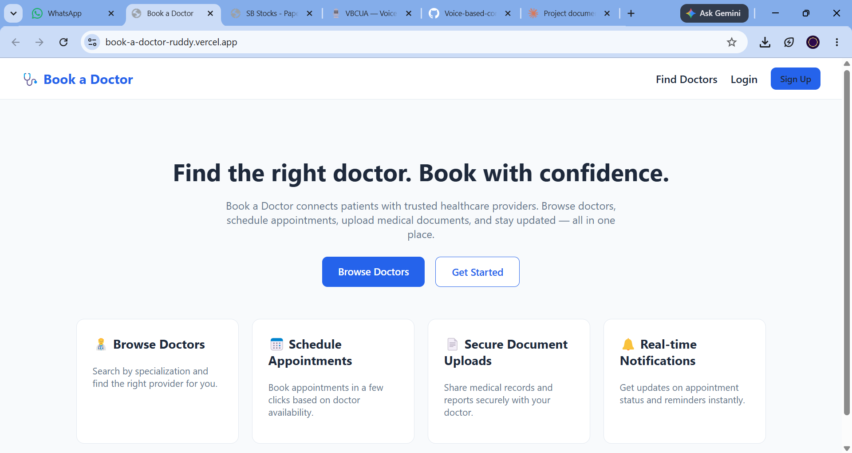
Home page — landing screen highlighting the platform's key features
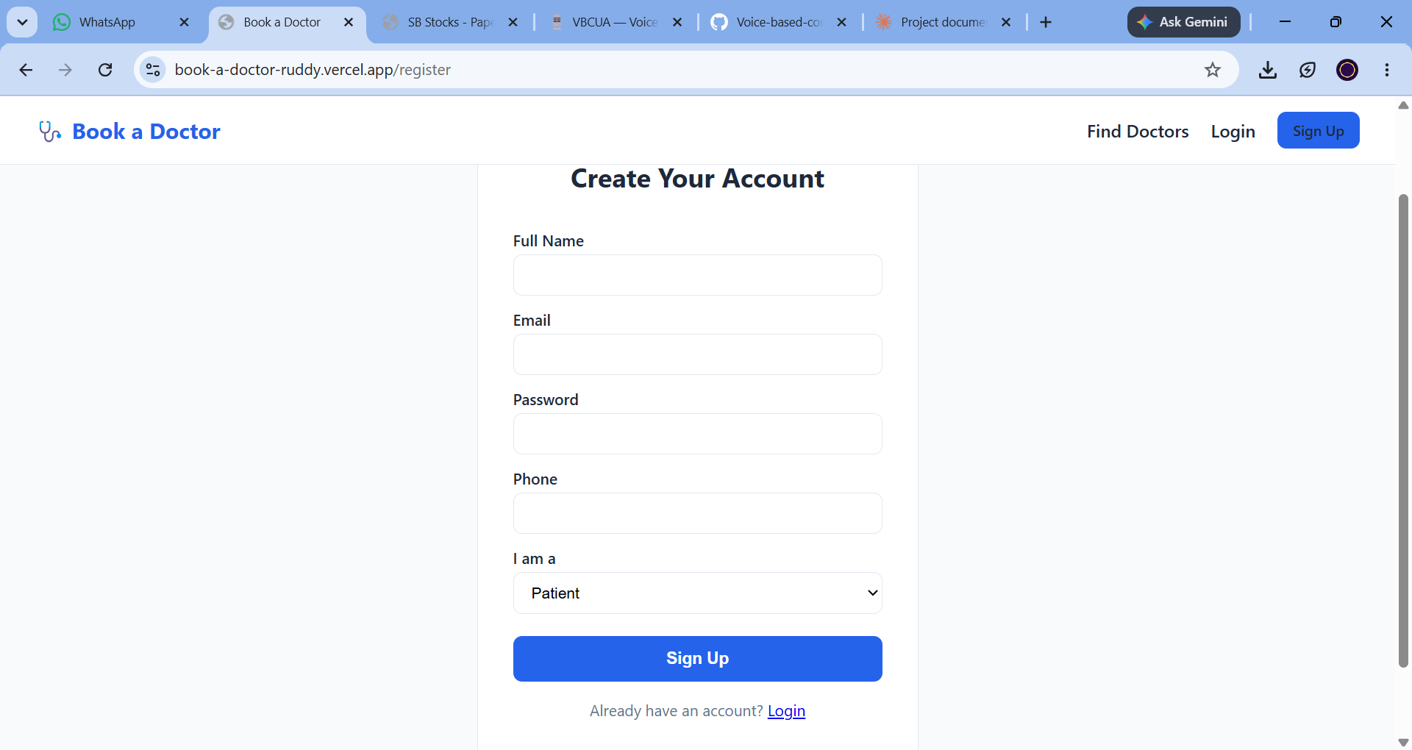
Sign-up page — account creation for patients, doctors, or admins
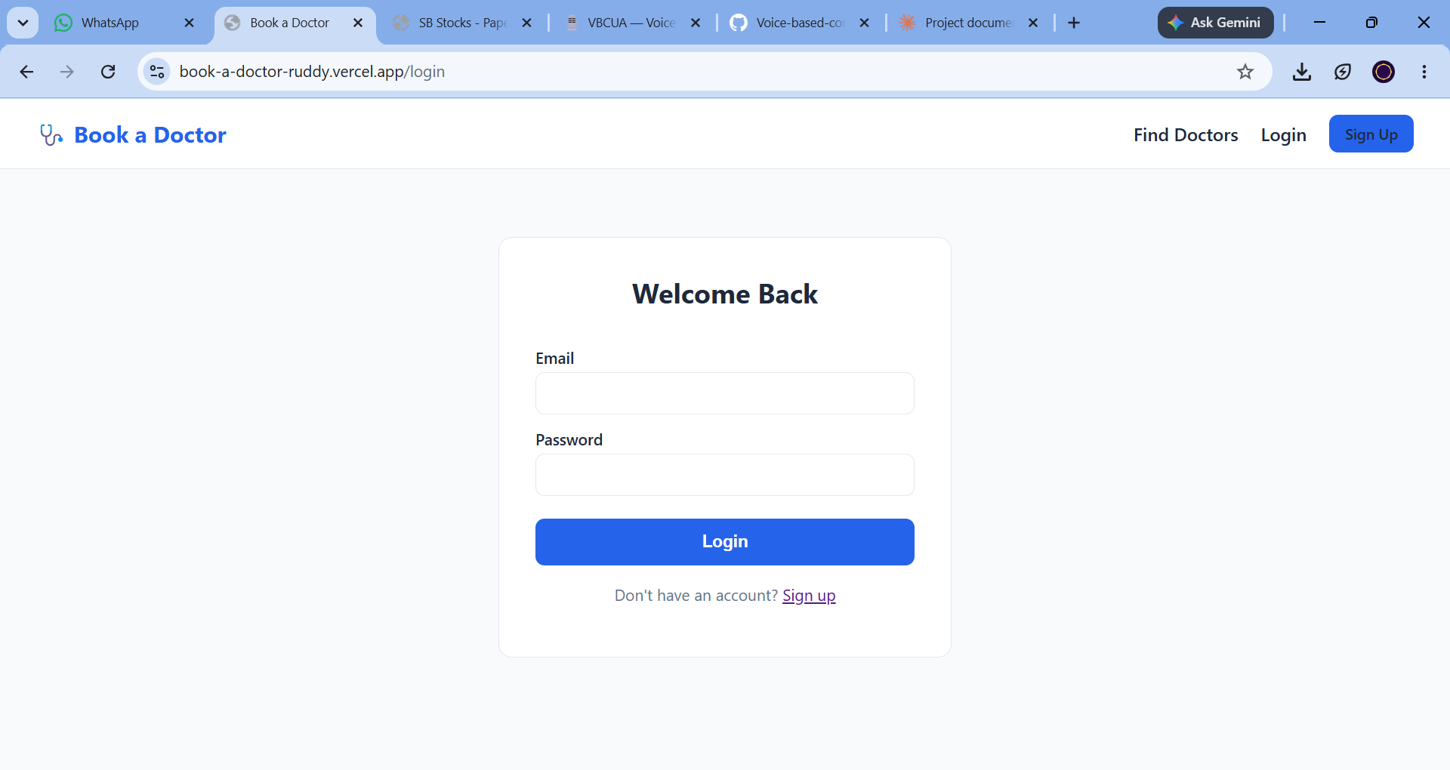
Login page — returning user authentication
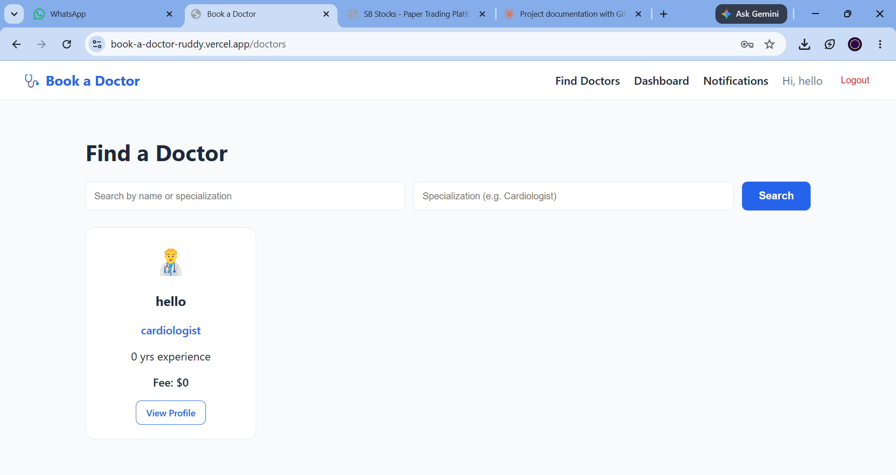
Find a Doctor page — search and browse approved doctor profiles
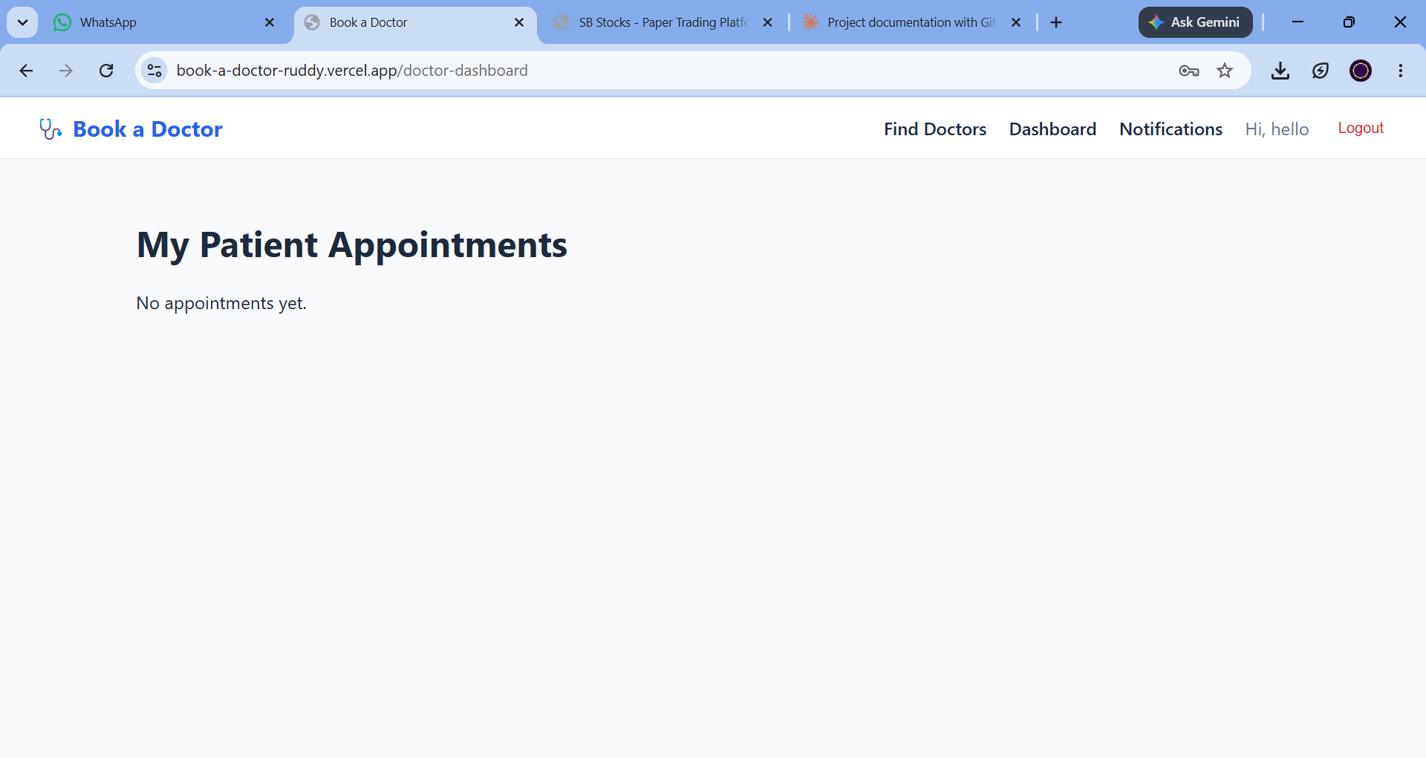
Doctor dashboard — patient appointments overview
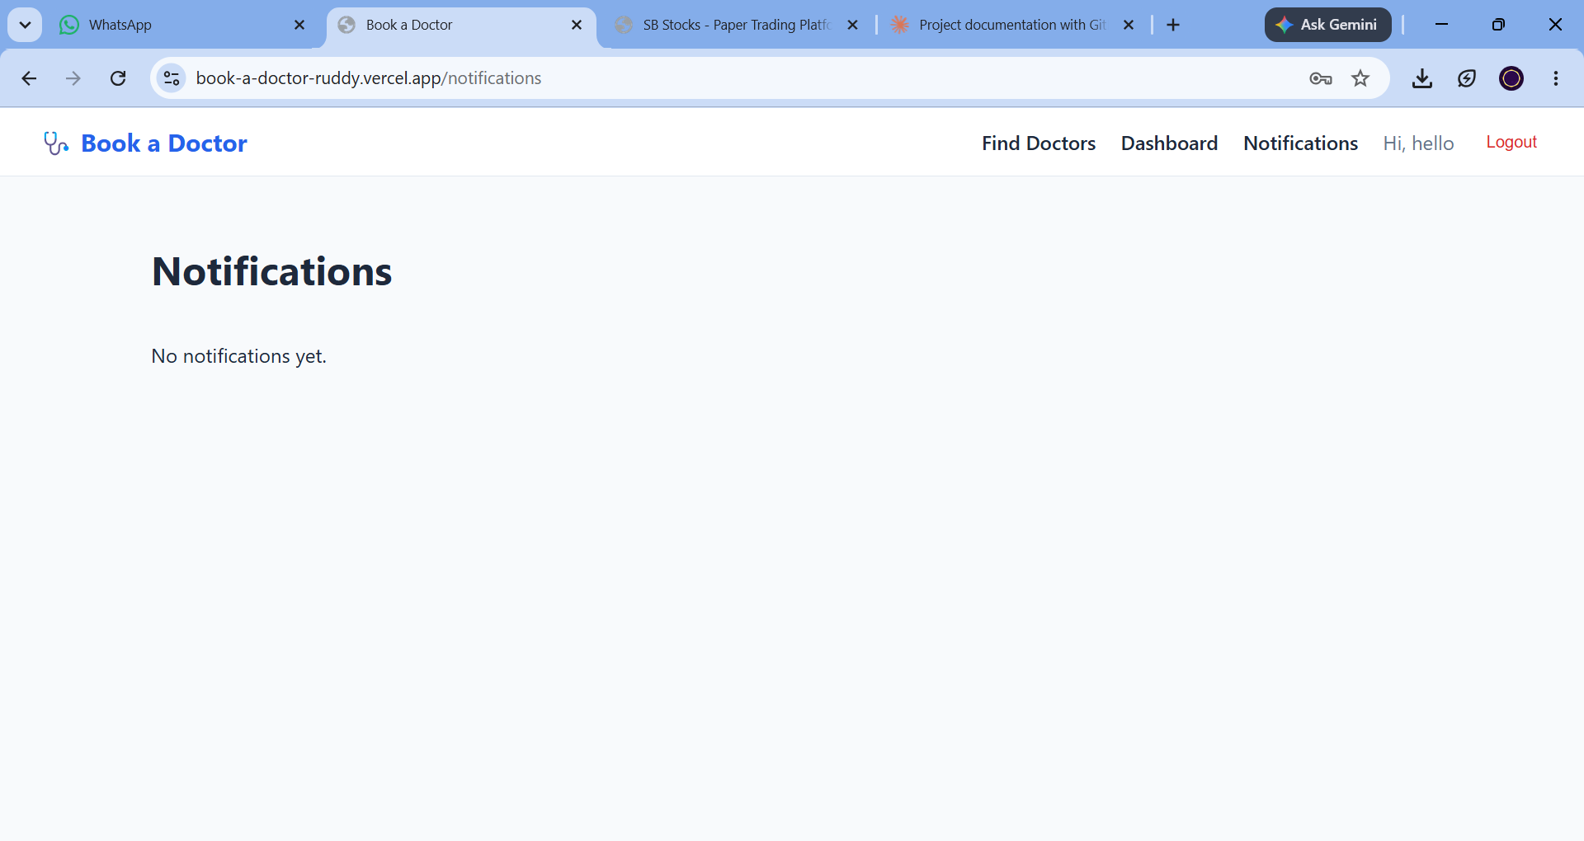
Notifications page — real-time updates on appointment status
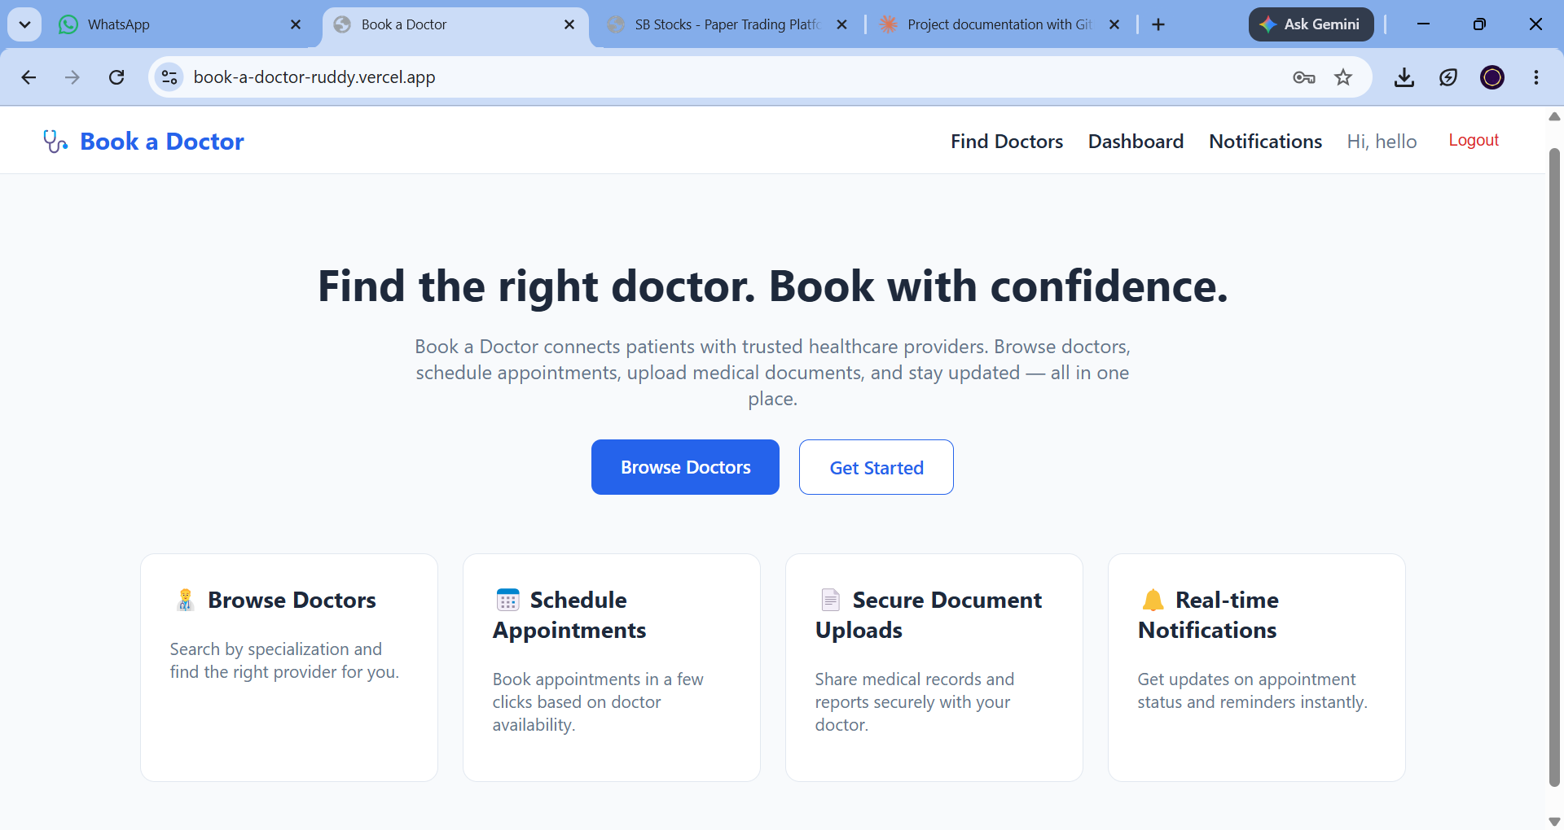
Home page — authenticated view with Dashboard and Notifications access

10. Testing
Testing was carried out primarily through manual end-to-end verification of each user flow:
- Functional testing of registration, login, and role-based access (patient / doctor / admin) across protected and public routes.
- Manual verification of the doctor search and filter functionality on the Find Doctors page.
- End-to-end testing of the appointment lifecycle — booking, status updates (pending → confirmed / completed / cancelled), and document uploads.
- API testing of individual endpoints (request/response shape, status codes, and validation errors) using tools such as Postman.
- Cross-checking that notifications are correctly generated on appointment creation and status changes.

11. Screenshots or Demo
A live, deployed version of the application is available for review, along with the full source code:
Live Demo: https://book-a-doctor-ruddy.vercel.app
GitHub Repo: https://github.com/ANVESH-77/book-a-doctor
Refer to Section 9 (User Interface) above for annotated screenshots of the core application screens.

12. Known Issues
- No public admin signup flow — an admin account must currently be created by manually updating a user's role field directly in MongoDB.
- Doctor availability slots are stored but not yet enforced against booking conflicts — the system does not automatically prevent double-booking of the same time slot.
- Uploaded documents are stored on local disk storage (via Multer); on ephemeral hosting platforms this means uploaded files may not persist across redeployments.
- No automated test suite is currently included in the repository — testing has been manual (see Section 10).

13. Future Enhancements
- Add a proper admin onboarding flow (e.g. invite-based or first-user-becomes-admin) instead of manual database edits.
- Enforce doctor availability against existing bookings to prevent scheduling conflicts.
- Migrate file storage to a cloud provider (e.g. AWS S3 / Cloudinary) for persistence across deployments.
- Add email/SMS notifications in addition to in-app notifications.
- Introduce automated testing (unit and integration tests) for both frontend and backend.
- Add doctor ratings and patient reviews after appointment completion.
- Support online video consultations alongside in-person appointment booking.

