# **TERPRESSO DATABASE**

We are a chain of coffeehouses and roastery services and are trying to digitize our data management processes, especially how our product inventory, customer database, transactions and supplier database is stored and use it to our business advantage. We are interested in knowing how our products perform and improve our relationship with our ingredient supplier as well. We want our database to reflect our core business process and help us maintain the relationship between customers, suppliers and the products that we offer.

**General Information:**

**Note - we have used a key attribute to auto generate primary keys unique to each table at insertion.**

1. Each product is described by a unique product ID, name, price, and category.
2. Each store has a unique store ID, name, store revenue, location and operation cost.
3. Each supplier has a unique supplier ID, supplier Name.
4. Each supplier supplies at least one product but there can be multiple products supplied by the same supplier.
5. Each supplier is identified by a unique key called supplier ID.
6. Each customer has a unique customer ID, First and Last Name and a contact information (Phone Number).
7. Each OrderDetail has a unique order Id, Order date, and order unit price.
8. Each customer will place at least one order.
9. An order can only be placed by one customer, an order will have at least one product.
10. One product can belong in multiple orders.
11. An order can be placed only at one store, but a store will have multiple orders.
12. Each Customer who will place an order will only have one Phone number to be entered.
13. The supplier, store and the ingredients supplied by that supplier are linked by the ternary relationship called Supply which stores the information about unit price of the ingredients supplied,quantity supplied, and supplier order date.
14. The Orderdetail and Customer are linked through the relationship Order.
15. The Orderdetail and Product are linked through a relationship called Place, which also stores the quantity of the products ordered.
16. The details about Product and Product Ingredients are linked by the relationship Prepare which also stores the information about the quantity of ingredient required for preparing each product.
17. The OrderDetail and Store are linked through a relationship Belong.

**Mission statements**

Currently Terpresso business is witnessing a deteriorating condition of its inventory, as a coffeehouse that has pop up stores, we want to have the following information at our fingertips, so as to evaluate Terpresso business requirements better and optimize profits. In the end, we want Terpresso to venture out further and improve their customer relationship services.

1. **What are the Ranked most and least selling products?**
2. **What are the top 3 most and least profitable products?**
3. **Who are Terpresso’s most frequently returning customers and their contact details?**
4. **What is the store information and the total sales profit per store?**

**ER DIAGRAM:**

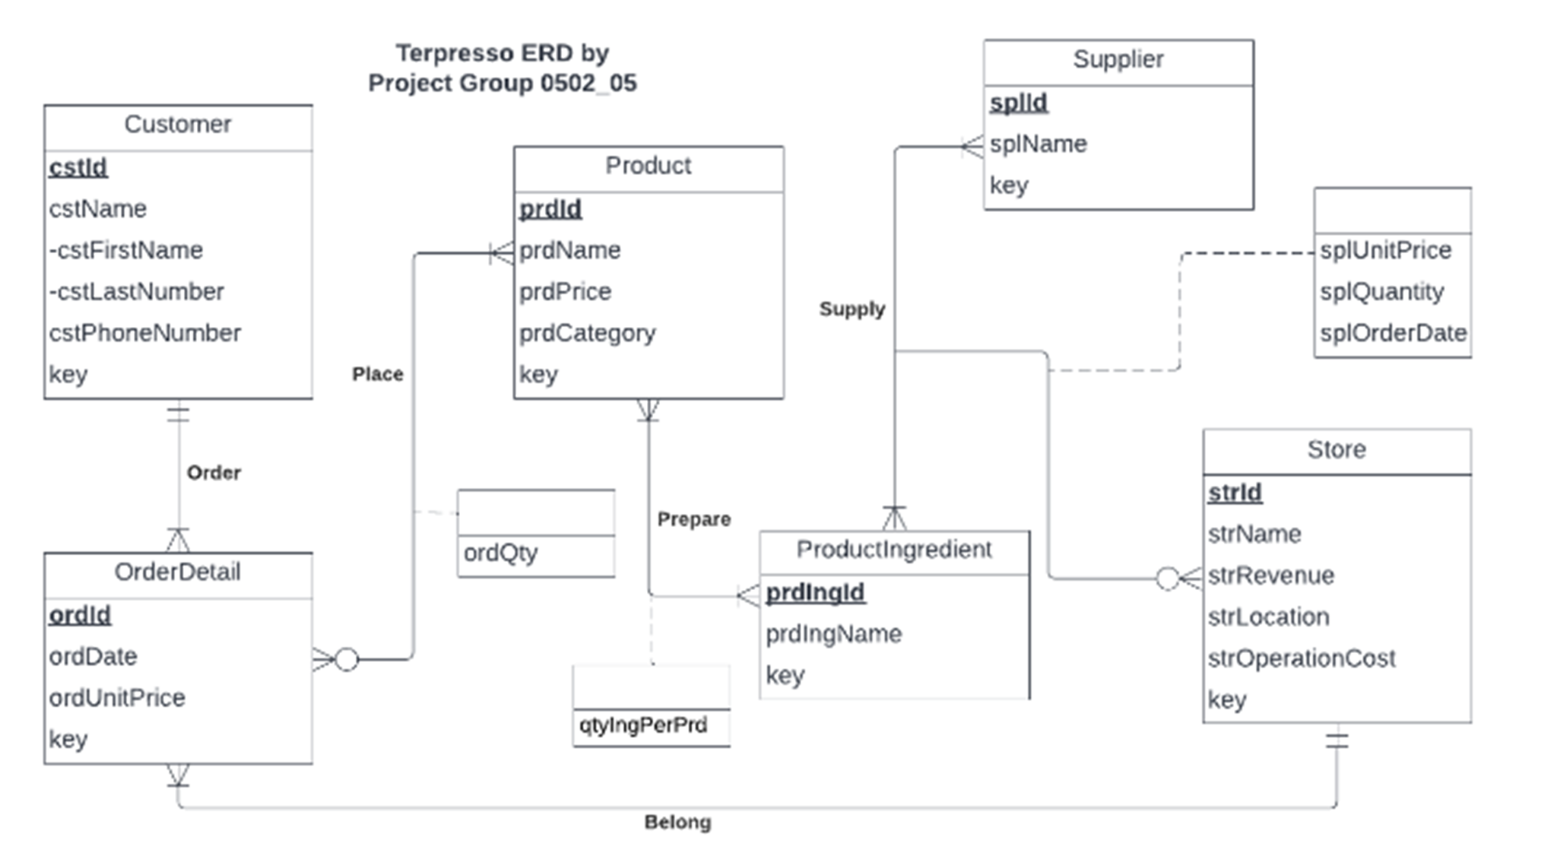

**ER SCHEMA:**

**Entities, Attributes and Primary Keys**

Customer (**cstId**, cstName, -cstFirstName, -cstLastName, cstPhoneNumber, key)

OrderDetail (**ordId**, ordDate, ordUnitPrice, key)

Product (**prdId**,prdName, prdPrice, prdCategory, key)

ProductIngredient (**prdIngId**, prdIngName, key)

Store (**strId**, strName, strRevenue, strLocation, strOperationCost, key)

Supplier (**splId**, splName, key)

## **Relationships, Attributes, Degrees, Participating Entities and Constraints**

Order: binary relationship

1 Customer to 1 or more OrderDetail

1 OrderDetail to 1 Customer

Place: binary relationship

1 OrderDetail to 1 or more Product

1 Product to 0 or more OrderDetail

Belong: binary relationship

1 OrderDetail to 1 Store

1 Store to 1 or more OrderDetail

Prepare : binary relationship

1 or more product to 1 ingredient

1 or more ingredient to 1 product

Supply: ternary relationship

1 Product and 1 Store to 1 or more Supplier

1 Store and 1 Supplier to 1 or more Product

1 Supplier and 1 Product to 0 or more Store

**Relational Schema:**

Customer (**cstId**, key, cstFirstName, cstLastName, cstPhoneNumber)

OrderDetail (**ordId**, key, *cstId,* *strId*, ordDate, ordUnitPrice)

Product (**prdId**,key, prdName, prdPrice, prdCategory)

ProductIngredient (**prdingId**, key, prdIngName)

Prepare (***prdIngId***, ***prdId*** , qtyIngPerPrd)

Store (**strId**, key, strName, strLocation, strRevenue, strOperationCost).

Supplier (**splId**, key, splName)

Place (***ordId*, *prdId,*** ordQty)

Supply (***splId*, *prdIngId*, *strId***, splUnitPrice, splQuantity, splOrderDate)

**Business rules:.**

[R1] If a customer who placed an order is deleted from the database, then the corresponding customer information is not changed in the database.

[R2] If a customer who placed an order has their information changed, the corresponding details are changed in the database.

[R3] When a product information that is present in an order is updated, the changes shall be updated in the database.

[R4] When a product is deleted from the database the corresponding information is still also deleted from the database.

[R5] If a store where orders are placed becomes inoperational and the store information is deleted, then the corresponding information is also deleted.

[R6] If a store information where orders are placed is updated, the corresponding information should be updated in the database.

[R7] When a supplier's information about who is supplying a product to a store is deleted, then the corresponding product and store information is deleted.

[R8] When a supplier's information about who is supplying a product to a store is updated, then the corresponding product and store information is also updated.

[R9] When the information about a product that a supplier is supplying to the store is deleted, the corresponding information is also deleted.

[R10] When a product information that the supplier is supplying to the store is updated, the corresponding information is also updated.

[R11] When a store information where a product is supplied by the supplier is deleted, the corresponding product and supplier information needs to be deleted.

[R12] When a store information where a product is supplied by the supplier is updated, the corresponding product and supplier information needs to be updated.

[R13] When an order is deleted from the database then the corresponding information about the order is also deleted from the database.

[R14]When information about an order is updated in the database then the corresponding information about the order is also updated from the database.

[R15]There can only be one supplier for a product, as only the supplier that offers the best price for purchasing is selected.

[R16] When a product ingredient is deleted from the database then the corresponding information about the product ingredient is also deleted from the database.

[R17]When an ingredient is updated in a recipe then the corresponding information about it is also updated in the database.

[R18] When a product is deleted from the database then the corresponding information about the product ingredient is also deleted from the corresponding database.

[R19]When a product ID is updated in the database then the corresponding information about it is also updated in the database.

**Referential integrity:**

| **Relation** | **Foreign Key** | **Base Relation** | **Primary Key** | **Business Rule** | **Constraint: ON DELETE** | **Business Rule** | **Constraint: ON UPDATE** |
| --- | --- | --- | --- | --- | --- | --- | --- |
| OrderDetail | cstId | Customer | cstId | R1 | NO CHANGE | R2 | CASCADE |
| OrderDetail | strId | Store | strId | R5 | CASCADE | R6 | CASCADE |
| Place | ordId | OrderDetail | ordId | R13 | CASCADE | R14 | CASCADE |
| Place | prdId | Product | prdId | R4 | CASCADE | R3 | CASCADE |
| Supply | splId | Supplier | splId | R7 | CASCADE | R8 | CASCADE |
| Supply | prdIngId | Product | prdIngId | R9 | CASCADE | R10 | CASCADE |
| Supply | strId | Store | strId | R11 | CASCADE | R12 | CASCADE |
| Prepare | prdIngId | ProductIngredient | prdIngId | R16 | CASCADE | R17 | CASCADE |
| Prepare | prdId | Product | prdId | R18 | CASCADE | R19 | CASCADE |

**Determining Functional Dependencies and Verifying 3NF:**

1. Customer Entity -

cstId uniquely determines the value of cstFirstName, cstLastname, cstPhoneNumber

cstId -> cstName, cstFirstName, cstLastName, cstPhoneNumber

cstId, cstFirstName, cstLastname, cstPhoneNumber are not multivalued attributes.

cstFirstName, cstLastname, cstPhoneNumber are identified by the whole primary key cstId.

cstFirstName, cstLastname, cstPhoneNumber attributes in the entity are just identified by the only primary key which is cstId.

1. OrderDetail (ordId, ordDate, ordQuantity, ordUnitPrice)

ordId uniquely determines the value of ordDate, ordQuantity, ordUnitPrice

ordId -> ordDate, ordQuantity, ordUnitPrice

ordId, ordDate, ordQuantity, ordUnitPrice are not multivalued attributes.

ordDate, ordQuantity, ordUnitPrice are identified by the whole primary key ordId.

ordDate, ordQuantity, ordUnitPrice are identified by only the primary key ordId.

1. Product (prdId,prdName, prdPrice, prdCategory, prdQuantity)

prdId uniquely determines the value of attributes prdName, prdPrice, prdCategory, prdQuantity.

prdId -> prdName, prdPrice, prdCategory, prdQuantity

prdId,prdName, prdPrice, prdCategory, prdQuantity are not multivalued attributes.

prdName, prdPrice, prdCategory, prdQuantity are identified by the whole primary key prdId.

prdName, prdPrice, prdCategory, prdQuantity are identified by only the primary key prdId.

1. Store (strId, strName, strRevenue, strLocation, strOperationCost)

strId uniquely determines the value of strName, strRevenue, strLocation, strOperationCost hence they are functionally dependent on strId.

strId -> strName, strRevenue, strLocation, strOperationCost

strName, strRevenue, strLocation, strOperationCost are not multivalued attributes.

strName, strRevenue, strLocation, strOperationCost are identified by the whole primary key cstId.

strName, strRevenue, strLocation, strOperationCost are identified by only the primary key cstId.

1. Supplier (**splId**, splName)

splId uniquely determines the value of attributes splName.

splId -> splName

splId,splName is not a multivalued attribute.

splName isidentified by the whole primary key prdId.

splName is identified by only the primary key prdId.

1. Place (***ordId*, *prdId,*** ordQty):

The composite primary key uniquely determines the value of each unique combination of order ID and product ID and each value of ordQty.

ordId and prdId is a unique pair and are not multivalued attributes, ordQty for each pair is not multivalued.

All the entries in the table are identified by the whole primary key.

1. Supply (***splId*, *prdIngId*, *strId ,***splUnitPrice, splQuantity, splOrderDate)

splId uniquely determines the value of attributes. splUnitPrice, splQuantity, splOrderDate.

splId -> splName , splUnitPrice, splQuantity, splOrderDate.

splId,splName, splUnitPrice, splQuantity, splOrderDate are not multivalued attributes.

Attributes splUnitPrice, splQuantity, splOrderDate are identified by the whole primary key prdId.

Attributes splUnitPrice, splQuantity, splOrderDate are identified by only the primary key prdId.

1. ProductIngredient (**prdIngId**, prdIngName)

prdIngId uniquely determines the value of prdIngName.

strId -> prdIngName

prdIngName is not a multivalued attribute.

prdIngName is identified by the whole primary key prdIngId.

prdIngName is identified by only the primary key prdIngId.

1. Prepare (***prdIngId***, ***prdId***, qtyIngPerPrd)

prdIngId and prdId uniquely determine the value of prdIngName.

prdIngId, prdId -> qtyIngPerPrd

qtyIngPerPrd is not a multivalued attribute for one combination of prdIngId and prdId.

qtyIngPerPrd is identified by the whole primary key.

qtyIngPerPrd is identified by only the primary key prdIngId.

Customer

INSERT INTO Customer ( cstFirstName, cstLastName, cstPhoneNumber)

VALUES ( 'Madhulika', 'Nambi', '9764568890');

| cstId | cstFirstName | cstLastName | cstPhoneNumber |
| --- | --- | --- | --- |
| CST0010 | Madhulika | Nambi | 9764568890 |

OrderDetail

INSERT INTO OrderDetails ( cstId, strId, ordDate, ordUnitPrice)

VALUES ( 'CST0010' , ‘STR0010’ , ‘2022/12/10’ , 10.87);

| ordId | cstId | strId | ordDate | ordUnitPrice |
| --- | --- | --- | --- | --- |
| ORD0010 | CST0010 | STR0010 | 2022/12/10 | 10.87 |

Product

INSERT INTO Product ( prdName, prdPrice, prdCategory)

VALUES ( 'Iced Coffee- Vanilla' , 6.35, 'Coffee');

INSERT INTO Product ( prdName, prdPrice, prdCategory)

VALUES ( 'Butter croissant' , 5.5 , ‘Food’);

| prdId | prdName | prdPrice | prdCategory |
| --- | --- | --- | --- |
| PRD0010 | Iced Coffee- Vanilla | 6.35 | Coffee |
| PRD0028 | Butter croissant | 5.5 | Food |

ProductIngredient

INSERT INTO ProductIngredient ( prdIngName)

VALUES ( 'Iced Coffee- Vanilla');

| prdId | prdName |
| --- | --- |
| PIN0010 | Iced Coffee- Vanilla |

Prepare

INSERT INTO Prepare(prdIngId, prdId, qtyIngPerPrd)

VALUES (‘PIN0010’, ‘PRD0010’, 1);

| prdIngId | prdId | qtyIngPerPrd |
| --- | --- | --- |
| PIN0010 | PRD0010 | 0.1 |

Place

INSERT INTO Place (ordId, prdId, ordQty)

VALUES (‘ORD0010’, ‘PRD0010’, 1);

INSERT INTO Place (ordId, prdId, ordQty)

VALUES (‘ORD0010’, ‘PRD0028’, 1);

| ordId | prdId | ordQty |
| --- | --- | --- |
| ORD0010 | PRD0010 | 1 |
| ORD0010 | PRD0028 | 1 |

Store

INSERT INTO Store ( strName, strLocation, strRevenue, strOperationCost)

VALUES ('Terpresso1' , 'Van Munching', 4800 , 3500);

| strId | strName | strLocation | strRevenue | strOperationCost |
| --- | --- | --- | --- | --- |
| STR0010 | Terpresso1 | Van Munching | 4800 | 3500 |

Supplier

INSERT INTO Supplier ( splName)

VALUES ( 'Coffee Beans & Co');

| splId | splName |
| --- | --- |
| SPL0010 | Coffee Beans & Co |

Supply

INSERT INTO Supply (splId, prdIngId, strId, splUnitPrice, splQuantity, splOrderDate)

VALUES (‘SPL0010’, ‘PIN0010’, ‘STR0010’, 300, 10, ‘2021/12/05’ );

| splId | prdIngId | strId | splUnitPrice | splQuantity | splOrderDate |
| --- | --- | --- | --- | --- | --- |
| SPL0010 | PIN0010 | STR0010 | 300 | 10 | 2021/12/05 |

| **Data types** |
| --- |

| key | int |
| --- | --- |
| cstId | varchar(10) |
| cstFirstName | varchar(20) |
| cstLastName | varchar(20) |
| cstPhoneNumber | char(10) |
| ordId | varchar(10) |
| ordDate | date |
| ordQty | int |
| ordUnitPrice | decimal(5,2) |
| prdId | varchar(10) |
| prdName | varchar(50) |
| prdPrice | decimal(4,2) |
| prdCategory | varchar(20) |
| qtyIngPerPrd | decimal(5,2) |
| prdIngId | varchar(10) |
| prdIngName | varchar(50) |
| strId | varchar(10) |
| strName | varchar(50) |
| strRevenue | decimal(7,2) |
| strLocation | varchar(50) |
| strOperationCost | decimal(7,2) |
| splName | varchar(50) |
| splUnitPrice | decimal(6,2) |
| splQuantity | int |
| splOrderDate | date |