**Readme**

Group Members: ANWESHA GUPTA, JANHAVI NAMJOSHI, MADHULIKA NAMBI, UDIT SINGH

Group No: 05

Course: BUDT703

**Source of the data:**

The data about customers and their orders was taken from a google form - <https://forms.gle/b9iDjZMjQ7n2kGN19> that was circulated in MSIS track MB11 and MB12, all of the other attributes like the details about the stores, suppliers were fictitious, and remaining data was filled by us using a random data generator. This data was then inserted into the SQL database using SQL insert statements.

The data recorded by the google form, which we stored in excel:

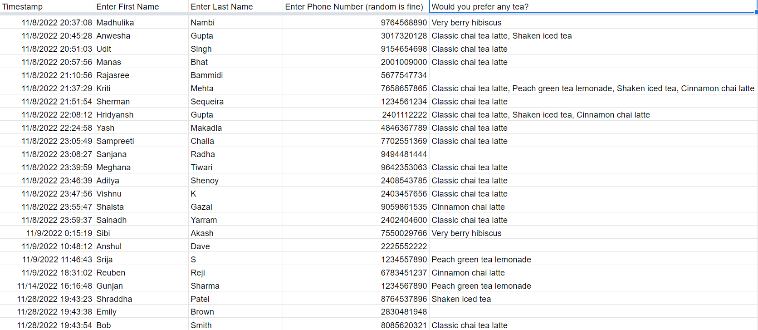

The data that was filled by us:

1. Details about the stores



2. Details about the products sold at Terpresso

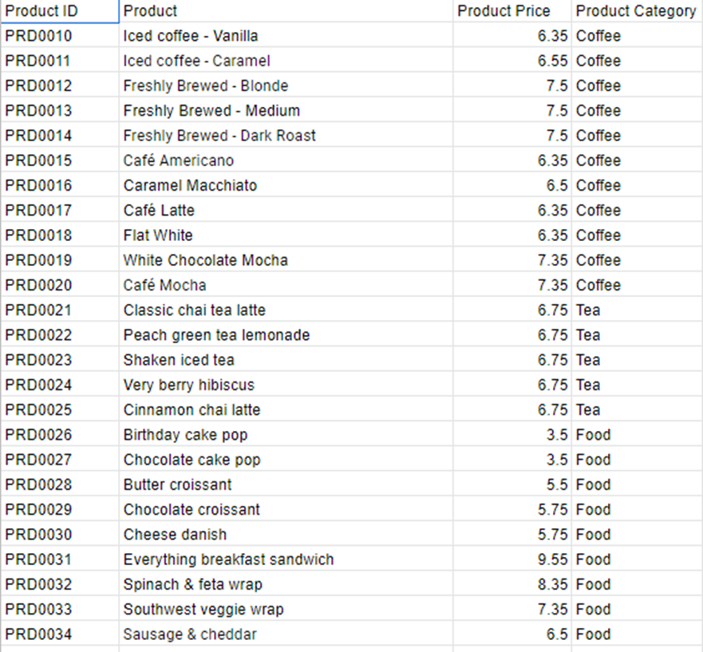

3. Details about the suppliers:

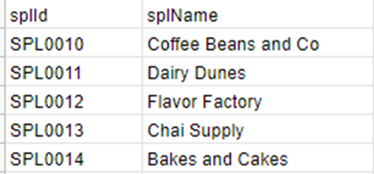

4. The details about ingredients that are required to prepare the products:

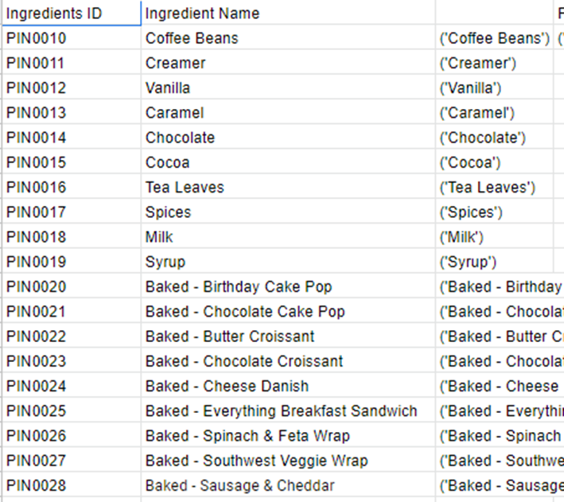

Other information like the quantity supplied and the price of the ingredients supplied , date of orders, price of the products and quantity of ingredients used for each product were also filled by us and we finally ended up with a dataset which has 1391 values spread across 9 tables.

**References:**

1. <https://www.starbucks.com/>

We referenced starbucks’s menu for naming the products in Terpresso’s menu.

**Testing the Project:**

Testing the tables that we created:

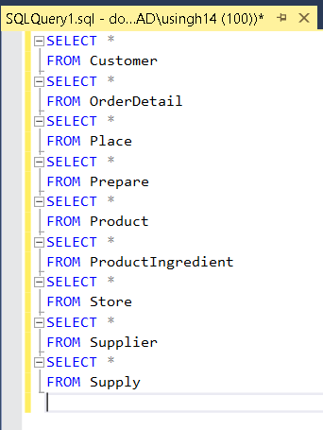

1. Customer Table:

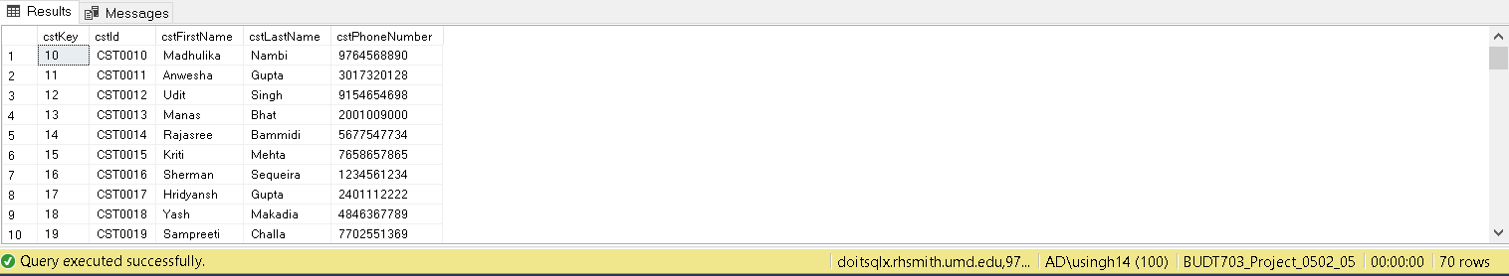

1. OrderDetail:

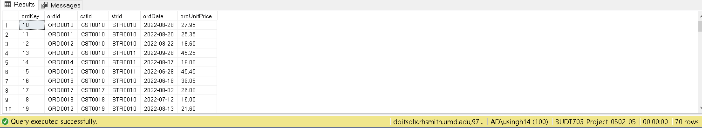

1. Place:

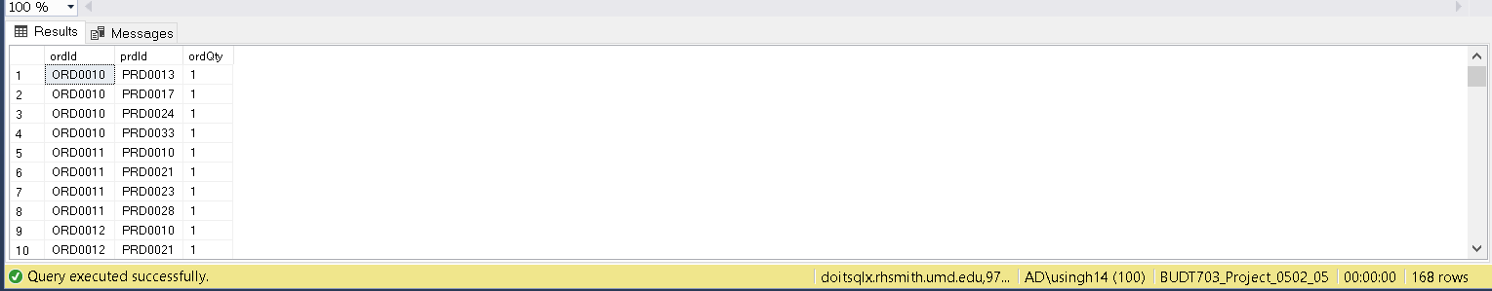

1. Prepare:

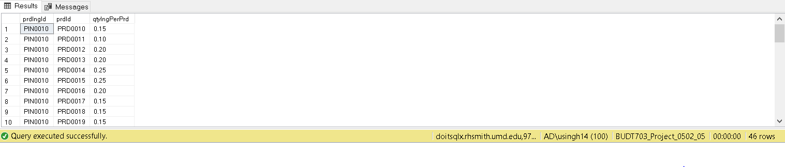

1. PrdIngredient:

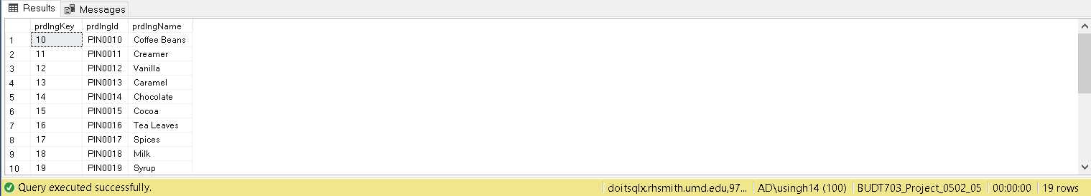

1. Product:

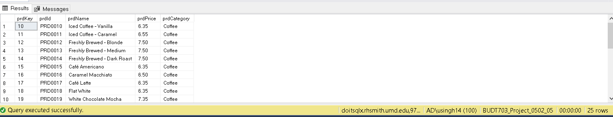

1. Store:

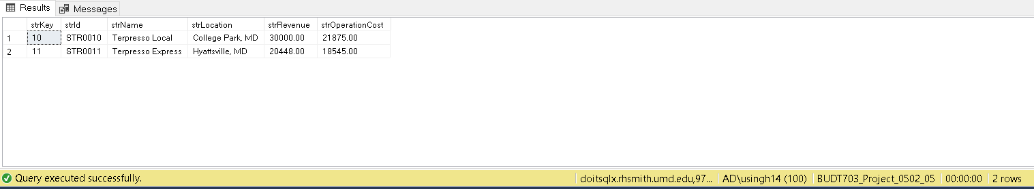

1. Supplier:

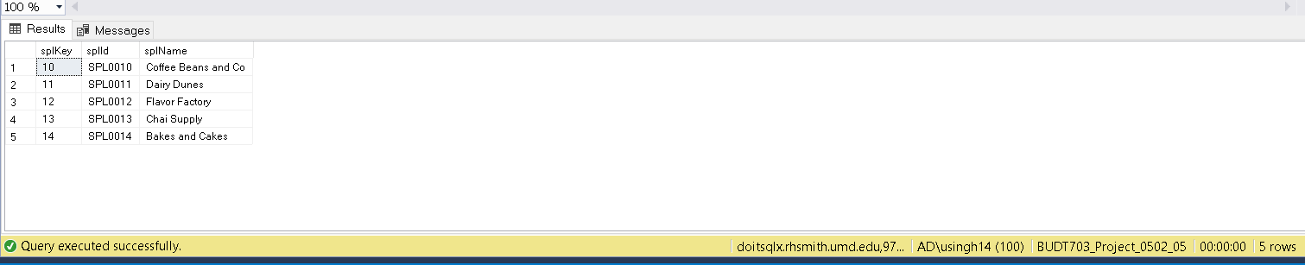

1. Supply: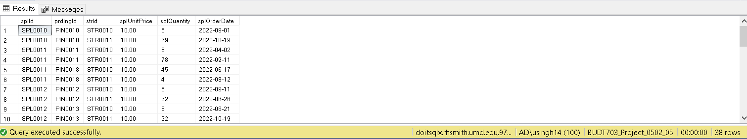

**Mission Statement**

1. **What are the Ranked most and least selling products?**

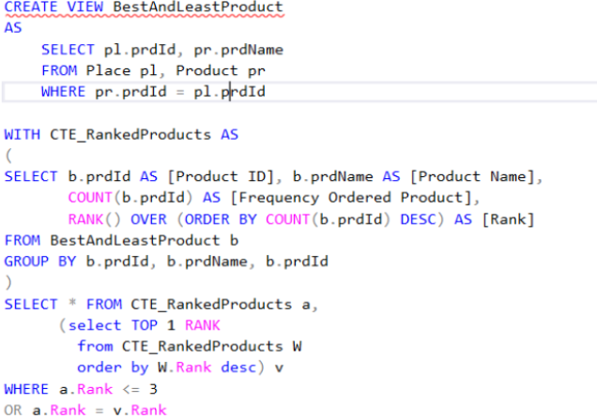

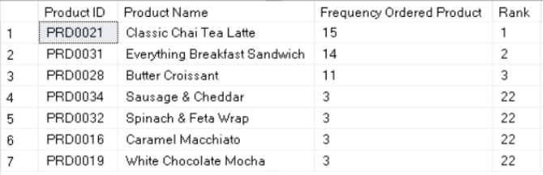

1. **What are the top 3 most and least profitable products?**

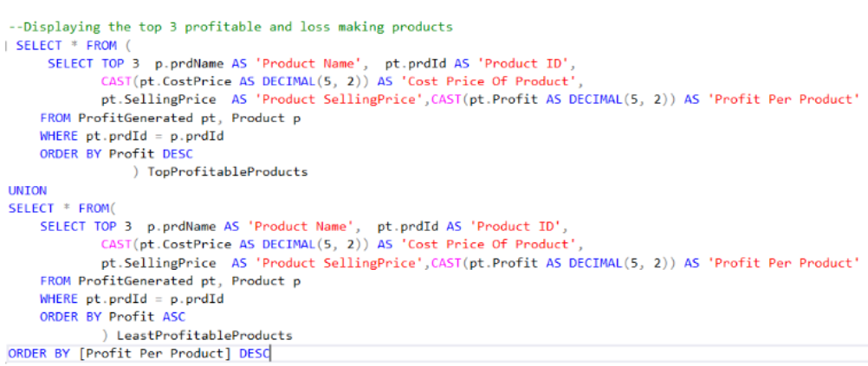

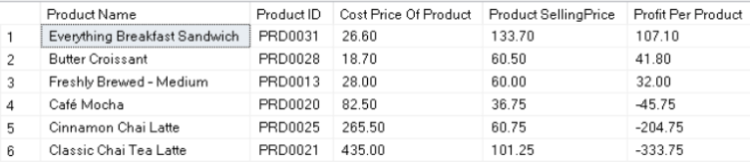

1. **Who are Terpresso’s most frequently returning customers and their contact details?**

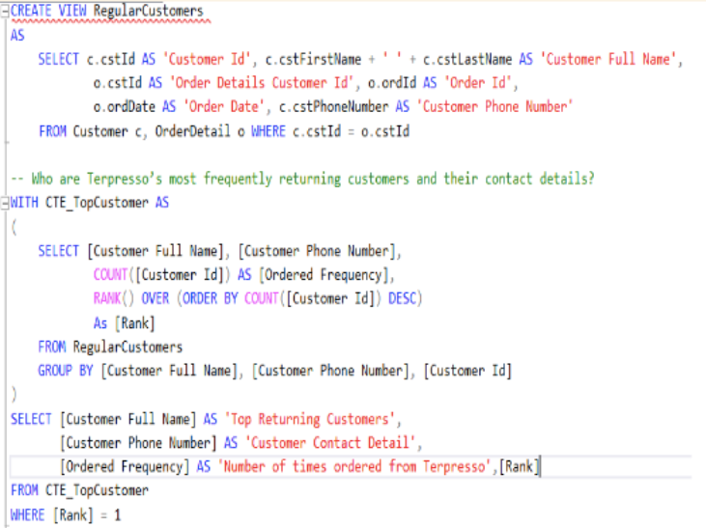

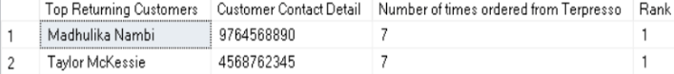

1. **What is the store information and the total sales profit per store?**

