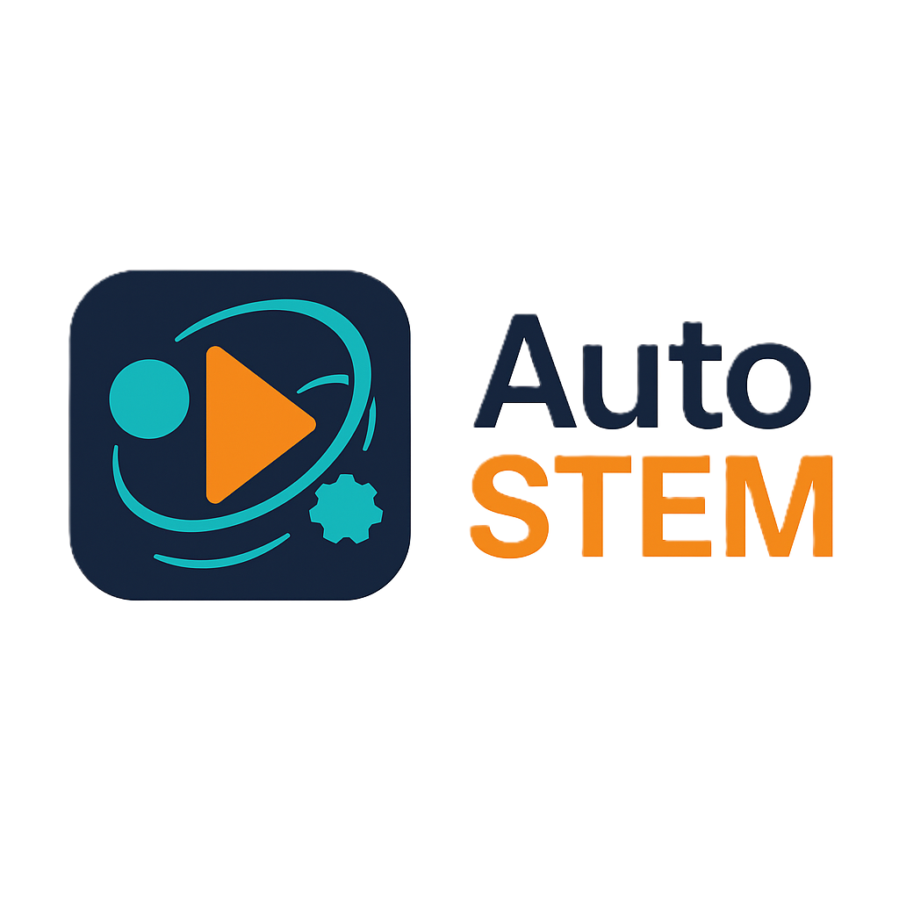

B.R.I.D.G.E. — Operator Manual
  - Boosting Robotics Interaction and Dynamic Guidance through Edutainment
  - AutoSTEM Virtual Toolkit



1. Introduction

1.1 Project Scope
The B.R.I.D.G.E. simulator is an educational serious game designed to introduce users to block-based programming through an interactive and visual environment.
Within the AutoSTEM project, the simulator is used as a Virtual Toolkit to support STEM education activities, with a specific focus on control systems and computational thinking.
In this context, the application is centered on the BalaC robot and its PID control playground, where users are tasked with creating programs of increasing complexity by tuning control parameters and observing system behavior in real time.
B.R.I.D.G.E. refers to the educational framework and project structure, while the software application used within the AutoSTEM project is distributed under the name AUTOSTEM.

1.1.1 Utility
B.R.I.D.G.E. provides the logical foundations of programming and control systems through a visual, intuitive, and guided approach.
The block-based environment allows users, even without prior experience, to understand fundamental programming concepts and explore PID control mechanisms in a simplified and interactive way.

1.1.2 Target Audience
The B.R.I.D.G.E. simulator, within the AutoSTEM framework, is intended for:
- Students approaching programming and control systems concepts
- Teachers and educators involved in STEM learning activities
- Beginners interested in understanding PID control through a visual and interactive tool
The BalaC PID playground is particularly suited for secondary school and early university level education, where users can experiment with control logic in a safe simulated environment.

1.2 Main Objective and Technical Context
B.R.I.D.G.E. was developed using the Unity 6 game engine, with the HDRP (High Definition Render Pipeline) graphics pipeline. Unity employs the C# programming language, and Visual Studio Code was used as the development environment.
Within the AutoSTEM project, the simulator is used as a Virtual Toolkit to support educational activities focused on robotics and control systems.
The BalaC robot model, used in the PID playground, was developed using CAD tools (e.g., Solid Edge), while environmental assets and additional graphical elements were created using tools such as Blender and integrated within Unity.
All graphical models were imported into Unity in standard formats such as .obj and .fbx.

2. Installation
To operate the program, minimum system requirements must be met.

2.1 Operating System Requirements
Operating System | Minimum Requirements
Windows | Windows 10 64-bit with DirectX 12 support. Previous versions do not guarantee HDRP compatibility.
Table 2.1: Minimum operating system requirements for Unity HDRP applications.

2.2 Minimum Hardware Requirements
Component | Minimum Requirement
Processor (CPU) | Modern quad-core processor (e.g., Intel Core i5 or AMD Ryzen equivalent).
Graphics Card (GPU) | GPU compatible with Shader Model 5.0 and Compute Shaders. Recommended minimum: NVIDIA GTX 1060 (6 GB) or AMD equivalent.
Storage Unit (SSD) | SSD recommended for reduced load times and faster resource management.
Table 2.2: Minimum hardware requirements (main components).

2.3 Software Installation
The game B.R.I.D.G.E. is distributed via the official GitHub repository. Operators can download the latest version and install it following the procedures indicated for each operating system.
Windows
- Access the official repository: https://github.com/LabMACS/2025_TDSG/releases/tag/v1.1.0
- Select AUTOSTEM.zip → Download ZIP and save the file.
- Extract the content into a folder of your choice.
- Alternative: use git to clone the repository: git clone https://github.com/LabMACS/2025_TDSG/releases/tag/v1.1.0.git

2.4 Software Startup
Windows
- Access the AUTOSTEM folder.
- Run the AUTOSTEM.exe file.
- Wait for loading until the main screen appears.
Once executed, the game will start, presenting the main screen with access to the BalaC PID playground environment.

3. Project Description
The B.R.I.D.G.E. simulator, within the AutoSTEM project, is designed as an educational tool to support the understanding of programming logic and control systems through a visual and interactive environment.
In this configuration, the simulator focuses on the BalaC robot and its PID control playground.
The main objectives are:
- To facilitate the learning of programming concepts through visual block-based logic.
- To introduce the fundamentals of PID (Proportional-Integral-Derivative) control.
- To provide a safe and controlled environment for experimenting with control systems.
Genre: educational serious game focused on control systems and programming fundamentals.
Target Audience: students, beginners in programming, and users interested in understanding PID control.
Player Objective: complete the assigned tasks by configuring a functional PID control system through visual programming blocks, observing system response in real time.

3.1 Explanation of Custom Blocks
This section describes the custom blocks available for controlling the BalaC robot within the PID playground environment.
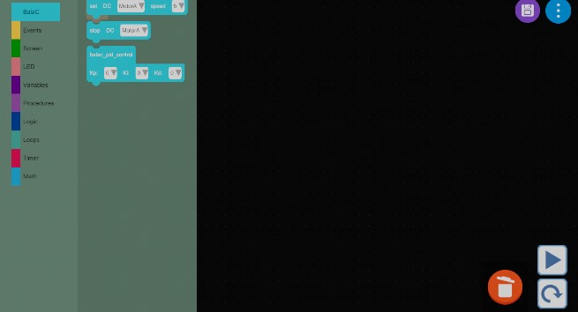
Figure 3.1: BalaC custom blocks.
Access to the control primitives of AutoSTEM occurs through the dedicated section in the programming interface. By selecting the "BalaC" category, one accesses the panel containing the functional blocks for managing movement and sensors.

3.1.1 BalaC Custom Blocks
set_dc_motor: Manages the actuation of the motors. The block requires the configuration of two fundamental parameters: the output channel (selectable between MotorA and MotorB) and the speed setpoint, defined via a scalar numeric value.
stop_dc_motor: Commands the immediate interruption of electrical power to the specified motor (A or B), stopping the wheel.
basic_pid_control: Implements a PID (Proportional-Integral-Derivative) feedback control algorithm. This block allows the calibration of the three characteristic gains:
- Kp: Proportional constant, linked to the instantaneous error.
- Ki: Integral constant, for correcting the steady-state error (accumulated over time).
- Kd: Derivative constant, for predicting the future trend of the error.
This block is the core component of the BalaC control system and is used to maintain the robot in a balanced upright position.

License
This work is licensed under the Creative Commons Attribution-NonCommercial-ShareAlike 4.0 International License (CC BY-NC-SA 4.0).
You are free to share and adapt the material for non-commercial purposes, provided that appropriate credit is given and any modifications are distributed under the same license.
Contributors:
- Ripani Alessandro
- Davide Collevecchio
- Francesco Giachini
- David Scaradozzi
- Martina Morano
- Giacomo Fiara
- Flavia Gioiello
- Andre Yamashita

