

B.R.I.D.G.E. — User Manual
  - Boosting Robotics Interaction and Dynamic Guidance through Edutainment
  - AutoSTEM Virtual Toolkit



1. Introduction
Welcome to the B.R.I.D.G.E. manual, an educational serious game dedicated to learning block-based programming.
Within the Erasmus+ AutoSTEM project, B.R.I.D.G.E. is used as a Virtual Toolkit to support STEM education, with a specific focus on control systems and computational thinking.
The purpose of this manual is to provide a comprehensive overview of the B.R.I.D.G.E. simulator and its functionalities, supporting users in understanding and applying the basic concepts of block-based programming and PID control.
In this context, B.R.I.D.G.E. refers to the educational framework and project structure, while the software application used within the AutoSTEM project is distributed under the name AUTOSTEM.

1.1 Purpose of the Project
The main educational objective is to introduce users to computational thinking and control logic through a playful, interactive, and progressive approach.
Within the AutoSTEM framework, the simulator focuses on the BalaC robot and its PID control playground, where users can experiment with control parameters and observe system behavior in real time.
This approach enables learners to understand fundamental programming concepts and the principles of feedback control systems in a simplified and intuitive environment.

1.2 Target Audience
The manual is intended for students, teachers, and learners who wish to explore the principles of block-based programming and control systems through an interactive environment.
In particular, it is designed for:
- Secondary school students approaching programming and control concepts
- Early university students interested in robotics and PID control
- Teachers and educators involved in STEM learning activities
The BalaC PID playground is especially suited for educational contexts where users can safely experiment with control logic and system behavior.

1.3 Preliminary Requirements
To use the B.R.I.D.G.E. game correctly, it is necessary to have a system that meets the following minimum and recommended requirements. This section provides an overview of the hardware and software requirements needed to guarantee a stable and smooth user experience.

System Requirements
Operating System:
- Windows: Windows 10 version 21H1 (build 19043) or newer (x64), or Windows 11 version 21H2 (build 22000) or newer (Arm64).
Graphics Card:
- GPU compatible with DirectX 10, DirectX 11, DirectX 12, or Vulkan. GTX 1060 or AMD equivalent is advised.
CPU:
- Quad-core or hex-core processor of recent generation, such as Intel Core i5-8400 or AMD Ryzen 5 2600.
- A processor with at least 6 physical cores is recommended to ensure stability and reduce stuttering.
- Older processors or those with fewer than 4 cores are not recommended, as they may cause performance drops or crashes during HDRP execution.
Memory and Storage:
- At least 4 GB of RAM (8 GB or more recommended).
- SSD recommended for better load times.

2. Installation
This section outlines the procedures necessary to install and launch the B.R.I.D.G.E. application. It also specifies the necessary software and hardware requirements, the official download links, and the steps to correctly run the game.

2.1 Software and Hardware Installation Requirements
Supported Operating System:
- Windows 10 version 21H1 (build 19043) or newer (x64), or Windows 11 version 21H2 (build 22000) or higher (Arm64).
Software Dependencies:
- Updated browser (Chrome, Firefox, or Edge).
- Graphics packages compatible with DirectX, Vulkan, or Metal depending on the operating system.

2.2 Software Download
The game B.R.I.D.G.E. is distributed via an official GitHub repository. Users can download the latest version of the software by following the specific instructions for each operating system.
Windows
- Access the official B.R.I.D.G.E. repository on GitHub: https://github.com/LabMACS/2025_TDSG/releases/tag/v1.1.0.
- Click on AUTOSTEM.zip and select Download ZIP.
- Extract the ZIP file into a folder of your choice.
- Alternatively, if you have git installed, run the command: git clone https://github.com/LabMACS/2025_TDSG/releases/tag/v1.1.0.git

2.3 Launching the Software
After downloading and extracting the package content, the game can be launched by following the steps indicated for your operating system.
Windows

Open the AUTOSTEM folder.
- Double-click on the executable file AUTOSTEM.exe.
- Wait for the application to load.
Once executed, the game will start, presenting the main screen with access to the BalaC PID playground environment.

3. Application Description and Usage
This section describes the main mechanics of the B.R.I.D.G.E. simulator and provides an operational guide for approaching block-based programming within the BalaC PID playground environment.
Within the AutoSTEM project, the simulator is used as a Virtual Toolkit to support the learning of programming logic and control systems through an interactive experience.

3.1 Details on Main Features
B.R.I.D.G.E. is designed to introduce users to the fundamental concepts of programming logic through a visual block-based interface.
In this configuration, the simulator focuses on the BalaC robot, allowing users to interact with a PID control system by adjusting parameters and observing the system response in real time.

3.1.1 Game Interface (GUI)
The user can access the BalaC environment directly and select the available PID playground level.
Once the level is selected, the GUI presents the following areas:
- Scenario Area: The main world, where the BalaC robot is positioned within the simulation environment.
- Workspace (Code Area, top left): The working area where the user builds the logic. The library of blocks (Movement, Logic, Loops) is available here and can be dragged and connected together.
- Level Explanation (below Workspace): Here the user is prompted with the objective of the current level.
- Options (top right button): A menu where the user can change various settings, such as game volume and aim sensitivity, or go back to the level selection.
- Status GUI (bottom left corner): Depicts the robot's status, position, and orientation at any given time.
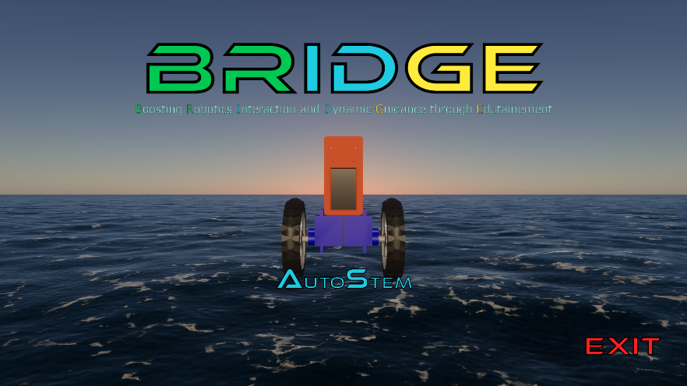
Figure 3.1: Main screen of B.R.I.D.G.E.

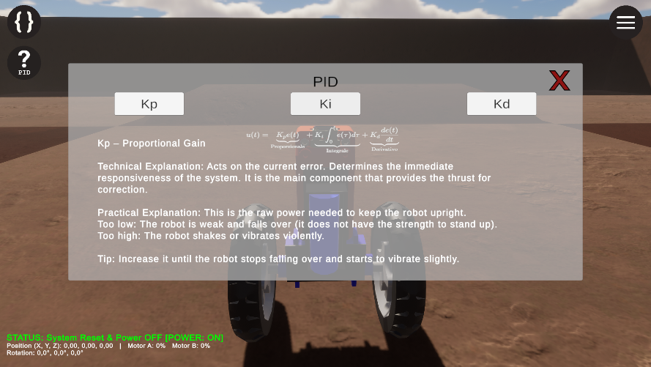
Figure 3.2: Game Explanation and GUI.

3.1.2 Programming Mechanics
The core gameplay is based on the behavioral manipulation of the BalaC robot:
- Contextual Selection: Based on the selected level, the user has access to specific custom blocks designed for the BalaC PID playground and its control objectives.
- Mindful Execution: The game engine interprets the blocks in real-time and prompts the user on the progress of the program, so that if something goes wrong the user can easily understand why and where.
- Block System: The user does not write textual code but uses the Visual Scripting paradigm, snapping logical blocks together to define actions (e.g., motor control, PID tuning).

3.2 Step-by-Step Instructions
The procedure to complete a typical game cycle is illustrated below: from programming setup to code execution.

3.2.1 Phase 1: Programming (Drag & Drop)
- Launch the BalaC PID playground environment.
- Open the programming panel by clicking the button in the top left corner.
- Drag the desired blocks (e.g., Movement Block, Loop Block, PID Block) into the Workspace.
- Connect the blocks together ensuring the snap is correct (indicated by visual and audio feedback).
- Identify the objective of the level (e.g., maintaining the robot upright through correct PID values).
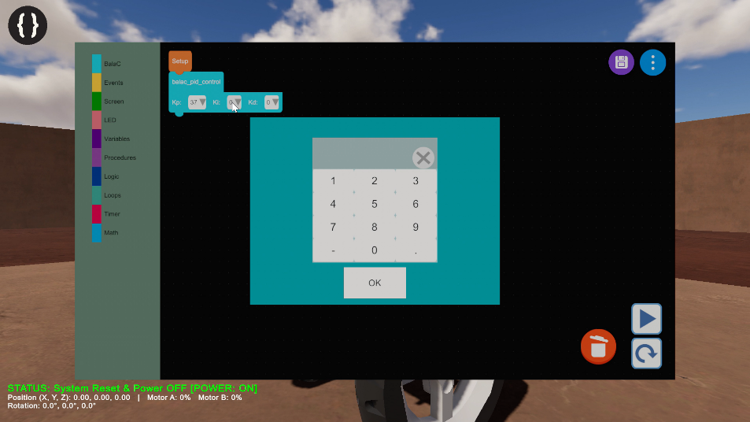
Figure 3.3: Programming interface

3.2.2 Phase 2: Execution and Debugging
- Press the PLAY button located in the bottom right of the programming panel.
- Observe the behavior of the robot in the scenario:
  - If the robot completes the task: the level is passed.
  - If an error or instability occurs: press the RESET button.
- In case of failure, the user can return to the initial position. Modify the sequence of blocks or the inputs in the Workspace and retry the execution.

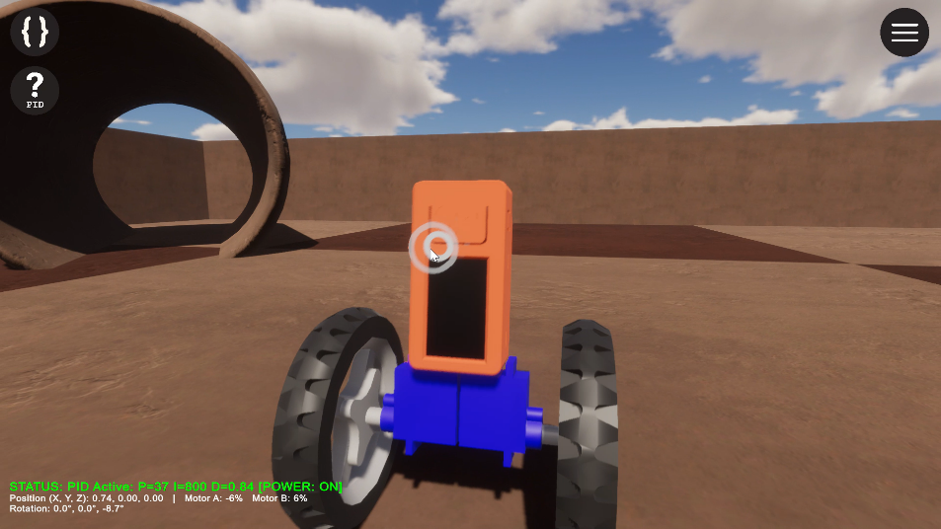
Figure 3.4: Scenario simulation

4. Usage Examples

4.1 Game Startup
Upon launching the game, the initial screen is displayed. This screen provides access to the BalaC PID playground environment.
The user can start the simulation and access the available programming level directly from the main interface.

4.2 Environment Access
The simulator provides access to the AutoSTEM (BalaC) PID playground:
- AutoSTEM (BalaC): 1 playground level.
Once the environment is selected, the game loads the available level for the BalaC robot.

4.3 Level Structure
The level has a specific goal. The goal consists of maintaining the BalaC robot in an upright position through the correct tuning of PID parameters.
The user must interact with the programming environment to define the control logic and observe the system response.

4.4 Game Menu
Two main icons are always available during gameplay:

4.4.1 Programming Icon
In the top-left corner, there is an icon dedicated to programming. This icon allows the user to access the programming functionalities necessary to interact with the BalaC PID environment.

4.4.2 Options
In the top-right corner, there is the Options icon. Through the menu, it is possible to:
- Return to the initial screen.
- Change settings.
- Exit the game.

4.5 Custom Blocks Guide

4.5.1 BalaC Custom Blocks
This section describes the custom blocks created for BalaC and how they are used.
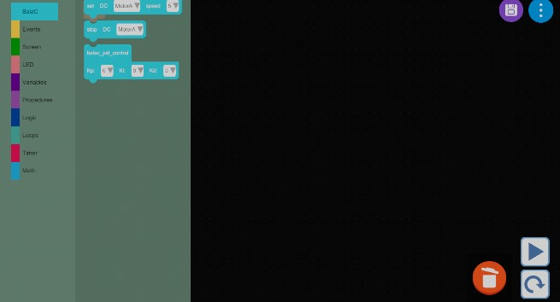
Figure 4.2: BalaC control blocks.

Access to the control primitives of AutoSTEM occurs through the dedicated section in the programming interface. By selecting the "BalaC" category, one accesses the panel containing the functional blocks for managing movement and sensors.
set_dc_motor: Manages the actuation of the motors. The block requires the configuration of two fundamental parameters: the output channel (selectable between MotorA and MotorB) and the speed setpoint, defined via a scalar numeric value.
stop_dc_motor: Commands the immediate interruption of electrical power to the specified motor (A or B), stopping the wheel.
basic_pid_control: Implements a PID (Proportional-Integral-Derivative) feedback control algorithm. This block allows the calibration of the three characteristic gains:
- Kp: Proportional constant, linked to the instantaneous error.
- Ki: Integral constant, for correcting the steady-state error (accumulated over time).
- Kd: Derivative constant, for predicting the future trend of the error.

5. Troubleshooting
This section addresses the main issues that may occur during the installation and use of the B.R.I.D.G.E. application, providing practical guidance for their resolution. The issues are categorized by usage phase (installation, configuration, and runtime).

5.1 Installation Errors
During the installation or package extraction phase, some common problems may occur:
- Missing or damaged files: If the ZIP file extraction fails or some files appear corrupt, ensure you have downloaded the complete archive from the official GitHub repository. Redownload the package and repeat the extraction.
- Error "Unable to start application": On Windows, this error may depend on missing libraries (.dll) or an incomplete extraction. Verify that the AUTOSTEM.exe file is in the same directory as its resources (AUTOSTEM_Data folder) and that the antivirus has not blocked the content.

5.2 Common Configuration Issues
Some issues may emerge at the first launch or during graphical configuration:
- Black screen on startup: This may be caused by outdated graphics drivers. Update GPU drivers (Nvidia, AMD, or Intel) and ensure the system supports OpenGL 3.2+, Vulkan, or Metal.
- Incorrect resolution or window size: Resolution-related problems may occur (e.g., UI elements not showing correctly). Make sure to start the game with the monitor set to 1920 × 1080.
- No audio: Verify that the correct audio output device is selected in the operating system and that the volume is not muted within the game.

5.3 Possible Software Crashes or Malfunctions
In case the game closes suddenly or presents operational anomalies, it is recommended to:
- Verify system requirements: Ensure the hardware meets the minimum requirements (CPU, GPU, and RAM). Ensure your screen resolution is set to 1920 × 1080 to avoid UI issues.
- Check Unity logs: After a crash, Unity automatically generates a log file. On Windows: C:\Users\<user>\AppData\LocalLow\TDSG\AUTOSTEM\Player.log. Analyzing this file can help identify the source of the problem.
- Crash on startup: Often due to incompatible graphics library versions or missing files in the package. Reinstall the game or update system libraries (Vulkan/OpenGL).
- Slow performance or lag: Try to close any background applications consuming system resources.

Greetings and Acknowledgments
Thank you for choosing to use B.R.I.D.G.E. We hope your experience has been pleasant and that the manual has helped you understand all available features.
A heartfelt thank you goes to all users who contributed feedback and suggestions, which help us constantly improve the product. Have fun and enjoy the experience!

License
This work is licensed under the Creative Commons Attribution-NonCommercial-ShareAlike 4.0 International License (CC BY-NC-SA 4.0).
You are free to share and adapt the material for non-commercial purposes, provided that appropriate credit is given and any modifications are distributed under the same license.
Contributors:
- Ripani Alessandro
- Davide Collevecchio
- Francesco Giachini
- David Scaradozzi
- Martina Morano
- Giacomo Fiara
- Flavia Gioiello
- Andre Yamashita

