# RES FTP Service GUI.

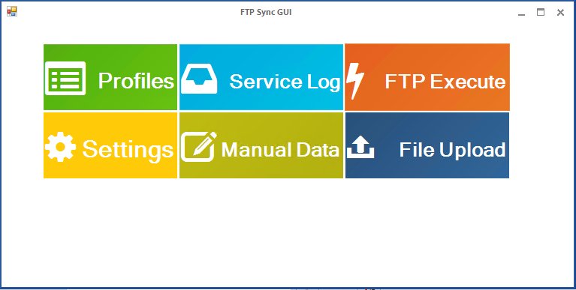

GUI main menu

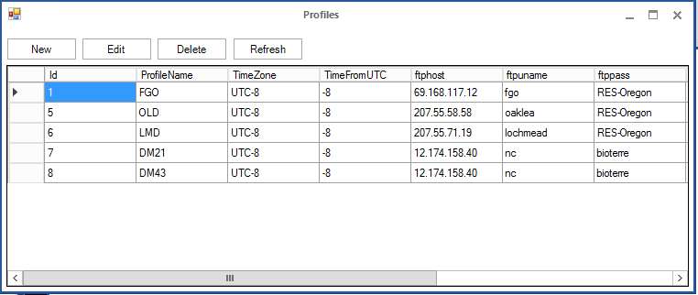

List of FTP Profiles. (With add new profile, edit, delete support) The refresh button refresh the values after insertion or modification.

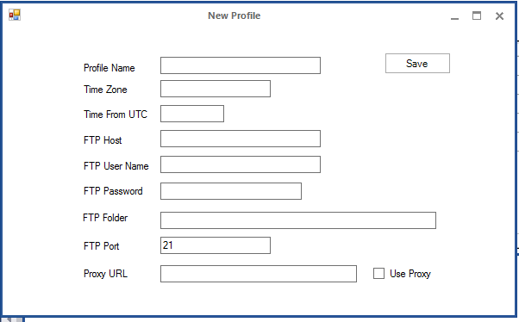

New FTP Profile form.

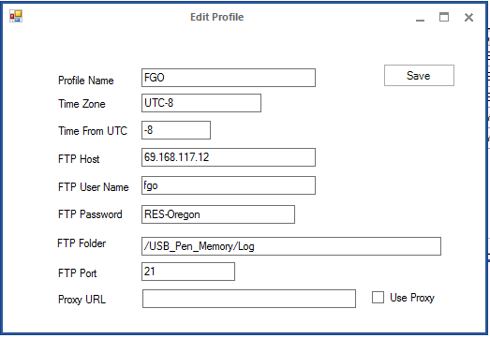

FTP Profile edit form

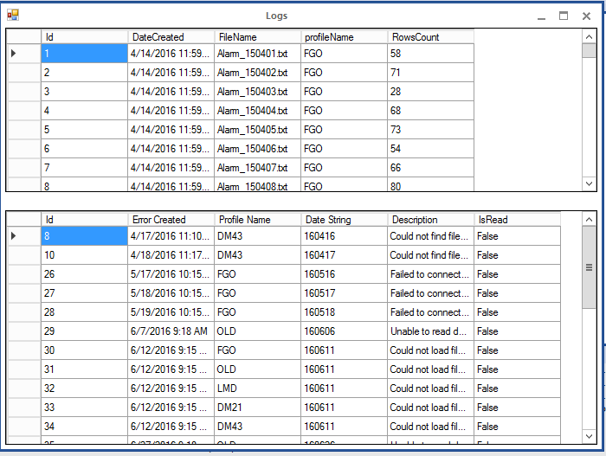

Service and errors Log.

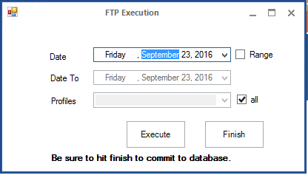

ftp execution. You must not use today as execution Date.

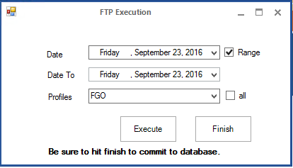

FTP execution per profile – date range. After all, calls completed the “Finish” button must be click in order the data to be available in BI Service.

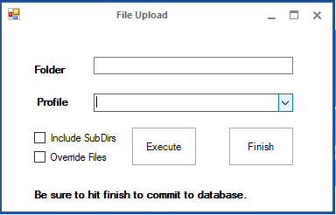

File Upload. Used to insert files from file system (User’s folder selection, by double click on Folder input box)

**

The “Include SubDirs” checkbox enables the insertion for all files including all the files inside subfolders.

After all, calls completed the “Finish” button must be click in order the data to be available in BI Service.

The “Override Files” option enables the override of the existing data in database.

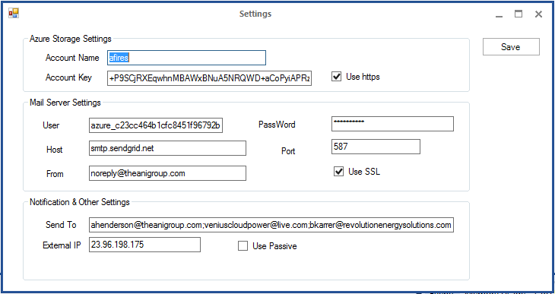

Service configuration.

Azure Storage Settings, Mail Server Settings, Notification recipients list.

External IP must be the Azure VM’s external IP address, and use Passive unchecked in order to work correctly with the existing FTP Servers.

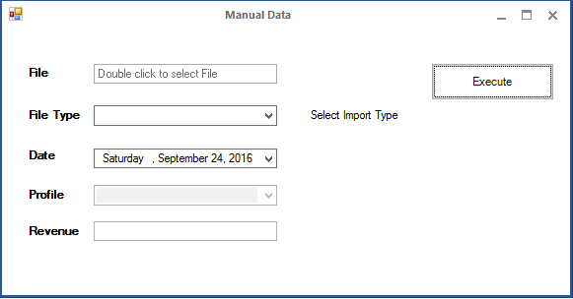

Manual data Form

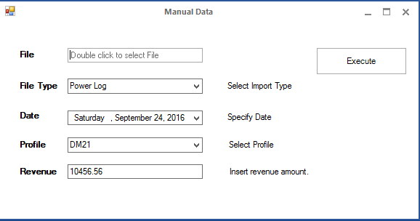

Power Log – You must specify profile, the monthly revenue and the end of working month as Date.

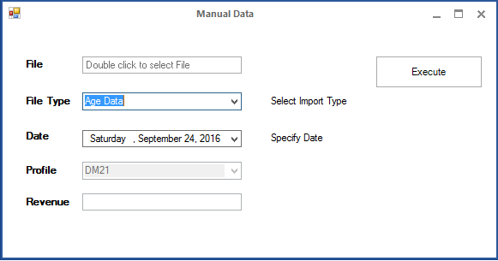

Site age – You specify only the Date (The Date must be the end (Friday) of the week).

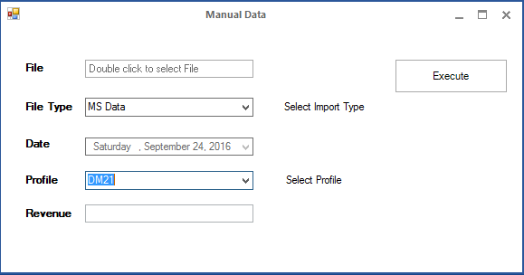

MS Data – You specify only the profile.