Reason Theme/Graphics

Anil

6/30/2020

## R Markdown

This is an R Markdown document that describes Reason graphics style in R. Packages: pensionviewr & reasonTheme

##Defining - Colors - ggplot() themes, labels, and margins

# All images should use web safe colors — this gives us a range of orange and blue  
# colors that fit with Reason’s branding, as well as reds and greens that we can use to  
# indicate positive or negative data patterns. The following colors are most suitable:  
#https://www.rapidtables.com/web/color/Web_Safe.html  
  
palette_reason <- data.frame(  
 Orange = "#FF6633",   
 LightOrange = "#FF9933",  
 DarkGrey = "#333333",   
 SpaceGrey = "#A69FA1",  
 DarkBlue = "#0066CC",  
 GreyBlue = "#6699CC",   
 Yellow = "#FFCC33",   
 LightBlue = "#66B2FF",   
 SatBlue = "#3366CC",   
 Green = "#669900",  
 LightGreen = "#00CC66",  
 Red = "#CC0000",  
 LightRed = "#FF0000")  
  
##Convert color code to RedGreenBlue palette (with rgb())  
rgb1 <- col2rgb(palette_reason$SatBlue, alpha = FALSE)/255  
rgb1

## [,1]  
## red 0.2  
## green 0.4  
## blue 0.8

rownames(rgb1) <- c("red", "green", "blue")  
ColorName <- rgb(rgb1[1],rgb1[2],rgb1[3])  
ColorName

## [1] "#3366CC"

#Customize color code  
ColorName2 <- rgb(0.1,0.5,0.8)  
ColorName2

## [1] "#1A80CC"

#######  
for (i in (1:length(palette_reason))){  
x <- plot(c(5, 10), c(15, 30), type= "n", main=c(colnames(palette_reason[i])), xlab = "",   
ylab = c(as.character(palette_reason[1,i])), xaxt="n", yaxt="n",cex.lab=1.5, cex.main=2)  
rect(5, 15, 10, 30, col = as.character(palette_reason[1,i]), border = "transparent")  
## Standard Colors for graphics in R  
}

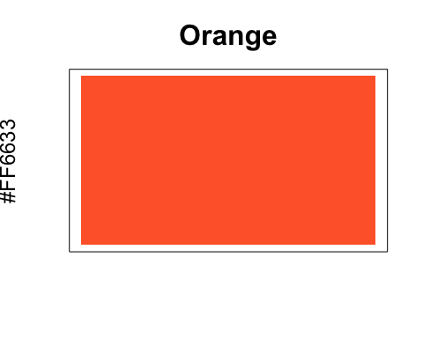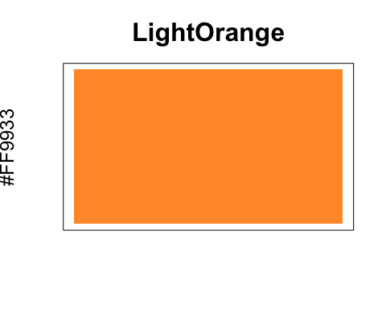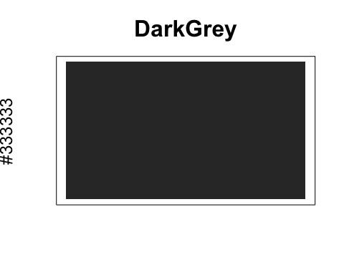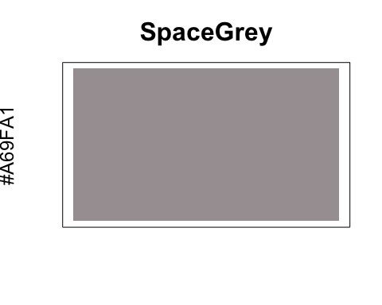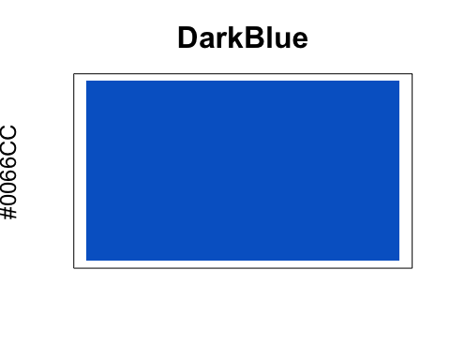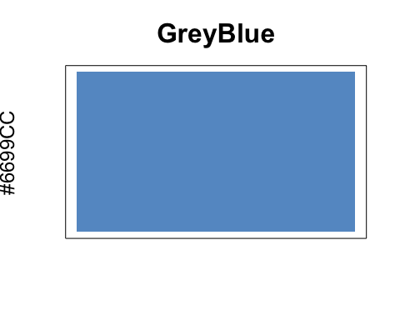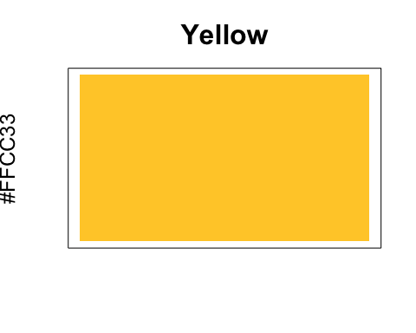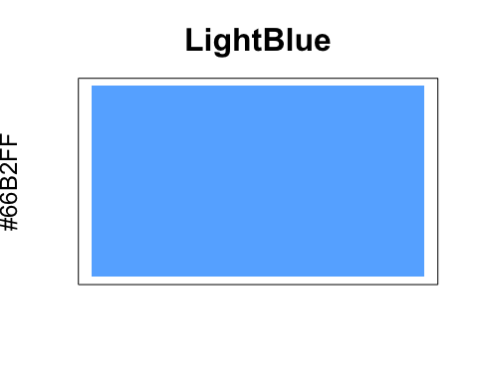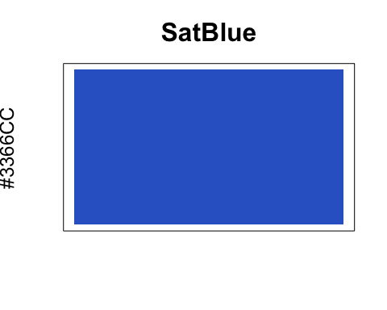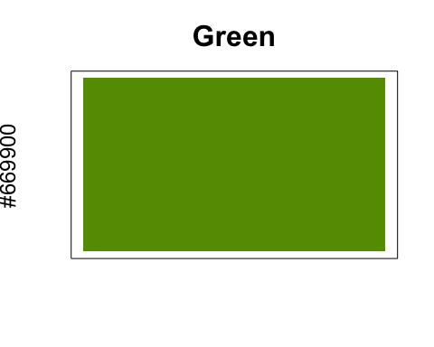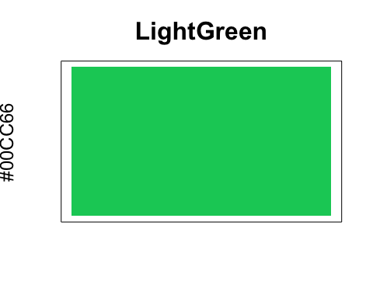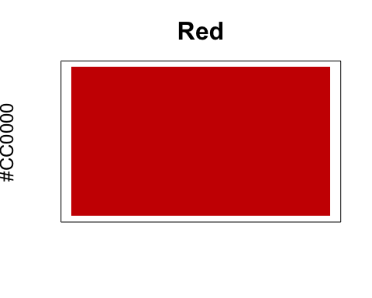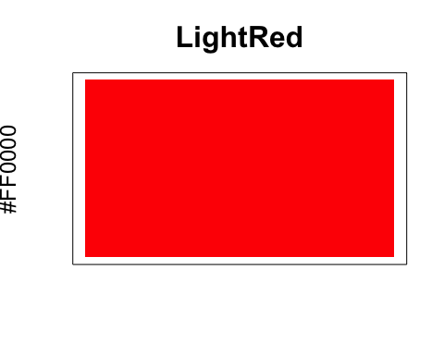

# Standardized R parameters:

### Base R package: ggplot2 (main parts)

* geometry (ex: line, bar, point, text)
* scale (ex: x-axis, y-axis, color, shape)
* mapping of data to scales (ex: car type maps to the x-axis)
* theme (ex: title font, caption color)

### Base Font: “Calibri”

### Base Font size: 14.0

### Base Line size: 0.5

### Base Theme: reasonTheme (

#plot.title (size = base_size * 12 / 8.5, margin = ggplot2::margin(b = 10L))  
 #plot.margin (t = half_line,  
 r = base_line_size * 24,  
 b = half_line,  
 l = half_line)  
 #axis.title(face = "bold", size = base_size)  
 #axis.title.x(margin = ggplot2::margin(t = 8L))  
 #axis.title.y(angle = 90L,margin = ggplot2::margin(r = 4L))  
 #axis.ticks.length(4L, "pt")

### What you have to specify in ggplot(), after setting Reason theme, when you graph somthing in R:

* Data to use for the graph (data.frame)
* Y-axis & X-axis scales (ticks = n)
* Y-axis & X-axis limits (limits = c(x,y))
* Colors (color = or fill =, using colors in palette_reason)
* Title (ggtitle())

## Latest Mountain of Debt Plot using deptPlot() from pensionviewr

### Modified colors, ending ticks & year labels

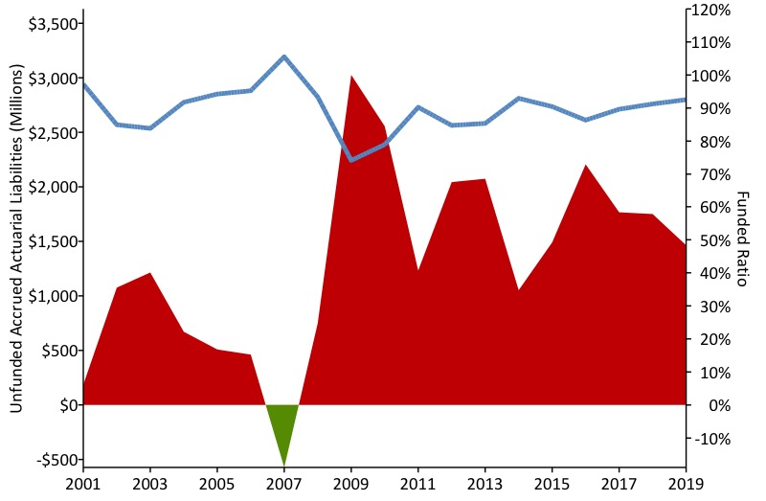

Latest Modified Debt Plot - PERSI

## Original Mountain of Debt Plot using deptPlot() from pensionviewr

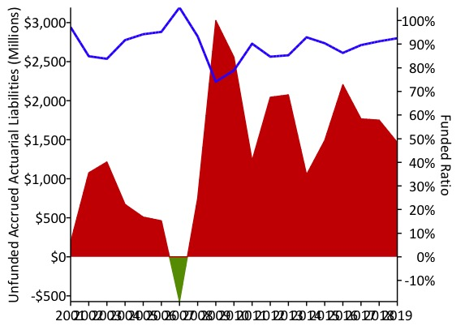

Original Debt Plot - PERSI