MOBILE PHONE PRICE ANALYSIS & PREDICTION
Project Report
Developed using Python, Pandas, NumPy, Matplotlib, Scikit-learn, Flask, and Joblib

1. Introduction
The mobile phone market offers a wide range of smartphones with different specifications, features, and prices. The price of a mobile phone depends on several factors such as brand, RAM, storage capacity, camera specifications, battery capacity, and screen size.
This project, titled “Mobile Phone Price Analysis & Prediction Using Machine Learning”, focuses on analyzing mobile phone data and developing a machine learning model to predict the price of a smartphone based on its specifications.
The project includes data collection, data cleaning, exploratory data analysis, data visualization, machine learning model development, model evaluation, and deployment through a simple Flask web application.
The main objective is to demonstrate how data analytics and machine learning can be used to understand mobile phone pricing patterns and make price predictions from given specifications.
1.1 Objectives
- To clean and preprocess mobile phone data.
- To analyze mobile phone prices based on different specifications.
- To visualize important patterns in the dataset.
- To develop a machine learning model for price prediction.
- To evaluate the performance of the prediction model.
- To create a simple web application for predicting mobile phone prices.

2. Dataset Description
The dataset used in this project contains information about mobile phones and their technical specifications. The dataset includes both numerical and categorical features that can be used to analyze and predict mobile phone prices.
2.1 Dataset Features
FEATURE | DESCRIPTION
Brand | Brand name of the mobile phone
RAM_GB | RAM capacity in GB
Storage_GB | Internal storage capacity in GB
Camera_MP | Camera resolution in megapixels
Battery_mAh | Battery capacity in mAh
Screen_Size | Screen size in inches
Price | Price of the mobile phone

The raw dataset is stored in:
"dataset/mobile_raw_data.csv"
After data cleaning and preprocessing, the cleaned dataset is stored in:
"dataset/mobile_cleaned_data.csv"
The dataset contains some missing values, duplicate records, and inconsistent brand formatting. These issues were handled during the data cleaning stage.

3. Data Cleaning and Preprocessing
Data cleaning is an important step in the project because raw data may contain missing values, duplicate records, and inconsistent information.
The following preprocessing steps were performed:
3.1 Brand Standardization
Extra spaces were removed from the Brand column and brand names were standardized into a consistent format.
For example, different forms such as "vivo", "vivo" and "Vivo" were converted into a standard format.
3.2 Handling Missing Values
Missing values in numerical columns were identified using Pandas. The missing numerical values were replaced with the median value of the corresponding column.
3.3 Removing Duplicate Records
Duplicate rows were identified and removed from the dataset to avoid repeated records affecting the analysis.
3.4 Cleaned Dataset
After preprocessing, the cleaned data was saved as:
"dataset/mobile_cleaned_data.csv"
This cleaned dataset was then used for data analysis, visualization, and machine learning.

4. Data Analysis
After cleaning the dataset, exploratory data analysis was performed to understand the pricing patterns of mobile phones.
The analysis focused on the average, minimum, and maximum mobile phone prices and the relationship between price and different phone specifications.
4.1 Average Mobile Phone Price
The average price of all mobile phones in the cleaned dataset was calculated using the mean of the Price column.
4.2 Minimum and Maximum Price
The minimum and maximum prices were calculated to understand the overall price range of the mobile phones in the dataset.
4.3 Average Price by Brand
The average price for each mobile phone brand was calculated. This helps compare the pricing patterns of different brands.
4.4 Average Price by RAM
The average mobile phone price was also calculated for different RAM capacities. This helps identify the relationship between RAM and mobile phone price.
4.5 Most Expensive and Cheapest Phone
The dataset was analyzed to identify the mobile phone with the highest price and the mobile phone with the lowest price.
These analyses helped in understanding the major pricing patterns present in the dataset.

5. Data Visualization
Data visualization was performed using Matplotlib to represent important relationships in the mobile phone dataset.
Three visualizations were created as part of this project.
5.1 Average Price by Brand
A bar chart was created to compare the average mobile phone price across different brands.
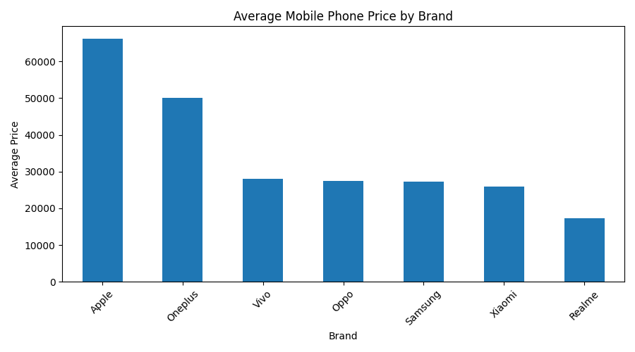
Figure 1: Average Mobile Phone Price by Brand
5.2 RAM vs Mobile Phone Price
A scatter plot was created to study the relationship between RAM capacity and mobile phone price.
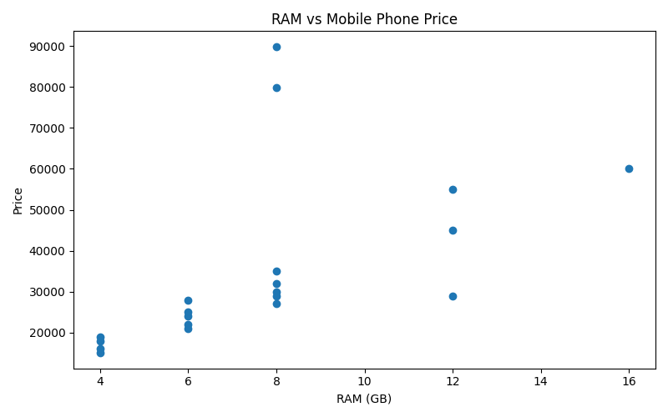
Figure 2: RAM vs Mobile Phone Price
5.3 Storage vs Mobile Phone Price
A scatter plot was created to analyze the relationship between storage capacity and mobile phone price.
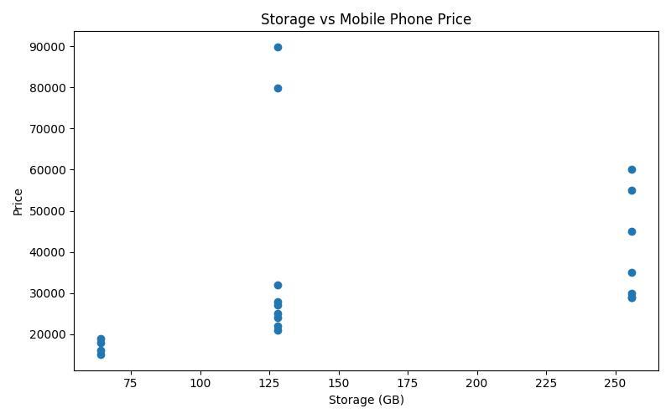
Figure 3: Storage vs Mobile Phone Price
These visualizations help in understanding how different mobile phone specifications are related to their prices.
6. Machine Learning Model
A machine learning model was developed to predict the price of a mobile phone based on its specifications.
6.1 Selected Features
The following features were used as input variables:
- Brand
- RAM
- Storage
- Camera
- Battery Capacity
- Screen Size
The target variable was:
- Price
6.2 Data Preprocessing for Machine Learning
The Brand column is a categorical feature, so One-Hot Encoding was used to convert brand names into numerical form.
The numerical features were passed directly to the machine learning model.
6.3 Train-Test Split
The cleaned dataset was divided into training and testing datasets.
- 80% of the data was used for training.
- 20% of the data was used for testing.
A fixed random state of 42 was used to make the result reproducible.
6.4 Algorithm Used
The machine learning algorithm used in this project is:
Random Forest Regression
Random Forest Regression combines multiple decision trees to make numerical predictions. It was selected to learn the relationship between mobile phone specifications and their prices.
6.5 Model Pipeline
A Scikit-learn pipeline was created that combines the preprocessing step and the Random Forest Regression model.
The trained model was saved using Joblib as:
"model/phone_price_prediction_model.pkl"

7. Model Evaluation
The trained Random Forest Regression model was evaluated using the test dataset.
Two evaluation metrics were used:
7.1 Mean Absolute Error (MAE)
Mean Absolute Error measures the average absolute difference between the actual prices and the predicted prices.
The obtained MAE was:
Mean Absolute Error (MAE): ₹17,744.96
7.2 R² Score
The R² Score measures how well the model explains the variation in the target variable.
The obtained R² Score was:
R² Score: 0.15
These results were obtained by running the Random Forest Regression model on the prepared dataset. Since the project uses a small demonstration dataset, the evaluation results should be interpreted as an academic project result rather than a production-level prediction benchmark.

8. Flask Web Application
A simple web application was developed using Flask to provide an interactive interface for mobile phone price prediction.
The application loads the trained machine learning model and accepts mobile phone specifications from the user.
8.1 User Inputs
The web application accepts the following inputs:
- Brand
- RAM in GB
- Storage in GB
- Camera in MP
- Battery capacity in mAh
- Screen size
After the user submits the specifications, the trained Random Forest Regression model predicts the estimated mobile phone price.
8.2 Application Execution
The Flask application is started using:
"python app.py"
The application runs locally at:
"http://127.0.0.1:5000"
The web interface provides a simple and user-friendly way to test the trained machine learning model.
A screenshot of the running Flask application is included in this report
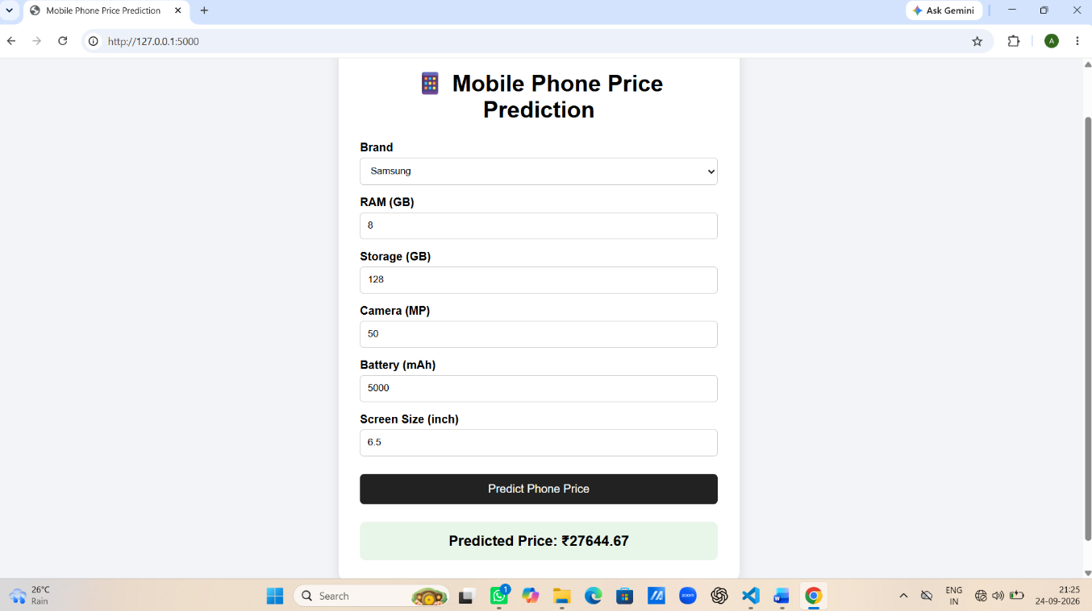
Figure 4: Mobile Phone Price Prediction Web Application

9. Technologies Used
The following technologies and libraries were used to develop the project:
- Python – Programming language
- Pandas – Data manipulation and analysis
- NumPy – Numerical operations
- Matplotlib – Data visualization
- Scikit-learn – Machine learning and model evaluation
- Joblib – Saving and loading the trained model
- Flask – Web application development
- VS Code – Development environment
10. Project Structure
The project is organized into the following main files and folders:
Mobile-Phone-Price-Prediction/
│
├── AnkitaDey_MobilePhonePricePrediction.py
├── app.py
├── requirements.txt
├── AnkitaDey_ProjectReport.docx
├── README.md
│
├── dataset/
│ ├── mobile_raw_data.csv
│ └── mobile_cleaned_data.csv
│
├── model/
│ └── phone_price_prediction_model.pkl
│
└── templates/
└── index.html
The main Python file performs data cleaning, analysis, visualization, model training, evaluation, and sample prediction. The Flask application provides the web-based prediction interface.

11. Conclusion
The Mobile Phone Price Analysis & Prediction Using Machine Learning project successfully demonstrates the use of data analytics and machine learning for mobile phone price prediction.
The project included data cleaning, exploratory data analysis, visualization, feature preprocessing, Random Forest Regression, model evaluation, and Flask-based deployment.
The analysis helped identify pricing patterns based on mobile phone specifications such as RAM, storage, camera, battery capacity, screen size, and brand.
The trained model was successfully saved and integrated with a Flask web application. Users can enter mobile phone specifications through the web interface and receive an estimated price.
This project provided practical experience in Python programming, data analysis, machine learning, model evaluation, and web application development.

12. Future Scope
The project can be improved further by:
- Using a larger and more diverse mobile phone dataset.
- Including additional features such as processor, operating system, 5G support, and display resolution.
- Comparing multiple machine learning algorithms.
- Performing hyperparameter tuning to improve model performance.
- Deploying the web application on a cloud platform.
- Adding more interactive visualizations and user-friendly features.

13. References
- Python Documentation
- Pandas Documentation
- NumPy Documentation
- Matplotlib Documentation
- Scikit-learn Documentation
- Flask Documentation
- IBM SkillsBuild learning resources

