Past 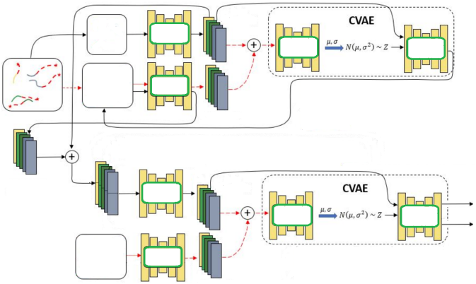

encoding

Destination

encoding

Predicted

**Past**

**history**

**End**

**point**

**Social**

destination

encoding

Future

trajectory

encoding

**pooling**

**Future**

**trajectory**

Predicted trajectory

Confidenceinterval