Overview

AODocs APIs let you access, manage, and configure AODocs objects and their associated metadata, such as libraries, classes, documents, attachments, and properties.

The APIs also let you interact indirectly with some AODocs-related [Google Drive API](https://developers.google.com/drive/api/v3/about-sdk) functionality, including accessing files and folders in Drive.

###### [diagram similar to but different from the below?]

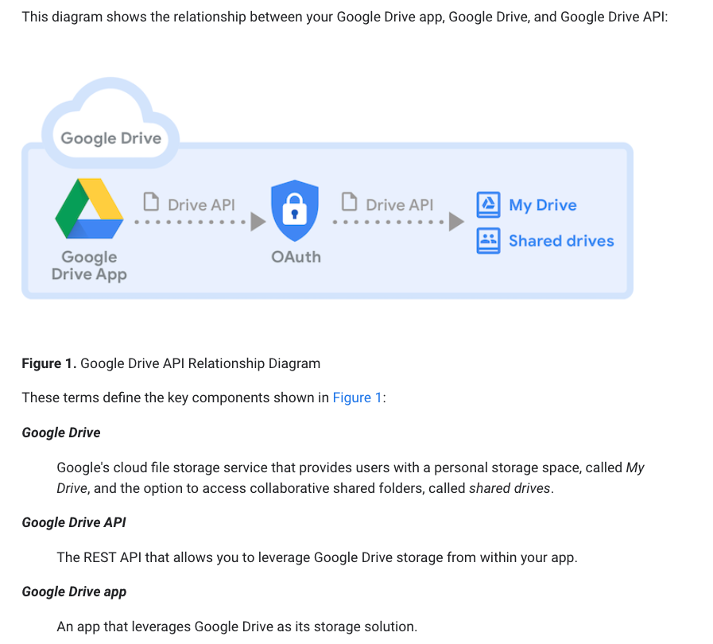

t

EXTRACT A TEMPLATE FOR EACH OPERATION PAGE

~~

APART FROM OPERATIONS, ALSO NEED SOME INFO ABOUT THE RESOURCE

IN **BASICS OF THE API**, SHOULD HAVE SOMETHING ABOUT THE RESOURCE

RESOURCES ARE GOOGLE-STYLE REST:

RESOURCES ARE USED AS EITHER INPUT OR OUTPUT

REQUEST BODY OR RESPONSE BODY

GET/UPDATE/PATCH SEMANTICS SHOULD BE EXPLAINED REGARDING RESOURCES

NEED TO EXPLAIN HOW THE FIELDS FIELD… "PARTIAL RESPONSE" USING THE FIELDS QUERY PARAMETER

NEED STH ABOUT GENERAL PRINCIPLES OF WORKING WITH RESOURCES

WE DO HAVE AN API GUIDELINE FROM GOOGLE:

API DESIGN GUIDE WE TRY TO FOLLOW

WHEN YOU HAVE A RESOURCE…

FIRST ARTICLE ABOUT AODOCS PRINCIPLES/CONCEPTS/ELEMENTS

USUALLY WE HAVE AN API RESOURCE THAT CORRESPONDS TO CONCEPT IN AODOCS

A LOT TO PUT INTO THE BASICS OF THE API

ALSO HAVE A WAY OF EXPLAINING THE SPECIFIC RESOURCE, WHAT IT'S USED FOR, WHAT ARE THE TRICKS

INSTEAD OF HAVING THE FIELDS OF NOTE IN EVERY METHOD THAT USES THE SAME RESOURCE, EXTRACT THAT AND HAVE A BLOCK OF CONTENT EXPLAINING HOW THIS RESOURCE WORKS, WHAT ARE THE INTERESTING FIELDS, ETC.

**IN THE NEW API IT'S MUCH SIMPLER, BECAUSE YOU JUST HAVE TO GO TO API LIBRARY AND HERE'S EVERY METHOD explained.**

regardless of how thoroughly it's explained in API Explorer, still need to explain some of the more important resource behaviour stuff.

definitely need an **ApiDocument** article

API resource-based article or articles

Articles about specific and important resources.

Focusing on the methods you'll miss something.

It's not really interesting to have a focus on library resource it's not that hard to understand.

Document resource is much more nuanced.

diff Document ApiDocument

in terms of the levels,

eventually in our

level 3 is just a section in level 2

/////

(Ways to) Get Started / Getting Started / Start

You have a few options for getting started with the AODocs API(s).

[The one-minute experience: APIs Explorer]

~~

The one-hour experience: Your First App

__

[Developer Guides (prerequisites, auth requests, usage limits, manage group settings) / How-Tos (if already understand, then how to guides; or, if need fundamentals, then task concepts) / Guides (if already understand, see guides on left)]

____

Reference

---