**Detail Design**

**On**

**City Corporation Budget Transparency (CCBT)**

**Course No: CSE 3204**

**Course Title: Software Engineering and Information System Project**

**Md, Abdul Lotif**

**Student Id: 160212**

**&**

**Saimum Islam**

**Student Id: 160227**

**Project Manager:   
Dr. Kazi Masudul Alam   
Associate Professor,  
Computer Science & Engineering Discipline,  
Khulna University**

**ER Diagram:**

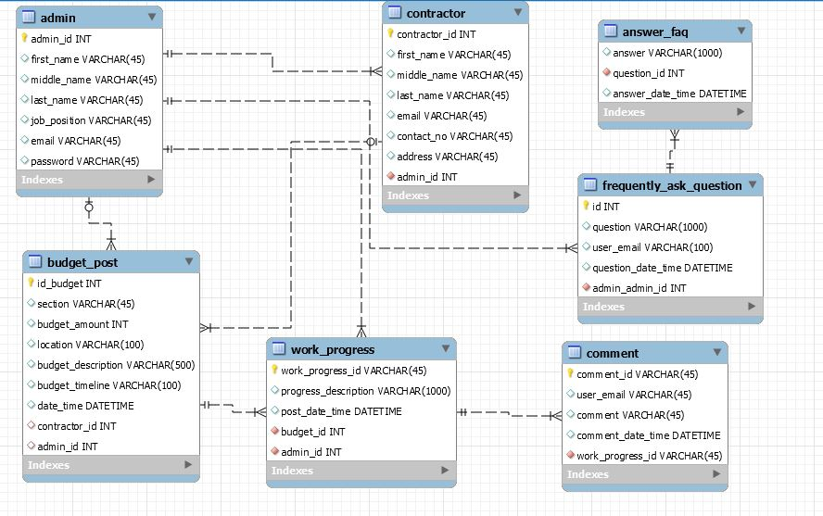

*Fig: ER Diagram*

**Class Diagram:**

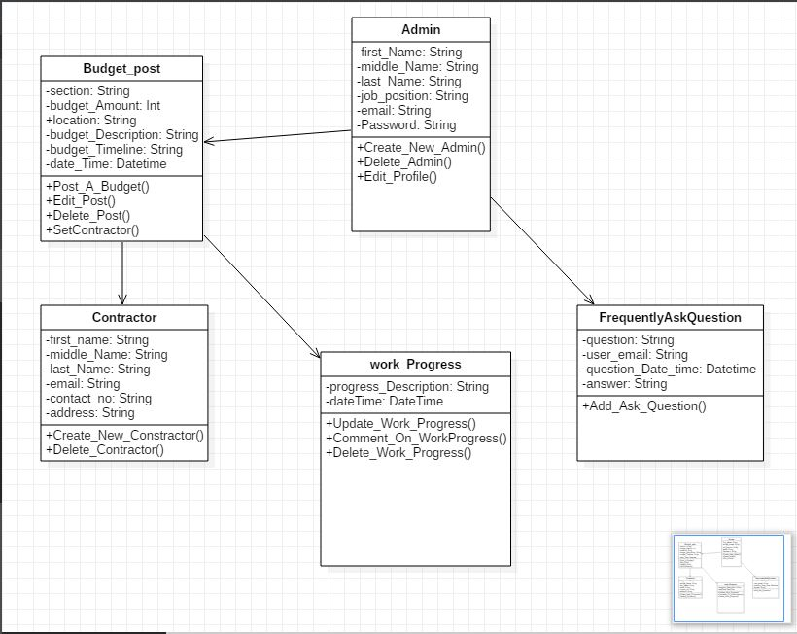

*Fig: Class Diagram*

**Details Class Digram:**

**Class Admin**

boolean **Create_A_Post (** String first_name, String middle_name, String last_name, String job_position, String email **)**

boolean **Delete_Admin (** String admin_Id **)**

admin **View_Profile (** String admin_id **)**

boolean **Edit_Profile (** String id **)**

List<admin> **Get_Admin_list ( )**

**Class Budget_Post**

Boolean **Post_A_Budget (** String section, String budget_Amount, String location, String budget_Description, String budget_Timeline, Datetime current_DateTime **)**

Budget_Post **View_Budget_Post(** String Post_Id **)**

boolean **Edit_Post (** String Post_Id **)**

boolean **Delete_Post (** String Post_id **)**

boolean **Set_Contractor (** String Post_Id **)**

List<Budget_Post> **Get_Budget_Post_List_By_Section (** String section **)**

**Class Contractor**

boolean **Create_New_Contractor (** String first_Name, String middle_Name, String Last_Name, String email, String contact_No, String address **)**

boolean **Delete_Contractor (** String contractor_Id **)**

List<Contractor> **Get_All_Contractor_List ( )**

Contractor **View_Contractor_Profile (** String contractor_Id **)**

**Class Work_Progress**

boolean **Update_Work_Progress(** String budget_Id, String progress_Description**,** Datetime current_DatetTme **)**

List<Work_Progress> **Get_All_Work_Progress_List(** String budget_Post_Id **)**

boolean **Comment_On_Work_Progress (** String work_Progress_Id **)**

List<Comment> **Get_Comment_List(** String work_Progress_Id **)**

boolean **Delete_Work_Progress(** String work_Progress_Id **)**

**Class Frequently_Ask_Question**

boolean **Add_FAQ(** String question, String user_email, String Answer **)**

**User Interface:**

**Home Page:**

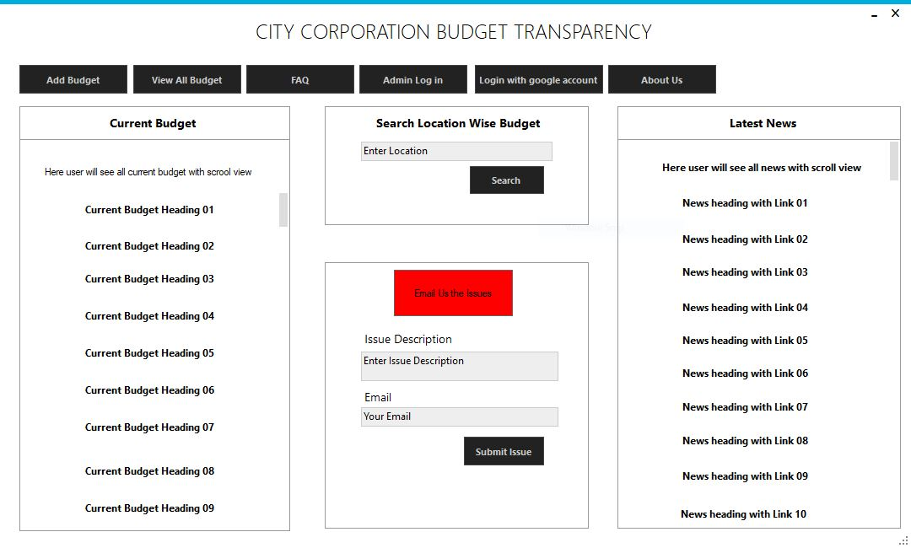

*Fig: Home Page*

**Admin Login Page:**

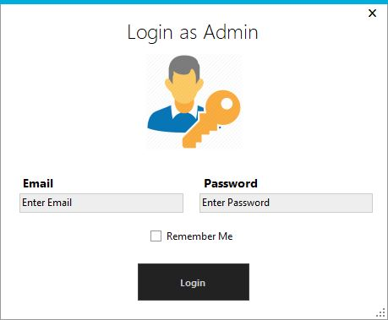

*Fig: Admin Login Page*

**Add New Budget:**

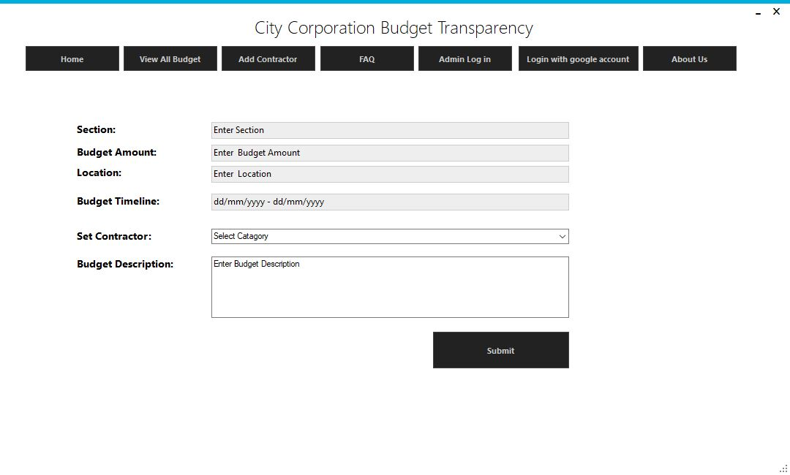

*Fig: Add New Budget*

**View All Budget:**

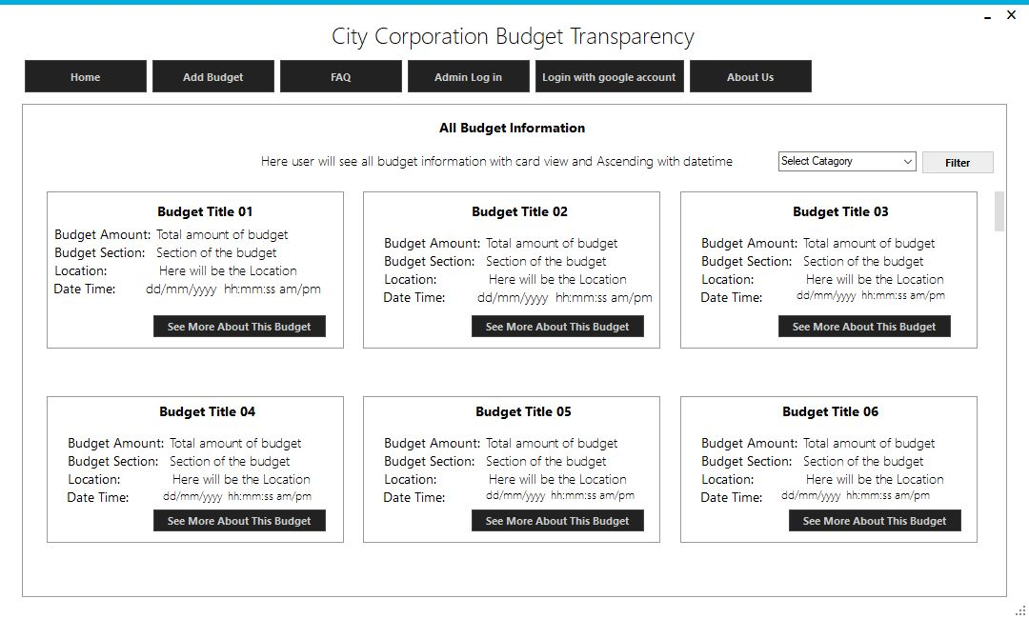

*Fig: View All Budget*

**Full Information of A Budget:**

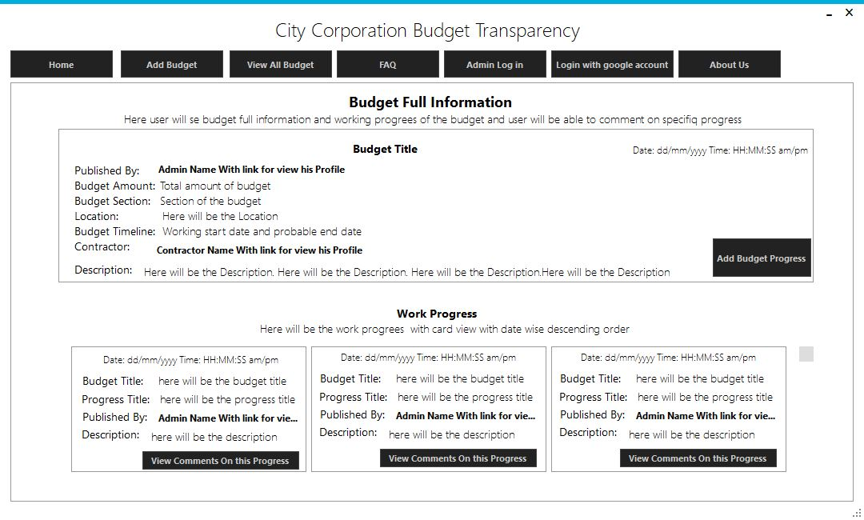

*Fig: Full Information of A budget*

**Add Working Progress of A Budget:**

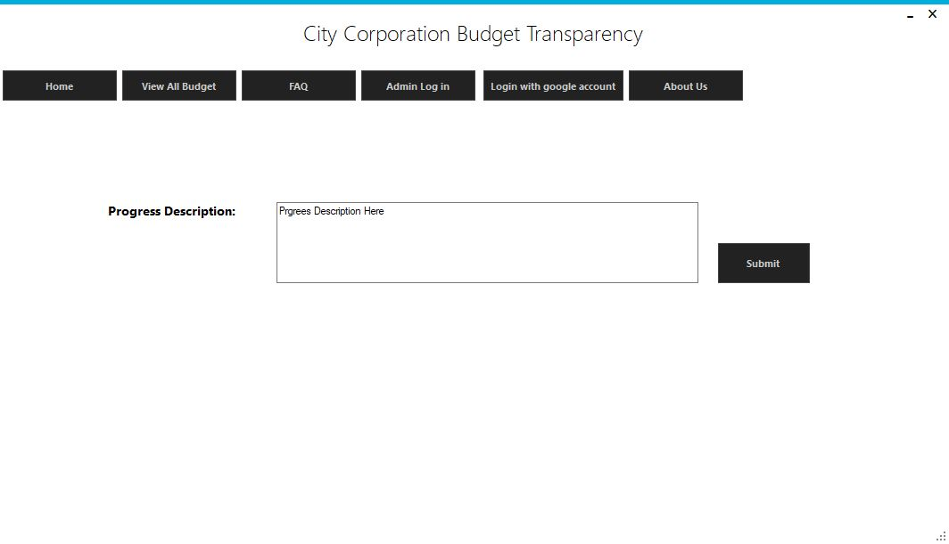

*Fig: Add working progress of a budget*

**View and Comment On Working Progress:**

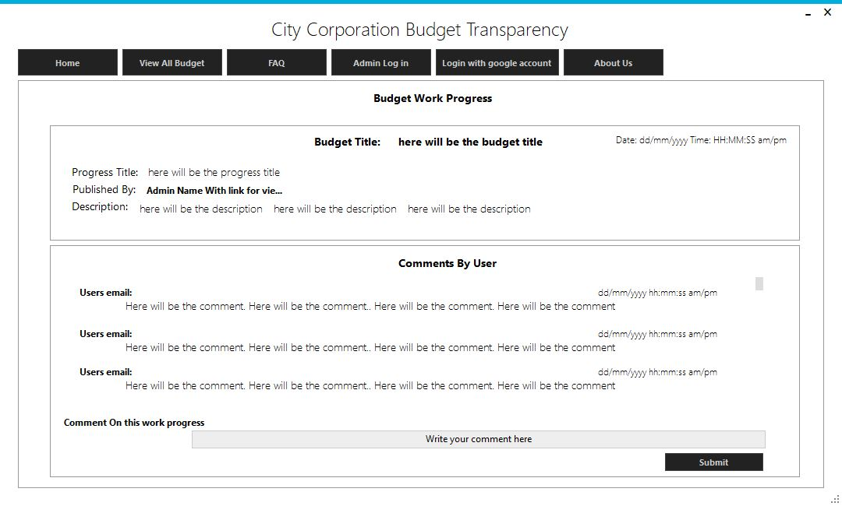

*Fig: View and comment on working progress*

**Create Contractor:**

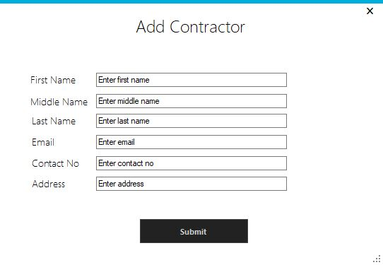

*Fig: Add or Create Contractor*

**View Contractor Profile:**

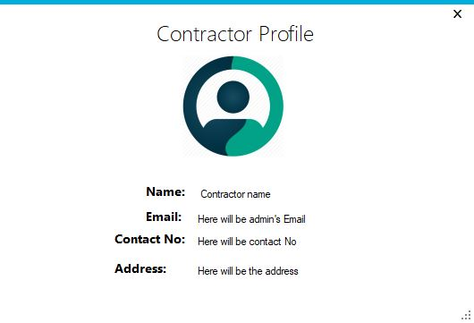

**View Admin Profile:**

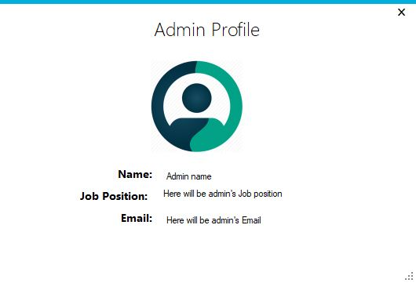

**Add Frequently ask question and answer:**

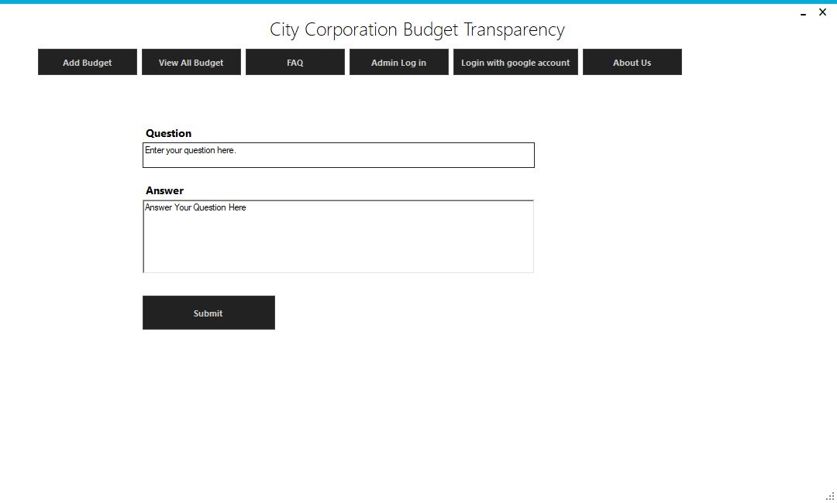

**View FAQ List:**

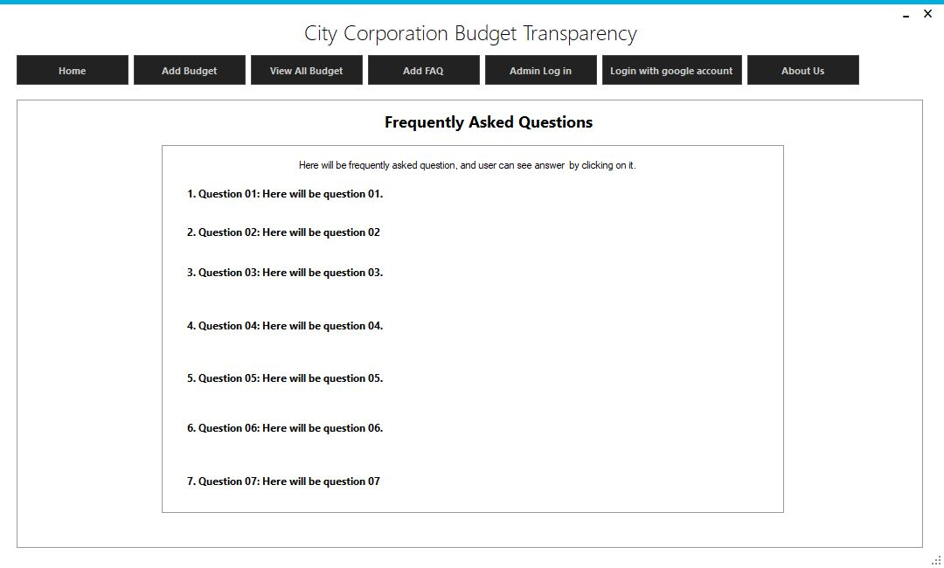

**Fig: View FAQ list**

**View Answer of a specific FAQ:**

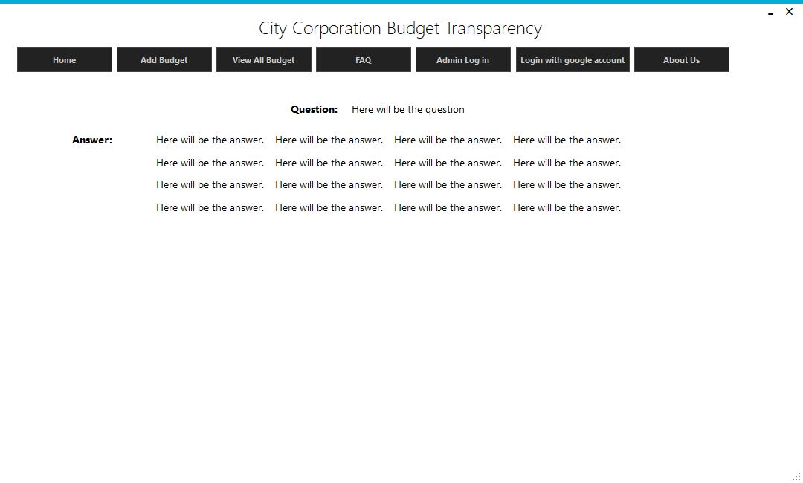

Fig: View answer of a FAQ

**About Us Page:**

