Software Requirements Specification

for

City Corporation Budget Transparency

Version 1.0

01/08/18

Table of Contents

Table of Contents 2

Revision History 3

1. Introduction 4

1.1 Purpose 4

1.2 Document Conventions 4

1.3 Intended Audience and Reading Suggestions 4

1.4 Product Scope 4

1.5 References 5

2. Overall Description 5

2.1 Product Perspective 5

2.2 Product Functions 5

2.3 User Classes and Characteristics 5

2.4 Operating Environment 6

2.5 Design and Implementation Constraints 6

2.6 User Documentation 6

2.7 Assumptions and Dependencies 6

3. External Interface Requirements 6

3.1 User Interfaces 6

3.2 Hardware Interfaces 6

3.3 Software Interfaces 7

3.4 Communications Interfaces 7

4. System Features 7

4.1 System Features for Admin 7

4.2 System Features for users 7

4.3 Use Cases Description……………………………………………………………………………………………………….…………. 8

4.3.1 Access Budget Transparency Home page……………………………………………………………………………8

4.3.2 Create New Admin Account………………………………………………………...……………………………....9-10

4.3.3 Create a post………………………………………………………………………....…………………..…………...…10-11

4.3.4 Update a post………………………………………………………………………...…………………..…………...…11-12

4.3.5 Delete a post………………………………………………………………………....…………………..…………...…12-13

4.3.6 Set Contractor …………………………………………….…………………………………………..………...………13-14

4.3.7: Update Working Progress ………………………………………………………………………………………...14-15

4.3.8: Ask question and answer a question…………………………………………………………..……………..15-16

5. Other Nonfunctional Requirements 16

5.1 Safety Requirements 16

5.2 Security Requirements 16

5.3 Software Quality Attributes 16

Revision History

|  |  |  |  |
| --- | --- | --- | --- |
| **Name** | **Date** | **Reason For Changes** | **Version** |
| Use case | 13.08.18 | Modify use case | 1.0 |
| Use case update | 04.9.18 | Update Use Case | 1.1 |
| Use Case Update | 02.10.18 | Update Use Case | 1.2 |
|  |  |  |  |
|  |  |  |  |
|  |  |  |  |

# Introduction

## Purpose

In the last two decades, international institutions, donors, academics are interested in budgetary transparency that promotes public access to information about budgets, government policies and financial activities of governments in order to make them accessible to citizens. Therefore, the purpose of our project is to make publicly accessible of a small portion of government activities such as the budget of a city corporation. It is one part of the Smart City System. The scope of the product is in Khulna city.

## Document Conventions

This document uses the following conventions:

|  |  |
| --- | --- |
| KCC | Khulna City Corporation |
| FAQ | Frequently asked question. |
| UC | Use Case |

## Intended Audience and Reading Suggestions

This project is a prototype for Budget transparency and it is restricted within Khulna City. This will be useful for KCC and as well as to the citizen, because they will able to find all of the information about the budget that provides by Government for a specific field. This document is intended for KCC and users and citizens.

## Product Scope

The main purpose of the budget transparency system is to reduce the corruption of a city corporation. With this project, people will be able to see the total amount of the budget and therefore, the corruption of this field will be reduced.

There are also some other objectives and goals and they are,

* Citizen will be able to contact with KCC easily.
* KCC will be able to update about the budget.
* KCC will be able to inform the citizen about the working progress of the specific field.

## References

* Budgetary Transparency – an Improving Factor for Corruption Control and Economic Performance by Maria Violeta Cimpoerua,*, Valentin Cimpoerub.
* <https://docs.google.com/spreadsheets/d/1KTn7hKx7eDI_5enyCP9r2Zx-v4rHbfzcvStapub1W9Q/edit#gid=660185579>
* <https://www.tutorialspoint.com/software_engineering/software_requirements.htm>
* <https://web.cs.dal.ca/~hawkey/3130/srs_template-ieee.doc>

# Overall Description

## Product Perspective

This system will be free for all. It will be a web-based system that will support all type of operating systems. This system will provide a simple mechanism for users to share their complaint with authority to solve it. The following are the other features that will be included in this system:

* Cross-platform Support: Will Offer operating support for most of the known and commercial operating systems.
* User account: The system will need a account to make a comment using google API..
* Search: search will be simply local search engine based on keywords.
* Discussion Forum: System will provide users with a platform to discuss and KCC will be able to see this.
* FAQs section: Frequently asked section contain answer of the problem which citizen frequently faced.

## Product Functions

The major features of the system as shown in below:

## User Classes and Characteristics

Users of the system should be able to find all information about the budget. The system will support two types of user privileges, one is citizen and other is admin. Citizen or user will have the permission to access the Citizen functions and the admin will have the permission to access all type of functions.

The user should be able to do the following functions:

* See all budget information for the specific field.
* Able to contact with the KCC easily.
* Discuss the issues.
* See all development progress.

The admin shod have the following functionalities:

* Publish information about the budget.
* View all kind of issues asked by the user.
* Able to update the progress for the specific field.

## Operating Environment

Operating environment for our system:

* Database
* Operating System: Windows 10
* Platform: .NET
* Software: Visual Studio 2017

## Design and Implementation Constraints

This system will be provisioned to be built on the .NET framework which is highly flexible. The decision regarding which database will we use should be taken considering the fact that data being exchanged or stored is large, and the appropriate data management system will yield efficient performance. We will use SQL for queries/applications and Implement the database at least using a centralized database management system

## User Documentation

The system is not completed yet. Therefore, user documentation is not available at that moment.

## Assumptions and Dependencies

* Database server errors may occur.
* Lack of information on the budget.
* Working progress may not submit properly by admin.

# External Interface Requirements

## User Interfaces

As the front-end software interfaces we will use ASP.NET and for back-end software we will use SQL.

## Hardware Interfaces

* Windows 10
* HTML, CSS supported browser.

## Software Interfaces

The following software will be used for this system application:

|  |  |
| --- | --- |
| **Software will be used** | **Description** |
| Operating System | We have chosen Windows operating system, because windows is more friendly than others. |
| Database | For storing data we have chosen SQL database. |
| ASP.NET | We have chosen ASP.NET framework. |

## Communications Interfaces

All types of web browser will support the project.

# System Features

Our project is budget transparency. Here the city people can directly interact with the city corporation works. People can able to know the process of dividing the budget and how the corporation implements their work. There will be the proper details about the budget works and the corporation will update the progress the work. The people can review the works and able to give their decision.

## System Features for admin

4.1.1 Description and Priority

Here the admin will be the city corporation workers. They will maintain the total services. They update everything about the budget system.

4.1.2 Stimulus/Response Sequences

Update the progress report and give the answer of the people comment.

4.1.3 Functional Requirements

They will update the budget progress. They can’t delete the comment of the people.

## System Features for users.

They can review the progress of work. They can share their ideas about the work.

## Use cases description

**4.3.1: Access Budget Transparency Home page.**

|  |  |  |
| --- | --- | --- |
| **UC_01** | **Use Case Name:** | Access Budget Transparency Home page. |
|  | **Brief Description:** | Total Description about budget of a city corporation. |
|  | **Priority** | Essential |
|  | **Trigger** | Alumni select the Budget Transparency link on the KCC home page. |
|  | **Precondition** | N/A |
|  | **Basic Path** | KCC web server sends the citizens to the Budget transparency server. |
|  | **Alternate Path** | Directly insert web link. |
|  | **Post condition** | Citizen is on KCC home page. |
|  | **Exception Path** | If there is a connection failure, the  Budget Transparency returns to the wait state. |

**4.3.2: Create New Admin Account**

|  |  |  |
| --- | --- | --- |
| **UC_02** | **Use Case Name:** | Create New Admin Account |
|  | **Brief Description:** | Admin Account can be created, but need to approve by main admin. |
|  | **Priority** | Optional |
|  | **Trigger** | User choose to Create New Admin Account. |
|  | **Precondition** | User are connected to the internet and on Budget Transparency Home page |
|  | **Basic Path** | 1. The City Corporation Server presents the user with a form of fields first name, middle name, last name, job position, email, password. 2. Fill in the form and click Create Admin. 3. City corporation sever checks to se if all required fields are not empty. 4. If the required fields are not empty, the City corporation server creates a new Admin and waiting for approval of main account. 5. If main admin approves then city corporation server creates a new entry on Admin table of the City corporation Budget Transparency Database. 6. If any of the required fields are empty, the City Corporation server returns a message and returns the create new admin form. 7. City Corporation Server returns the admin to Budget Transparency Home page. |
|  | **Alternate Path** | N/A |
|  | **Post condition** | New Admin is created in the Admin table of the Budget Transparency Database |
|  | **Exception Path** | 1. If the connection is terminated before the form is submitted, the fields are all cleared and the City Corporation Server is returned to the wait state. |

**4.3.3: Create a post**

|  |  |  |
| --- | --- | --- |
| **UC_03** | **Use Case Name:** | Create a post |
|  | **Brief Description:** | Admin can be able to create a post on a specific budget. |
|  | **Priority** | Optional |
|  | **Trigger** | Admin choose to Create a post. |
|  | **Precondition** | User are on admin mode, connected to the internet and on the Budget Transparency Home page. |
|  | **Basic Path** | 1. The City Corporation Server presents the admin with a form of fields section, budget, location, budget description, budget timeline. 2. Fill in the form and click Publish Post. 3. City corporation sever checks to if all required fields are not empty. 4. If the required fields are not empty, the City corporation server creates a new record on Post table of the budget Transparency Database. 5. If any of the required fields are empty, the City Corporation server returns a message and returns the create new post. 6. After Updated post successfully City Corporation server returns a success message. 7. City Corporation Server returns the admin to Budget Transparency Home page. |
|  | **Alternate Path** | N/A |
|  | **Post condition** | A record is created in the Post Table of the Budget Transparency Database. |
|  | **Exception Path** | 1. If the connection is terminated before the form is submitted, the fields are all cleared and the City Corporation Server is returned to the wait state. |

**4.3.4: Update a post**

|  |  |  |
| --- | --- | --- |
| **UC_04** | **Use Case Name:** | Update a post. |
|  | **Brief Description:** | Admin can be able to edit a published post. |
|  | **Priority** | Optional |
|  | **Trigger** | Admin choose to update a post. |
|  | **Precondition** | User are on admin mode, connected to the internet and on the Budget Transparency Home page. |
|  | **Basic Path** | 1. The City Corporation Server presents the admin with a form with old Description. 2. Edit the form and click Update Post. 3. City corporation sever checks to if all required fields are not empty. 4. If the required fields are not empty, the City corporation server update the record on Post table of the budget Transparency Database. 5. If any of the required fields are empty, the City Corporation server returns a message and returns the Update post. 6. After Updated post successfully City Corporation server returns a success message. 7. City Corporation Server returns the admin to Budget Transparency Home page. |
|  | **Alternate Path** | N/A |
|  | **Post condition** | A record is created in the Post Table of the Budget Transparency Database. |
|  | **Exception Path** | 1. If the connection is terminated before the form is submitted, the fields are all cleared and the City Corporation Server is returned to the wait state. |

**4.3.5: Delete a post**

|  |  |  |
| --- | --- | --- |
| **UC_05** | **Use Case Name:** | Delete a post. |
|  | **Brief Description:** | Admin can be able to delete a published post. |
|  | **Priority** | Optional |
|  | **Trigger** | Admin choose to delete a post. |
|  | **Precondition** | User are on admin mode, connected to the internet and on the Budget Transparency Home page. |
|  | **Basic Path** | 1. The City Corporation Server presents a message to admin for delete confirmation. 2. After Delete a post successfully City Corporation server returns a success message. 3. City Corporation Server returns the admin to Budget Transparency Home page. |
|  | **Alternate Path** | N/A |
|  | **Post condition** | A record is deleted from the Post Table of the Budget Transparency Database. |
|  | **Exception Path** | 1. If the connection is terminated before the form is submitted, the City Corporation Server is returned to the wait state. |

**4.3.6: Set Contractor**

|  |  |  |
| --- | --- | --- |
| **UC_05** | **Use Case Name:** | Set Contractor. |
|  | **Brief Description:** | Admin can be able to set the contractor details for specific Budget. |
|  | **Priority** | Optional |
|  | **Trigger** | Admin choose to set new contractor . |
|  | **Precondition** | User are on admin mode, connected to the internet and on the Budget Transparency Home page. |
|  | **Basic Path** | 1. The City Corporation Server presents a form with fields first name, middle name, last name, email, contact no, address to admin for set contractor. 2. After set a contractor successfully City Corporation server returns a success message. 3. City Corporation Server returns the admin to Budget Transparency Home page. |
|  | **Alternate Path** | N/A |
|  | **Post condition** | A record is added to the Contractor table of the Budget Transparency Database. |
|  | **Exception Path** | 1. If the connection is terminated before the form is submitted, the City Corporation Server is returned to the wait state. |

**4.3.7: Update working progress**

|  |  |  |
| --- | --- | --- |
| **UC_05** | **Use Case Name:** | Update working progress. |
|  | **Brief Description:** | Admin can be able to update working progress. |
|  | **Priority** | Optional |
|  | **Trigger** | Admin choose to update working progress . |
|  | **Precondition** | User are on admin mode, connected to the internet and on the Budget Transparency Home page. |
|  | **Basic Path** | 1. The City Corporation Server presents a form with fields. 2. After publish working progress successfully City Corporation server returns a success message. 3. City Corporation Server returns the admin to Budget Transparency Home page. |
|  | **Alternate Path** | N/A |
|  | **Post condition** | A record is added to the working_progress table of the Budget Transparency Database. |
|  | **Exception Path** | 1. If the connection is terminated before the form is submitted, the City Corporation Server is returned to the wait state. |

**4.3.8: Ask question and answer a question.**

|  |  |  |
| --- | --- | --- |
| **UC_06** | **Use Case Name:** | Ask Question and answer a question. |
|  | **Brief Description:** | User will be able to ask a question. |
|  | **Priority** | Optional |
|  | **Trigger** | User choose to ask a question or reply. |
|  | **Precondition** | Create a user using google API. |
|  | **Basic Path** | 1. The City Corporation Server presents a form to user. 2. If all required filed is not empty, city corporation server create a entry on ask question Table or comment table of budget Transparency database. 3. City Corporation Server returns the user to Budget Transparency Home page. |
|  | **Alternate Path** | N/A |
|  | **Post condition** | A record is inserted on the ask question or comment table of the Budget Transparency Database. |
|  | **Exception Path** | If the connection is terminated before the form is submitted, the City Corporation Server is returned to the wait state. |

# Other Nonfunctional Requirements

## Safety Requirements

City corporation should be conscious of updating budget.

## Security Requirements

The security of the website should be higher as this will be used as our one of government website.

## Software Quality Attributes

A good It related people needed to maintain the website. This follow a model so it is one kind of custom product as our need we can use it.

**Detail Design**

**ER Diagram:**

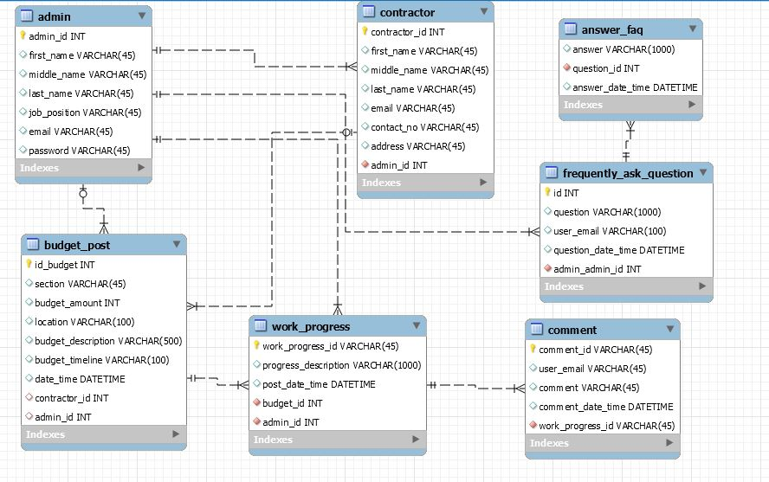

*Fig: ER Diagram*

**Class Diagram**

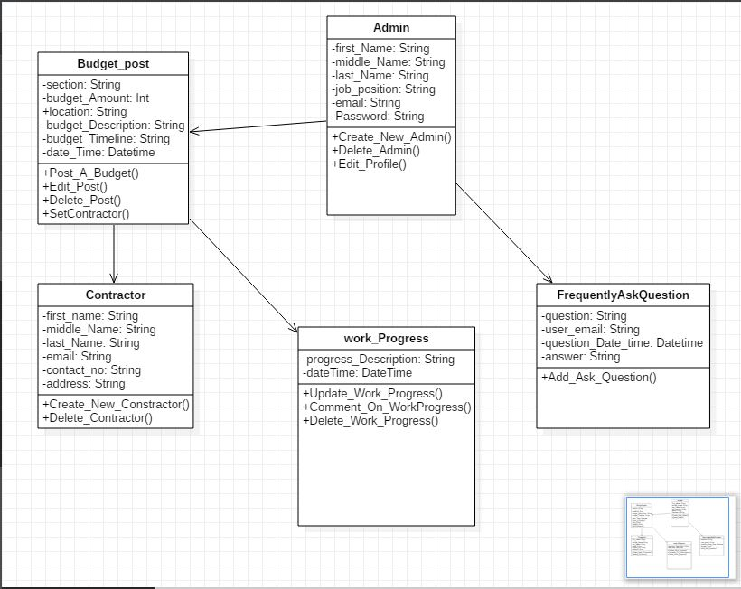

*Fig: Class Diagram*

**Detail Class Diagram**

**Class Admin**

boolean **Create_A_Post (** String first_name, String middle_name, String last_name, String job_position, String email **)**

boolean **Delete_Admin (** String admin_Id **)**

admin **View_Profile (** String admin_id **)**

boolean **Edit_Profile (** String id **)**

List<admin> **Get_Admin_list ( )**

**Class Budget_Post**

Boolean **Post_A_Budget (** String section, String budget_Amount, String location, String budget_Description, String budget_Timeline, Datetime current_DateTime **)**

Budget_Post **View_Budget_Post(** String Post_Id **)**

boolean **Edit_Post (** String Post_Id **)**

boolean **Delete_Post (** String Post_id **)**

boolean **Set_Contractor (** String Post_Id **)**

List<Budget_Post> **Get_Budget_Post_List_By_Section (** String section **)**

**Class Contractor**

boolean **Create_New_Contractor (** String first_Name, String middle_Name, String Last_Name, String email, String contact_No, String address **)**

boolean **Delete_Contractor (** String contractor_Id **)**

List<Contractor> **Get_All_Contractor_List ( )**

Contractor **View_Contractor_Profile (** String contractor_Id **)**

**Class Work_Progress**

boolean **Update_Work_Progress(** String budget_Id, String progress_Description**,** Datetime current_DatetTme **)**

List<Work_Progress> **Get_All_Work_Progress_List(** String budget_Post_Id **)**

boolean **Comment_On_Work_Progress (** String work_Progress_Id **)**

List<Comment> **Get_Comment_List(** String work_Progress_Id **)**

boolean **Delete_Work_Progress(** String work_Progress_Id **)**

**Class Frequently_Ask_Question**

boolean **Add_FAQ(** String question, String user_email, String Answer **)**

**User Interface**

**Home Page:**

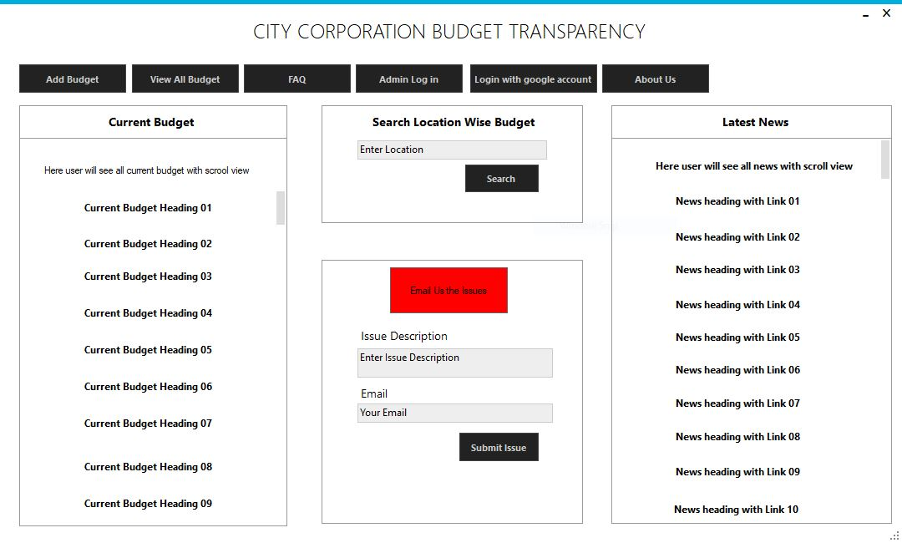

*Fig: Home Page*

**Admin Login Page:**

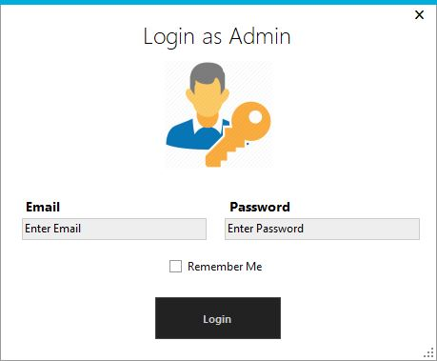

*Fig: Admin Login Page*

**Add New Budget:**

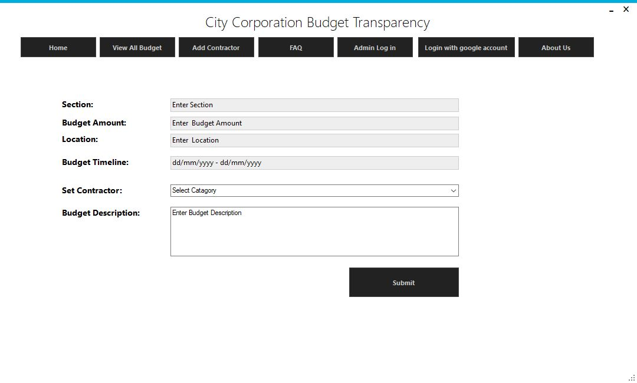

*Fig: Add New Budget*

**View All Budget:**

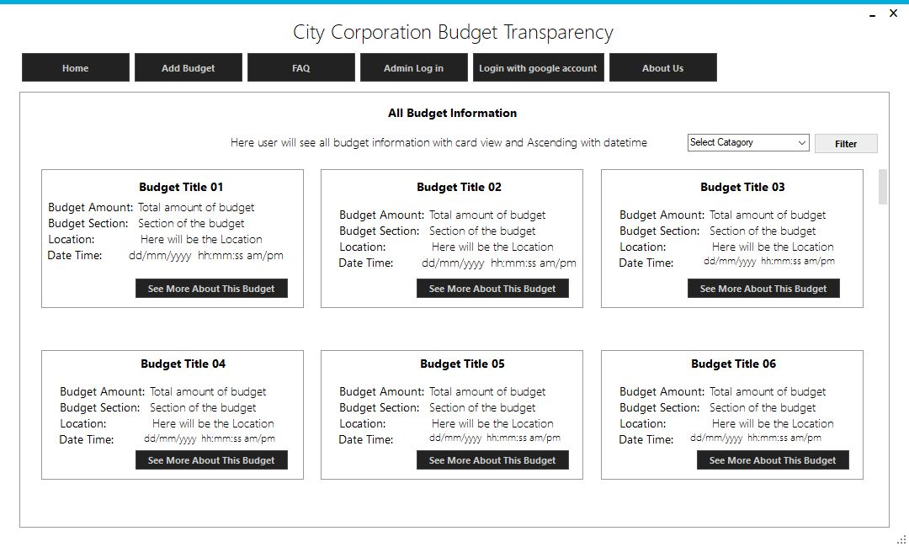

*Fig: View All Budget*

**Full Information of A Budget:**

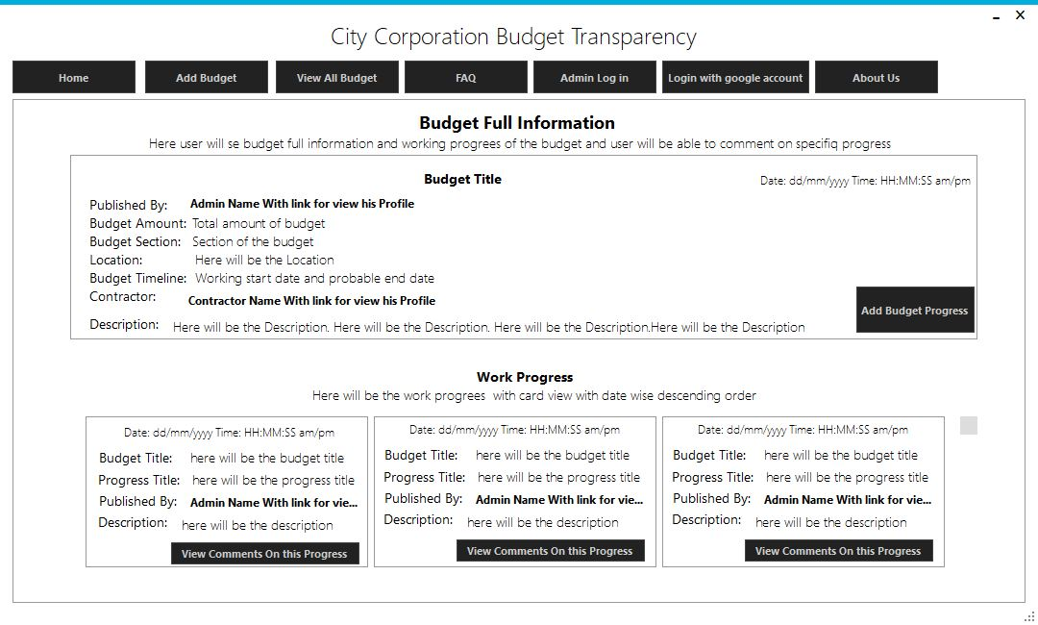

*Fig: Full Information of A budget*

**Add Working Progress of A Budget:**

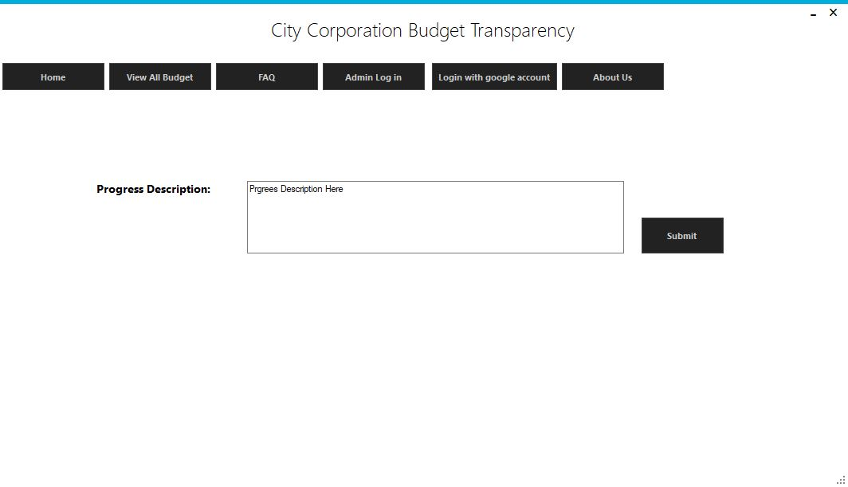

*Fig: Add working progress of a budget*

**View and Comment On Working Progress:**

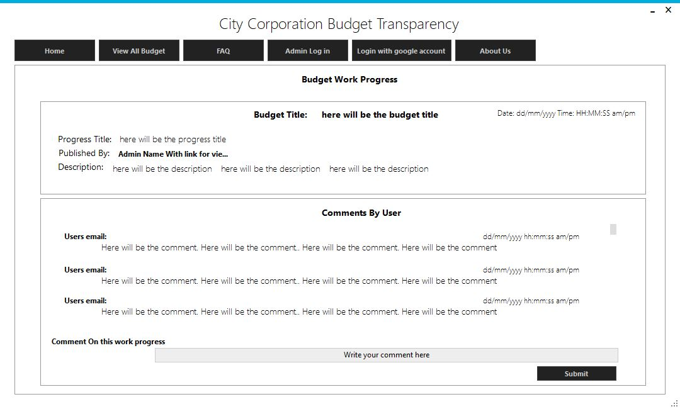

*Fig: View and comment on working progress*

**Create Contractor:**

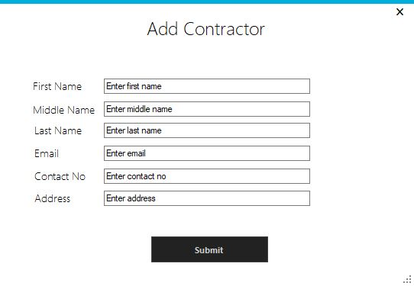

*Fig: Add or Create Contractor*

**View Contractor Profile:**

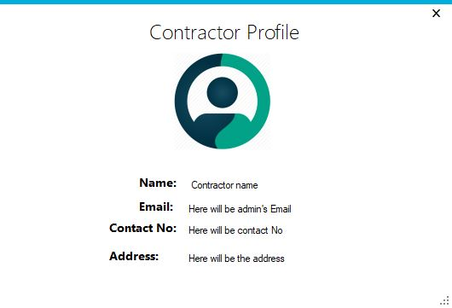

**View Admin Profile:**

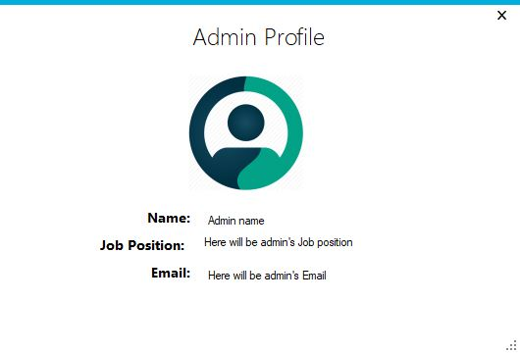

**Add Frequently ask question and answer:**

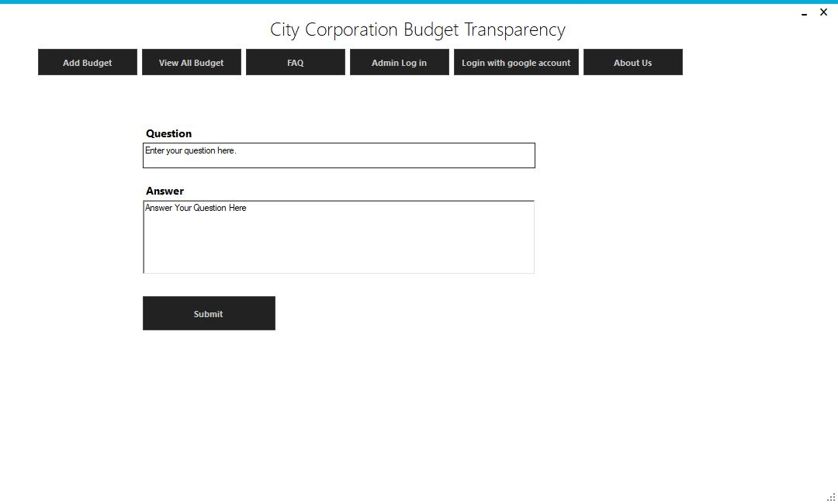

**View FAQ List:**

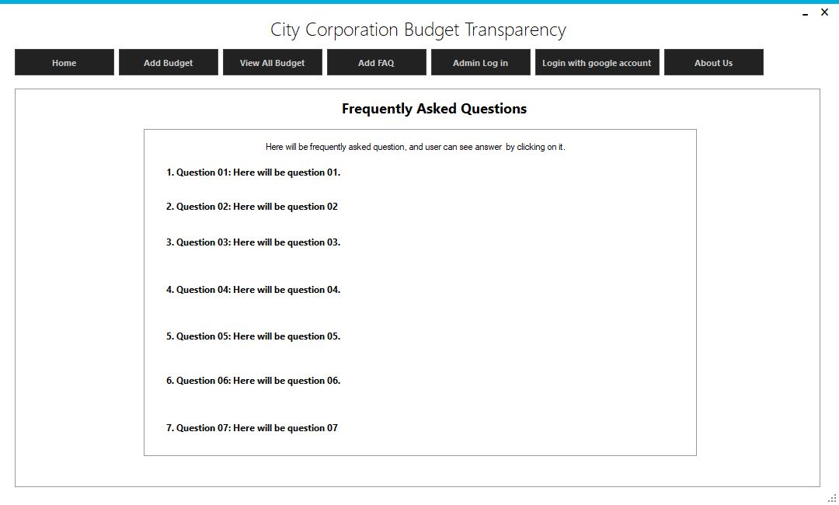

**Fig: View FAQ list**

**View Answer of a specific FAQ:**

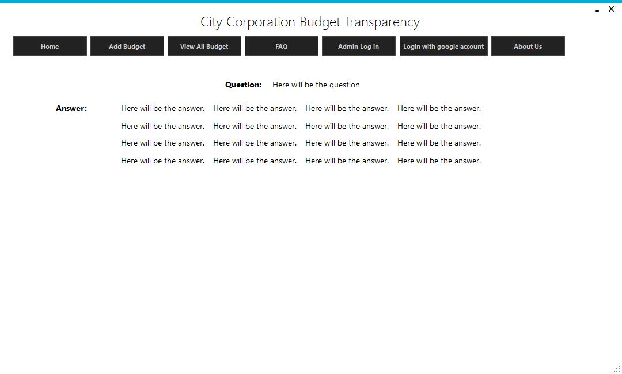

Fig: View answer of a FAQ

**About Us Page:**

