Table of Contents

1. Introduction 1

1.1 Purpose 1

1.2 Document Conventions 1

1.3 Intended Audience and Reading Suggestions 1

1.4 Product Scope 2

1.5 References 2

2. Overall Description 2

2.1 Product Perspective 2

2.2 Product Functions 2

2.3 User Classes and Characteristics 2

2.4 Operating Environment 3

2.5 Design and Implementation Constraints 3

2.6 User Documentation 4

2.7 Assumptions and Dependencies 4

3. External Interface Requirements 5

3.1 User Interfaces 5

3.2 Hardware Interfaces 5

3.3 Software Interfaces 5

3.4 Communications Interfaces 6

4. System Features 6

4.1 System Feature 1 6

4.2 System Feature 2 (and so on) 7

5. Other Nonfunctional Requirements 10

5.1 Performance Requirements 10

5.2 Safety Requirements 10

5.3 Security Requirements 11

5.4 Software Quality Attributes 11

**6**. **Use Case**

Software Requirements Specification

for

City Corporation Branch

Work Coordination

Version 1.1 approved

Mazhar Ibna Zahur and Kushal Gosh

Computer Science and Engineering Discipline, Khulna University

1.8.18

# 1 Introduction

This section gives a scope description and overview of everything included in this SRS document. Also, the purpose for this document is described and a list of abbreviations and definitions is provided.

## Purpose

The purpose of this document is to give a detailed description of the requirements for the “City Corporation Branch Work Coordination” (CCBWC) software. It will illustrate the purpose and complete declaration for the development of system. It will also explain system constraints, interface and interactions with other external applications.

## Document Conventions

We shall follow SRS template introduced by IEEE. We will follow use ‘Times New Roman’ front. For a section the front size will be 18 and the front will be also bolded. The front size of the body will be 12.The statement of the great significance will be highlighted.

## Intended Audience and Reading Suggestions

The document is intended for different types of reader such as project manager, users, testers and documentation writers. The document will be included overall description of the system and their functionalities, user classes, product functions, operating environment, design, external interface and requirements, implementation, system features. The readers should read the documents step by step. The document also included the user interaction of that system.

## Product Scope

There are different types of Branches in Khulna City Corporation. Like water billing, roads department, street light department, monitoring department etc. All departments are independent in their works. Sometimes their needs work coordination. Our project will help them to manage their works in one place so that they can manage their works efficiently.

## References

[1] IEEE Software Engineering Standards Committee, “IEEE Std 830-1998, IEEE Recommended Practice for Software Requirements Specifications”, October 20, 1998.

[2]https://www.tutorialspoint.com/software_testing_dictionary/software_requirement_specification.htm

## 2.1 Overall Description

This section will give an overview of the whole system. The system will be explained in its context to show how the system interacts with other systems and introduce the basic functionality of it. It will also describe what type of stakeholders that will use the system and what functionality is available for each type. At last, the constraints and assumptions for the system will be presented.

## 2.2 Product Perspective

“City Corporation Branch Work Coordination” (CCBWC) software will help us to maintain the communication and co-ordination among the different Branches of Khulna City Corporation. Like water billing, roads department, street light department, monitoring department etc. These branches work independently, if these branches can communicate with each other the work efficiency increases.

## 2.3 Product Functions

There are three types of user in our Product:

* Branch Coordinator As Admin
* Every Branch Manager As Co-admin as well as User
* General User
* **Branch Coordinator Features:**
* Login
* Add new Branches
* Add Branch Manger
* Change Password
* Monitor Every Branch Manager
* Update General Notice and Events
* **Branch Manager Features:**
* Login as Branch Manager
* Monitoring His Pages
* Update his Branch Notice Board
* Can communicate with Other Branch Managers
* Can post General Notice board by the approval of Branch Coordinator
* Answer Public Questions in FAQ sections
* Update his Branch information.
* **General User**
* Can See General Notice board
* Can Search Specific Branch
* See All Branch Information.
* Ask Questions in FAQ sections
* Can See Every Branch Page

## 2.4 User Class and Characteristics

User Friendly:

Our project is very useful & also easy to use so, all users with internet connections can access the system and use it.

Open source software developers and contributors:

− Software Developers: To make any development in source code or to add more features, people need to have good programming knowledge.

− Translators: People of all age groups with very good knowledge of a language not included in the current translation list.

## 2.5 Operating Environment

Operating environment for the Branch coordination system is as listed below.

* distributed database
* client/server system
* Operating system: Windows.
* database: MySQL
* platform: HTML , CSS, Bootstrap

## 2.6 Design and Implementation Constraints

1. The global schema, fragmentation schema, and allocation schema.
2. SQL commands for above queries/applications
3. How the response for application 1 and 2 will be generated. Assuming these are global queries. Explain how various fragments will be combined to do so.
4. Implement the database at least using a centralized database management system.

## 2.7 Assumptions and Dependencies

Let us assume that this is a “City Corporation Branch Work Coordination” (CCBWC) software and it is used in the following application:

* Overview of all the branches in Khulna City Corporation.
* Co-ordination of branches of Khulna City Corporation.
* Increasing the effectiveness of different branches.

# 3. External Interface Requirements

**3.1 User Interfaces**

* Front-end software: HTML, CSS , Bootstrap
* Back-end software: MySQL, XAMP Server

**3.2 Hardware Interfaces**

* Any Mobile (Android, IOS), Any Operating System.
* A browser which supports PHP, HTML & Javascript
* Dedicate Server
* Internet Connection

**3.3 Software Interfaces**

Following are the software used for Branch coordination system.

|  |  |
| --- | --- |
| **Software used** | **Description** |
| Operating system | We have chosen Windows operating system for its best support and user-friendliness. |
| Database | To save message, works list, important dates, etc we have chosen  MySQL database. |
| PHP,HTML, CSS, Bootstrap | To implement the project we have chosen PHP for backend logic work and HTML, CSS and Bootstrap for designing interfaces. |

**3.4 Communications Interfaces**

This project supports all types of web browsers and hardware device that has internet connection

# 4. System Features

### 4.1.1 Description and Priority

### “City Corporation Branch Work Coordination” (CCBWC) software maintains information of different branches of city corporation and maintains communication among them. Of course, this project has a high priority because it is very important to maintain co-ordination of branches for maximum efficiency.

**4.1.2 Stimulus**

* Search for a branch and it’s on going works.
* Displays a detailed list of ongoing works of different branches in City Corporation.
* Communication among different branches.

# 5. Other Nonfunctional Requirements

## 5.1 Performance Requirements

The basic objective of normalization is to reduce redundancy which means that information is to be stored only once. Storing information several times leads to wastage of storage space and increase in the total size of the data stored.

If a database is not properly designed it can give rise to modification anomalies. Modification anomalies arise when data is added to, changed or deleted from a database table. Similarly, in traditional databases as well as improperly designed relational databases, data redundancy can be a problem. These can be eliminated by normalizing a database.

Normalization is the process of breaking down a table into smaller tables. So that each table deals with a single theme. There are three different kinds of modifications of anomalies and formulated the first, second and third normal forms (3NF) is considered sufficient for most practical purposes. It should be considered only after a thorough analysis and complete understanding of its implications.

**5.2 Safety Requirements**

If there is extensive damage to a wide portion of the database due to catastrophic failure, such as a disk crash, the recovery method restores a past copy of the database that was backed up to archival storage (typically tape) and reconstructs a more current state by reapplying or redoing the operations of committed transactions from the backed up log, up to the time of failure.

**5.3 Security Requirements**

Security systems need database storage just like many other applications. However, the special requirements of the security market mean that vendors must choose their database partner carefully.

**5.4 Software Quality Attributes**

* **Availability:** The City Corporation should be available on the specified date and specified time as many users and branches are doing advance search and co-ordination.
* **Correctness:** The City Corporation should strict to their rules and regulation.
* **Maintainability:** The administrators and users should maintain correct schedules of time.
* **Usability:** The facilities should satisfy a maximum number of branch co-ordination.

**7. Use Case**

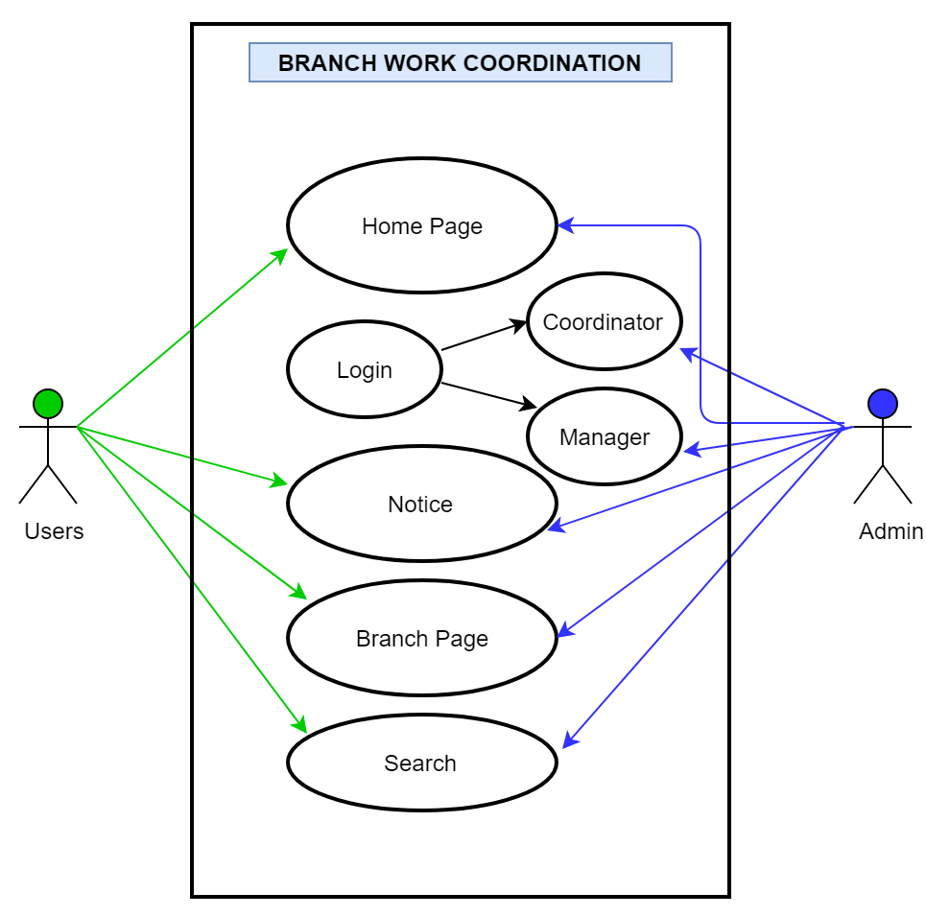

**6.1 Use Case Descriptions**

**Home Page Functional Description**

|  |  |
| --- | --- |
| Function Name | Description |
| Brief Description | The Home Page will provide every basic feature. Login options for both Branch Coordinator and Branch Managers and Search option and General Notice board. |
| Priority | Essential |
| Trigger | General user can access if he/she has internet and Admin need User name and Password |
| Precondition | The user must connected through the internet |
| Basic Path | Dedicated server need to lunch this application |
| Post Condition | User is on the Home Page |
| Exception Path | If there is a connection failure ,the server returns to the wait state |

**Login Panel Functional Description**

|  |  |
| --- | --- |
| Function Name | Description |
| Brief Description | Login for Branch Coordinator and Branch Manager |
| Priority | Essential |
| Trigger | * 1. Branch Manager Login as Branch Manager   2. Branch Coordinator Login as Admin |
| Precondition | The user must connected through the internet |
| Basic Path | Dedicated server need to lunch this application |
| Post Condition | Both Same page different role |
| Exception Path | Username and Password need for this |

**Notice Board Functional Description**

|  |  |
| --- | --- |
| Function Name | Description |
| Brief Description | All Important notice for both user and Branch manager |
| Priority | Essential |
| Trigger | Any User |
| Precondition | The user must connected through the internet |
| Basic Path | 1. Branch Manager can post Notice by the Admin approval. 2. Branch coordinator approve post and post important notice and events. |
| Post Condition | General Notice board |
| Exception Path | If there is a connection failure ,the server returns to the wait state |

**Branch Page Functional Description**

|  |  |
| --- | --- |
| Function Name | Description |
| Brief Description | Specific Branch information |
| Priority | Essential |
| Trigger | Branch Manager |
| Precondition | The user must connected through the internet |
| Basic Path | 1. Branch Manager can post Notice in the page 2. Update his Branch work Schedule 3. Update important news and events. |
| Post Condition | Branch Manager approval |
| Exception Path | If there is a connection failure ,the server returns to the wait state |

**Search Functional Description**

|  |  |
| --- | --- |
| Function Name | Description |
| Brief Description | Both user and Admin can search any work by Ward number or Road number |
| Priority | Essential |
| Trigger | User and Admin |
| Precondition | NA |
| Basic Path | NA |
| Post Condition | NA |
| Exception Path | NA |