**Detail Design**

**On**

**City Corporation Branch Work Coordination (CCBWC)**

**Course No: CSE 3204**

**Course Title: Software Engineering and Information System Project**

**Mazhar Ibna Zahur**

**Student Id: 130222**

**&**

**Kushal Gosh**

**Student Id: 140223**

**Project Manager:   
Dr. Kazi Masudul Alam   
Associate Professor,  
Computer Science & Engineering Discipline,  
Khulna University**

**ER Diagram:**

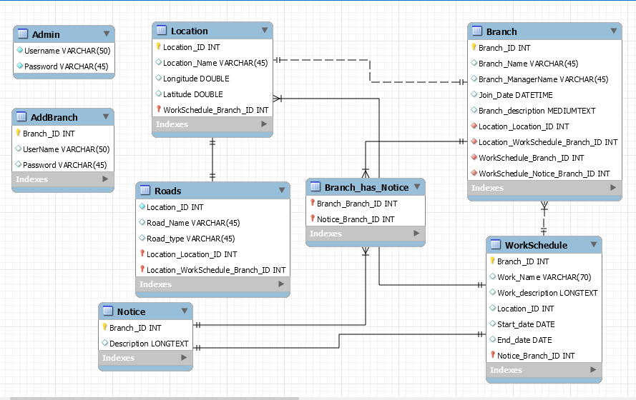

*Fig: ER Diagram*

**Class Diagram:**

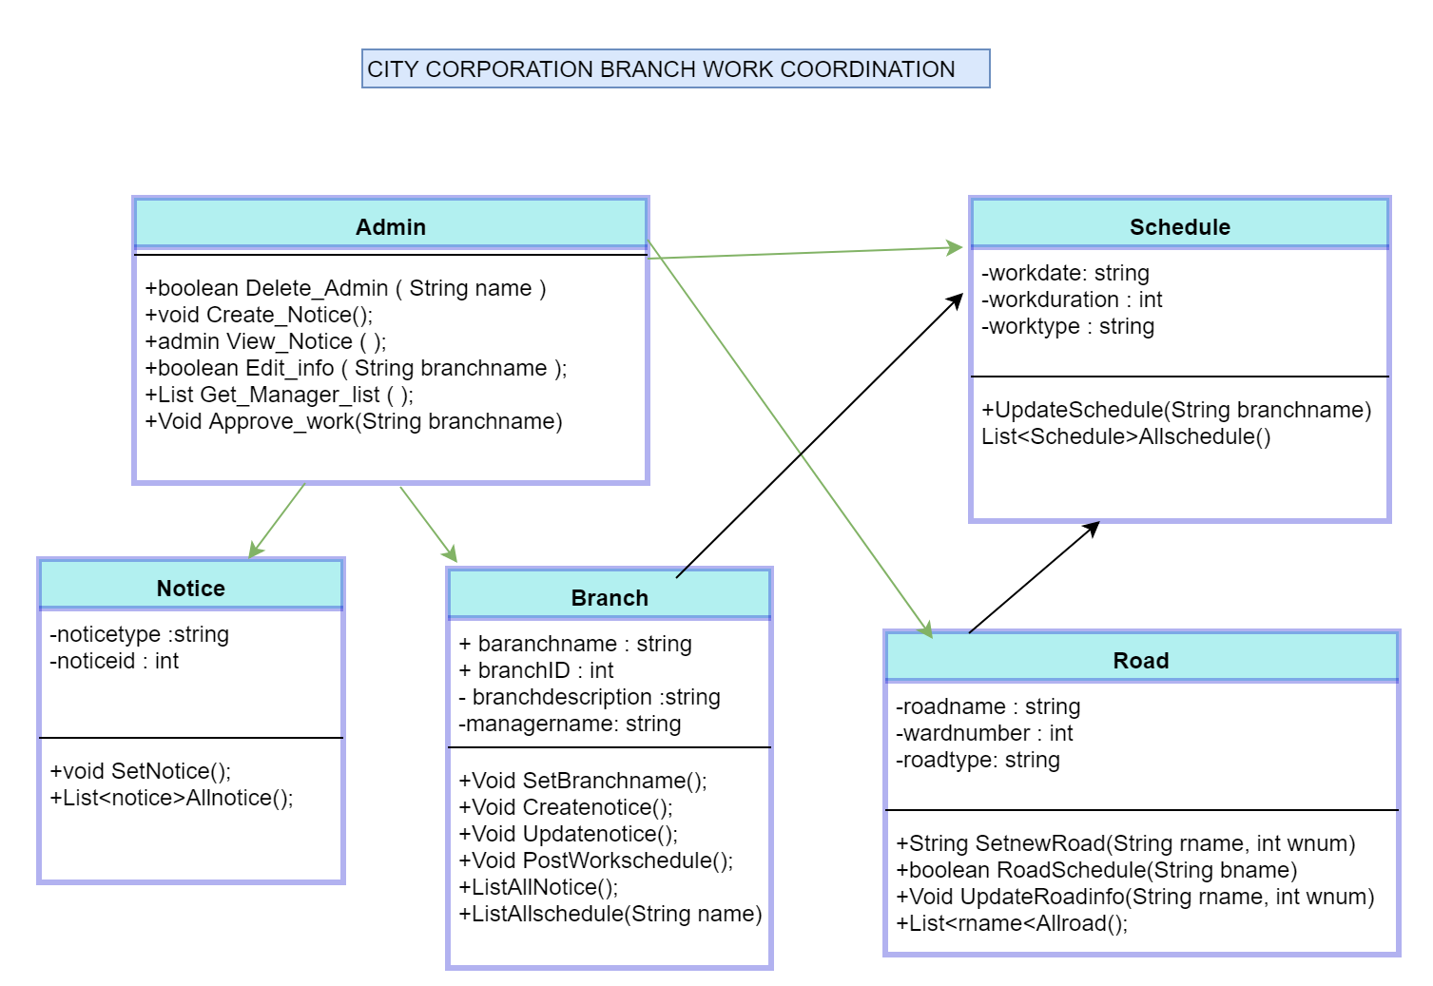

*Fig: Class Diagram*

**Details Class Digram:**

**Class Admin**

**void** **Create_A_Branch (** String branchname, String manager, String password, String description **)**

boolean **Delete_Admin (** String name **)**

**void Create_Notice()**

admin **View_Notice (**  **)**

boolean **Edit_info (** String branchname **)**

List<admin> **Get_Manager_list ( )**

**Void Approve_work(**String branchname**)**

**Class Branch**

Void **SetBranchname();**

Void **Createnotice();**

Void **Updatenotice();**

Void **PostWorkschedule();**

List<notice>**AllNotice();**

List<schedule>**Allschedule(**String name**);**

**Class Notice**

Void **SetNotice();**

List<notice>**AllNotice();**

**Class Road**

Void **SetNewRoad(String name, int wardnumber);**

Boolean **RoadSchedule(String branchname);**

Void **UpdateRoadInfo(String name, int WardNumber)** ;

List<Rname> **AllRoad();**

**Class Schedule**

Void **UpdateSchedule(String branchname);**

List<Schedule> **AllSchedule();**

**User Interface:**

**Home Page:**

in home page on left side every branch name are Shown. Right side all notice are shown and any one can search any branch or location from search bar.

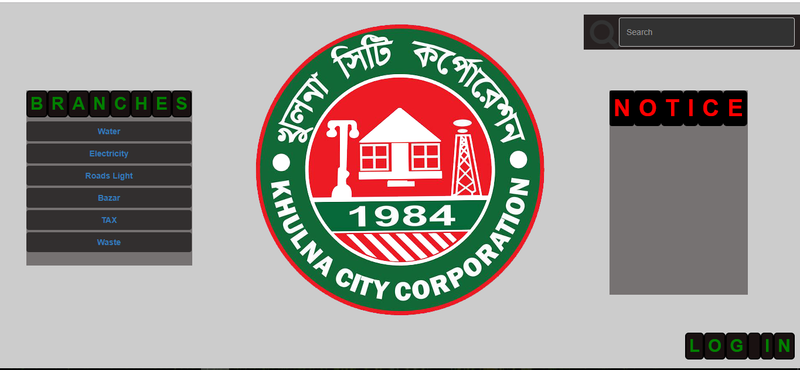

*Fig: Home Page*

**Branch Page**

In branch page all works going on are shown in white color map view and if no work is going color will black.

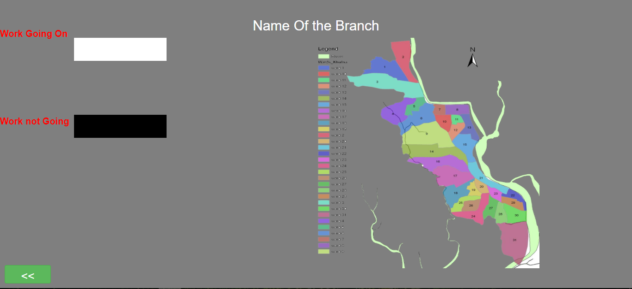

Fig: Branch Page

**Search Page**

After search by Ward number or branch name, work process will show in map view.

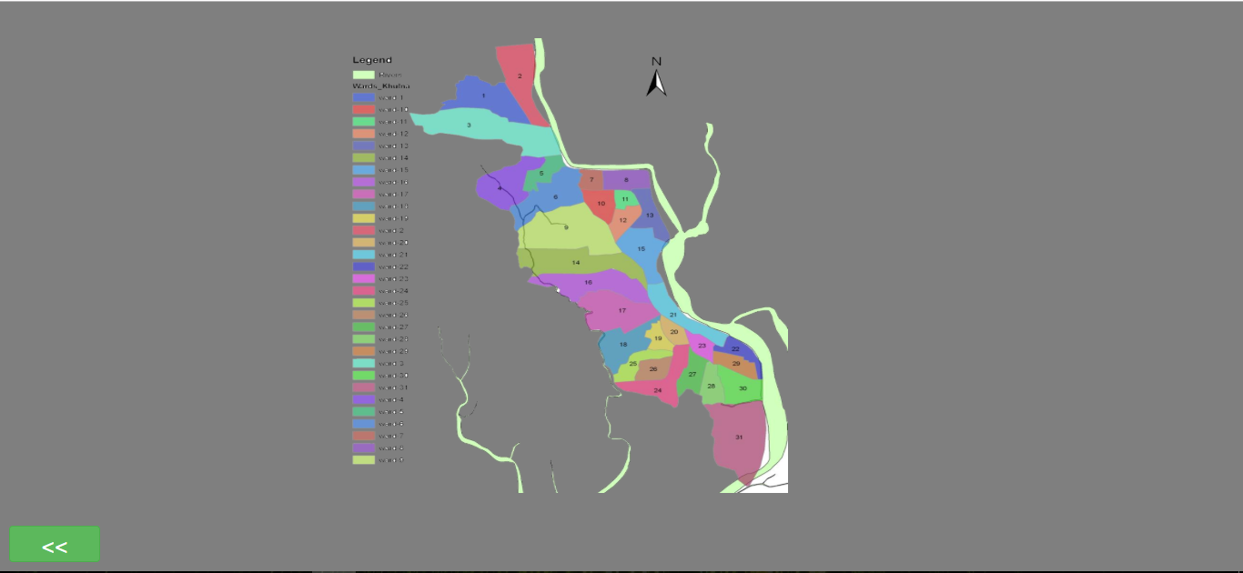

Fig: Search

**Login Page**

There are two role for login. Login as Admin and Branch Manager.



Fig: Login page

**Login As Admin**

Admin can create branch, post notice, edit notice and coordinate works through this page.

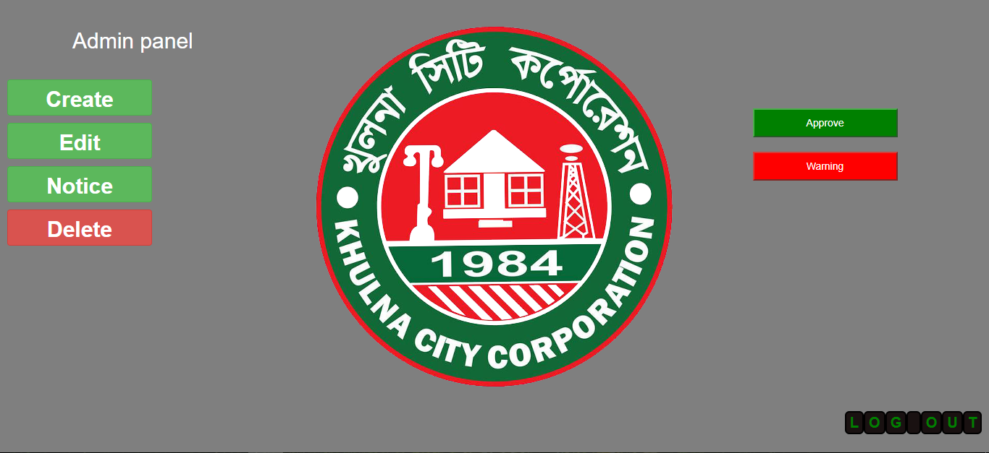

Fig: Admin Page

**Create Branch**



Fig: Create Branch

**Edit Branch**



Fig: Edit Branch info

**Post Notice**

Here right side admin will see all notice including branch manager and his own. Left side he can create notice.

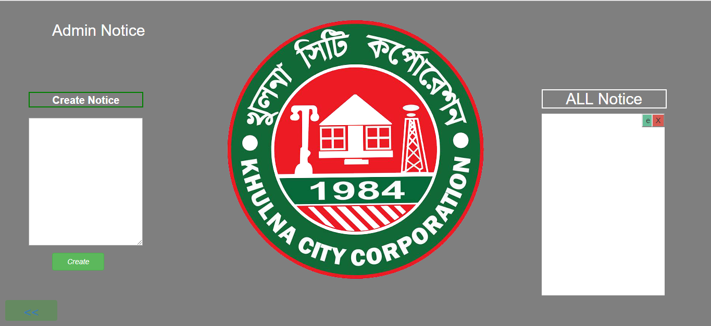

Fig: Admin Notice

**Schedule Approval**

Every manager works schedule need to be approved. By clicking on Approve admin can see approval request.

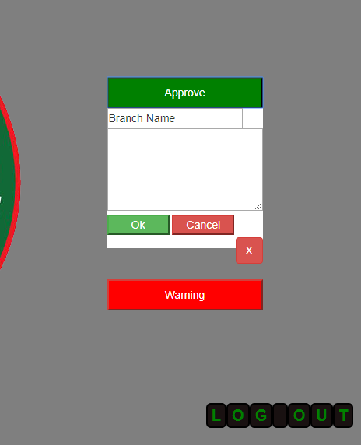

Fig: Approval request

**Coordination**

If one or more branch work get conflicted, admin get warning.

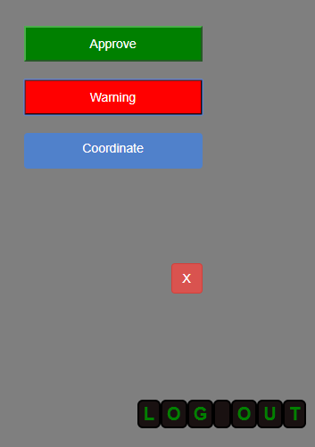

Fig : Conflict Warning

**Coordination Page**

Here admin will decide which work will get approval.

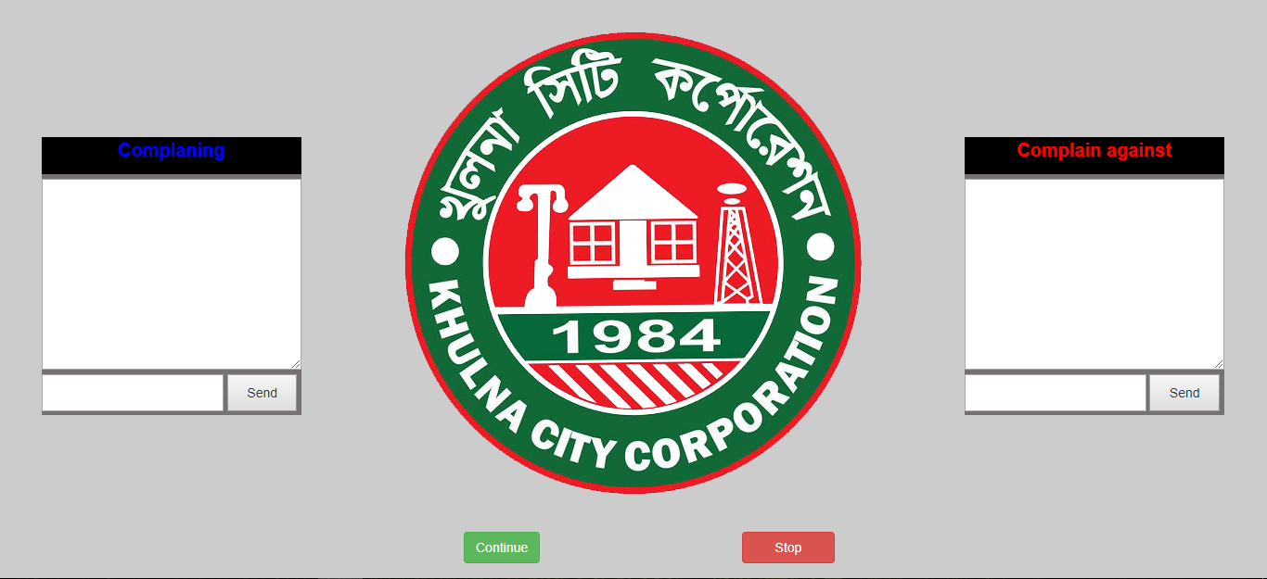

Fig: Branch Coordination

**BranchManager Page**

Branch manager can post work schedule and he can see his all work schedule. He can edit and delete by approved from admin. But he can directly create notice without approval.

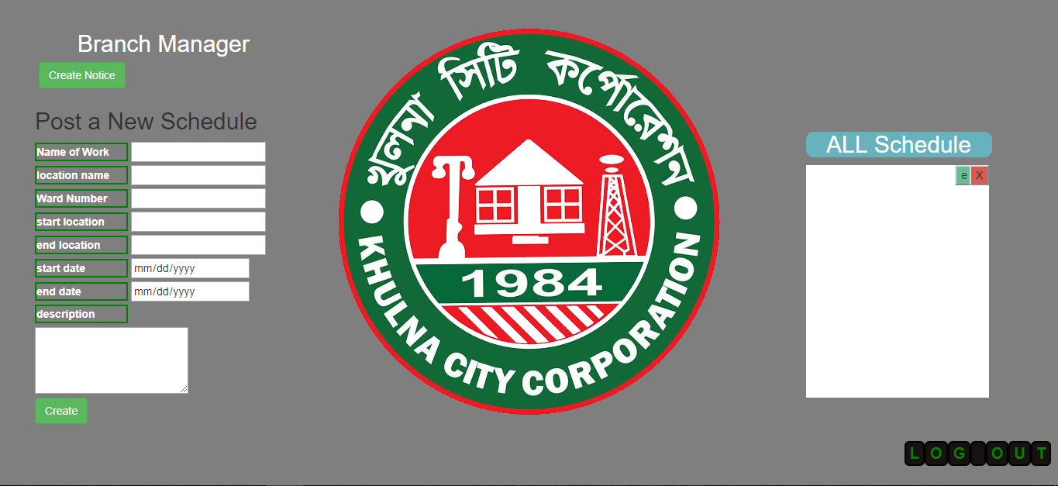

Fig: Branch Manager

**ManagerNotice**



Fig: Manager Notice