Software Requirements Specification

For

Market Price Monitoring

Version 0.3

Prepared by

Durjoy Bapery

Student ID:150229

and

Tanmai Kumar Ghosh

Student ID:150232

Computer Science and Engineering Discipline, Khulna University

28/10/2018

**Page ii**

Table of Contents

Table of Contents ii

Revision History ii

1. Introduction 1

1.1 Purpose 1

1.2 Document Conventions 1

1.3 Intended Audience and Reading Suggestions 1

1.4 Product Scope 1

1.5 References 1

2. Overall Description 2

2.1 Product Perspective 2

2.2 Product Functions 2

2.3 User Classes and Characteristics 2

2.4 Operating Environment 3

2.5 Design and Implementation Constraints 3

2.7 Assumptions and Dependencies 4

3. External Interface Requirements 4

3.1 User Interfaces 4

3.2 Hardware Interfaces 4

3.3 Software Interfaces 4

3.4 Communications Interfaces 5

4. System Features 5

4.1 Description and Priority 5

4.2 Functional Requirements 6

5. Other Nonfunctional Requirements 16

5.1 Performance Requirements 16

5.2 Safety Requirements 16

5.3 Security Requirements 16

5.4 Software Quality Attributes 16

5.5 Details Design……………………………………………………………………………………………………………………………17

Revision History

|  |  |  |  |
| --- | --- | --- | --- |
| **Name** | **Date** | **Reason For Changes** | **Version** |
|  |  |  |  |
|  |  |  |  |

Page 1

# Introduction

This section gives a scope description and overview of everything included in this SRS document. Also, the purpose for this document is described and a list of abbreviations and definitions is provided.

**1.1 Purpose**

The purpose of this document is to give a detailed description of the requirements for the “Market Price Monitoring”. It will illustrate the purpose and complete declaration for the development of system. It will also explain system constraints, interface and interactions with other external applications.

**1.2 Document Conventions**

The following conventions are used throughout the documentation:

HTML- Hyper Text Markup Language.

CSS- Cascading Style Sheets.

**1.3 Intended Audience and Reading Suggestions**

The document is intended for the different types of reader such as developers, project manager, marketing staff, users, testers and documentation writers. The documentation contains overall description of the software such as product perspective, product functions, user classes and characteristics, operating environment, design and implementation constraints and user documentation, external interface and requirements and system features. The readers are suggested to read the documentation sequentially.

**1.4 Product Scope**

There are several markets in Khulna city. There is no system available to monitor the market price. But this is very important. Suppose, a customer wants to buy a product. He visits a market but does not find the product. It is a kind of harassment for the customer. It is also time consuming. Let us assume another case, an outsider comes to Khulna city and he wants to buy some products. But he does not know location of the markets available in Khulna city and products available in the market. Our system will help the users for both of the cases. The price of the products varies from market to market. Our system will monitor the market price and update the price in regular interval. Our goal is to design a system that will minimize the efforts of the customer by giving the opportunities discussed above.

**1.5 References**

[1] IEEE Software Engineering Standards Committee, “IEEE Std 830-1998, IEEE Recommended  
Practice for Software Requirements Specifications”, October 20, 1998.

Page 2

[2] Geagea, S., S. Zhang, N. Sahlin, F. Hasibi, F. Hameed, E. Rafiyan, and M. Ekberg. "Software Requirement Specification-Amazing Lunch Indicator." (2010)**.**

[3] <https://krazytech.com/projects/software-requirements-specification-report> (accessed on 31 july,2018).

**2. Overall Description**

This section will give an overview of the whole system. The system will be explained in its context to  
show how the system interacts with other systems and introduce the basic functionality of it.

**2.1 Product Perspective**

This system will consist of one part: web portal. The mobile application  
will be used to find markets and view information about them while the web portal will be used for managing the information about the market and the system as a whole.

The portal will provide the information of the markets such as the location, available products, the price of the product of particular market.

**2.2 Product Functions**

With the web portal, the customer can search based on several categories such as market and product. If the customers search by market, the information of the market will be provided. If the customers search by the products, the market containing the product and price will be provided.

The web portal will provide functionality to manage the system and the market information. It will also provide information about the system, for example show when there is a new update.

**2.3 User Classes and Characteristics**

There are two kinds of users that interact with the system: normal users and the administrators. Each of the two types of users has different use of the system.

Normal users will use web portal for gathering the information of the markets. They will use the mobile application for finding the location of the markets.

The administrators will manage the web portal. They will manage the information of the markets such as the available products, updating price etc.

Page 3

The users(customers) will be able to get the following facilities:

* Can see the list of markets in web portal.
* Can see the available products in a particular market.
* Can see updated price list.
* Can search by market name and product name.

The administrators will be able to perform the following functions:

* Can update the product list.
* Can update the price list.
* Can add the new admin.
* Can add new markets.

**2.4 Operating Environment**

The system will operate in android platform as well as window platform. The GPS based application will be designed in android platform. The web portal will be designed in the window platform.

The operating environment of Market Price Monitoring is given below:

* client/server system.
* Operating system: Windows.
* database: sql+ database.

Page 4

## Design and Implementation Constraints

The Internet connection is also a constraint for the application. The web portal will be constrained by the capacity of the database.

* 1. **Assumptions and dependencies**

One assumption about the product is that it will perform window platform. If the server is not connected, the system will not be run.

1. **External Interface Requirements**

**3.1 User Interfaces**

At first, we will design the web portal. In web portal there is a homepage showing the Registration and Log In button. The new users can register by clicking this button. The existing users can Log In using the Log In button by providing required information. After Log In, a page will appear. In this there are some activities such as market list, updating price list etc. By clicking the market list, the list of markets will appear.

**3.2 Hardware Interfaces**

We will use GPS module which is a build in feature in most of the smartphones. The module will interact with the android application.

**3.3 Software Interfaces**

The following software will be used for designing the system:

* HTML
* CSS
* Web Browser
* ASP.NET

Page 5

**3.4 Communications Interfaces**

The communication between the different parts of the system is important since they depend on each  
other. However, in what way the communication is achieved is not important for the system and is  
therefore handled by the underlying operating systems for both the mobile application and the web portal.

**4. System Features**

**4.1 Description and Priority**

The short description of the system features is given below:

* The users can see the market list available in the Khulna city. There are several markets in the city. But the new comers don’t know the name of the market. By the list, they will know the name of markets of the city.
* The information of the markets will be provided such as available products, opening and closing time, location etc.
* The price of the products will be updated in regular interval so that the customers can go the market by comparing the price.
* The users can search by market and product wise. This will reduce the efforts of the customers.

Page 6

**4.2 Functional Requirements**

This section includes the requirements that specify all the fundamental actions of the software system.

**4.2.1 System Boundary**

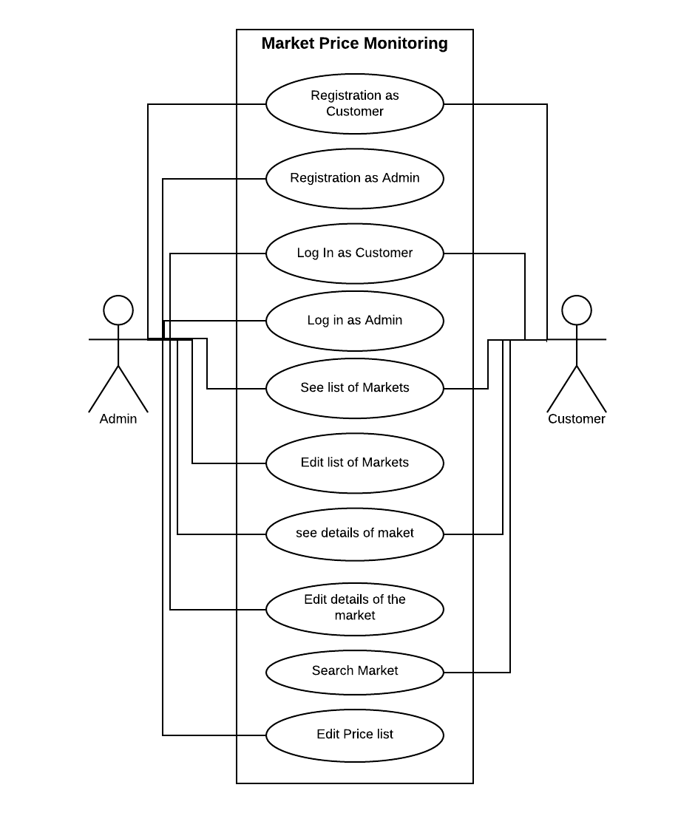

Page 7

**4.3.1 Use Case Description**

**4.3.1.1 Registration as Customer**

|  |  |
| --- | --- |
| **Use Case Name:** | **Registration as Customer** |
| **Brief Description:** | The user must have to register to access the full system. |
| **Priority** | Essential |
| **Trigger** | User have to click Registration button to fill the registration form. |
| **Precondition** | User is connected to the Server and on the home page. |
| **Basic Path** | 1. The web site provides the registration form.  2. User has to fill the registration form providing required information.  3. After clicking Register button information will be sent to the server. |
| **Alternate Path** | N/A |
| **Post condition** | User is on the Home Page |
| **Exception Path** | If there is a connection failure, the Server returns to the wait state. |

|  |  |
| --- | --- |
| **Use Case Name:** | **Registration as Admin** |
| **Brief Description:** | The admin can only add the new admin. |
| **Priority** | Essential |
| **Trigger** | Admin have to click Registration button to fill the registration form. |
| **Precondition** | Admin is connected to the Server and on Admin panel page. |
| **Basic Path** | 1. The web site provides the registration form.  2. Admin has to fill the registration form providing required information.  3. After clicking Register button information will be sent to the server. |
| **Alternate Path** | N/A |
| **Post condition** | Admin is on the admin panel page. |
| **Exception Path** | If there is a connection failure, the Server returns to the wait state. |

Page 8

**4.3.1.2 Registration as Admin**

Page 9

**4.3.1.3 Log in as User**

|  |  |
| --- | --- |
| **Use Case Name:** | **Log in as Customers** |
| **Brief Description:** | The user must have to access the full system. |
| **Priority** | Essential |
| **Trigger** | User have to click Log In button to fill the form. |
| **Precondition** | User is connected to the Server and on the home page. |
| **Basic Path** | 1. The web site provides the Log In form.  2. User has to fill the Log In form providing user name and password.  3. After clicking Log In button information will be verified.  4.If the user name and password is correct, the use will be Logged in. |
| **Alternate Path** | N/A |
| **Post condition** | User is on the Alumni Home Page |
| **Exception Path** | If there is a connection failure, the Server returns to the wait state. |

Page 10

|  |  |
| --- | --- |
| **Use Case Name:** | **Log in as Admin** |
| **Brief Description:** | The admin must have to log in t the to control full system. |
| **Priority** | Essential |
| **Trigger** | Admin has to click Log In button to fill the form. |
| **Precondition** | Admin is connected to the Server and on the home page. |
| **Basic Path** | 1. The web site provides the Log In form.  2. Admin has to fill the Log In form providing user name and password.  3. After clicking Log In button information will be verified.  4.If the user name and password is correct, the use will be Logged in. |
| **Alternate Path** | N/A |
| **Post condition** | Admin is on the Admin panel page. |
| **Exception Path** | If there is a connection failure, the Server returns to the wait state. |

**4.3.1.4 Log in as Admin**

Page 11

**4.3.1.5 See list of markets**

|  |  |
| --- | --- |
| **Use Case Name:** | **See list of markets** |
| **Brief Description:** | The user can see the list of markets under Khulna city corporation. |
| **Priority** | Essential |
| **Trigger** | User has to click Market list button to see the list of markets. |
| **Precondition** | User is connected to the Server and on logged in. |
| **Basic Path** | 1. The web site provides the list of markets. |
| **Alternate Path** | N/A |
| **Post condition** | Admin is on the Bazar list page. |
| **Exception Path** | If there is a connection failure, the Server returns to the wait state. |
| **Basic Path** | 1. The web site provides the list of markets. |
| **Alternate Path** | N/A |
| **Post condition** | Admin is on the Bazar list page. |
| **Exception Path** | If there is a connection failure, the Server returns to the wait state. |

Page 12

**4.3.1.6 See Details of the markets**

|  |  |
| --- | --- |
| **Use Case Name:** | **See Details of the markets** |
| **Brief Description:** | The user can see the details of the markets. |
| **Priority** | Essential |
| **Trigger** | User has to click on the market name in the market list page. |
| **Precondition** | Admin is connected to the Server and on the market list page. |
| **Basic Path** | 1. User can see the location of the markets.  2. User can see the available products of the markets.  3. User can see the opening and closing time of the markets. |
| **Alternate Path** | N/A |
| **Post condition** | User is on the market details page. |
| **Exception Path** | If there is a connection failure, the Server returns to the wait state. |

Page 13

**4.3.1.7 Edit Details of the markets**

|  |  |
| --- | --- |
| **Use Case Name:** | **Edit Details of the markets** |
| **Brief Description:** | The admin can edit the details of the markets. |
| **Priority** | Essential |
| **Trigger** | Admin has to click on Edit detail button on the market details page. |
| **Precondition** | Admin is connected to the Server and on the market details page. |
| **Basic Path** | 1. User can update the opening and closing time of the markets.  2. User can update the available products of the markets. |
| **Alternate Path** | N/A |
| **Post condition** | Admin is on the market details page. |
| **Exception Path** | If there is a connection failure, the Server returns to the wait state. |

Page 14

**4.3.1.8 Search Markets**

|  |  |
| --- | --- |
| **Use Case Name:** | **Search Markets** |
| **Brief Description:** | The user can search for markets. |
| **Priority** | Essential |
| **Trigger** | User has to click on the search button to search by the market name. |
| **Precondition** | User is connected to the Server and on the market list page. |
| **Basic Path** | 1. User can see the details of the markets.  2. User can also see the price list of the available products in the particular market. |
| **Alternate Path** | N/A |
| **Post condition** | User is on the market details page. |
| **Exception Path** | If there is a connection failure, the Server returns to the wait state. |

Page 15

**4.3.1.9 Edit Price list**

|  |  |
| --- | --- |
| **Use Case Name:** | **Edit price list** |
| **Brief Description:** | The admin can update the price of the product. |
| **Priority** | Essential |
| **Trigger** | User has to click on update button to update the price list. |
| **Precondition** | Admin is connected to the Server and on the market details page. |
| **Basic Path** | 1. The admin can update the price list in regular interval. |
| **Alternate Path** | N/A |
| **Post condition** | U is on the market details page. |
| **Exception Path** | If there is a connection failure, the Server returns to the wait state. |

Page 16

# 5. Other Nonfunctional Requirements

**5.1 Performance Requirements**

The performance of the system will depend on the specifications of the used devices. Performance varies from device to device.

**5.2 Safety Requirements**

If there is extensive damage to a wide portion of the database due to catastrophic failure, such as a disk crash, the recovery method restores a past copy of the database that was backed up to archival storage (typically tape) and reconstructs a more current state by reapplying or redoing the operations of committed transactions from the backed-up log, up to the time of failure.

## Security Requirements

The proper security should be confirmed for the customers as well as the users. The passwords should not be shown. They should be hidden.

## Software Quality Attributes

The following attributes are prerequisites for a good software:

* **AVAILABILITY:**Since we are hosting our project on the server it will be available all the time.
* **CORRECTNESS:**The system should generate an appropriate report about different activities of the lab and should keep track of all records.
* **MAINTAINABILITY:**The system should maintain correct schedules of labs and the documentation of all the lab equipment.
* **USABILITY:**The system should satisfy a maximum number of user’s needs.

Page 17

**5.5 Details Design on Market Price Monitoring**

The details design of Market Price Monitoring is given below:

**Class: Customer**

Boolean CreateCustomer (Int customer_id, String customer_name, String Address, String Email, String Contact)

List< market >see_marketList()

List< product >see_productList()

List<price> see_priceList(product_name)

Boolean LoginCustomer(String User_name, String Password)

**Class: Admin**

Boolean CreateAdmin (Int Admin_Id, String Admin_name, String Contact, String Email, String Admin)

Boolean update_ market_list (String Market_name, Market_type,Market_location,Opening_time,closing_time);

Boolean update_ product_list(product_name, Market_name)

Boolean update_ product_price(Market_name, Product_name, product_price)

Boolean CreateNewAdmin (Admin_name, password)

Boolean adminLogin(user_name, password)

**Class: Market**

Boolean CreateMarket (String market_name, String market_type, String location, Time opening_time, Time Closing_time)

**Class: Shop**

Boolean CreateShop (IString shop_name, String contact, String shop_type)

**Class: Product**

Boolean CreateProduct (String product_name, String origin, String type)

List<Product,Market>get_priceLitst(product_name)

**Class: Price**

Boolean CreatePrice (Product_name, Float price)