**Software Requirements Specification**

**For**

**National Events, Cultural Events date time location Finder**

**Submitted to:**

**Dr. Kazi Masudul Alam**

**Associate Professor,**

**CSE Discipline, Khulna University.**

**Prepared by**

**Miss Rokeya Akter (160210)**

**&**

**Ferdousi Haque (160228)**

**01.08.2018**

***Page ii***

**Table of Contents**

**Table of Contents .......................................................................................................................... ii Revision History ...............................................................................** Error! Bookmark not defined.

### 1. Introduction ..............................................................................................................................1

1.1 Purpose ............................................................................................................................................ 1

1.2 Document Conventions .................................................................................................................... 1

1.3 Intended Audience and Reading Suggestions .................................................................................. 1

1.4 Product Scope .................................................................................................................................. 1

1.5 References ........................................................................................................................................ 2

### 2. Overall Description ..................................................................................................................2

2.1 Product Perspective ......................................................................................................................... 2

2.2 Product Functions ............................................................................................................................ 2

2.3 User Classes and Characteristics ..................................................................................................... 2

2.4 Operating Environment .................................................................................................................... 3

2.5 Design and Implementation Constraints .......................................................................................... 3

2.6 User Documentation ........................................................................................................................ 3

2.7 Assumptions and Dependencies ...................................................................................................... 3

### 3. External Interface Requirements ...........................................................................................4

3.1 User Interfaces ................................................................................................................................. 4

3.2 Hardware Interfaces ......................................................................................................................... 4

3.3 Software Interfaces .......................................................................................................................... 4

3.4 Communications Interfaces ............................................................................................................. 4

### 4. System Features ........................................................................................................................4

4.1 System Feature 1 .............................................................................................................................. 5

4.2 System Feature 2 (and so on) ........................................................................................................... 5

### 5. Other Nonfunctional Requirements .......................................................................................6

5.1 Safety Requirements ........................................................................................................................ 6

5.2 Security Requirements ..................................................................................................................... 6

5.3 Software Quality Attributes ............................................................................................................. 6

# 1 Introduction

## 1.1 Purpose

We will describe a product named National events, Cultural Events date time location finder in this document. The scope of the product is among Khulna city. It is one part of the smart City system.

## 1.2 Document Conventions

This document uses the following conventions.

|  |  |
| --- | --- |
| DB | Database |
| ER | Entity Relationship |
| KCC | Khulna City Corporation |

## 1.3 Intended Audience and Reading Suggestions

This product is a prototype for event finder system and it is restricted within Khulna city. This project is useful for KCC and as well as to the citizens. The document is intended for KCC, users and citizens.

## 1.4 Product Scope

The purpose of the event finder system is to create an event by KCC and to find the events according to the event’s date, time location and easy-to-use application for users. The other objectives and goals are

* KCC will be able to insert the list of guests.
* KCC will also be able to update and delete their events.

## 1.5 References

* [https://docs.google.com/spreadsheets/d/1KTn7hKx7eDI_5enyCP9r2Zxv4rHbfzcvStapub1W9Q/edit#gid=660185579L](https://docs.google.com/spreadsheets/d/1KTn7hKx7eDI_5enyCP9r2Zx-v4rHbfzcvStapub1W9Q/edit#gid=660185579L)
* <https://web.cs.dal.ca/~howkey/3130/src_template-ieee.doc>
* <https://www.tutorialspoint.com/software_engineering/software_requirements.html>

# 2 Overall Description

## 2.1 Product Perspective

The event finder system stores the following information

* Event_details
* Citizen / User_Descrptions  KCC / Admin Descriptions.

## 2.2 Product Functions

The major features of database system as shown below.

## 2.3 User Classes and Characteristics

Users of the system should be able to retrieve event information where, when, and how long the event will hold from the database. The system will support two types of user privileges. Citizens and Admin. Citizens will have accessed to citizen’s functions, and admin will have accessed to both Citizen and event management functions.

The citizen should be able to do the following functions:

* See an event details
* Find out the location of the event • Find the duration of the event.

The admin should have been following management functionalities:

* Add an event
* View event schedule
* Delete an event
* Update for events.

There are a number of event which held at different locations on different dates and time.

## 2.4 Operating Environment

Operating environment for the events finder system is as listed below:

* Database
* Operating system: Windows 10
* Platform: .net
* Software: Visual Studio 2017

## 2.5 Design and Implementation Constraints

1. SQL commands for queries/applications
2. Implement the database at least using a centralized database management system

## 2.6 User Documentation

*As the system is not completed yet, so user documentation cannot be made.*

## 2.7 Assumptions and Dependencies

*Let us assume that*

* *During the bad climate, the event may postponed in that case,citizen may get wrong information*
* *For any reasons, the event may not begin timely.*
* *Database server errors may occur.*

## 3.1 User Interfaces

* *Front-end software: .net*
* *Back-end software: SQL*

## 3.2. Hardware Interfaces

* Windows 10
* A browser which supports CSS, HTML

## 3.3. Software Interfaces

Following are the software used for the events finder system application

|  |  |
| --- | --- |
| **Software used** | **Description** |
| Operating system | We have chosen Windows operating system for its best support and user-friendliness |
| Database | To save the events details we have chosen SQL database. |
| .Net | To implement the project we have chosen .Net language for its more interactive support. |

## 3.4. Communications Interfaces

The project will support all types of web browser.

# 4. System Features

The event finder system maintains information on different types of events time date, location etc.

### 4.1. System Features for Admin

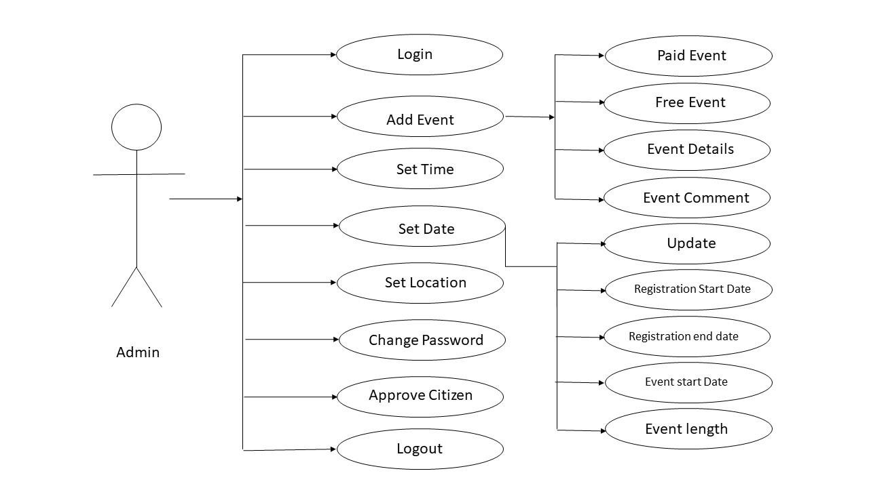

### 4.2. System Features for Citizen

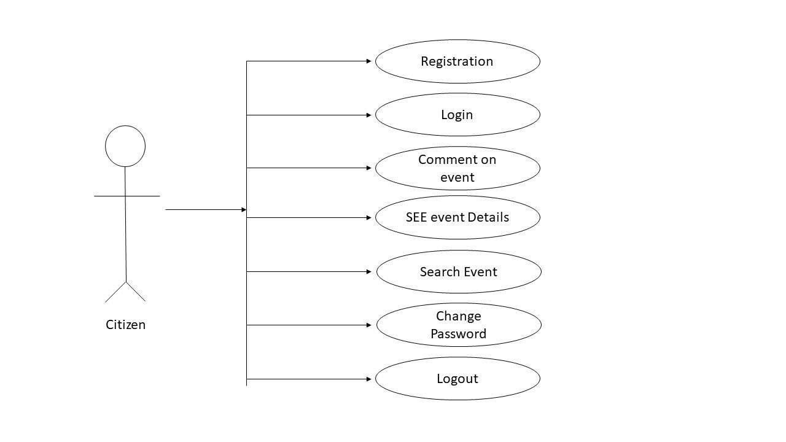

# 5. Other Nonfunctional Requirements

## 5.1. Safety Requirements

If there is extensive damage to a wide portion of the database due to a disk crash. Therefore, admin should careful in this case.

## 5.2. Security Requirements

Security systems need database storage just like many other applications. However, The requirements of the security means that admin must choose their database partner carefully.

## 5.3. Software Quality Attributes

* **AVAILABILITY:** The event should be available on the specified date and specified time.
* **CORRECTNESS:** The event should start from correct start time.
* **MAINTAINABILITY:** The administrators should maintain correct schedules of events.