**Detail Design**

**On**

**Restaurant Management System(RMS)**

**Course No: CSE 3204**

**Course Title: Software Engineering and Information System Project**

**Deep Dutta**

**Student ID: 140205**

**&**

**Kawsher Morshed**

**Student ID: 140235**

**Project Manager:   
Dr. Kazi Masudul Alam   
Associate Professor,  
Computer Science & Engineering Discipline,  
Khulna University**

**ER Diagram:**

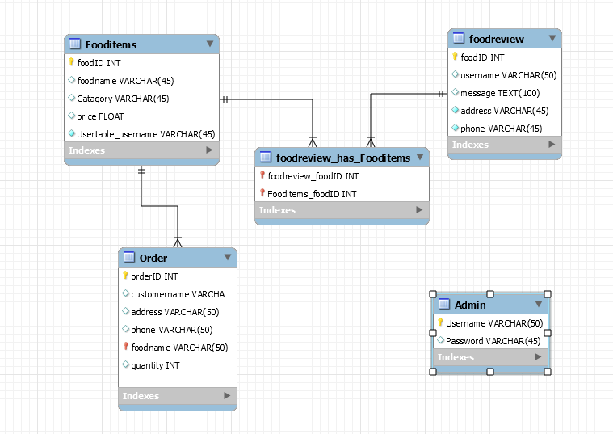

*Fig: ER Diagram*

**Class Diagram:**

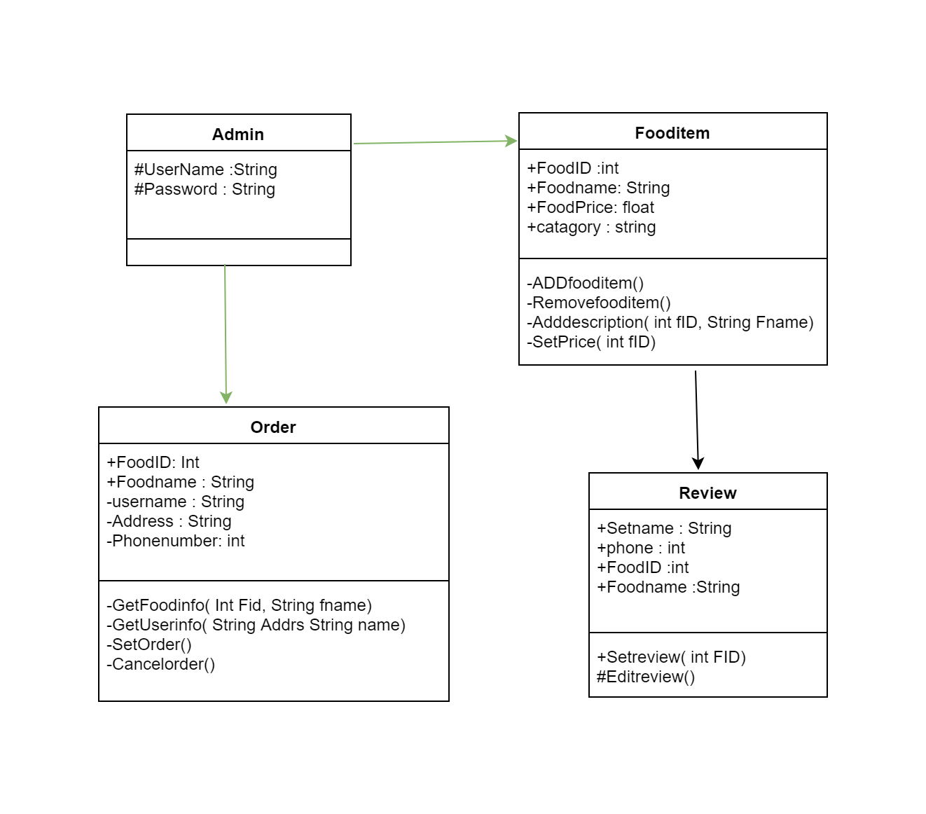

*Fig: Class Diagram*

**Details Class Digram:**

**Class Admin**

Void **AddNewItem(string name, int fid, float price, string description, string category);**

Void **Updatefoodlist(string name, int fid, float price, string description, string category) ;**

List<order>**All_Order**();

List<fooditem> **All_item ( );**

**Class FoodItem**

Void **Getfooditem(string name int fid);**

Void **Getcatagory(string catagory);**

List**<fooditem>all_item();**

**Class Order**

Void **Setorder(string foodname, string name, string phonenumber, string addess);**

Void **Cancelorder(int orderid);**

**Class Review**

Void **PostReview( string name, string phonenumber, int fid, string message);**

Void **EditReview(int reviewid);**

**Home page:**

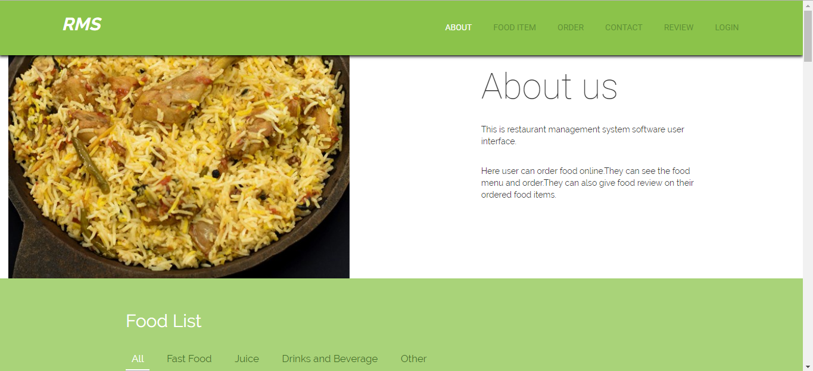

*Fig: Home Page*

**Admin Login Page:**

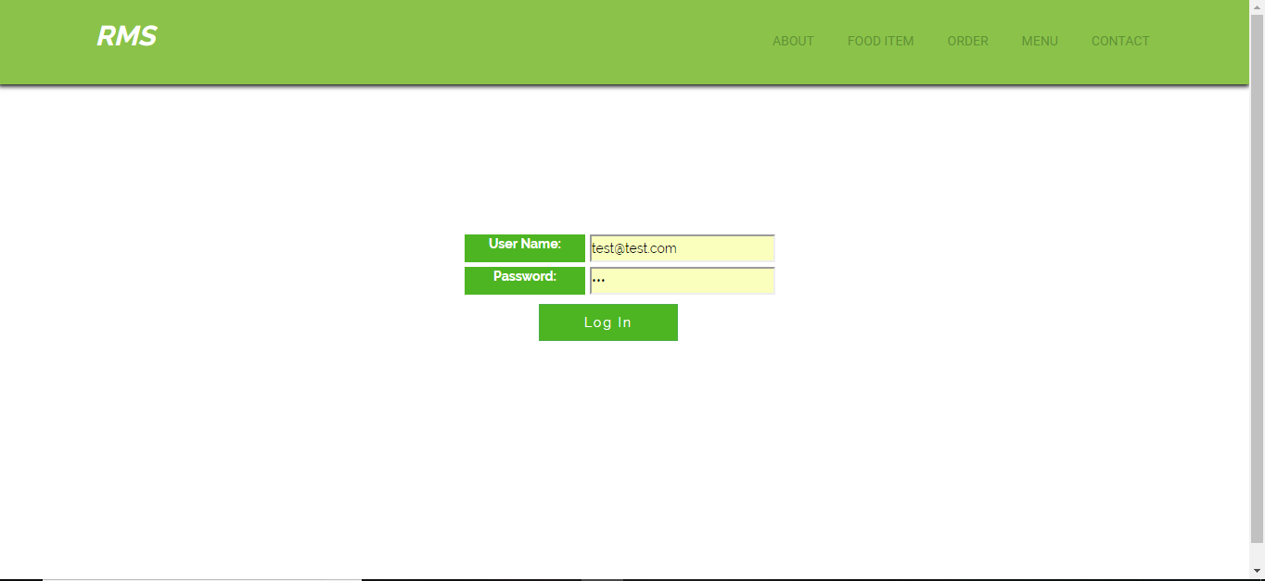

*Fig: Admin Login Page*

**Admin Page:**

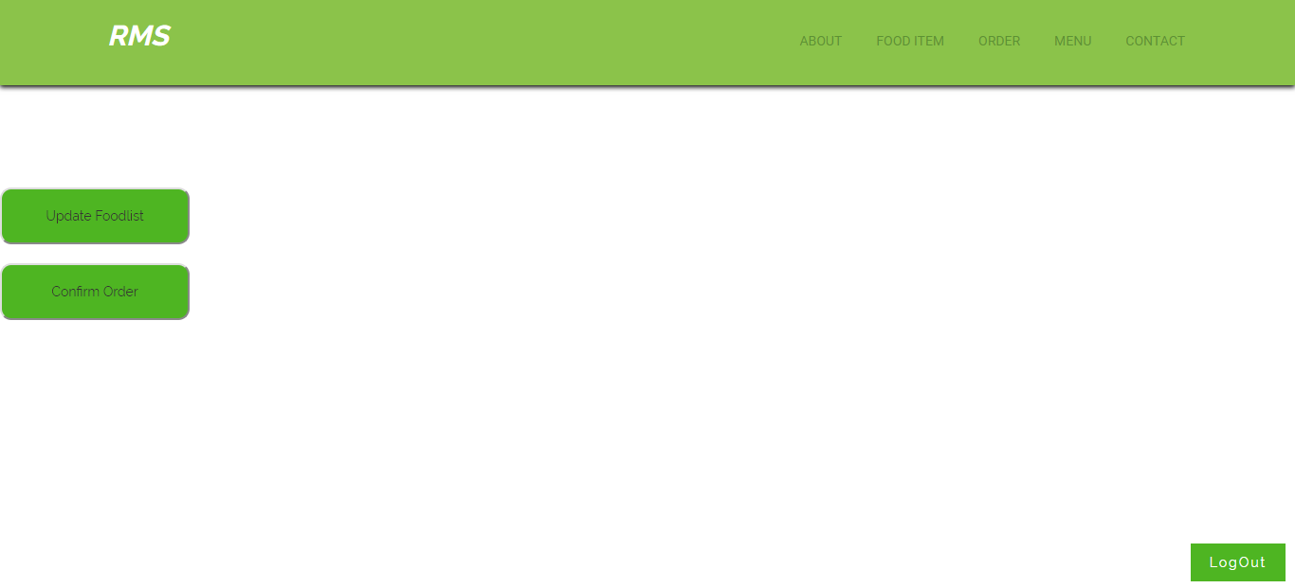

*Fig: Admin Page*

**Add new fooditem:**

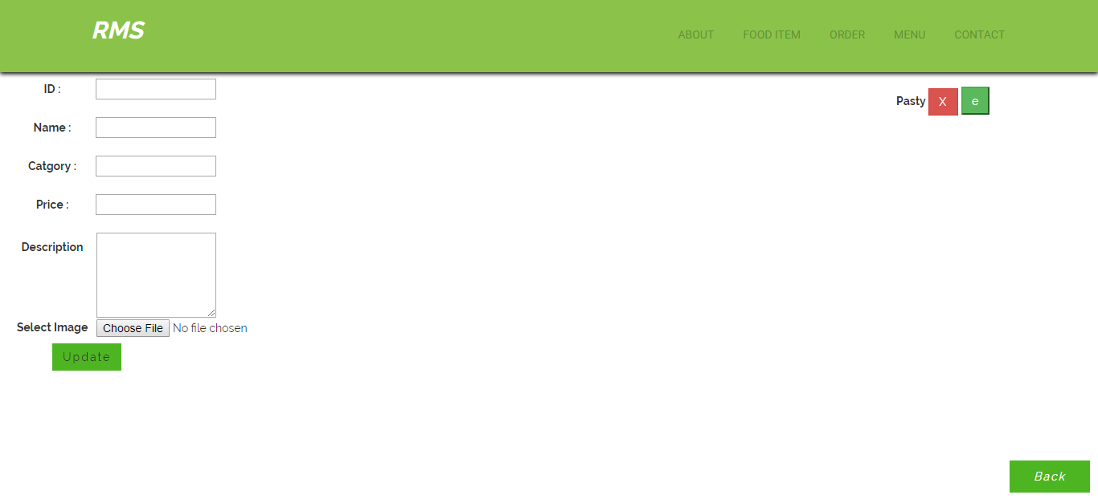

*Fig: Add fooditem*

**Order Confirmation:**

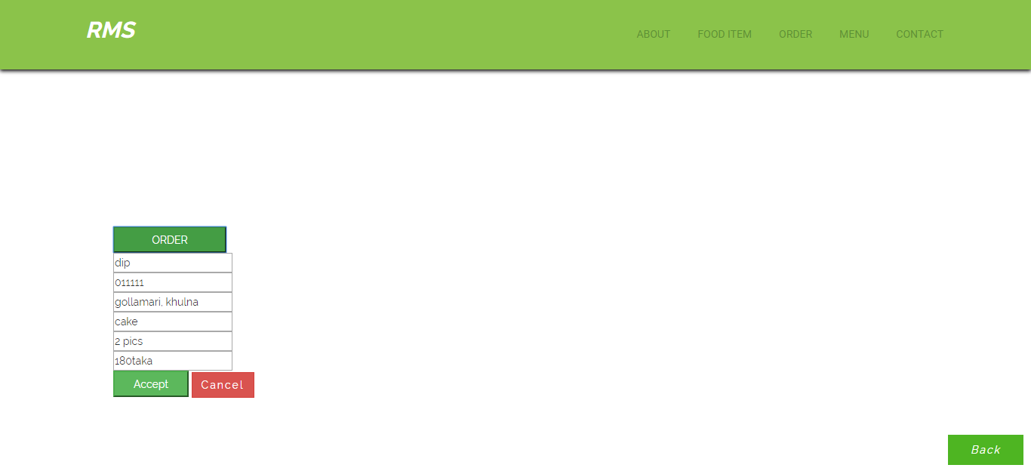

*Fig: Order confirm & cancel page*

**FoodList with catagory:**

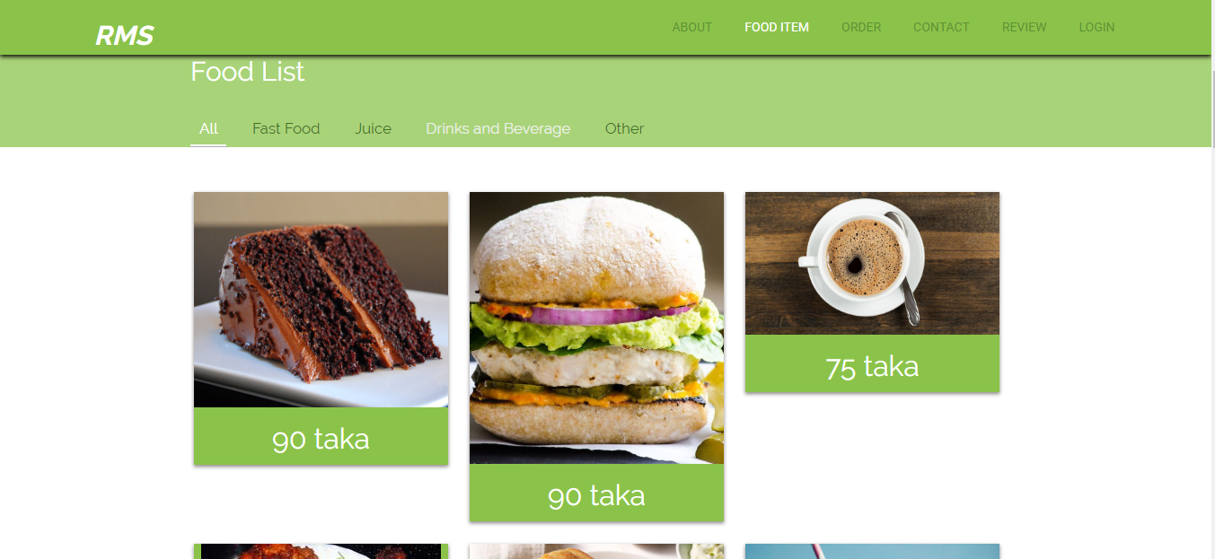

*Fig:FoodList*

**Fast Food Catagory:**

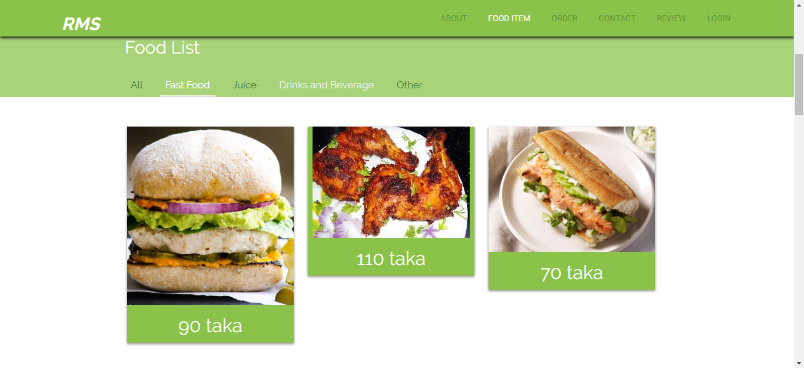

*Fig: Fast Food*

**Juice Item:**

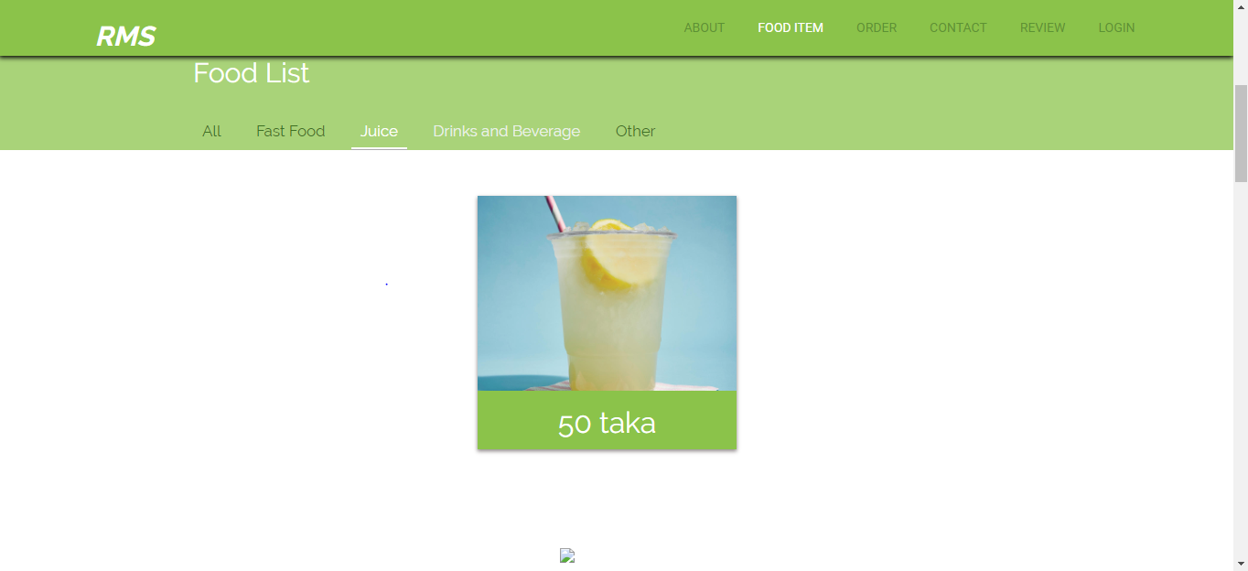

*Fig: Juice*

**Drinks & Beverage:**

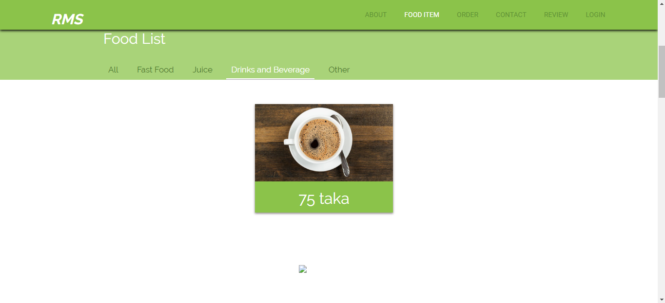

**Other Foods:**

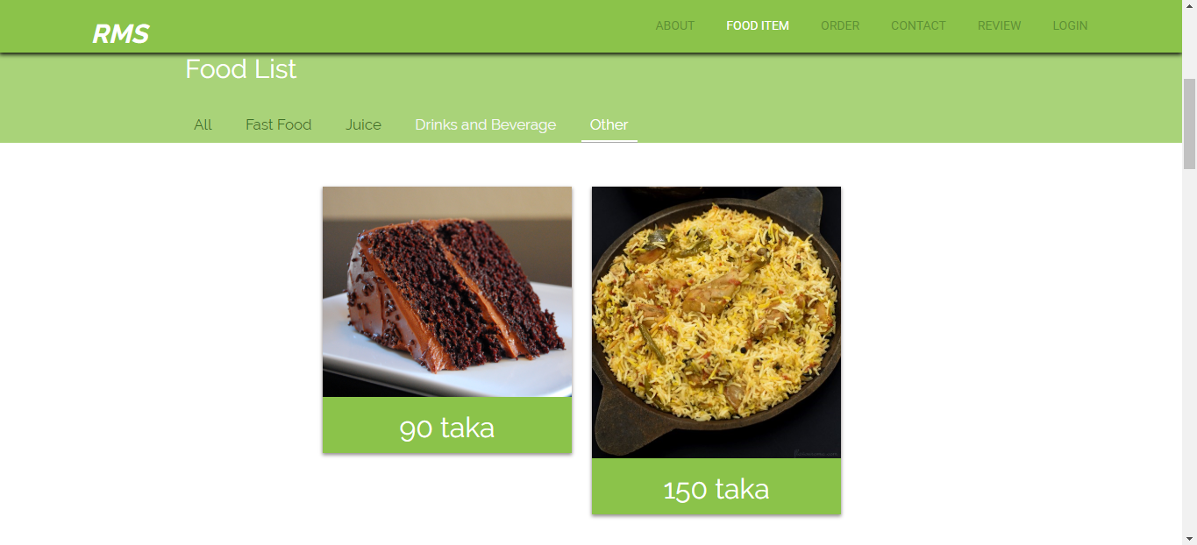

**User Order:**

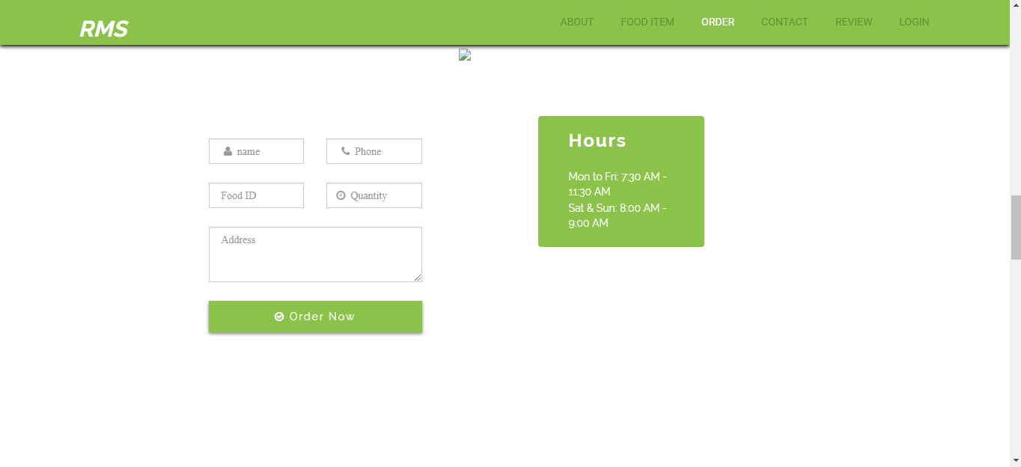

**Contact Page:**

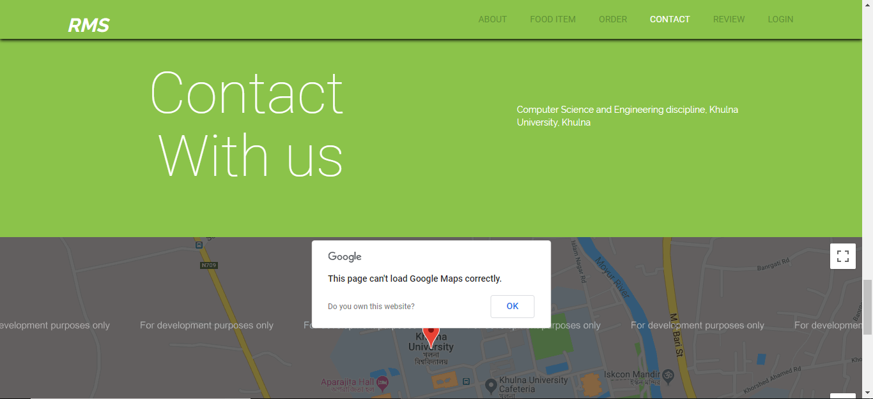

**Fig: How to contact**

**Review Page:**

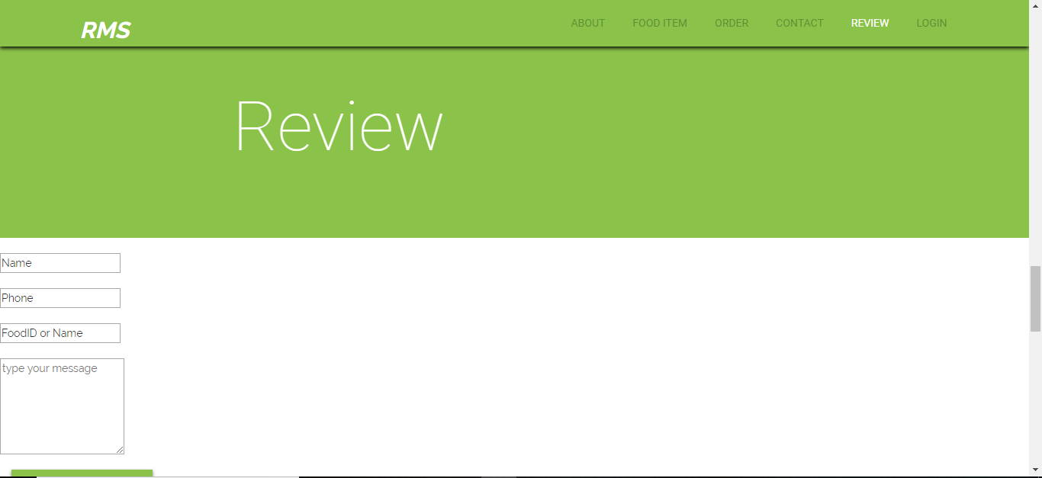

Fig: User review