**Detail Design**

**On**

**Student Tuition Finder**

**Course No: CSE 3204**

**Course Title: Software Engineering and Information System Project**

**Arjuman Sreashtho**

**Student Id: 160214**

**&**

**Antor Ali**

**Student Id: 160221**

**Project Manager:   
Dr. Kazi Masudul Alam   
Associate Professor,  
Computer Science & Engineering Discipline,  
Khulna University**

**Class User**

**{**

**Void setUserID(String UserID)**

**String getUserID()**

**Void setEmail(String Email)**

**String getEmail( )**

**Void setPassword(String Password)**

**String getPassword()**

**Boolean CreateUser()**

**Boolean DeleteUser(String UserID)**

**Boolean UpdateUser()**

**}**

**Class UserRole**

**{**

**Void setUserRole(String Role)**

**String getUserRole()**

**Boolean setUserRole(String Role)**

**}**

**Class UserDetails**

**{**

**Void setUserFirstName(String FirstName)**

**String getUserFirstName();**

**Void setUserMiddleName(String MiddleName)**

**String getUserMiddleName();**

**Void setUserLastName(String LastName)**

**String getUserLastName();**

**Boolean updateFirstName(String FirstName)**

**Boolean updateMiddleName(String MiddleName)**

**Boolean updateLastName(String LastName)**

**}**

**Class ContractNumber**

**{**

**Void setPhoneNumber(String PhoneNumber)**

**String getPhoneNumber()**

**Boolean deletePhoneNumber()**

**Boolean updatePhoneNumber(String PhoneNumber)**

**}**

**Class UserAddress**

**{**

**Void setRoadNum(String RoadNumber)**

**String getRoadNum()**

**Void setRoadName(String RoadName)**

**String getRoadName()**

**Void setBuildingName(String BuildingName)**

**String getBuildingName()**

**Void setAreaName(String Area)**

**String getAreaName()**

**Void setDistrict(String District)**

**String getDistrict()**

**}**

**Class Post**

**{**

**Void setPostID(String ID)**

**String getPostID()**

**Void setRole(String Role)**

**String getRole()**

**Void setAmmount(String Salary)**

**String getAmmount()**

**Void setPostDate(String Date)**

**String getPostDate()**

**Boolean createPost()**

**Boolean updatePost()**

**Boolean deletePost()**

**}**

**Class Subject**

**{**

**Void setUser(String UserID)**

**Void userRole(String UserID)**

**Void setSubject(String Subject)**

**String getSubject()**

**ArrayList<String> getAllTeachersOfThatSubject()**

**ArrayList<String> getAllStudentsOfThatSubject()**

**}**

**Class TuitionLocation**

**{**

**Void setLocation(String location)**

**String getLocation()**

**Void setRole(String Role)**

**String getRole()**

**ArrayList<String> getAllTeacherOfThatLocation()**

**ArrayList<String> getAllStudentOfThatLocation()**

**}**

**Class Institute**

**{**

**Void setStudentID(String ID)**

**String getUserID()**

**Void setInstituteName(String name)**

**String getInstituteName()**

**Void setRole(String Role)**

**String getRole()**

**ArrayList<String> getAllTeachers()**

**ArrayList<String> getAllStudents()**

**}**

**E-R Diagram:**

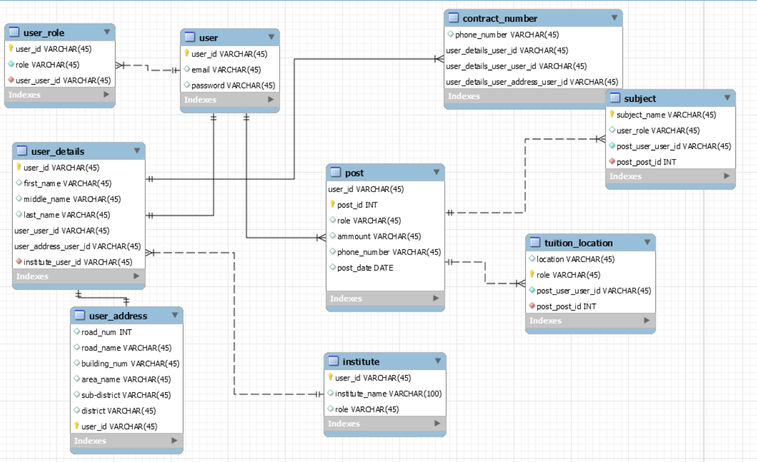

**Class Diagram:**

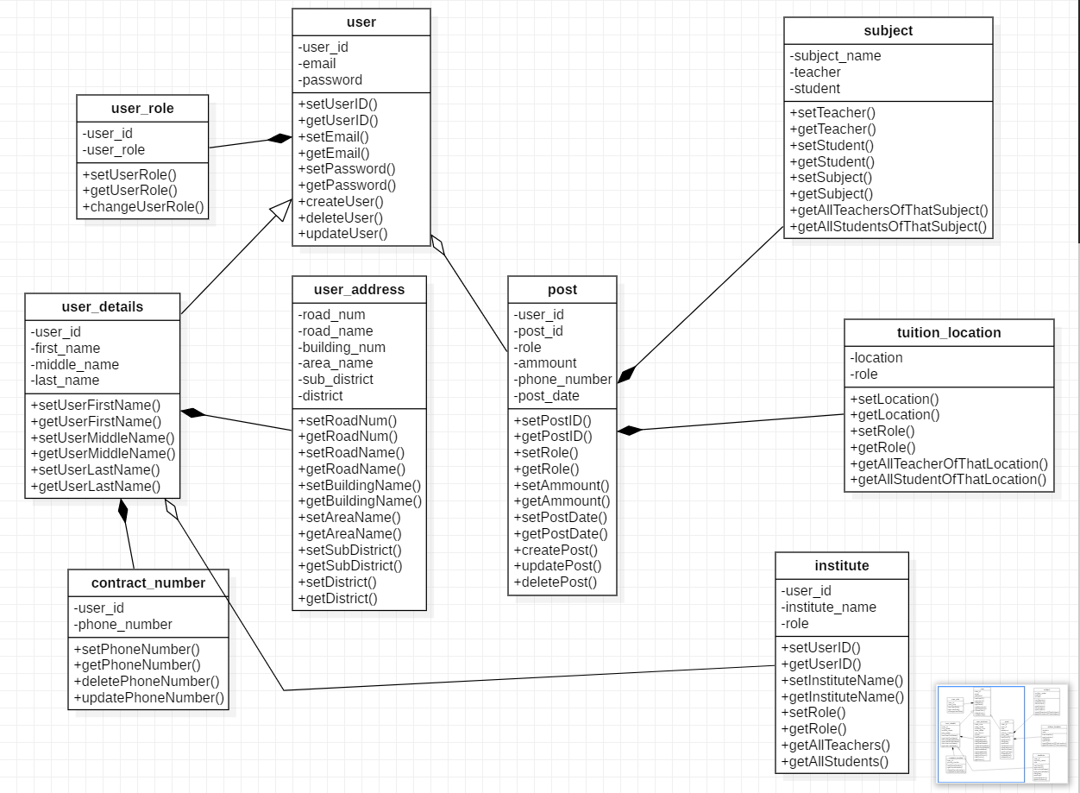

**Website Layout:**

**Home Page:**

* This is the home page of the project.
* User can see all options of the site.
* Here Sign Up button is used for creating new user and Log In button is used for log in (if user already has an account).
* User can also see the other options of the website without log in.
* If user wants to request for a tuition, he/she must log in.

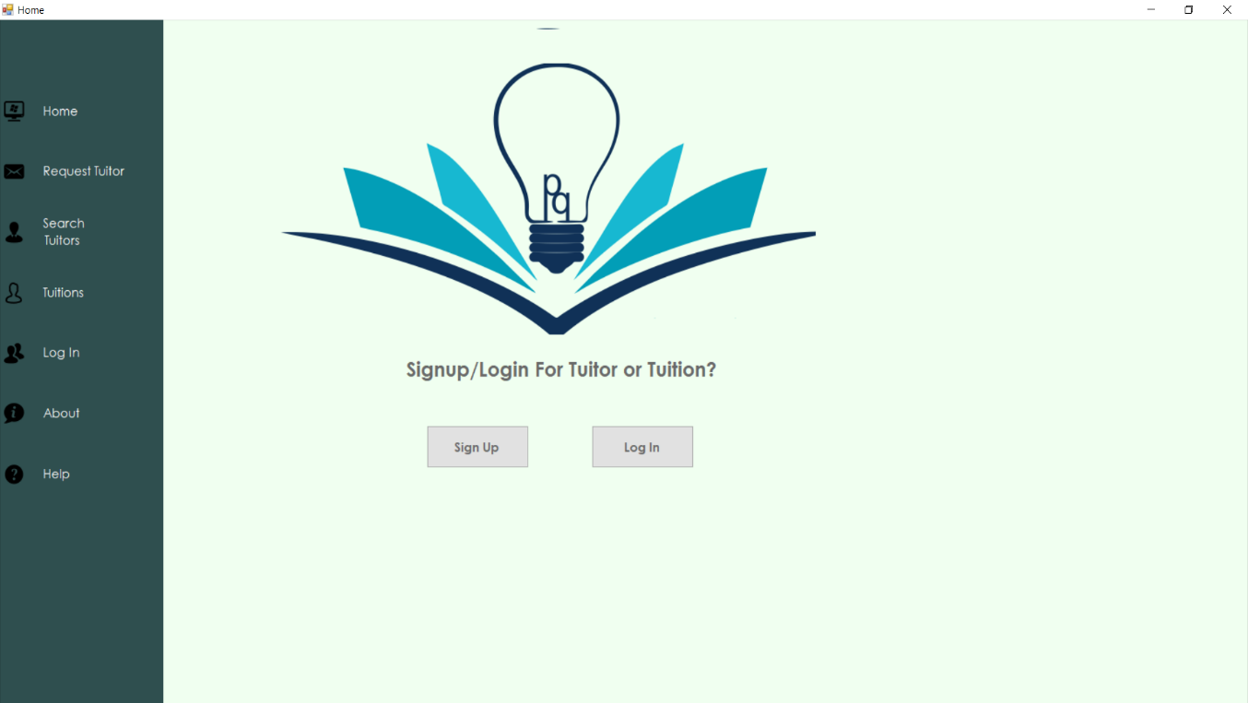

**Log In:**

* If user click on Log In button, he/she will see this page.
* Here user needs to put his/her Username and password and click on Log in button to log in his/her account.
* If user doesn’t have any account, he/she needs to click on ‘Don’t Have an Account?’ hyperlink to create an account.
* User can log in from sidebar Log In option and that will show other pages.

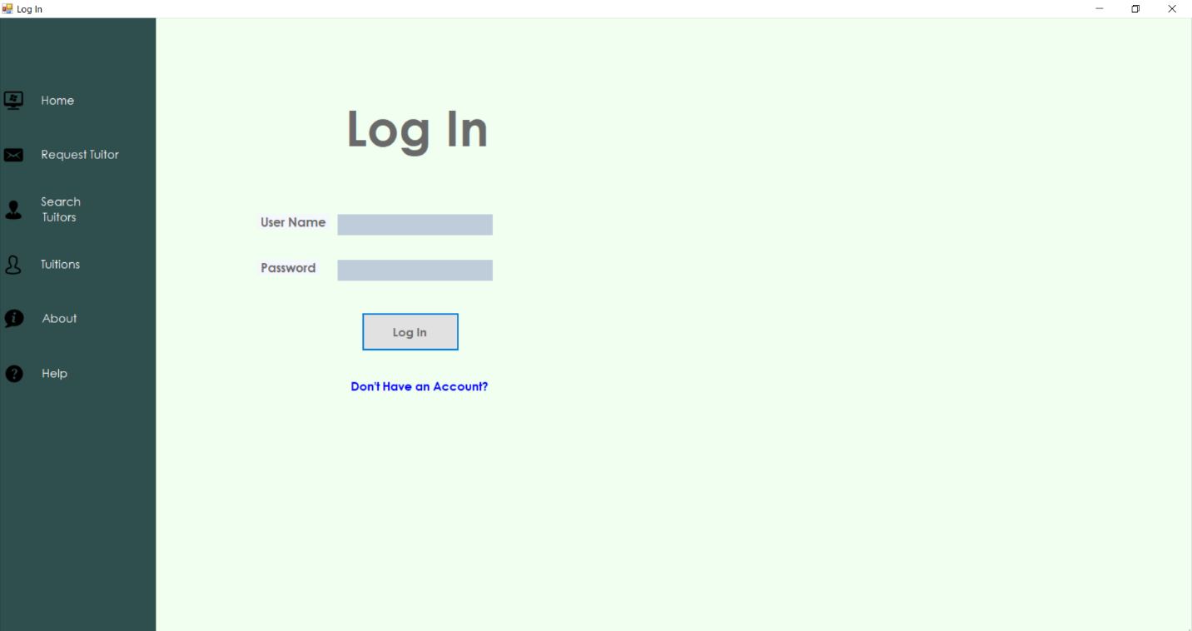

**Sign Up:**

* If User click on Sign Up button from home page or click ‘Don’t Have an Account?’ from Log In page, He/she will see this sign up page.
* User has to fulfill these required information.
* And click Sign Up button to create an account.
* Here role option will select if user wants to create his/her account as an teacher or student.

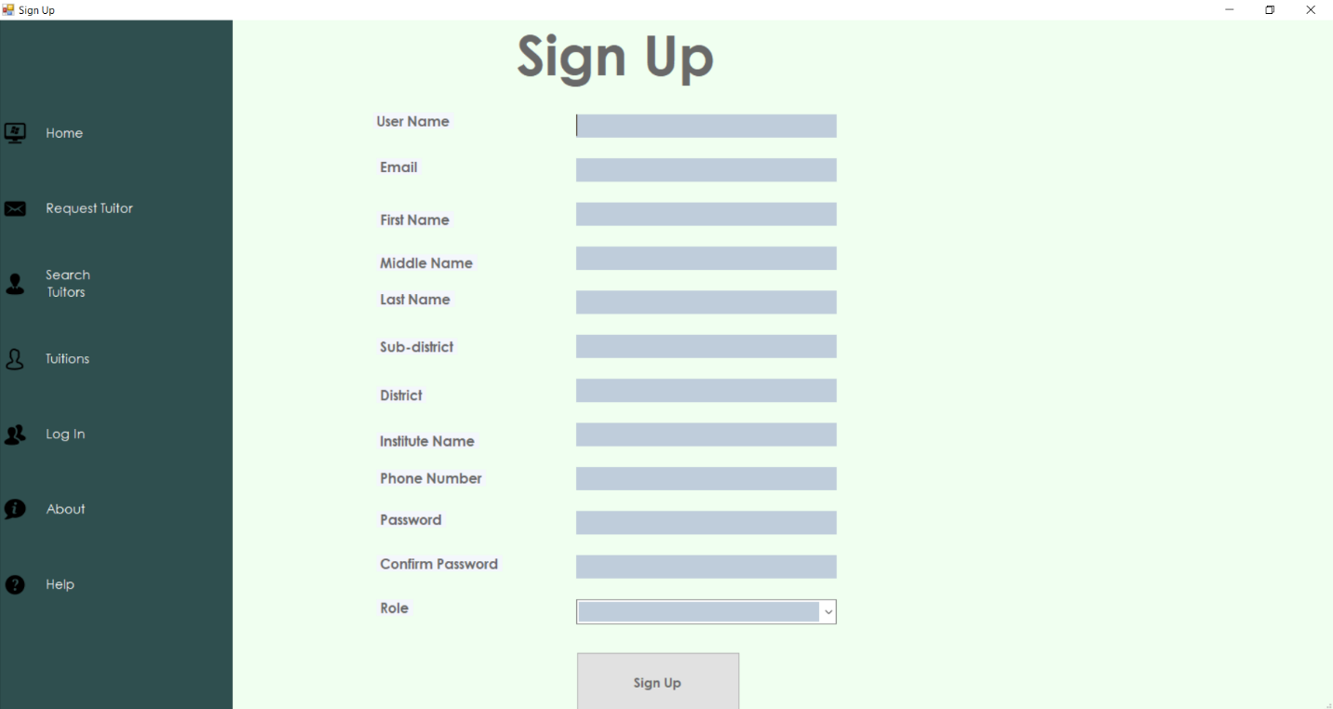

**Request For Tutor:**

* Here user can request for a circular for tuition.
* He/she needs to fulfill the requirements and click on Request button.
* If user doesn’t have an account, he/she can’t post.

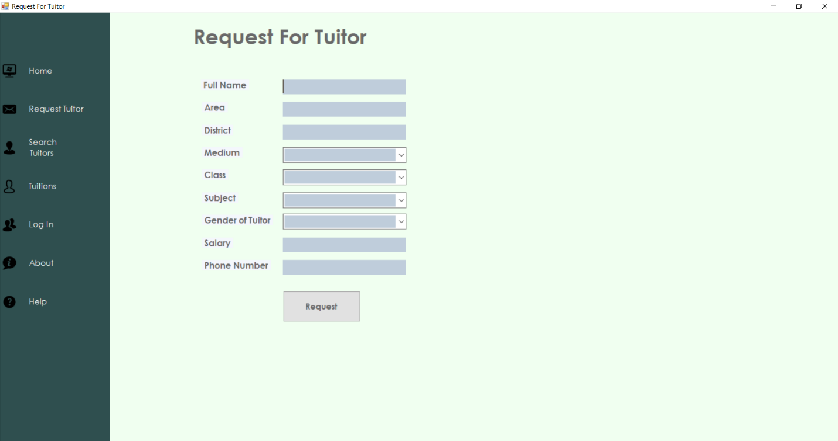

**Search Tutors:**

* User can search for tutors using this page.
* He/she can use as many filter options showing in the user interface.
* If he/she doesn’t select any of them, he/she can’t see any result.

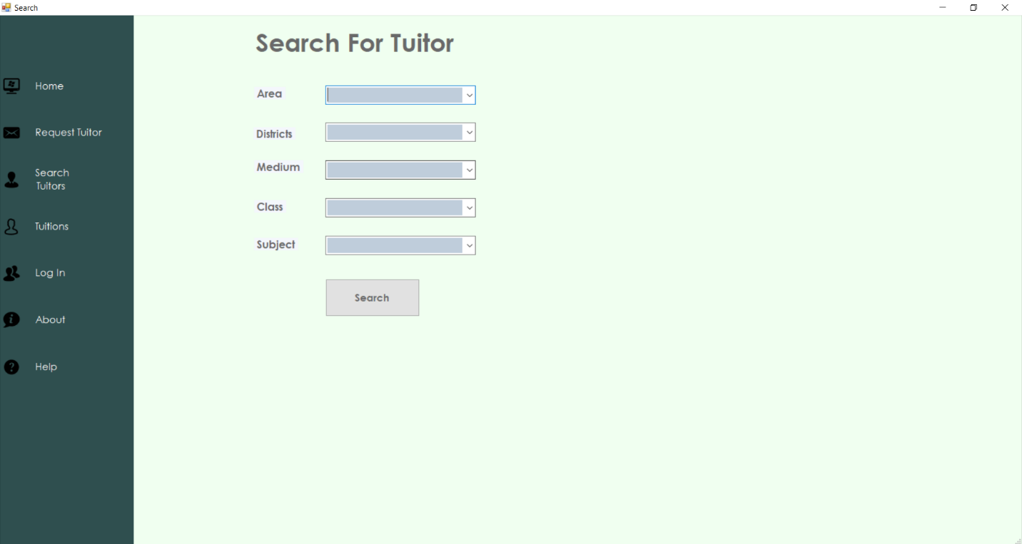

**Tuitions:**

* When user clicks this option, he/she will see a page where all the circular for the tuitions.
* If he/she clicks on the View Details button of a circular, it will show full information of the post.

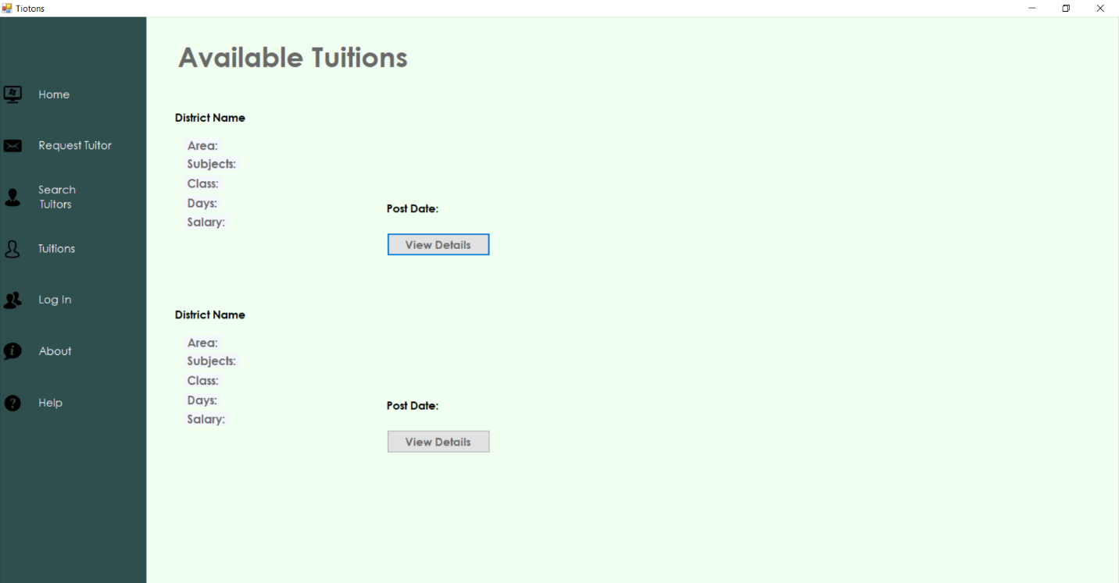

**Help:**

* In this page, if user clicks on ‘How it works?’ hyperlink, it will show the user manual of the site.
* If user face any problem while using the site, he/she can report us and give his/her email address, so we can send the feedback of the problem.

