- Download python3 version of eye motion repair script from GitHub.
  - https://github.com/AOIPLab/Eye_Motion_Repair/tree/python3_version
- Determine the Python version needed for the MATLAB version.
  - https://www.mathworks.com/support/requirements/python-compatibility.html
  - If MATLAB 2023b, need Python 3.9-3.11 (3.11 vetted).
  - Python Release Python 3.11.0 | Python.org
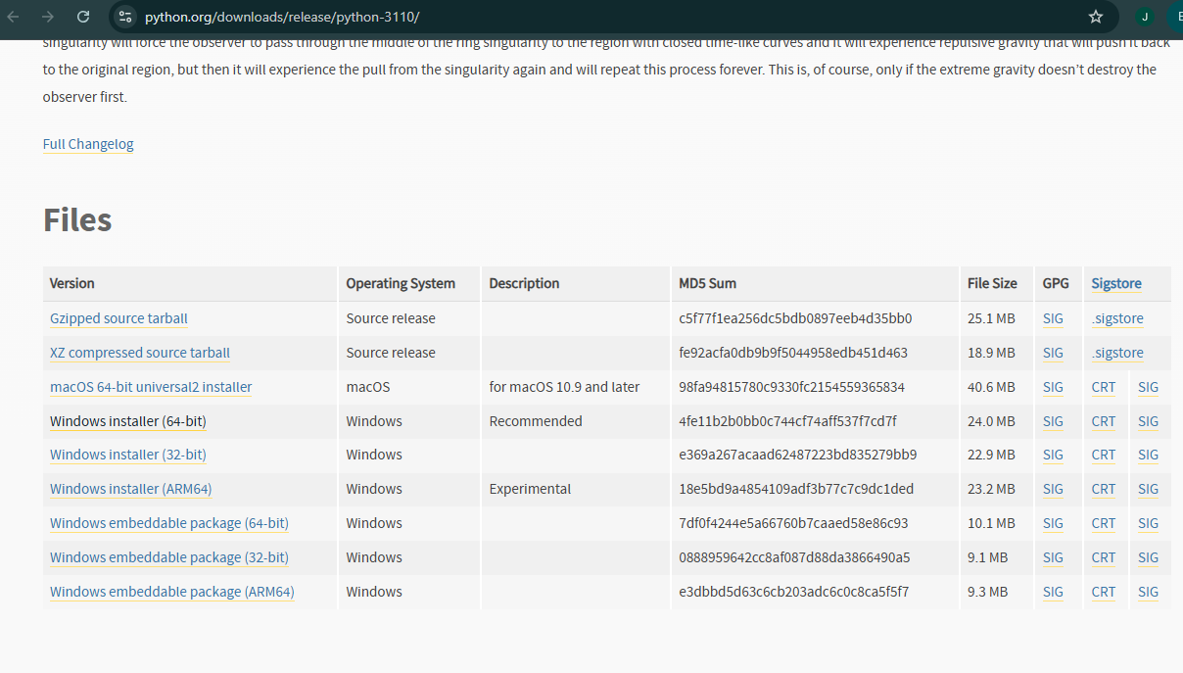
  - NOTE: If not using python 3.11, edit the python path listed in line 56 of script.
- Installing Python:
  - Select custom installation.
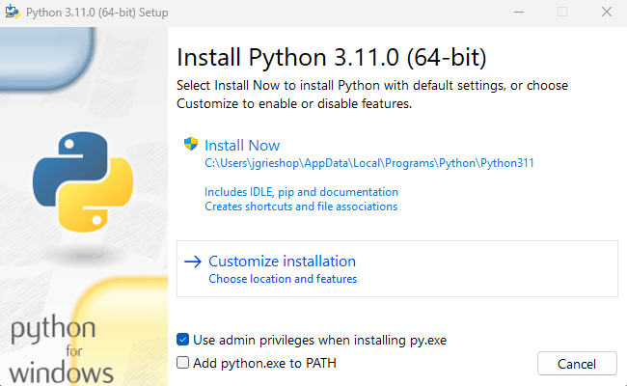
  - Optional Features: Check all boxes except py launcher.
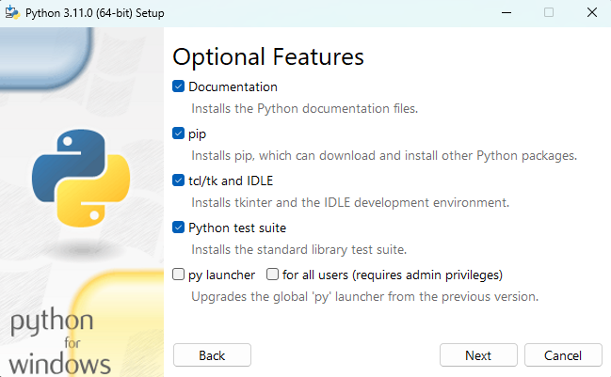
  - Advanced Options: Check Install Python for all users, create shortcuts for installed applications, precompile standard library
  - Install location must be: C:\Python3## (i.e. 311)

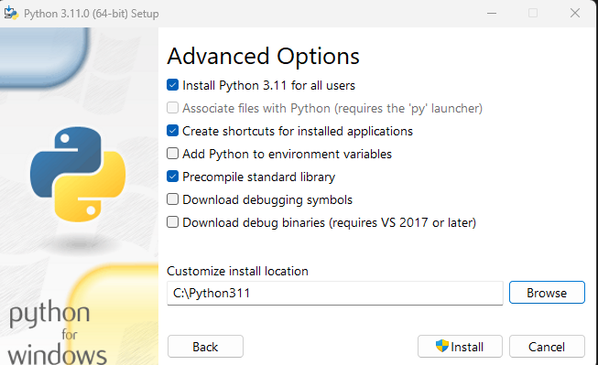
- Launch PyCharm and open script
  - Create new interpreter (existing interpreter (python.exe in the python311 location)
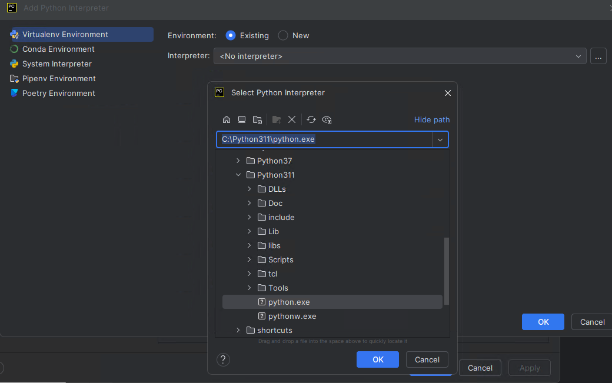
  - Install numpy for the interpreter
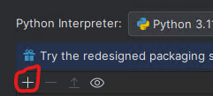
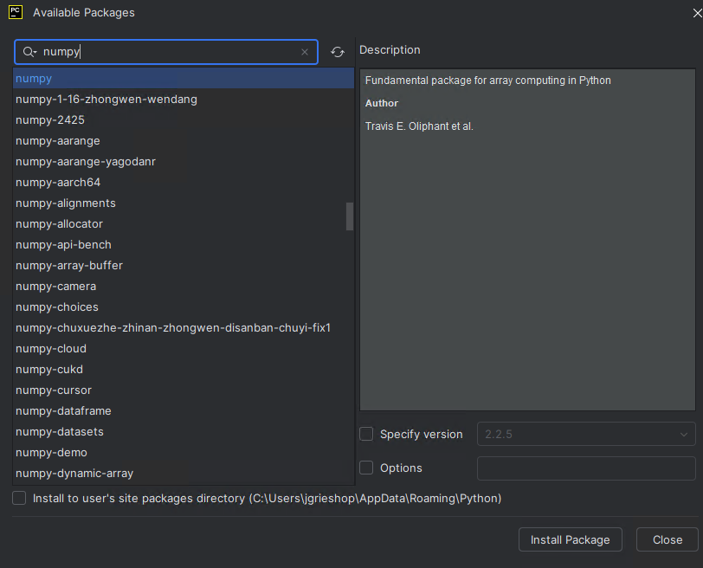
- You may need to wait for the skeletons to update
- Once everything is loaded, run the script
  - On initial script run through, script will prompt you to select the python folder within the MATLAB installation folder.
  - It will then perform the linking commands between MATLAB and Python and will end the script.
- The script should now work as expected.

